EBSMCP MCP Server
Overview, Linux Installation, and Microsoft 365 Copilot Integration Guide
Prepared 2026-09-02

1. Overview

1.1 What This Document Covers
This guide covers four things: what the EBSMCP MCP server is and how it is built, how to install and run it on a Linux server, how to prepare a least-privilege, read-only Oracle E-Business Suite (EBS) database account for it to connect with, and how to register and authenticate it as a tool source for Microsoft 365 Copilot.

1.2 Product Architecture
EBSMCP is built as a licensable, multi-tenant product — each deployment (one Kubernetes namespace, one set of secrets, one Entra tenant) serves exactly one customer, never more than one at a time. Within that one customer, a single deployment can still reach several EBS databases at once (e.g. PROD, UAT, QA — see Section 4.6) — that is a separate axis from "which customer/Entra tenant," not tied to it. It is made up of five services:
- mcp-server — the Model Context Protocol server this guide is about. Exposes Oracle EBS (and Fusion) data and diagnostics as callable MCP tools to any MCP-compatible AI client.
- management-api — the backend behind the admin console: identity-to-role mappings, audit querying, admin authentication.
- admin-gui — the web console administrators use to manage identity mappings and review audit history.
- identity-service — owns the Postgres schema mapping a real person/subject to their allowed target system, mapped role, and (for functional personas) allowed Org IDs.
- audit-service — owns the Postgres schema that structured audit records land in.
All state that matters for compliance and access control — who can call what, and what they actually called — lives in Postgres, managed by identity-service and audit-service, not inside the MCP server itself. The MCP server is intentionally close to stateless.
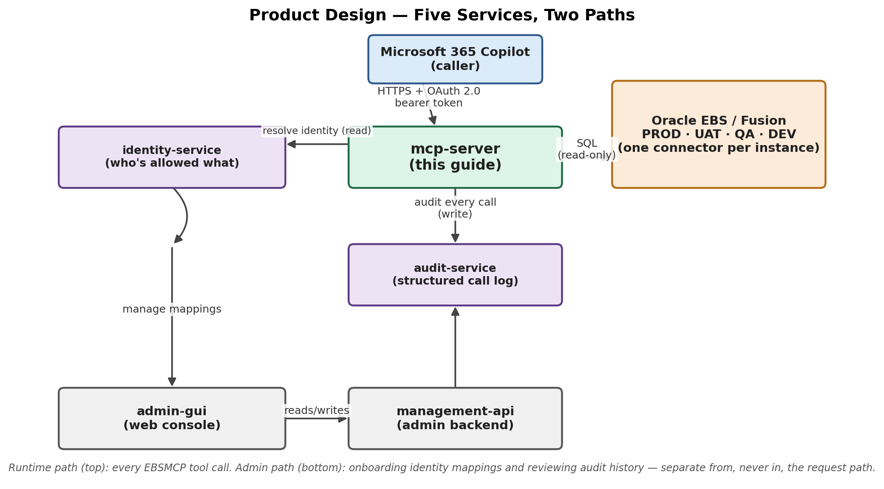
Figure 1. Product design — the five services and the two paths through them.

1.3 MCP Tool Catalog Summary
As of this writing the DBA persona alone exposes 64 tools across 12 categories, each reading standard Oracle dictionary/dynamic-performance views or EBS application tables (one of the 64, list_ebs_instances, is a discovery tool rather than a diagnostic one — see Section 4.6):
Category | Tools | Covers
instance_health | 21 | Tablespaces, undo, TEMP, memory, locks, SQL, indexes, alert log, invalid objects, init parameters, open cursors, recycle bin, licensing
security_configuration | 11 | DB accounts, privileged roles/grants, DB links, FND application users, responsibilities, failed logins, profile values
memory | 5 | SGA/PGA sizing and advice
concurrent_processing | 4 | Concurrent manager/request health and load
workflow | 4 | Workflow engine diagnostics
redo_archive_backup | 4 | Redo logs, archive logs, archive pipeline, RMAN backups
patch_version_tracking | 4 | Applied patches, product versions, DB component registry, ADOP session status
output_printing | 3 | Concurrent printing / Output Post Processor
high_availability_dr | 2 | Data Guard lag, restore points, RAC, database services
index_health | 2 | Unusable indexes, non-indexed foreign keys
diagnose_request / notification_diagnosis | 2 | Composed, multi-query drill-down tools

1.4 Security Model
Every tool call goes through the same pipeline:
- Identity resolution — the caller's bearer token (or, in local dev, a fixed stub subject) resolves to a subject, an environment, a target system (ebs, fusion, or ebs_dba), a mapped role, and — for functional personas only — a fixed set of allowed Org IDs.
- Entitlement filtering — a tool call may narrow the caller's allowed scope, never widen it. The DBA persona (ebs_dba) is deliberately all-or-nothing: no Org ID scoping, because database-level diagnostics have no Org concept to scope against.
- SQL execution — GV$ and DBA_ dictionary/dynamic-performance views are referenced bare (GV$SESSION, DBA_TABLESPACES — never SYS.-qualified, and never bare V$, only GV$, so the same query works unmodified on a single-instance database and on RAC); EBS application tables are always fully schema-qualified (APPLSYS.OBJECT, AD.OBJECT). The bare form for GV$/DBA_ relies on Oracle's standard public synonyms rather than a SYS. prefix — verified live against the account this catalog was built against, but see Section 4.1's note before assuming it holds for a different, non-legacy read-only account without checking. Every free-text filter value is a bound parameter, never string-interpolated.
- Audit logging — every call, successful or not, is written as a structured record (correlation ID, subject, tool, params, effective Org IDs, status, latency) before the result reaches the caller.

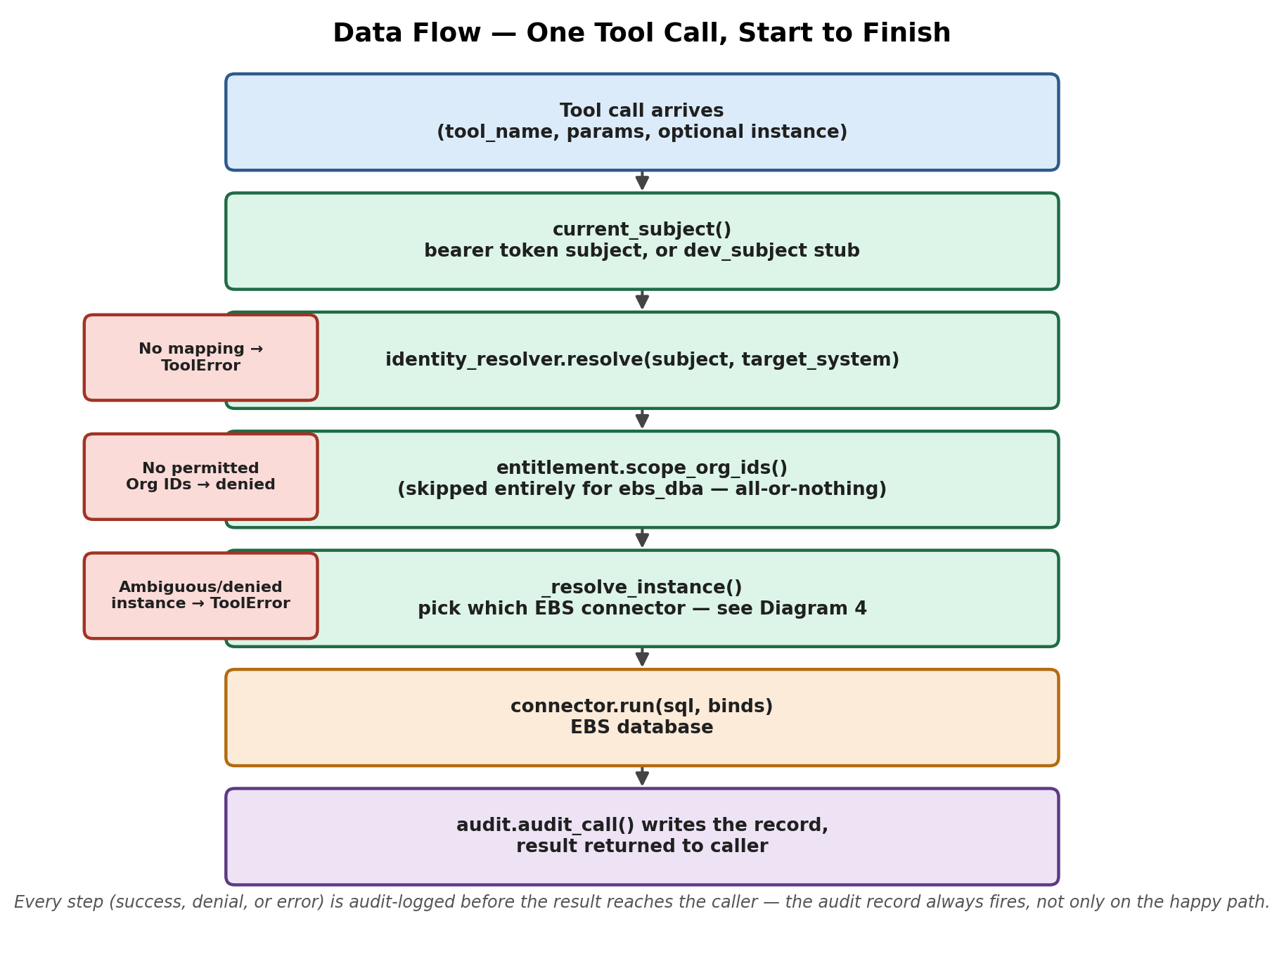
Figure 2. Data flow — one tool call, start to finish, through resolve_scoped_call.

2. Prerequisites
- A Linux server — Ubuntu 22.04+ or RHEL/Rocky 8+ (or equivalent). 2 vCPU / 4 GB RAM is comfortably enough for the mcp-server container by itself.
- Docker Engine 24+ and the Docker Compose plugin (the recommended deployment path — this matches the docker-compose.yml shipped in the repository).
- Outbound network access from the server to: the Oracle EBS/Fusion database listener (TCP 1521, or your site's configured port), and https://login.microsoftonline.com (Entra ID token and JWKS validation).
- Inbound HTTPS reachability from Microsoft 365 Copilot's infrastructure — the MCP server must sit behind a TLS-terminating reverse proxy on a real, resolvable domain name. The container itself only ever speaks plain HTTP.
- A registered domain name and a TLS certificate for that domain (e.g. via Let's Encrypt).
- An Entra ID tenant, with a role capable of creating App Registrations (Application Administrator or Cloud Application Administrator).
- Oracle EBS database connection details, and DBA access once per EBS instance you plan to connect (PROD, UAT, QA, ...) — the read-only account setup in Section 4 is the same procedure, run once per instance.

3. Installing the MCP Server on a Linux Server

3.1 Install Docker
On Ubuntu/Debian:
curl -fsSL https://get.docker.com | sudo sh
sudo usermod -aG docker $USER
newgrp docker
docker --version && docker compose version
On RHEL/Rocky/Alma:
sudo dnf install -y dnf-plugins-core
sudo dnf config-manager --add-repo https://download.docker.com/linux/rhel/docker-ce.repo
sudo dnf install -y docker-ce docker-ce-cli containerd.io docker-compose-plugin
sudo systemctl enable --now docker

3.2 Get the Code
git clone <your-repository-url> ebsmcp
cd ebsmcp

3.3 Configure Environment Variables
Set these in the root .env file next to docker-compose.yml — the shipped docker-compose.yml's mcp-server service already reads them from there automatically (see the environment: block it defines; mcp-server/.env.example documents the same variables for the non-compose case, running the container directly). The Dockerfile already fixes EBSMCP_TRANSPORT, EBSMCP_HTTP_HOST, and EBSMCP_HTTP_PORT for the container — do not override those unless you have a specific reason to.
Variable | Purpose
EBSMCP_ENVIRONMENT | dev / test / uat / prod — one deployment serves exactly one.
EBS_DB_DSN | Oracle DSN, e.g. host:1521/service_name — see Section 4.6.
EBS_DB_USER / EBS_DB_PASSWORD | The read-only account created in Section 4.
EBSMCP_ENTRA_TENANT_ID | Your Entra ID tenant (directory) ID — see Section 5.
EBSMCP_ENTRA_AUDIENCE | The MCP server's own App Registration (client) ID — Section 5.
EBSMCP_RESOURCE_SERVER_URL | The MCP server's public HTTPS base URL, e.g. https://ebsmcp.yourdomain.com
EBSMCP_ENTRA_SUBJECT_CLAIM | Token claim used as the caller's subject. Defaults to preferred_username; leave unset unless you have a reason to change it.
IDENTITY_DB_URL | Optional — the identity-service Postgres connection string, for real identity-mapping lookups instead of the fixed dev stub.

Note: Until EBSMCP_ENTRA_TENANT_ID, EBSMCP_ENTRA_AUDIENCE, and EBSMCP_RESOURCE_SERVER_URL are all set, the server accepts no bearer tokens at all and treats every caller as a single fixed dev identity. That is fine for local testing; it must never be the state of a deployment Microsoft 365 Copilot can reach.
Two variables are easy to miss and both cause a silent, total failure if skipped — not a clean error pointing at the cause:
- EBSMCP_EBS_INSTANCES — required for more than one EBS database (PROD/UAT/QA/...); a single-instance deployment can keep using the plain EBS_DB_DSN/EBS_DB_USER/EBS_DB_PASSWORD form instead. See Section 4.6 for both forms and the ebs-instances.sample.env file shipped in the repository root.
- EBSMCP_ALLOWED_HOSTS / EBSMCP_ALLOWED_ORIGINS — streamable-http's DNS-rebinding protection defaults to an empty list, which REJECTS EVERY request outright until your real domain is named here. This is independent of Entra config — a correctly configured Entra setup still gets nothing but connection failures if these are left unset once behind a real reverse proxy. Set both to your public domain, e.g.:
EBSMCP_ALLOWED_HOSTS=["ebsmcp.yourdomain.com"]
EBSMCP_ALLOWED_ORIGINS=["https://ebsmcp.yourdomain.com"]
Both are JSON arrays, not comma-separated strings — pydantic-settings parses them as JSON and fails to start the container at all on malformed input, including an accidentally-empty string (docker compose interpolation footgun: ${VAR:-} with VAR unset passes an empty string, not "unset" — the shipped docker-compose.yml already handles this correctly with [] fallbacks, worth knowing if you adapt it).

3.4 Build and Start
docker compose build mcp-server
docker compose up -d mcp-server
docker compose logs -f mcp-server
To run the full stack (admin console included), use docker compose up -d --build instead — see the comments at the top of docker-compose.yml for the additional root .env values (ADMIN_SESSION_SECRET, etc.) that involves.

3.5 Put a TLS Reverse Proxy in Front
The container listens on plain HTTP, port 8080, on the streamable-http path /mcp. Both Entra ID and Microsoft 365 Copilot require an HTTPS endpoint. A ready-to-adapt reference config ships at nginx/templates/default.conf.template in the repository — use it rather than a minimal example like the one below, which omits settings streamable-http actually needs:
server {
listen 443 ssl;
server_name ebsmcp.yourdomain.com;
ssl_certificate /etc/letsencrypt/live/ebsmcp.yourdomain.com/fullchain.pem;
ssl_certificate_key /etc/letsencrypt/live/ebsmcp.yourdomain.com/privkey.pem;
location / {
proxy_pass http://127.0.0.1:8080;
proxy_set_header Host $host;
proxy_set_header X-Forwarded-Proto https;
# streamable-http is a long-lived SSE-style connection, not a
# request/response round trip — without these three, a tool
# call's response silently never arrives (buffered/timed out),
# not a clean error. Missing from earlier drafts of this guide.
proxy_http_version 1.1;
proxy_buffering off;
proxy_read_timeout 3600s;
}
}
Note: Do not expose port 8080 directly to the internet. Firewall it to localhost/internal network only and let the reverse proxy be the sole public entry point.

3.6 Verify the Deployment
- docker compose ps — mcp-server should show as healthy/running.
- curl -i https://ebsmcp.yourdomain.com/mcp — should respond (a plain GET without a session will return a protocol-level error, not a connection failure; that's expected).
- curl -i https://ebsmcp.yourdomain.com/.well-known/oauth-protected-resource/mcp — once Entra config is set (Section 5), this returns the OAuth resource metadata that Microsoft 365 Copilot's tooling uses for discovery.
- Point an MCP-aware client (the MCP Inspector, or Claude Code itself) at the public URL to confirm tools list and a real diagnostic call both work end to end.

4. Oracle EBS Database-Side Preparation
This section creates a dedicated, read-only Oracle account for the MCP server — never reuse the apps schema owner or any application account for this.
Run this whole section once per EBS instance if you're connecting more than one (PROD, UAT, QA, ...) — same account name and setup each time; only the DSN and (normally) the password differ per instance.

4.1 Design Decisions
- No SYSDBA, no DBA role, no CREATE/INSERT/UPDATE/DELETE anywhere. SYSDBA in particular is a connection mode, not a passive grant — it does not do what it sounds like it does for a normal application connection, and is grossly over-privileged for this purpose regardless.
- SELECT_CATALOG_ROLE is the correct grant for DBA_* and GV$* access — this is the standard, well-documented Oracle role for exactly this kind of read-only DBA tooling account, and is what every query in this catalog that touches a DBA_*/GV$* dictionary or dynamic-performance view depends on.
- GV$/DBA_* views are queried bare (GV$SESSION, not SYS.GV$SESSION) — the SYS.-qualified form was tried first and found to fail even for an adequately privileged account in practice; the bare form resolves via Oracle's standard public synonyms instead, which is why SELECT_CATALOG_ROLE above is what actually matters, not a SYS. grant. This was verified against the account this catalog was built and tested against — it has NOT been separately verified that a freshly-created ebsmcp_ro account (as opposed to reusing an existing, long-lived DBA login) resolves the same bare names identically on every EBS instance. Confirm with a throwaway SELECT against GV$SESSION as ebsmcp_ro before trusting this in production, per instance. EBS application tables (APPLSYS., AD.) are always fully schema-qualified regardless — only the DBA_*/GV$* catalog views use the bare/synonym-dependent form.

4.2 Create the Read-Only Account
CREATE USER ebsmcp_ro IDENTIFIED BY "<a strong, generated password>"
DEFAULT TABLESPACE users
TEMPORARY TABLESPACE temp
QUOTA 0 ON users;
GRANT CREATE SESSION TO ebsmcp_ro;
Note: QUOTA 0 ON users confirms the account can never create objects of its own, even by accident — it has no CREATE TABLE or similar privilege anyway, this just removes the possibility outright. Generate the password with a secrets manager; do not commit it anywhere. Consider a dedicated profile with a long PASSWORD_LIFE_TIME for this service account so it does not silently expire.

4.3 Grant Catalog / Dynamic-Performance View Access
One role grant covers every DBA_* and GV$* view the entire tool catalog reads (queried bare, per 4.1) — there are more than 60 of them across instance health, security, patching, backup, and HA/DR tools; SELECT_CATALOG_ROLE covers all of them at once:
GRANT SELECT_CATALOG_ROLE TO ebsmcp_ro;

4.4 Grant Access to Specific EBS Application Tables
The application-layer tools (concurrent processing, workflow, FND user/security, patch history) read specific APPLSYS-owned tables directly, and are not covered by SELECT_CATALOG_ROLE. Grant SELECT on exactly these:
GRANT SELECT ON APPLSYS.FND_APPLICATION TO ebsmcp_ro;
GRANT SELECT ON APPLSYS.FND_CONCURRENT_PROCESSES TO ebsmcp_ro;
GRANT SELECT ON APPLSYS.FND_CONCURRENT_PROGRAMS TO ebsmcp_ro;
GRANT SELECT ON APPLSYS.FND_CONCURRENT_PROGRAMS_TL TO ebsmcp_ro;
GRANT SELECT ON APPLSYS.FND_CONCURRENT_QUEUES TO ebsmcp_ro;
GRANT SELECT ON APPLSYS.FND_CONCURRENT_QUEUES_TL TO ebsmcp_ro;
GRANT SELECT ON APPLSYS.FND_CONCURRENT_REQUESTS TO ebsmcp_ro;
GRANT SELECT ON APPLSYS.FND_LOGINS TO ebsmcp_ro;
GRANT SELECT ON APPLSYS.FND_PRINTER TO ebsmcp_ro;
GRANT SELECT ON APPLSYS.FND_PRODUCT_INSTALLATIONS TO ebsmcp_ro;
GRANT SELECT ON APPLSYS.FND_PROFILE_OPTIONS TO ebsmcp_ro;
GRANT SELECT ON APPLSYS.FND_PROFILE_OPTION_VALUES TO ebsmcp_ro;
GRANT SELECT ON APPLSYS.FND_RESPONSIBILITY TO ebsmcp_ro;
GRANT SELECT ON APPLSYS.FND_RESPONSIBILITY_TL TO ebsmcp_ro;
GRANT SELECT ON APPLSYS.FND_RESP_FUNCTIONS TO ebsmcp_ro;
GRANT SELECT ON APPLSYS.FND_SVC_COMPONENTS TO ebsmcp_ro;
GRANT SELECT ON APPLSYS.FND_UNSUCCESSFUL_LOGINS TO ebsmcp_ro;
GRANT SELECT ON APPLSYS.FND_USER TO ebsmcp_ro;
GRANT SELECT ON APPLSYS.FND_USER_RESP_GROUPS TO ebsmcp_ro;
GRANT SELECT ON APPLSYS.WF_ITEM_ACTIVITY_STATUSES TO ebsmcp_ro;
GRANT SELECT ON APPLSYS.WF_NOTIFICATIONS TO ebsmcp_ro;
GRANT SELECT ON APPLSYS.AD_ADOP_SESSIONS TO ebsmcp_ro;
Known caveat: Two tools (patch_history's applied_patches view) query AD.AD_APPLIED_PATCHES and AD.AD_BUGS. On some instances these are genuinely owned by an AD schema; on others (including the instance this catalog was validated against) there is no AD schema at all and the equivalent objects live under APPLSYS instead. Check which is true for your instance before granting:
-- Run this first to see which owner actually holds these tables on your instance:
SELECT owner, table_name FROM ALL_TABLES
WHERE table_name IN ('AD_APPLIED_PATCHES', 'AD_BUGS');
-- Then grant against whichever owner that query returns, e.g. either:
GRANT SELECT ON AD.AD_APPLIED_PATCHES TO ebsmcp_ro;
GRANT SELECT ON AD.AD_BUGS TO ebsmcp_ro;
-- or:
GRANT SELECT ON APPLSYS.AD_APPLIED_PATCHES TO ebsmcp_ro;
GRANT SELECT ON APPLSYS.AD_BUGS TO ebsmcp_ro;

4.5 Optional Convenience Synonyms
Not required by the MCP server — every query it runs is already fully schema-qualified. These are purely so a DBA logged in interactively as ebsmcp_ro can query the same objects without typing the schema prefix:
BEGIN
FOR t IN (
SELECT 'FND_APPLICATION' obj FROM dual UNION ALL
SELECT 'FND_CONCURRENT_PROCESSES' FROM dual UNION ALL
SELECT 'FND_CONCURRENT_PROGRAMS' FROM dual UNION ALL
SELECT 'FND_CONCURRENT_REQUESTS' FROM dual UNION ALL
SELECT 'FND_USER' FROM dual UNION ALL
SELECT 'FND_RESPONSIBILITY' FROM dual UNION ALL
SELECT 'FND_UNSUCCESSFUL_LOGINS' FROM dual UNION ALL
SELECT 'FND_PRODUCT_INSTALLATIONS' FROM dual UNION ALL
SELECT 'AD_ADOP_SESSIONS' FROM dual
) LOOP
EXECUTE IMMEDIATE 'CREATE OR REPLACE SYNONYM ebsmcp_ro.' || t.obj ||
' FOR APPLSYS.' || t.obj;
END LOOP;
END;
/

4.6 Point the MCP Server at This Account
Single EBS instance — in the root .env file (see Section 3.3, not mcp-server/.env when running via docker compose):
EBS_DB_DSN=your-db-host:1521/your_service_name
EBS_DB_USER=ebsmcp_ro
EBS_DB_PASSWORD=<the password set in 4.2>

More than one EBS instance
Set EBSMCP_EBS_INSTANCES instead — one JSON object, one entry per instance, same ebsmcp_ro account/password pattern from 4.2–4.5 repeated per database (different DSN and normally a different password each time, since they're independent databases). A filled-in example ships at ebs-instances.sample.env in the repository root:
EBSMCP_EBS_INSTANCES={"PROD":{"dsn":"prod-host:1521/EBSPROD","user":"ebsmcp_ro","password":"..."},"UAT":{"dsn":"uat-host:1521/EBSUAT","user":"ebsmcp_ro","password":"..."}}
Instance names (PROD/UAT/... above) are arbitrary — use whatever your site calls its environments; they're what a caller passes as the instance parameter on any DBA tool, and are matched case-insensitively. When only one instance is configured (or a given caller is only entitled to reach one), it's auto-selected and no caller ever needs to pass instance explicitly; list_ebs_instances (Section 1.3) reports which instances a given caller can currently reach.
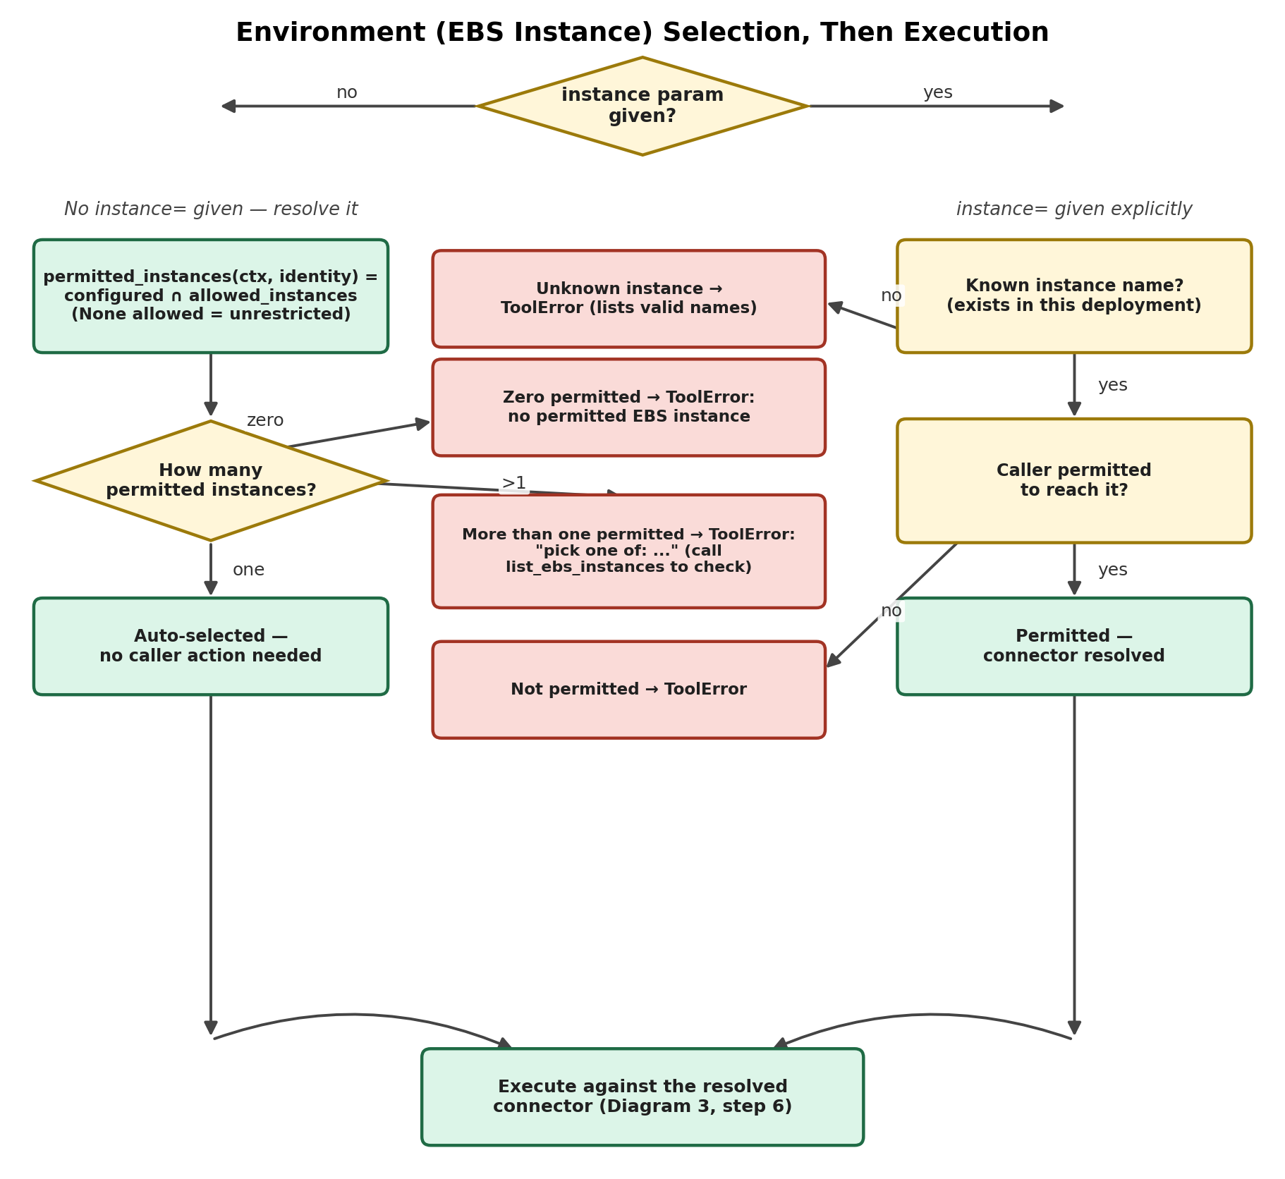
Figure 3. Environment (EBS instance) selection, then execution.

Note: Validate connectivity with a throwaway script before trusting it in the running container — python-oracledb's thin mode needs no Oracle Client install, so a plain oracledb.connect(user=, password=, dsn=) call from the server itself is enough to confirm the DSN, service name, and grants are all correct.

5. Registering the MCP Server with Microsoft Entra ID
A companion document, EBSMCP_Entra_ID_Setup.docx, covers this same ground as a shorter, standalone walkthrough — use whichever form is more convenient to hand to whoever is doing the Entra admin work; this section and Section 6 go into more platform-specific detail (the Microsoft 365 Agents Toolkit path, the plugin manifest auth object) that the companion document doesn't.
The MCP server acts as an OAuth 2.0 resource server: it validates bearer tokens issued by Entra ID, it does not issue or manage tokens itself. This section registers the server side; Section 6 registers the Microsoft 365 Copilot client side.
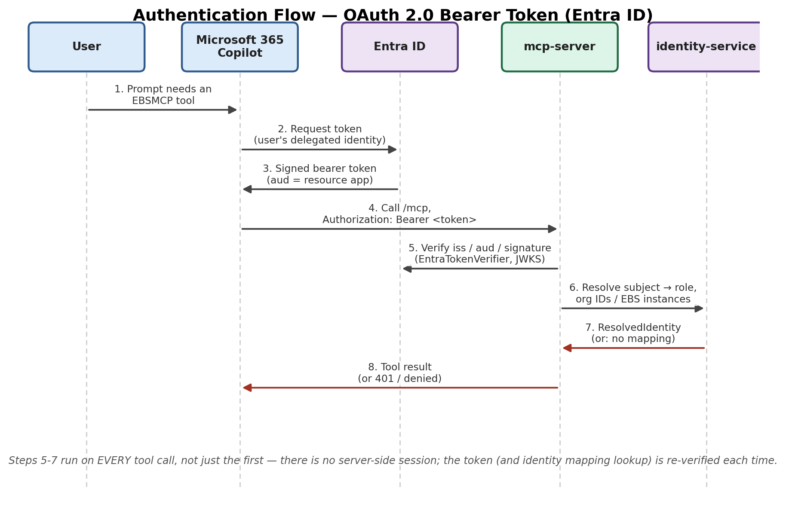
Figure 4. Authentication flow — OAuth 2.0 bearer token via Entra ID.

5.1 App Registration for the MCP Server
- In the Entra admin center, go to App registrations → New registration.
- Name it something identifiable (e.g. EBSMCP MCP Server), single-tenant unless you specifically need multi-tenant.
- No redirect URI is needed here — this app registration represents the resource (API), not a client that signs users in.
- Note the Application (client) ID from the Overview page — this becomes EBSMCP_ENTRA_AUDIENCE.
- Note the Directory (tenant) ID — this becomes EBSMCP_ENTRA_TENANT_ID.

5.2 Expose an API / Scope
- In the app registration, go to Expose an API. Set an Application ID URI if one is not already set (the default api://<client-id> is fine).
- Add a scope, e.g. mcp.tools.invoke, with Admins and users as who can consent (or Admins only, if you want every tenant that uses this to require explicit consent).
- This scope is what the Microsoft 365 Copilot client app (Section 6) will request delegated permission to.

5.3 Set the MCP Server's Environment Variables
EBSMCP_TRANSPORT=streamable-http # already the container default
EBSMCP_ENTRA_TENANT_ID=<Directory (tenant) ID>
EBSMCP_ENTRA_AUDIENCE=<Application (client) ID from 5.1>
EBSMCP_RESOURCE_SERVER_URL=https://ebsmcp.yourdomain.com
EBSMCP_ENTRA_SUBJECT_CLAIM=preferred_username # default; leave unless you have a reason
Once all three of EBSMCP_ENTRA_TENANT_ID, EBSMCP_ENTRA_AUDIENCE, and EBSMCP_RESOURCE_SERVER_URL are set, the server automatically starts validating real bearer tokens (issuer, audience, and signature via Entra's published JWKS) instead of using the fixed local-dev identity — there is no separate flag to flip. Restart the mcp-server container after setting these.

5.4 What This Enables
With real Entra config active, the server exposes standard OAuth discovery metadata that any compliant MCP client (including Microsoft's own tooling) uses automatically:
- https://ebsmcp.yourdomain.com/.well-known/oauth-authorization-server
- https://ebsmcp.yourdomain.com/.well-known/oauth-protected-resource/mcp
The caller's identity for every tool call is now the validated preferred_username claim from their real Entra token, resolved through identity-service's mapping store to their actual target system, mapped role, and Org scope — not a fixed stub.

6. Configuring Microsoft 365 Copilot to Use the MCP Server
Microsoft 365 Copilot reaches an MCP server through an agent's MCP plugin, authenticated with OAuth 2.0 authorization-code flow (PKCE by default). This section follows Microsoft's documented process directly — see Sources at the end of this document.

6.1 Register the Client (Plugin) App in Entra ID
Register a second, separate app registration — this one represents Microsoft 365 Copilot's client, not the MCP server:
- App registrations → New registration → name it e.g. EBSMCP Copilot Client.
- Under Certificates & secrets, create a client secret (or, to avoid secrets entirely, register it as a Single-page application platform instead of Web and rely on PKCE).
- Under API permissions, add a permission → APIs my organization uses → find the MCP server app registration from Section 5.1 → Delegated permissions → select the mcp.tools.invoke scope from Section 5.2.

6.2 Grant Admin Consent
Have a tenant administrator grant admin consent for that delegated permission in the same API permissions blade. This step is not verified automatically when the agent is later provisioned into Copilot — an unconsented scope provisions successfully and then fails later with a silent "Need admin approval" error, so confirm this before moving on.

6.3 Declare the MCP Plugin / Agent
Build a declarative agent with an MCP plugin using Microsoft 365 Agents Toolkit (the recommended path) — point the MCP server spec object at your public HTTPS URL (https://ebsmcp.yourdomain.com/mcp). Agents Toolkit reads the OAuth endpoints from your server's well-known metadata (Section 5.4) automatically.

6.4 Create the OAuth 2.0 Auth Config
Three steps, whether done through Agents Toolkit or manually:
- Register the OAuth client — the client ID/secret from 6.1 become the values Agents Toolkit (or the Teams developer portal) prompts for.
- Configure the redirect URI — add this exact URI to the Entra client app registration (Authentication → Add a platform → Web):
https://teams.microsoft.com/api/platform/v1.0/oAuthRedirect
- Create the auth config — Agents Toolkit does this automatically and writes the resulting auth config ID into the plugin manifest's runtime authentication object:
"auth": {
"type": "OAuthPluginVault",
"reference_id": "<auth config ID>"
}
If registering manually instead, via the Teams developer portal (Tools → OAuth client registration): set Base URL to your MCP server's public URL, Restrict usage by app to Any Teams app (binding to a specific Teams app ID breaks every tool call with a 404), Authorization/Token/Refresh endpoints to the values from your server's /.well-known/oauth-authorization-server metadata, and Scope to the delegated permission from 6.1. Include offline_access alongside it so Copilot can silently refresh tokens.

6.5 Microsoft Entra ID-Specific Constraints
Three constraints apply specifically because the resource is Entra-protected, and cannot be worked around in tooling:
- Dynamic client registration is not available — Entra ID does not publish an RFC 7591 registration endpoint, so the OAuth client above must be registered statically as in 6.1, not auto-registered at connect time.
- The agentConnectors manifest node has no native Microsoft Entra authorization type — an Entra-protected MCP server always needs the self-registered app + auth config above, even though the resource itself lives entirely inside Microsoft's own ecosystem.
- Scope consent is not verified at provisioning time — confirm admin consent (6.2) before provisioning, not after; a bad scope provisions cleanly and fails silently at first use.

6.6 Testing and Sign-Out
- Publish the agent to a test user or your own account and issue a prompt that should trigger an EBSMCP tool call — the first call prompts an OAuth sign-in.
- Users can sign out of the agent at any time from Chat settings → Agents in Microsoft 365 Copilot — this clears the stored token and forces a fresh sign-in on next use.

7. Operational Notes / Security Recap
- Never run the container with EBSMCP_TRANSPORT=stdio in production — stdio has no notion of a bearer token at all and only makes sense for local, single-client interactive use.
- The EBS account (per instance, for a multi-instance deployment) is read-only and has no SYSDBA/DBA role. It does depend on Oracle's standard public synonyms being present for the bare GV$*/DBA_* queries to resolve (see Section 4.1) — this is virtually always true out of the box, but is a real dependency, not something engineered around; EBS application tables (APPLSYS., AD.) never depend on synonyms at all, since those are always fully schema-qualified.
- Every tool call is audit-logged server-side before the result reaches the caller — correlation ID, subject, tool name, parameters, effective Org IDs, status, and latency.
- One deployment serves exactly one customer/Entra tenant — never point one running mcp-server instance at more than one tenant's Entra configuration. It MAY reach more than one EBS database at once (EBSMCP_EBS_INSTANCES, Section 4.6) for that one customer — that's a supported, intended configuration, not an exception to this rule.
- Rotate each EBS instance's account password and the Entra client secret on the same cadence as your other service-account credentials, and keep all of them out of version control.

8. Sources
Section 6 follows Microsoft's official documentation directly, current as of this document's preparation date:
- Configure OAuth 2.0 authentication — Microsoft Learn: learn.microsoft.com/en-us/microsoft-365/copilot/extensibility/plugin-authentication-oauth
- Configure authentication for MCP and API plugins in agents — Microsoft Learn: learn.microsoft.com/en-us/microsoft-365/copilot/extensibility/plugin-authentication

