**Simple Queries:**

**1. Find the name of the Subscriber who has a son as dependent.**

**SELECT m.FirstName, m.LastName, m.Minit from MemberData m, Dependent d, subscriber s where m.MemberCK=s.MemberCK and s.SubscriberID=d.MemberID and d.Relation='Son';**

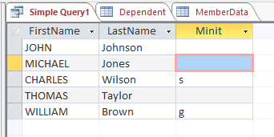

**2. Find the Address, City, State, ZipCode of the insurance provider 'Blue Cross and Blue Shield of NewYork'.**

**SELECT AddLine1, AddLine2, City, State, ZipCode from ProviderLocation p, InsuranceProvider i where p.ProviderID=i.ProviderID and i.ProviderName='Blue Cross and Blue Shield of NewYork';**

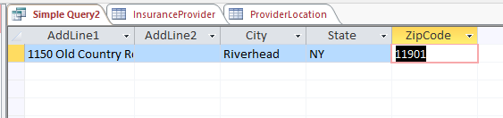

**3. Find the total amount Claimed by the SubscriberID '1000000005'.**

**SELECT Sum(ClaimedAmount) AS Total_amountClaimed**

**FROM Claims where SubscriberID='1000000005';**

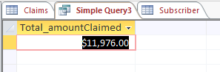

**4. What are the Plan names provided by the ProviderID 'PRV00001'.**

**SELECT p.PlanName from Plans p, InsuranceProvider i where i.ProviderID=p.ProviderID and i.ProviderID='PRV00001';**

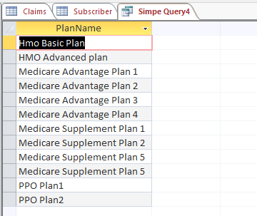

**5. Find the premiums of the Subscribers whose first name is 'DANIEL'**

**SELECT s.SubscriberID, s.Premium**

**FROM subscriber AS s, memberdata AS m**

**WHERE s.memberCK=m.memberCK and m.Firstname='Daniel';** 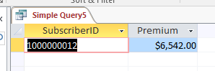

**6.** Find the number of Subscribers that took services under each provider where the no.od subscribers are greater than 5.

SELECT h.ProviderID, Count(*) AS no_of_subscribers

FROM Hospitals AS h, Subscriber AS s, TakesService AS ts

WHERE ts.HospitalID=h.HospitalID and s.SubscriberID=ts.SubscriberID

GROUP BY ProviderID

HAVING count(*)> 5;

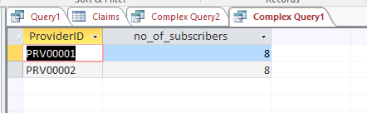

**7.** Find the number of Subscribers who took services where the provider is located in Texas.

SELECT count(SubscriberID) AS No_of_Subscriber

FROM TakesService

WHERE HospitalID in (select HospitalID from Hospitals where ProviderID in (select ProviderID from ProviderLocation where State='TX'));

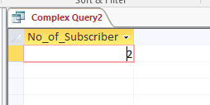

8. Write a query to display Premium and claimedamount of the subscriber whose claimstatus is paid and birsbursedamount is in between 5000 and 7000.

select S.Premium, c.Claimedamount from Subscriber s Inner Join claims c on s.SubscriberID=c.SubscriberID where c.ClaimStatus='Paid' and c.disbursedamount between 5000 and 7000;

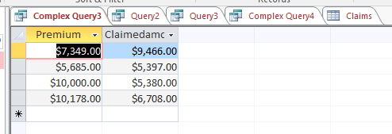

9. Find all the Provider names and their Address, City and State.

SELECT p.ProviderName, i.AddLine1, i.AddLine2, i.City, i.State from InsuranceProvider p LEFT JOIN ProviderLocation i on p.ProviderID=i.ProviderID;

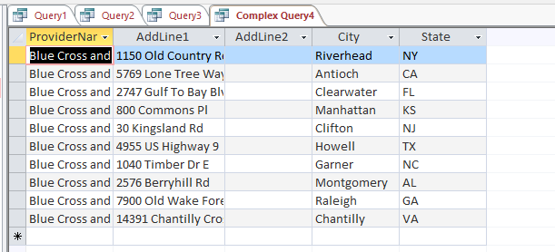

10. Find all the Member names and the serviceID taken or may not taken by them.

select m.FirstName, m.LastName, s.ServiceID from MemberData m LEFT JOIN TakesService s on m.MemberCK=s.MemberCK GROUP BY m.FirstName, m.LastName, s.ServiceID, m.MemberCK;

