**Ideation Phase**

**Empathize & Discover**

|  |  |
| --- | --- |
| Date | 19 June 2025 |
| Team ID | LTVIP2025TMID36583 |
| Project Name | Smart Sorting — Identifying Rotten Fruits and Vegetables Using Transfer Learning |
| Maximum Marks | 4 Marks |

**Empathy Map Canvas**

Project: Smart Sorting — Identifying Rotten Fruits and Vegetables Using Transfer Learning

Purpose: Understand the real needs, feelings, and challenges of key users (e.g., farmers, vendors, sorting staff) in the agricultural produce handling and sorting process.

Reference: Inspired by MURAL Empathy Map Canvas (https://www.mural.co/templates/empathy-map-canvas)

**USER:**

Primary User Persona:

Sorting staff / Farmer / Small-scale vendor involved in identifying and separating rotten produce from fresh stock manually.

**Empathy Map Canvas for Smart Sorting – Identifying Rotten Fruits and Vegetables Using Transfer Learning :**

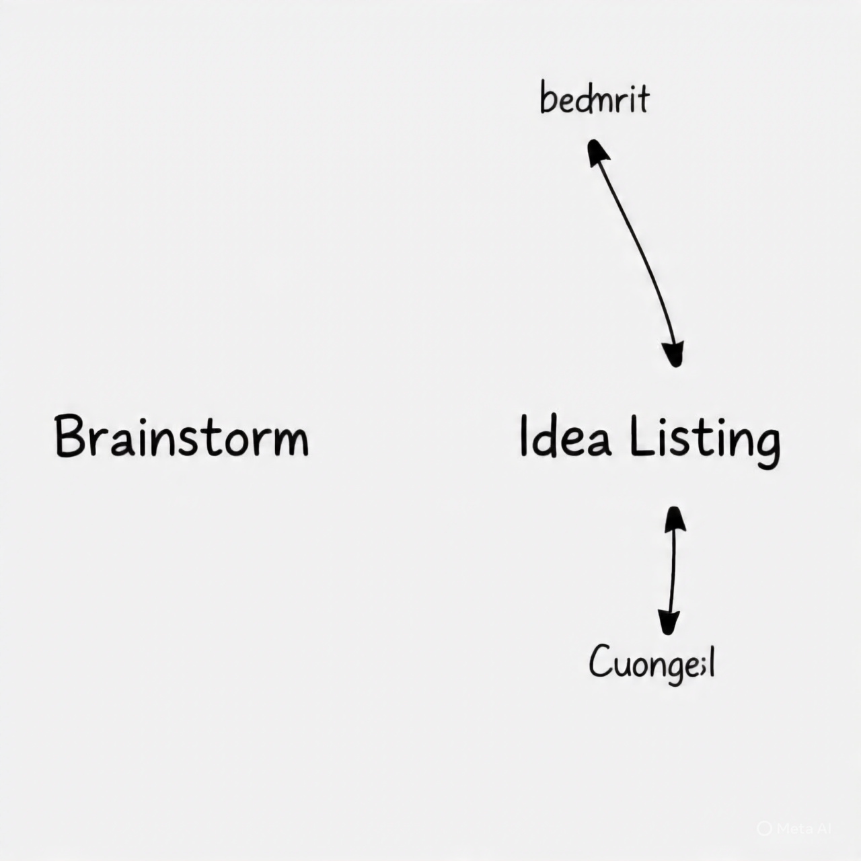

Concerned about speed, accuracy, and financial loss.

“You need to be quick while sorting – we have more produce coming.”

“If I misjudge, it may affect my income and customer trust.”

“I can’t afford to waste time checking each fruit manually.”

“Will I be able to identify spoilage early enough to avoid losses?”

Manual soring techniques by used by coworkers.

Piles of mixed-quality fruits and vegetables

Think & Feel

Hear See

Occasional spoilage unnoticed until it’s too late

“Customers complained about bad fruits yesterday.”

Poor lighting or inconsistent environments

Say & Do

Sometimes good fruits get thrown away

“Technology can help, but it’s expensive.”

It’s hard to tell if it’s rotten just by looking

PAINS

GAINS

Wastage of good produce due to incorrect judgement

Lack of proper training or tools for inspection

High rate of human error in identifying spoilage

Reducing effort while increasing accuracy

A tool that can quickly and reliably rotten produce