**Project Design Phase-II**

**Data Flow Diagram & User Stories**

|  |  |
| --- | --- |
| Date | 22 June 2025 |
| Team ID | LTVIP2025TMID36583 |
| Project Name | Smart Sorting: Identifying Rotten Fruits and Vegetables Using Transfer Learning |
| Maximum Marks | 4 Marks |

**Data Flow Diagrams:**

Smart Sorting system using transfer learning to detect rotten produce. It outlines the key components—image input, preprocessing, feature extraction via a pre-trained CNN (like VGG16), classification, and actionable sorting decisions.

Let me know if you'd like the diagram to emphasize any particular aspect, such as integration with Flask or front-end feedback loops!

**Example: DFD Level 0 for smart sorting**

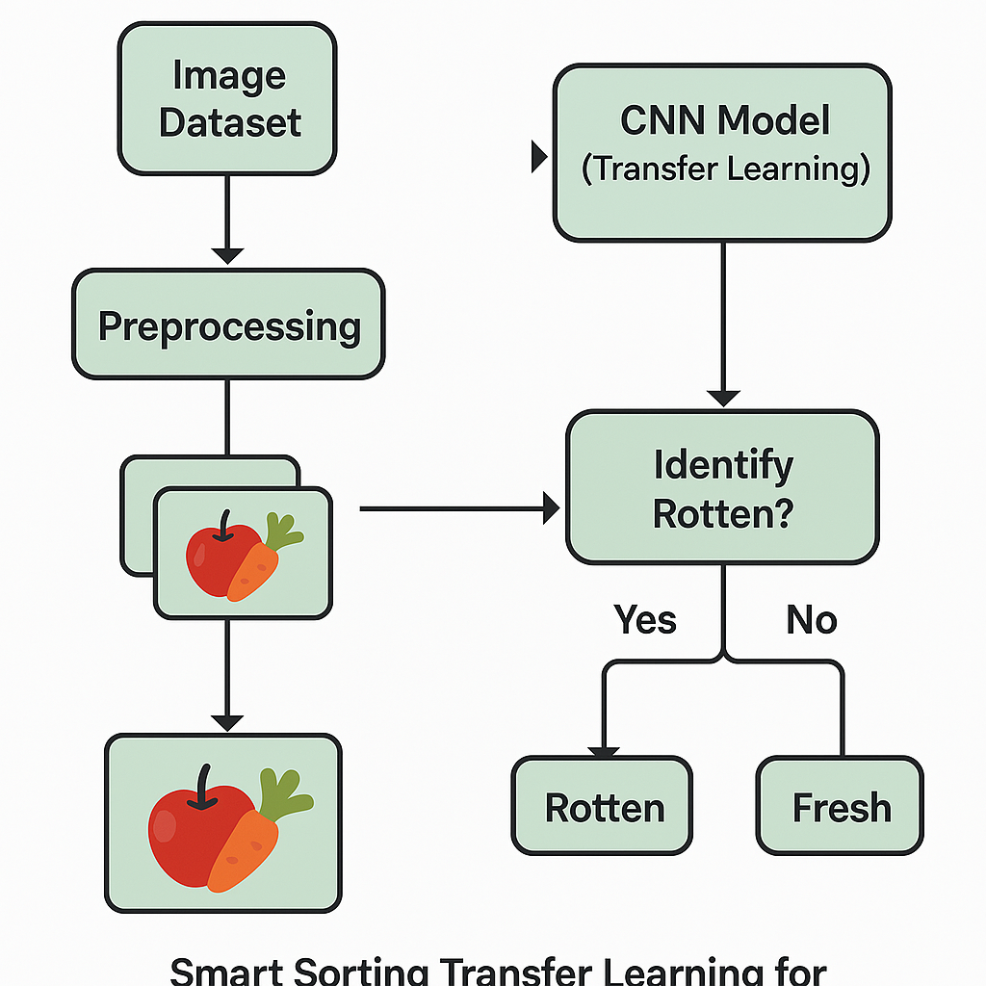

**User Stories:**

| **User Type** | **Functional Requirement (Epic)** | **User Story Number** | **User Story / Task** | **Acceptance Criteria** | **Priority** | **Release** |
| --- | --- | --- | --- | --- | --- | --- |
| **Farmer / Vendor** | **Registration** | **SS-US-1** | **As a user, I can register with my email and password to access the smart sorting system.** | **I can log in to the system after registering with valid credentials.** | **High** | **Sprint-1** |
| **Farmer / Vendor** | **Registration** | **SS-US-2** | **As a user, I receive a confirmation email after successful registration.** | **I receive an email with a confirmation link and can verify my account.** | **High** | **Sprint-1** |
| **Farmer / Vendor** | **Login** | **SS-US-3** | **As a user, I can log in with my registered email and password.** | **I can successfully log in and access the dashboard.** | **High** | **Sprint-1** |
| **Farmer / Vendor** | **Image Upload** | **SS-US-4** | **As a user, I can upload or capture images of fruits/vegetables for sorting.** | **The system accepts image input and confirms receipt.** | **High** | **Sprint-2** |
| **Farmer / Vendor** | **Prediction** | **SS-US-5** | **As a user, I can see whether the uploaded produce is “Fresh” or “Spoiled” based on AI detection.** | **The prediction is shown with a label and confidence score.** | **High** | **Sprint-2** |
| **Farmer / Vendor** | **Feedback** | **SS-US-6** | **As a user, I can give feedback if the prediction seems incorrect.** | **A form or button allows me to report incorrect prediction.** | **Medium** | **Sprint-3** |
| **Farmer / Vendor** | **View History** | **SS-US-7** | **As a user, I can view the history of my uploaded images and predictions.** | **I can see past records with timestamps and outcomes.** | **Medium** | **Sprint-3** |
| **Admin** | **Manage Users** | **SS-US-8** | **As an admin, I can view, edit, or delete registered users.** | **Admin panel displays user list with action buttons.** | **Medium** | **Sprint-2** |
| **Admin** | **Monitor Predictions** | **SS-US-9** | **As an admin, I can monitor AI prediction logs to ensure the system is performing accurately.** | **Admin sees dashboard with prediction counts, accuracy trends.** | **Medium** | **Sprint-3** |
| **Admin** | **Model Feedback Loop** | **SS-US-10** | **As an admin, I can review user feedback and retrain the model with new data.** | **Admin has access to feedback repository and retraining workflow.** | **High** | **Sprint-4** |
| **System** | **Transfer Learning Inference** | **SS-US-11** | **As a system, I apply a trained model to infer the condition of fruits/vegetables from uploaded images.** | **Model processes the input and returns result within acceptable time and accuracy.** | **High** | **Sprint-2** |