CloudMart — Technical Design Document

VPC and Networking
CIDR ranges
- VPC — 10.0.0.0/16
- Public subnet (one Availability Zone) — 10.0.1.0/24
- Private subnet (one Availability Zone) — 10.0.2.0/24Subnet layout
- Public subnet — EC2 Flask Dashboard only.
- Private subnet — RDS MySQL, all Lambda ENIs (Authorizer, Product, Order, Report Generate), and the VPC Interface Endpoints for SSM, EventBridge, and SNS.

How Lambdas inside the VPC reach AWS services — chosen: VPC Endpoints, not a NAT Gateway
Pros of VPC Endpoints (chosen): no hourly charge for the S3 Gateway Endpoint, lower ongoing cost than a NAT Gateway for the Interface Endpoints, traffic never leaves the AWS network. Cons: one endpoint must be configured per AWS service used, and it only works for AWS services with an available endpoint, not arbitrary internet destinations.
Pros of a NAT Gateway (not chosen): simple, works for literally any destination. Cons: continuous hourly and per-GB cost, not Free-Tier-eligible, and routes all egress traffic through a single resource.
Why VPC Endpoints win here: this project has a small, fixed list of AWS services the Lambdas need to reach — S3, SSM, EventBridge, SNS — exactly the case VPC Endpoints are built for. A NAT Gateway is the more general-purpose choice but is the wrong call on a Free Tier budget where avoiding continuous cost is a stated project priority.

Lambda Function URL vs. API Gateway — chosen: Function URL
Pros of a Function URL on the Authorizer (chosen): zero additional service to configure or pay for, simpler mental model. Cons: no built-in request validation or throttling — both must be handled entirely in Lambda code.
Pros of API Gateway (not chosen): built-in request validation, throttling, a native Lambda Authorizer construct. Cons: additional cost and configuration.

Physical delete vs. soft delete for products — chosen: soft delete
Say a customer buys a "Wireless Mouse" (product #501). A week later, you stop selling it and click delete. If you actually delete row #501 from the products table, one of two bad things happens:
- MySQL blocks the delete outright, because order_items still has a row pointing at product_id = 501 — a foreign key isn't allowed to point at nothing
- Or, if you forced it through, that customer's old order would now reference a product that doesn't exist — opening it would either crash or show blank data
- Add one column to products: is_active (true/false). "Deleting" a product now just means UPDATE products SET is_active = false WHERE product_id = 501. The row is still there — it still has a name, a price, everything. It just no longer shows up when customers browse the catalog, because GET /products only shows is_active = true by default.
- Result: the customer's old order still works perfectly — it points at a real row — but the product is gone from the store. That's the whole idea. It's called "soft" delete because the delete is reversible and non-destructive, as opposed to a "hard" delete which physically removes the row.

IAM Roles, Policies, and Permissions
AuthorizerExecutionRole
- Attached to the Authorizer Lambda.
- Permitted actions: ssm:GetParameter, lambda:InvokeFunction, and the standard CloudWatch Logs actions.
- ssm:GetParameter is restricted to the parameter ARN only — this role cannot read any other parameter, including database credentials.
- lambda:InvokeFunction is restricted to the Product Lambda and Order Lambda ARNs only.
ProductLambdaExecutionRole and OrderLambdaExecutionRole
- Attached to the Product Lambda and Order Lambda respectively.
- Include the AWS-managed VPC access policy, since both functions run inside the private subnet and need to create and manage elastic network interfaces.
- ssm:GetParameter restricted to the /cloudmart/db/* parameter path only.
- events:PutEvents restricted to the CloudMart EventBridge bus ARN only.
- cloudwatch:PutMetricData restricted to the cloudmart custom metric namespace.
- OrderLambdaExecutionRole additionally has sns:Publish, restricted to the low-stock and order-confirmation topic ARNs only.
ReportLambdaExecutionRole
- Attached to the Report Generate Lambda.
- VPC access policy, ssm:GetParameter for database credentials, and s3:PutObject.
- s3:PutObject is restricted to the reports bucket ARN and the reports/ key prefix specifically — this role cannot write anywhere else in that bucket or to any other bucket.
EC2DashboardInstanceRole
- Attached to the EC2 instance running the Flask dashboard.
- s3:GetObject restricted to the reports bucket ARN only, and ssm:GetParameter restricted to read-only, non-sensitive configuration parameters.
- This role deliberately cannot read the auth token parameter, invoke any Lambda, or modify any infrastructure.
GitHubActionsDeployRole
- Assumed by GitHub Actions through OIDC federation — no long-lived AWS access keys are stored anywhere in the repository.
- The trust policy is conditioned on GitHub's OIDC provider and on a subject condition matching this specific repository and branch, so no other GitHub repository can assume this role even if it discovered the role ARN.
- Permitted actions are scoped to CloudFormation operations on the five CloudMart stack ARNs, s3:PutObject on the artifacts bucket, iam:PassRole for the stack execution roles, and lambda:UpdateFunctionCode.

CloudFormation Stack Design
- network-stack — owns the VPC, the public and private subnets, the internet gateway, route tables, and every security group used anywhere in the system. It exports the VPC ID, both subnet IDs, and each security group ID so later stacks can reference them without redefining anything.
- data-stack — owns the RDS MySQL instance, its DB subnet group, and the S3 buckets used for Lambda deployment artifacts and daily reports. It imports the VPC and private subnet from network-stack, and exports the RDS endpoint and both bucket names.
- iam-stack — owns every IAM role in the system — one execution role per Lambda function, the EC2 instance role, and the GitHub Actions OIDC deployment role. It exports each role's ARN for app-stack to attach.
- app-stack — owns the actual Lambda functions (Authorizer, Product, Order, Report Generate), the EventBridge event bus and its rules, and the SNS topics. It imports the subnet and security group IDs from network-stack, the RDS endpoint from data-stack, and the role ARNs from iam-stack.
- monitoring-stack — owns the CloudWatch dashboard and all alarms. It imports Lambda function names from app-stack and the RDS instance identifier from data-stack, since alarms are defined against those specific resources.
Cross-stack reference
- data-stack imports VpcId, PrivateSubnetId, RDSSecurityGroupId from network-stack
- app-stack imports PrivateSubnetId, LambdaSecurityGroupId from network-stack
- app-stack imports RDSEndpoint, ArtifactsBucketName from data-stack
- app-stack imports every Lambda role ARN from iam-stack
- monitoring-stack imports Lambda function names from app-stack and the RDS instance identifier from data-stack

Deployment order and dependency chain
Because data-stack, iam-stack, and app-stack all depend on network-stack's exports, and app-stack additionally depends on both data-stack and iam-stack, the stacks must deploy in a fixed sequence rather than in parallel. GitHub Actions enforces this order as sequential steps in the same workflow job.
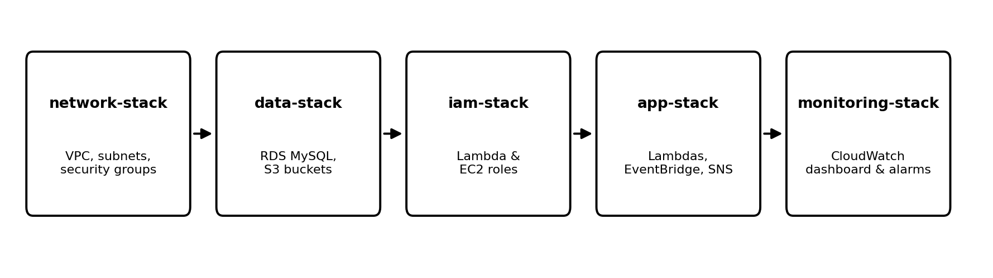

Security Group Rules
Every security group in this project follows the same principle: allow the minimum inbound traffic required, and reference other security groups as the source wherever possible instead of raw IP ranges. No security group allows inbound access from 0.0.0.0/0 on a database or internal service port.
EC2SG
- Inbound: port 443 from a specific, known IP range.
- Outbound: port 3306 to RDSSG, and port 443 to the VPC endpoint security group.
LambdaSG — all Lambda functions
- No inbound rules — Lambda functions are never called directly by anything other than the AWS Lambda service itself, so nothing needs to reach them over the network.
- Outbound: port 3306 to RDSSG, and port 443 to the VPC endpoint security group.
RDSSG — the MySQL database
- Inbound: port 3306, sourced only from LambdaSG and EC2SG — never from an IP range, and never from 0.0.0.0/0.
- No outbound rules are needed beyond the default.
Data Models
All persistent data lives in a single RDS MySQL instance.
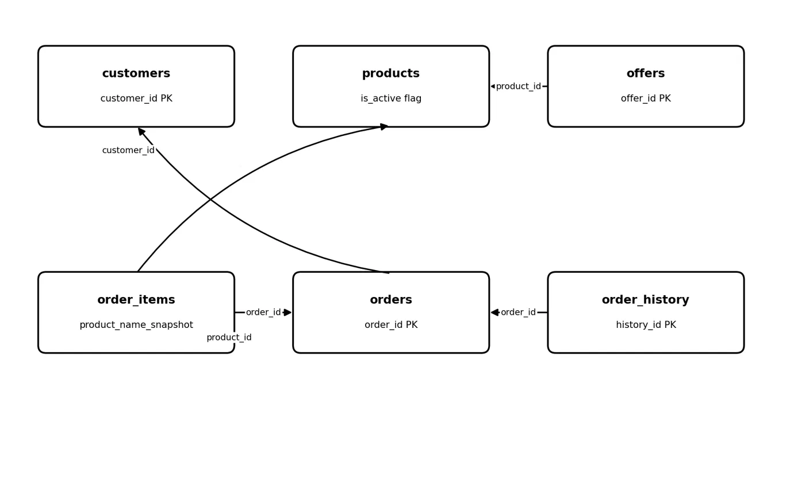
customers
- customer_id — primary key. name, email — email is unique, used to identify a returning customer.
- created_at — defaults to the current timestamp.
products
- product_id — primary key. name, description, price, category — category is a plain text field, not a foreign key.
- stock_count — the current quantity available. is_active — soft-delete flag; DELETE sets this to false rather than removing the row, so a product referenced by an existing order is never left pointing at nothing.
- updated_at — refreshed automatically on every edit.
- Indexed on category and is_active.
offers
- offer_id — primary key. product_id — foreign key to products.
- discount_percentage, starts_at, ends_at — a product can have historical, current, and scheduled future offers without ever overwriting its base price.
- Indexed on product_id, and a composite index on (starts_at, ends_at) to support the "is there an active offer right now" check.
orders
- order_id — primary key. customer_id — foreign key to customers.
- status, total_amount — total_amount is a denormalized sum of order_items, kept in sync by the Order Lambda at write time so reading an order never requires a join just for its total.
- Indexed on customer_id, status, and created_at.
order_items
- order_item_id — primary key. order_id, product_id — foreign keys to orders and products.
- product_name_snapshot, unit_price — both captured at the moment of purchase, so a later product edit, price change, or product deactivation never alters a historical order.
- Indexed on order_id and product_id.

order_history
- history_id — primary key. order_id — foreign key to orders.
- previous_status, new_status, changed_by — every status transition an order goes through is written here as its own row, rather than only ever showing the order's current state.
- Indexed on order_id and changed_at, to support viewing one order's full timeline in order.

CI/CD Pipeline
- GitHub Repository — push to main triggers the workflow
- GitHub Actions — authenticates to AWS via OIDC (no stored access keys)
- Package and upload artifacts to S3 — Lambda deployment packages are zipped and uploaded
- CloudFormation (Change Set) — every stack update goes through a Change Set review before execution, never a direct update
- Deploy stacks in order: network-stack -> data-stack -> iam-stack — this order matters because data-stack imports the VPC/subnet/security group exports from network-stack, and iam-stack references resources created by both.
GitHub Actions
CI/CD PIPELINE
GitHub Repository
Deploy stack (networkdataiam)
CloudFormation (change set)
Package and Artifacts to S3

deploy-infra.yml — triggers on changes under cloudformation/**
- Checkout code
- Assume GitHubActionsDeployRole via OIDC
- Deploy network-stack via CloudFormation Change Set
- Deploy data-stack via CloudFormation Change Set
- Deploy iam-stack via CloudFormation Change Set
deploy-app.yml — triggers on changes under lambdas/** or ec2-dashboard/**
- Checkout code
- Lint the Python code
- Package each Lambda into its own zip
- Upload the zips to the artifacts S3 bucket
- Assume GitHubActionsDeployRole via OIDC
- Deploy app-stack via CloudFormation Change Set — references the newly uploaded zips
- Deploy monitoring-stack via CloudFormation Change Set
No AWS access keys are stored in the repository at any point. aws cloudformation deploy generates and executes a Change Set automatically rather than updating any stack directly.

What EventBridge actually does here
Think of EventBridge as the shared announcement board for your whole system — every service tells it "this happened," and any interested service can listen for that announcement, without the sender and the receiver knowing anything about each other.
Who publishes to it:
- Order Lambda — publishes OrderPlaced, OrderConfirmed, and OrderFailed whenever an order moves through those states
- Product Lambda — publishes an inventory-change event whenever stock is updated
Who's listening, and what happens:
- A rule watching for low-stock conditions routes the matching event to the SNS low-stock topic, which emails the ops team
- The EventBridge Schedule (a separate, time-based rule — not triggered by an event, but by the clock) fires once a day and invokes the Report Generate Lambda, regardless of what else happened that day

Configuration Structure — SSM Parameter Store
- /cloudmart/prod/auth/token — SecureString. Consumed only by the Authorizer Lambda.
- /cloudmart/prod/auth/token-version — String. Used to invalidate the Authorizer's in-memory cache early if a token is rotated outside the normal 5-minute cycle.
- /cloudmart/prod/db/host — String. Consumed by the Product, Order, and Report Lambdas, and the EC2 dashboard.
- /cloudmart/prod/db/username — SecureString. Consumed by the same three Lambdas.
- /cloudmart/prod/db/password — SecureString. Consumed by the same three Lambdas.
- /cloudmart/prod/db/name — String. Consumed by the same three Lambdas and the dashboard.
- /cloudmart/prod/inventory/low-stock-threshold — String. Consumed by the Product and Order Lambdas, so the alert threshold can change without a code deployment.
- /cloudmart/prod/sns/low-stock-topic-arn — String. Consumed by the Order Lambda.
- /cloudmart/prod/sns/alarm-topic-arn — String. Referenced directly inside monitoring-stack rather than fetched at Lambda runtime.
- /cloudmart/prod/s3/reports-bucket — String. Consumed by the Report Lambda and the EC2 dashboard.

API Request and Response Contracts
POST /products
- Body: { "name": string, "description": string, "price": number, "category": string, "stock_count": integer }
- 401: missing/invalid token
- 500: unexpected server error
GET /products
- Query params: category (optional)
- 200: { "products": [ {...} ] }
- 401: missing/invalid token
GET /products/{id}
- 200: { "product_id": int, ... }
- 404: product not found
- 401: missing/invalid token
PUT /products/{id}
- Body: any subset of updatable fields
- 200: updated product
- 400: invalid field value
- 404: not found
- 401: unauthorized
DELETE /products/{id}
- 204: no content
- 404: not found
- 401: unauthorized
POST /orders
- Body: { "customer_id": int, "items": [ { "product_id": int, "quantity": int } ] }
- 201: { "order_id": int, "status": "CONFIRMED", "total_amount": number }
- 400: empty items array, invalid quantity
- 409: insufficient stock for one or more items
- 401: unauthorized
- 500: unexpected error
GET /orders/{id}
- 200: order + items
- 404: not found
- 401: unauthorized
GET /orders?customerId={id}
- 200: { "orders": [ {...} ] }
- 401: unauthorized
CloudWatch Metrics
OrdersPlaced
- Published by: the Order Lambda.
- When: immediately after an order is successfully written to RDS.
OrdersFailed
- Published by: the Order Lambda.
- When: inside the error-handling path, whenever an order fails validation, fails the stock check, or fails to persist.
- Dimensions: Environment and FailureReason, so the dashboard can break failures down by cause (for example INSUFFICIENT_STOCK v/s DB_UNAVAILABLE) rather than showing one undifferentiated failure count.
LowStockEvents
- Published by: whichever Lambda performs the inventory deduction (Product or Order Lambda) at the moment stock_count drops below the configured threshold.

Error Handling Strategy
Validation error (bad input) — e.g. missing field, negative price
- Logged at WARN level
- Returned to caller as 400 with the specific problem
- No metric published — this is the client's mistake, not a system failure worth alerting on
- No retry needed; the client fixes the input and resends
Business rule violation — e.g. insufficient stock on an order
- Logged at INFO level (expected, not exceptional)
- Returned as 409 with the reason
- Publishes OrdersFailed with FailureReason=INSUFFICIENT_STOCK
- No SNS alert
Auth failure — missing or invalid token
- Logged at WARN level, but the token value itself is never logged, even on failure
- Returned as a bare 401, no detail on why (see the previous message on why that's deliberate)
- No metric, no alert
RDS connection failure — database unreachable or timing out
- Logged at ERROR level
- Returned as 500
- Publishes OrdersFailed with FailureReason=DB_UNAVAILABLE
- Same on-failure destination path as above

Placing an Order
- Client sends POST /orders with Authorization: Bearer <token> to the Authorizer's Function URL
- Authorizer validates the token against SSM
- Authorizer invokes the Order Lambda
- Order Lambda checks stock in RDS, deducts inventory, writes the order and order_items rows
- Order Lambda publishes OrderPlaced (and OrderConfirmed or OrderFailed) to the EventBridge bus, and a custom OrdersPlaced metric to CloudWatch
- If stock fell below threshold during this transaction, an event routes to the SNS low-stock topic, which emails the ops team
- The response (order confirmation or failure) returns to the client through the Authorizer

