**MAC – Assignment**

**Question1 - Write about MAC Architecture, function, and channel structure**

**Answer –**

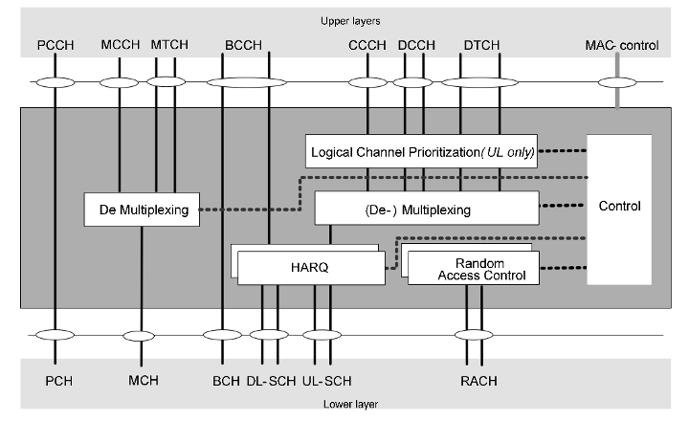

**MAC Architecture, Function, and Channel Structure**

**1. MAC Architecture in 5G Wireless:**

In 5G wireless networks, the Medium Access Control (MAC) layer is an integral part of the radio access network (RAN) and is situated above the physical layer (PHY) and below the radio link control (RLC) layer. The MAC architecture in 5G is designed to support high data rates, low latency, and massive connectivity. Key components include:

* **MAC Entities:** The MAC layer in 5G is divided into several entities that manage different aspects of data transfer, including scheduling, multiplexing, and de-multiplexing.
* **MAC Scheduling:** A key feature of the 5G MAC layer is its sophisticated scheduling capability. It supports dynamic scheduling of data transmission based on various criteria such as quality of service (QoS) requirements and channel conditions.
* **MAC PDU (Protocol Data Unit):** The MAC layer encapsulates RLC PDUs into MAC PDUs for transmission. It also performs segmentation and reassembly of data units to fit the radio frame structure.
* **MAC Control Elements (CE):** These are special control information elements carried in MAC PDUs to convey control information, such as scheduling requests and acknowledgments.

**2. MAC Function in 5G Wireless:**

The MAC layer in 5G performs several critical functions to ensure efficient and effective communication:

* **Channel Access and Scheduling:** The MAC layer handles the allocation of radio resources to users based on scheduling algorithms. It supports both uplink (UL) and downlink (DL) scheduling, allowing efficient utilization of the available spectrum. It uses dynamic scheduling to adapt to changing network conditions and user requirements.
* **HARQ (Hybrid Automatic Repeat reQuest):** The MAC layer implements HARQ to improve reliability. If a transmission is not successfully received, the MAC layer can request a retransmission of the data. HARQ combines error correction with retransmissions to enhance data integrity.
* **Multiplexing and Demultiplexing:** The MAC layer is responsible for multiplexing multiple data streams from different users or services into a single MAC PDU and demultiplexing them at the receiver end.
* **QoS Management:** The MAC layer supports Quality of Service (QoS) by managing the priority and resource allocation for different data flows, ensuring that high-priority services receive the necessary resources.
* **Resource Allocation:** The MAC layer allocates physical resources like time slots, frequency blocks, and codes to different users and services based on the scheduling information and network conditions.

**3. MAC Channel Structure in 5G Wireless:**

The channel structure in the MAC layer of 5G is designed to optimize the use of available spectrum and support high data rates and diverse service requirements. Key aspects include:

* **Physical Channels:** 5G defines several physical channels such as Physical Downlink Shared Channel (PDSCH) and Physical Uplink Shared Channel (PUSCH) for data transmission. These physical channels are used to transport MAC PDUs between the user equipment (UE) and the base station (gNodeB).
* **Logical Channels:** Logical channels in 5G are categorized into control channels and traffic channels. Control channels, like the Broadcast Control Channel (BCCH) and Paging Control Channel (PCCH), carry control information. Traffic channels, like the Dedicated Traffic Channel (DTCH), carry user data.
* **Control and Data Channels:** The MAC layer manages both control and data channels. Control channels carry signaling information for managing data transfer, while data channels carry user data. Efficient management of these channels is crucial for meeting the high-speed and low-latency requirements of 5G.
* **Time and Frequency Resources:** 5G utilizes a flexible framework for resource allocation. Time-frequency resources are managed in resource blocks (RBs) in the time-frequency grid. These RBs are allocated dynamically based on the scheduling needs and network conditions.
* **Hybrid Channels:** 5G introduces hybrid channels like the Physical Downlink Control Channel (PDCCH) which carries downlink control information to the UEs, and the Physical Uplink Control Channel (PUCCH) which carries uplink control information from the UEs.

**Question 2 - Mac procedure, random access Procedure ,Uplink Synchronization , DRX , Activation and deactivation of scells , Activation and deactivation of SCG,MAC PDY and Function , MAC Control CE , BSR, ,PHR,DRX, Timing Advanced , Scell Activation and deactivation, Timing Advanced Report MAC CE**

**Answer – MAC Procedures in 5G**

**Random Access Channel Procedure**:

* **Purpose**: Used by a UE to initiate a connection with the 5G network, especially when it has no prior synchronization.
* **Steps**:
  1. **Random Access Preamble**: The UE selects and sends a random access preamble in the Random Access Channel (RACH).
  2. **Random Access Response**: The gNodeB (gNB) responds with a Random Access Response (RAR) which includes timing adjustment and a temporary identity.
  3. **Connection Request**: The UE sends a Connection Request message to the gNB.
  4. **Connection Setup**: The gNB responds with a Connection Setup message.
  5. **Connection Complete**: The UE confirms with a Connection Complete message.

**1. Purpose of Random Access Procedure**

* **Initial Access**: Allows a UE to connect to the network for the first time or after a period of inactivity. This is essential for establishing a new connection or re-establishing an existing one.
* **Handover**: Facilitates the transition of a UE from one cell to another during handover, ensuring continuous connectivity and service.
* **Network Reconnection**: Provides a mechanism for UEs to reconnect to the network after losing connection, such as when moving out of coverage or experiencing a signal drop.

**2. Steps in the Random Access Procedure**

The Random Access Procedure involves several steps, each involving specific signaling and messages between the UE and the gNB. Here’s a step-by-step breakdown:

**a. Random Access Preamble Transmission**

1. **Initial Request**:
   * **Random Access Preamble**: The UE selects and transmits a Random Access Preamble (a pre-defined sequence) to the gNB. This preamble is used to initiate the Random Access Procedure.
   * **Channel Used**: The preamble is transmitted on the Physical Random Access Channel (PRACH), which is a specific uplink channel designated for this purpose.
2. **Preamble Selection**:
   * **Preamble Set**: The UE selects a preamble from a set of available preambles, which are randomly chosen to avoid collisions with other UEs.
   * **Timing Offset**: The UE adjusts the timing of the preamble transmission based on the network’s frame structure and its own timing advance settings.

**b. Random Access Response (RAR)**

1. **Network Response**:
   * **RAR Message**: The gNB responds to the UE's Random Access Preamble with a Random Access Response (RAR) message. This message is sent over the Physical Random Access Response Channel (PRACH-R).
2. **RAR Contents**:
   * **Grant Information**: The RAR includes information about the grant for the UE to use a specific time and frequency resource for further communication.
   * **Timing Advance (TA)**: The RAR provides a Timing Advance Command to adjust the UE’s transmission timing, ensuring proper synchronization.
   * **Temporary Identifier**: A temporary identifier is provided to the UE for subsequent communication with the gNB.

**c. Random Access Request (RAR) Completion**

1. **Message 3 (RRC Connection Request)**:
   * **UE Response**: After receiving the RAR, the UE sends a Random Access Request (RAR) message, which typically includes an RRC (Radio Resource Control) Connection Request message. This message is sent on the Physical Uplink Shared Channel (PUSCH).
   * **Message Content**: The request includes information such as the UE’s identifier, request type, and other relevant parameters needed for establishing the connection.
2. **Message 3 Transmission**:
   * **Timing and Resource Allocation**: The UE uses the timing and resource information provided in the RAR to correctly time and allocate resources for the transmission of the RRC Connection Request.

**d. Connection Setup**

1. **gNB Processing**:
   * **Request Handling**: The gNB processes the RRC Connection Request and prepares a response message, including connection setup parameters and configuration details.
2. **Message 4 (RRC Connection Setup)**:
   * **Setup Message**: The gNB sends an RRC Connection Setup message back to the UE, providing configuration parameters needed for completing the connection setup.
3. **UE Response**:
   * **Connection Setup Completion**: The UE sends a Connection Setup Complete message to the gNB, confirming receipt of the setup message and finalizing the connection establishment.

**3. Key Elements of the Random Access Procedure**

**a. Random Access Preamble**

* **Purpose**: To initiate the Random Access Procedure by sending a unique sequence to the gNB.
* **Frequency and Timing**: Transmitted on the PRACH, with specific timing and frequency characteristics.

**b. Random Access Response (RAR)**

* **Purpose**: Provides a response to the UE’s preamble, including timing advance and resource allocation.
* **Channels**: Sent over the Physical Random Access Response Channel (PRACH-R).

**c. RRC Connection Request and Setup**

* **Purpose**: To establish an RRC connection, allowing the UE to communicate with the network and perform necessary configurations.
* **Channels**: Uses the Physical Uplink Shared Channel (PUSCH) for the request and the Downlink Control Channel (PDCCH) for the response.

**4. Impact of Random Access Procedure**

**a. Network Efficiency**

* **Effective Access**: Facilitates efficient and timely access to the network for UEs, ensuring that initial connections and reconnections are handled smoothly.

**b. User Experience**

* **Seamless Handover**: Supports seamless handovers and reconnections, improving the overall user experience and reducing service interruptions.

**c. Resource Management**

* **Dynamic Allocation**: Allows the network to dynamically allocate resources based on the needs of the UE and current network conditions.

**5. Challenges and Considerations**

**a. Collisions**

* **Preamble Collisions**: Multiple UEs may select the same preamble, leading to collisions. Proper management and randomization are required to minimize this issue.

**b. Timing Accuracy**

* **Synchronization**: Accurate timing is crucial for ensuring that uplink transmissions are properly aligned and that resources are used efficiently.

**c. Signaling Overhead**

* **Management**: The Random Access Procedure involves multiple signaling steps, which must be managed efficiently to minimize network overhead and delays.

**Uplink Synchronization**:

* **Purpose**: Ensures that the UE's uplink transmissions are synchronized with the gNB's timing.
* **Method**: Achieved through Timing Advance Commands, which adjust the UE’s transmission timing.
  1. **Overview of Uplink Synchronization**

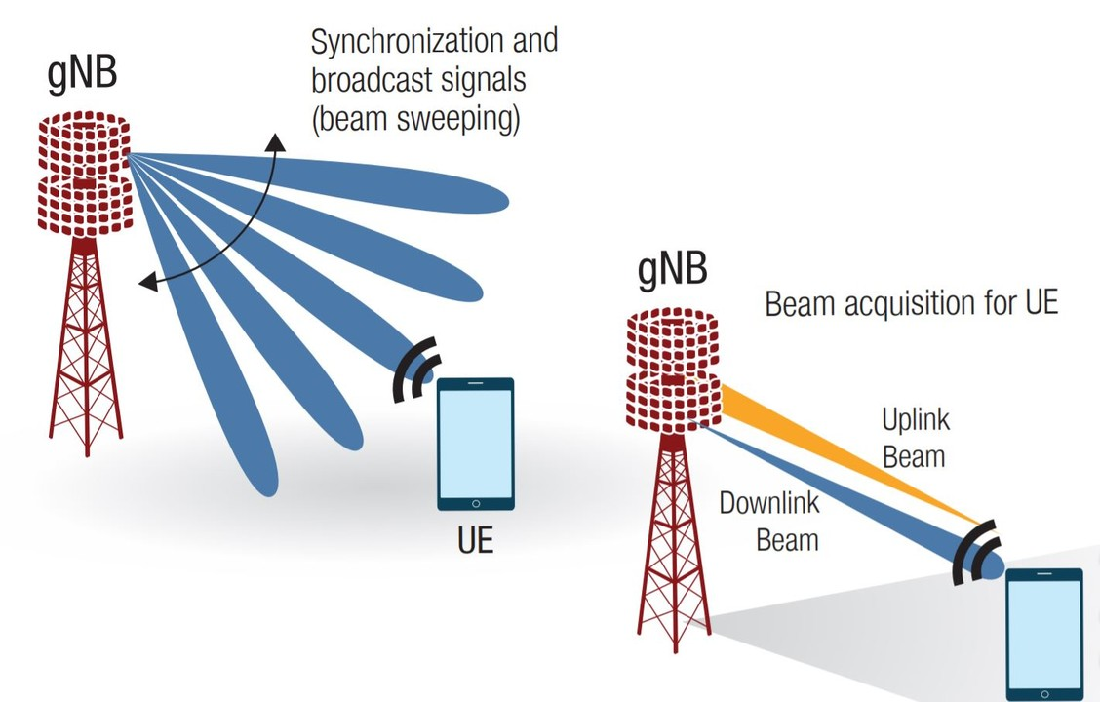

In the 5G New Radio (NR) system, uplink synchronization refers to the process by which a user device synchronizes its transmission timing with the network (specifically, the gNB, or next-generation Node B). This synchronization is critical for preventing interference, managing resources efficiently, and ensuring reliable communication.

**2. Key Concepts in Uplink Synchronization**

**a. Time and Frequency Synchronization**

* **Time Synchronization**: UEs need to align their transmission timing with the network's timing to avoid collisions and interference. Time synchronization ensures that data from multiple UEs arrives at the gNB at the correct times.
* **Frequency Synchronization**: UEs must also synchronize their transmission frequency with the network to ensure that their signals are received correctly without causing interference to other channels.

**b. Synchronization Signals**

* **Primary Synchronization Signal (PSS)**: This helps UEs synchronize with the network in terms of time and frequency. It provides the UE with the correct timing for its transmissions and helps it to find the network's reference signal.
* **Secondary Synchronization Signal (SSS)**: This signal provides additional timing information and helps UEs to identify the cell they are connected to and determine the cell’s frame structure.

**c. Synchronization Procedure**

1. **Initial Access and Random Access Procedure**: When a UE first connects to the network or needs to re-establish synchronization, it performs a random access procedure. This involves sending a Random Access Preamble to the gNB and receiving a Random Access Response.
2. **Timing Advance**: The gNB calculates a timing advance value based on the timing of the UE's transmissions and sends this value back to the UE. The UE then adjusts its transmission timing accordingly to ensure alignment with the network's timing.
3. **Channel Estimation**: The UE estimates the channel conditions to adapt its transmission power and timing. This is crucial for effective communication and resource management.

**3. MAC Layer's Role**

The MAC layer in 5G NR is responsible for managing the scheduling and transmission of data packets. It plays a significant role in synchronization:

* **Uplink Scheduling**: The MAC layer schedules when and how often UEs can transmit their data. Accurate timing is essential to ensure that scheduled transmissions do not overlap or interfere with other transmissions.
* **HARQ (Hybrid Automatic Repeat reQuest)**: The MAC layer uses HARQ for error correction in data transmissions. It relies on accurate timing to manage retransmissions effectively.
* **CQI (Channel Quality Indicator) Reporting**: The MAC layer collects and reports channel quality information. This helps the network to make decisions about scheduling and resource allocation.

**4. Challenges and Considerations**

* **Network Density**: In dense network environments, accurate synchronization becomes more challenging due to increased signal interference and the need for precise timing.
* **UE Mobility**: As UEs move, they must continuously adjust their synchronization parameters. Fast and accurate synchronization is essential to maintain seamless connectivity.
* **Resource Allocation**: Proper synchronization ensures that resources are allocated efficiently, preventing collisions and optimizing overall network performance.

**5. Technological Solutions**

* **Enhanced Synchronization Protocols**: 5G NR employs advanced synchronization protocols to address the challenges of higher data rates and increased network density.
* **Time and Frequency Synchronization Techniques**: Techniques like network time reference and frequency synchronization mechanisms help maintain precise alignment.

**DRX (Discontinuous Reception)**:

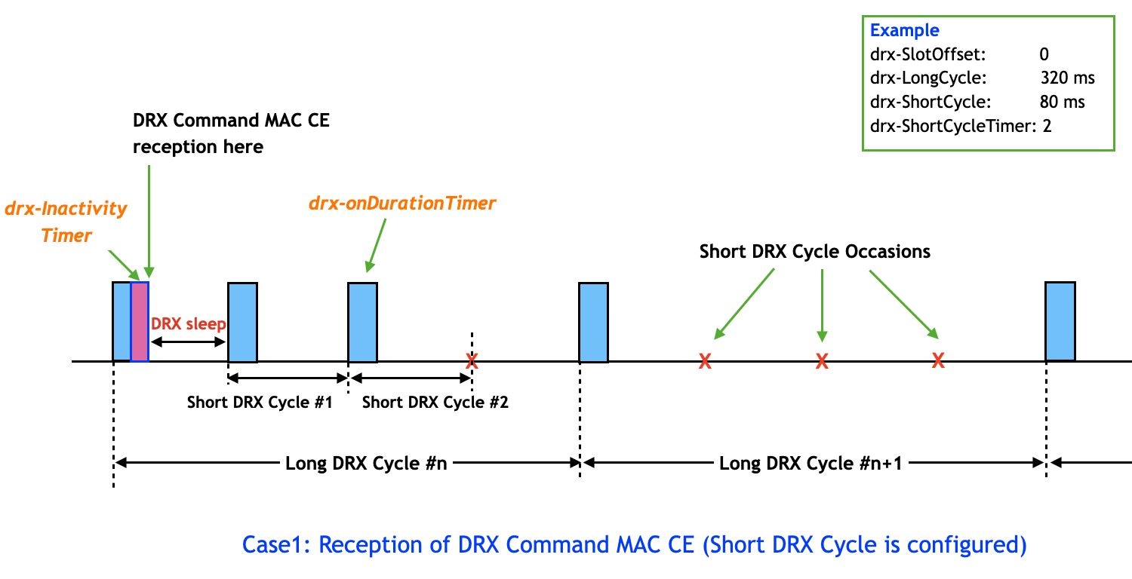

* **Purpose**: Reduces power consumption by allowing the UE to sleep during periods when no data is expected.
* **Activation/Deactivation**: Controlled via Network-controlled DRX configurations, which dictate when the UE should wake up to listen for incoming data.

**1. Overview of DRX**

Discontinuous Reception (DRX) is designed to optimize the UE's power consumption by allowing it to enter sleep modes during periods when there are no data transmissions or activity from the network. This is particularly important for battery-powered devices, as it extends their operational time between charges.

**2. Key Concepts of DRX**

**a. DRX Cycle**

The DRX cycle consists of two main phases:

* **Active Period**: During this time, the UE is awake and actively monitoring the network for incoming data or signaling messages. This is when the UE's radio transceiver is active, consuming more power.
* **Sleep Period**: In this phase, the UE goes into a low-power state where it does not monitor the network. This helps conserve battery life, but the UE must wake up periodically to check for any incoming data or signaling.

**b. DRX Timing Parameters**

* **DRX Cycle Time (DRX Cycle Length)**: This defines the duration of the complete DRX cycle, which includes both the active and sleep periods. It dictates how long the UE stays in each state before switching.
* **On-Duration**: The period during which the UE must stay active and monitor the network before entering the sleep period. This ensures that the UE does not miss any important data or signaling messages.
* **Sleep Duration**: The period during which the UE is in sleep mode. This helps in conserving battery power by reducing the time spent actively monitoring the network.
* **Short DRX Cycle**: For more frequent monitoring, a shorter DRX cycle can be used. This allows the UE to wake up more often and is useful for applications requiring more frequent updates.

**c. DRX and Paging**

When a network needs to reach a UE that is in sleep mode, it uses paging messages. The UE wakes up from its sleep period to check if there is a paging message intended for it. This ensures that the UE does not miss any critical messages or data requests.

**3. DRX in the 5G MAC Layer**

In the 5G MAC layer, DRX is implemented to manage the UE’s power consumption efficiently. Here’s how it works:

**a. Configuration and Signaling**

* **MAC Layer Configuration**: The DRX settings are configured and signaled by the gNB (next-generation Node B) to the UE. These configurations include the DRX cycle time, on-duration, and other parameters.
* **DRX Configuration Messages**: The gNB sends DRX configuration messages to the UE, detailing the parameters for the DRX cycle. This configuration is part of the RRC (Radio Resource Control) signaling in 5G.

**b. DRX Procedure**

1. **Activation**: When the UE first connects or after a DRX reconfiguration, the gNB instructs the UE on the DRX parameters. The UE then starts the DRX cycle according to these parameters.
2. **Monitoring**: During the active period, the UE monitors for incoming data and signaling. If no data or signaling is received, the UE proceeds to the sleep period.
3. **Paging and Wake-Up**: If the network needs to communicate with the UE during its sleep period, it sends a paging message. The UE wakes up, checks the paging message, and responds if necessary.
4. **Transition**: After the on-duration, the UE transitions into the sleep period. It remains in this low-power state until the next on-duration starts or until it receives a paging message.

**4. Benefits and Challenges**

**a. Benefits**

* **Battery Life**: DRX significantly improves the battery life of devices by reducing the amount of time the UE’s radio transceiver needs to be active.
* **Efficient Resource Use**: By managing when the UE is active, DRX helps in reducing unnecessary network traffic and resource usage, which benefits overall network efficiency.

**b. Challenges**

* **Paging Overhead**: Frequent paging can increase signaling overhead, especially in networks with many devices. Efficient paging strategies are necessary to minimize this overhead.
* **Latency**: While DRX helps with power savings, it can introduce latency in data reception. This is due to the time it takes for the UE to wake up and check for incoming data. This trade-off between power saving and latency needs to be carefully managed.

**5. Advanced DRX Features**

* **Adaptive DRX**: In some cases, DRX parameters can be adjusted dynamically based on the UE’s activity patterns or network conditions. This allows for more efficient power management tailored to specific needs.
* **DRX and Quality of Service (QoS)**: The DRX mechanism must work in conjunction with QoS requirements. For applications with high QoS demands, such as real-time communications, DRX settings may need to be adjusted to ensure timely delivery of data.

**Activation and Deactivation of Secondary Cells (Scells)**:

* **Purpose**: Enhances throughput and coverage by adding additional cells to the UE's connection.
* **Activation**: Managed through RRC (Radio Resource Control) signaling where the gNB instructs the UE to start using additional Scells.
* **Deactivation**: The gNB instructs the UE to stop using one or more of the additional Scells.

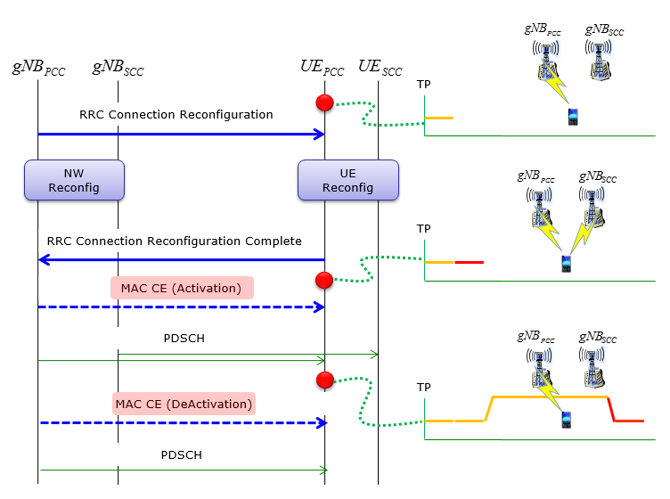

**1. Overview of Secondary Cells (Scells)**

* **Primary Cell (PCell)**: The PCell is the main cell through which the user equipment (UE) is primarily connected to the network. It handles the essential signaling and data transfer.
* **Secondary Cells (Scells)**: Scells are additional cells that are used to increase the data throughput by aggregating multiple carriers. The UE can connect to multiple Scells in addition to its PCell to improve performance and capacity.

**2. Activation of Secondary Cells**

The process of activating Scells involves several steps and interactions between the UE and the gNB (next-generation Node B). Here’s how the activation process typically works:

**a. Configuration and Signaling**

1. **RRC Connection Reconfiguration**: The activation of Scells is initiated through the Radio Resource Control (RRC) layer. The gNB sends an RRC Connection Reconfiguration message to the UE, which includes the configuration details for the Scells. This message specifies the Scells to be activated, their parameters, and the timing for activation.
2. **MAC Layer Configuration**: Upon receiving the RRC message, the MAC layer configures the UE to activate the specified Scells. This involves setting up the necessary MAC entities, including the scheduling of uplink and downlink resources for the Scells.

**b. Resource Allocation**

* **UL and DL Scheduling**: The gNB schedules resources for both uplink (UL) and downlink (DL) communications on the Scells. The MAC layer handles the allocation and management of these resources, ensuring that data can be transmitted and received efficiently on the Scells.
* **Carrier Aggregation**: The MAC layer manages the aggregation of carriers across the PCell and Scells. This involves combining the bandwidth of the multiple cells to provide higher data rates and better service quality.

**c. Activation Procedure**

1. **Channel Setup**: The MAC layer sets up the necessary transport channels for the Scells. This includes configuring the data channels (e.g., PUSCH and PDSCH) and control channels (e.g., PUCCH and PDCCH) as needed for the Scells.
2. **Data Transfer**: Once the Scells are activated, the UE begins using them for data transfer. The MAC layer handles the scheduling of data packets across the primary and secondary cells, ensuring that the data is properly balanced and transmitted.
3. **Monitoring and Adaptation**: The MAC layer continuously monitors the performance of the Scells. If necessary, it adapts the resource allocation based on network conditions and UE requirements.

**3. Deactivation of Secondary Cells**

Deactivating Scells involves similar processes but in reverse order. The gNB instructs the UE to stop using specific Scells, which involves the following steps:

**a. Configuration and Signaling**

1. **RRC Connection Reconfiguration**: To deactivate Scells, the gNB sends an RRC Connection Reconfiguration message to the UE. This message instructs the UE to release or deactivate the specified Scells and to revert to using only the PCell.
2. **MAC Layer Adjustment**: The MAC layer updates its configuration based on the new instructions. It stops scheduling resources for the deactivated Scells and adjusts the data paths accordingly.

**b. Resource Deallocation**

* **UL and DL Resource Release**: The MAC layer releases the uplink and downlink resources allocated for the deactivated Scells. This helps in freeing up network resources and optimizing the use of available bandwidth.
* **Carrier Aggregation Adjustments**: The MAC layer stops aggregating carriers from the deactivated Scells. This involves reconfiguring the transport channels to focus solely on the PCell.

**c. Deactivation Procedure**

1. **Channel Release**: The MAC layer releases the transport channels associated with the deactivated Scells. This includes deactivating data and control channels.
2. **Data Transfer Adjustment**: The UE adjusts its data transfer to use only the PCell. The MAC layer ensures that data traffic is smoothly transitioned from the Scells back to the primary cell.
3. **Performance Monitoring**: The MAC layer continues to monitor network performance and adjusts resource allocation as needed to ensure that the UE's service quality remains satisfactory after the Scells have been deactivated.

**4. Benefits and Challenges**

**a. Benefits**

* **Enhanced Data Rates**: Activating Scells allows for higher data throughput by aggregating multiple carriers. This improves the overall network performance and user experience.
* **Improved Coverage and Capacity**: Scells can help improve network coverage and capacity by using multiple cells to serve a single UE, especially in high-demand areas.

**b. Challenges**

* **Complexity in Management**: Managing multiple cells and their activation/deactivation adds complexity to the network’s resource management. Efficient signaling and resource allocation are crucial.
* **Interference Management**: When using multiple cells, managing interference between cells becomes important. Proper coordination is needed to ensure that Scells do not cause excessive interference to each other or other cells.

**Activation and Deactivation of SCG (Secondary Cell Group)**:

* **Purpose**: Involves multiple secondary cells, used to support higher data rates and improved coverage.
* **Activation**: The gNB sends commands to the UE to activate a group of secondary cells.
* **Deactivation**: The gNB sends commands to deactivate the group of secondary cells.

**Overview of SCGs (Secondary Cell Groups)**

* **Primary Cell (PCell)**: This is the main cell through which the UE maintains its primary connection to the network.
* **Secondary Cells (Scells)**: These are additional cells that the UE can connect to in addition to the PCell to enhance performance.
* **Secondary Cell Group (SCG)**: An SCG is a collection of secondary cells (Scells) that are managed together. The SCG enables efficient resource management and coordination across multiple secondary cells.

**2. Activation of SCG**

Activating an SCG involves setting up multiple secondary cells to work in coordination with the PCell. The process includes several steps:

**a. Configuration and Signaling**

1. **RRC Connection Reconfiguration**: The activation of an SCG is initiated by an RRC (Radio Resource Control) Connection Reconfiguration message sent by the gNB to the UE. This message includes information about the SCG, such as the list of Scells to be added, their configuration parameters, and scheduling details.
2. **MAC Layer Configuration**: Upon receiving the RRC message, the MAC layer on the UE configures the necessary settings for the SCG. This includes preparing the MAC entities to handle data and control channels for the new Scells.

**b. Resource Allocation**

* **Scheduling Resources**: The MAC layer schedules uplink (UL) and downlink (DL) resources for the newly activated Scells within the SCG. This involves assigning time-frequency resources and managing the scheduling of data transfers.
* **Carrier Aggregation**: The MAC layer handles carrier aggregation across the PCell and the newly activated Scells. This means combining the bandwidth from multiple cells to achieve higher data rates and better network performance.

**c. Activation Procedure**

1. **Channel Setup**: The MAC layer sets up the necessary transport channels for the new Scells in the SCG. This includes configuring data channels (e.g., PUSCH, PDSCH) and control channels (e.g., PUCCH, PDCCH).
2. **Data Transfer**: Once the SCG is activated, the UE starts utilizing the additional Scells for data transfer. The MAC layer manages data transmission and reception across the PCell and Scells, ensuring efficient use of available resources.
3. **Performance Monitoring**: The MAC layer continuously monitors the performance of the SCG, including the quality of connections and data transfer rates. It may adjust resource allocation based on network conditions and UE requirements.

**3. Deactivation of SCG**

Deactivating an SCG involves removing one or more secondary cells from the group and reverting to the primary cell for communication. The process includes:

**a. Configuration and Signaling**

1. **RRC Connection Reconfiguration**: To deactivate an SCG, the gNB sends an RRC Connection Reconfiguration message to the UE. This message instructs the UE to release or deactivate the specified Scells in the SCG and to revert to using only the PCell.
2. **MAC Layer Adjustment**: The MAC layer adjusts its configuration based on the new instructions. This includes deactivating the Scells and reallocating resources to the remaining cells.

**b. Resource Deallocation**

* **UL and DL Resource Release**: The MAC layer releases the uplink and downlink resources previously allocated to the deactivated Scells. This helps free up network resources and optimize the use of available bandwidth.
* **Carrier Aggregation Adjustments**: The MAC layer stops aggregating carriers from the deactivated Scells and adjusts the data paths to focus solely on the PCell.

**c. Deactivation Procedure**

1. **Channel Release**: The MAC layer releases the transport channels associated with the deactivated Scells. This involves deactivating data and control channels that were used for the Scells.
2. **Data Transfer Adjustment**: The UE adjusts its data transfer to use only the PCell. The MAC layer ensures a smooth transition of data traffic from the Scells back to the primary cell.
3. **Performance Monitoring**: Even after deactivation, the MAC layer continues to monitor network performance to ensure that the quality of service is maintained with the remaining PCell.

**4. Benefits and Challenges**

**a. Benefits**

* **Increased Data Throughput**: Activating an SCG allows for higher data rates by utilizing multiple Scells. This improves overall network performance and user experience.
* **Enhanced Coverage and Capacity**: SCGs can help improve network coverage and capacity by distributing the load across multiple cells.

**b. Challenges**

* **Complexity in Management**: Managing multiple cells within an SCG adds complexity to network operations. Efficient coordination and signaling are required to handle these complexities.
* **Interference Management**: Proper interference management is crucial when using multiple cells. The MAC layer must coordinate to prevent excessive interference between cells within the SCG and other cells.

**5. Advanced SCG Features**

* **Dynamic SCG Configuration**: The network can dynamically adjust SCGs based on real-time conditions, such as network load and user mobility. This ensures optimal performance and resource utilization.
* **SCG and QoS Management**: The SCG configuration must align with Quality of Service (QoS) requirements. Advanced QoS management ensures that applications with high demands, such as real-time communications, receive the necessary resources and performance.

**MAC PDUs (Protocol Data Units)**:

* **Purpose**: Carry data and control information between the higher layers and the physical layer.
* **Function**: MAC PDUs encapsulate user data and control information for efficient scheduling and transmission.

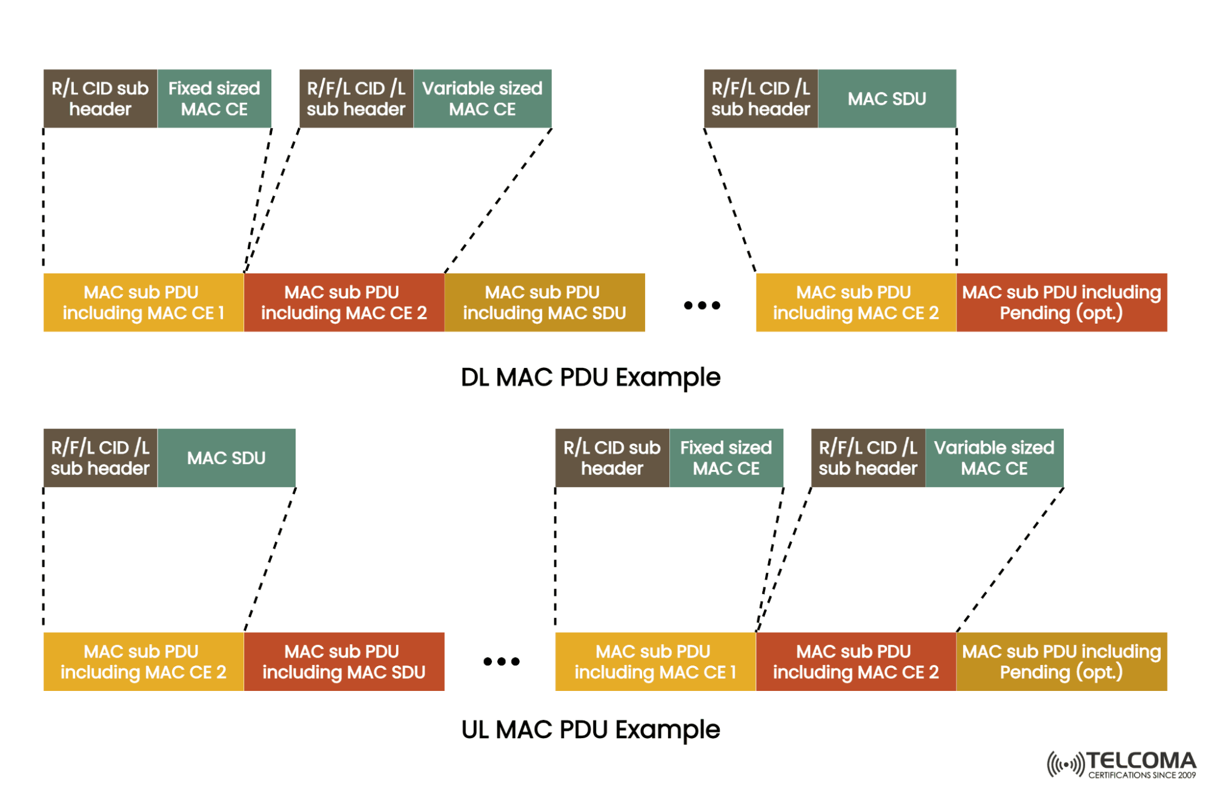

**1. Overview of MAC PDUs**

* **MAC PDU**: A MAC PDU is a data unit used in the MAC layer to transport data and control information between the UE and the gNB. PDUs are used for both uplink (UL) and downlink (DL) communications and are fundamental to the MAC layer’s function in managing data transfers and resource allocation.

**2. Structure of MAC PDUs**

The structure of a MAC PDU consists of several components, each serving a specific purpose:

**a. MAC Header**

* **MAC Header**: The MAC header contains control information necessary for the correct processing and interpretation of the MAC PDU. It includes fields such as:
  + **MAC PDU Type**: Indicates whether the PDU is for data transfer or control signaling.
  + **Scheduling Information**: Provides details on how resources are allocated for the PDU, such as the allocation of time-frequency resources.
  + **Identifier Fields**: Includes identifiers for the UE, logical channels, and other relevant entities.

**b. MAC Payload**

* **MAC Payload**: This is the actual data being transferred or the control information being sent. The payload can include:
  + **User Data**: In the case of data PDUs, this is the user data being transmitted.
  + **Control Information**: For control PDUs, this includes information related to resource allocation, signaling, or acknowledgments.

**c. MAC Trailer**

* **MAC Trailer**: The MAC trailer may contain additional information needed for the correct processing of the PDU, such as:
  + **Cyclic Redundancy Check (CRC)**: Used for error detection to ensure data integrity.
  + **Padding**: Added to meet specific size requirements or alignment constraints.

**3. Types of MAC PDUs**

MAC PDUs can be categorized based on their purpose and the type of information they carry:

**a. Data MAC PDUs**

* **Uplink Data MAC PDU**: Contains user data from the UE to the gNB. It includes the data payload and may also include control information relevant to the uplink transmission.
* **Downlink Data MAC PDU**: Contains user data from the gNB to the UE. It includes the data payload and may also include control information for the downlink transmission.

**b. Control MAC PDUs**

* **Acknowledgment (ACK) PDU**: Used to acknowledge the receipt of data or signaling messages. It provides feedback to the sender regarding the successful reception of its MAC PDU.
* **Scheduling Request (SR) PDU**: Used by the UE to request resources for uplink data transmission. It informs the gNB that the UE has data to send and needs scheduling resources.
* **Paging PDU**: Used by the network to notify the UE about incoming calls, messages, or other events. It prompts the UE to wake up from its sleep mode.
* **Random Access Response (RAR) PDU**: Used to respond to a Random Access Request from the UE, providing the necessary parameters for establishing a connection.

**4. MAC PDU Operation**

**a. Uplink Transmission**

1. **PDU Creation**: The UE creates a MAC PDU based on the data to be sent and the control information provided by the MAC layer.
2. **PDU Transmission**: The MAC PDU is transmitted over the air interface to the gNB. The gNB processes the PDU and extracts the relevant information.
3. **Acknowledgment**: The gNB sends an acknowledgment PDU to the UE, confirming the successful reception of the data.

**b. Downlink Reception**

1. **PDU Reception**: The UE receives MAC PDUs from the gNB over the air interface.
2. **PDU Decoding**: The MAC layer decodes the received PDUs, extracts the MAC header, payload, and any other relevant information.
3. **Data Handling**: The UE processes the user data or control information contained in the MAC PDU and takes appropriate action based on the received information.

**5. MAC PDU Handling**

**a. Segmentation and Reassembly**

* **Segmentation**: Large data packets may be segmented into smaller MAC PDUs for transmission. The MAC layer handles the segmentation of data to fit within the constraints of the MAC PDU size.
* **Reassembly**: On the receiving end, the MAC layer reassembles segmented MAC PDUs into the original data packets.

**b. Error Handling**

* **Error Detection**: CRC or other error-checking mechanisms are used to detect errors in MAC PDUs. If an error is detected, the PDU may be retransmitted or handled according to the error recovery procedures.
* **Retransmission**: In case of errors, the MAC layer may initiate retransmissions to ensure reliable data delivery.

**6. MAC PDU in Resource Management**

**a. Scheduling**

* **Resource Allocation**: The MAC layer uses MAC PDUs to manage the allocation of resources for both uplink and downlink transmissions. It ensures that data is transmitted efficiently and that resources are allocated according to the scheduling policies.
* **Scheduling Information**: MAC PDUs carry information related to the scheduling of resources, including the timing and frequency of data transmissions.

**b. Quality of Service (QoS)**

* **QoS Handling**: MAC PDUs include information related to the QoS requirements of the data being transmitted. This helps in managing data flows and ensuring that QoS parameters are met.

**MAC Control CEs (Control Elements)**:

* **Purpose**: Used for control signaling within the MAC layer to manage various procedures.
* **Function**: Includes Buffer Status Reports (BSR), Scheduling Requests, and other control messages.

**1. Overview of MAC Control Elements (CEs)**

* **MAC CEs**: Control Elements are messages used for various management functions within the MAC layer. They are used to control and manage the behavior of the MAC layer and to convey information necessary for maintaining and optimizing network operations.

**2. Purpose of MAC CEs**

MAC CEs serve several purposes within the MAC layer:

* **Resource Management**: CEs are used to manage and configure resources allocated to UEs, such as scheduling and quality of service (QoS) parameters.
* **Control Information**: They carry control information needed for various operations, including handovers, beamforming, and network slice management.
* **Configuration and Optimization**: CEs help in configuring and optimizing the MAC layer’s operation, including adjustments for load balancing, interference management, and power control.

**3. Types of MAC Control Elements**

Several types of MAC CEs are used in 5G networks, each serving a specific function:

**a. Scheduling Request (SR) CE**

* **Purpose**: Used by the UE to request uplink resources from the network. When the UE has data to send but lacks sufficient resources, it sends an SR CE to the gNB.
* **Operation**: The gNB responds with a Scheduling Grant, allocating resources to the UE for its uplink transmission.

**b. Paging CE**

* **Purpose**: Used by the network to page the UE. This is typically used to notify the UE about incoming calls, messages, or other important events.
* **Operation**: The gNB sends a Paging CE to the UE, which prompts the UE to wake up from sleep mode or check for pending notifications.

**c. Random Access Response (RAR) CE**

* **Purpose**: Used to respond to a UE’s Random Access Request. This CE contains the necessary parameters for the UE to establish a connection.
* **Operation**: The gNB sends an RAR CE to the UE, providing information such as timing advance and allocation of resources for the next steps in the connection setup.

**d. HARQ (Hybrid Automatic Repeat reQuest) CE**

* **Purpose**: Used for managing retransmissions of data in case of errors. HARQ CEs are involved in acknowledging the receipt of data and requesting retransmissions if errors are detected.
* **Operation**: The gNB sends HARQ CEs to the UE to indicate whether the data has been successfully received or if a retransmission is needed.

**e. Measurement Report CE**

* **Purpose**: Used by the UE to report measurements of the radio environment to the network. This includes measurements related to signal strength, quality, and interference.
* **Operation**: The UE sends a Measurement Report CE to the gNB, which helps the network make decisions related to handovers, resource allocation, and network optimization.

**f. Resource Status Report CE**

* **Purpose**: Provides information about the status of resources, such as the availability of uplink or downlink resources.
* **Operation**: The UE sends this CE to the gNB to inform it about the current resource status, which aids in resource management and scheduling.

**4. Structure of MAC Control Elements**

MAC CEs generally have a structured format, which includes:

* **Header**: Contains information about the type of CE and any necessary identifiers or parameters.
* **Body**: Carries the actual control information. The content varies depending on the type of CE.
* **Trailer**: May include additional information such as error detection codes or padding, though this is less common for CEs compared to PDUs.

**5. Operation of MAC CEs**

**a. CE Creation and Encoding**

1. **Creation**: The gNB or UE creates a MAC CE based on the control information or management task required. This involves preparing the CE’s header and body according to the specified format.
2. **Encoding**: The MAC CE is encoded into a format suitable for transmission over the air interface. This ensures that the CE can be correctly interpreted by the receiving entity.

**b. Transmission and Reception**

1. **Transmission**: The MAC CE is transmitted as part of a MAC PDU. It is included in the appropriate control channel, such as the PDCCH (Physical Downlink Control Channel) or the PUCCH (Physical Uplink Control Channel).
2. **Reception**: The receiving entity (UE or gNB) receives the MAC CE, decodes it, and processes the contained control information. This might involve updating resource allocations, responding to requests, or adjusting network parameters.

**c. Processing and Response**

1. **Processing**: Upon receiving a MAC CE, the entity processes the information according to the CE’s purpose. This could involve initiating a resource allocation, updating scheduling information, or other management tasks.
2. **Response**: In some cases, a response may be generated based on the received MAC CE. For instance, a Scheduling Request CE might result in a Scheduling Grant CE.

**6. Importance and Challenges**

**a. Importance**

* **Efficient Management**: MAC CEs enable efficient management of network resources, scheduling, and communication. They ensure that control information is communicated effectively between the UE and gNB.
* **Network Optimization**: CEs are critical for network optimization tasks, including load balancing, interference management, and QoS management.

**b. Challenges**

* **Complexity**: The management of various types of MAC CEs and their interactions can add complexity to the network operation. Ensuring that CEs are correctly processed and responded to is crucial for maintaining network performance.
* **Latency**: The timely processing of MAC CEs is essential to avoid delays in resource allocation and other management functions. Network performance can be impacted if CEs are not handled efficiently.

**BSR (Buffer Status Report)**:

* **Purpose**: Reports the amount of data present in the UE’s buffers to the network.
* **Usage**: Helps the gNB allocate resources for uplink transmission efficiently based on the buffer status.

**1. Purpose of Buffer Status Report (BSR)**

* **Resource Request**: The BSR allows the UE to communicate the status of its uplink buffer to the network. This status includes information about the amount of data waiting to be transmitted.
* **Scheduling and Allocation**: By providing the buffer status, the BSR helps the network (gNB) determine how much uplink resource should be allocated to the UE. This is essential for efficient scheduling and ensuring that the UE's data is transmitted without excessive delay.
* **Flow Control**: BSRs are used for managing data flow and ensuring that the UE does not accumulate excessive data that could lead to buffer overflow or increased latency.

**2. Types of Buffer Status Reports**

There are different types of BSRs based on their purpose and the information they convey:

**a. Short BSR**

* **Purpose**: Provides a summary of the amount of data buffered in the UE’s transmission buffers, but only includes a brief snapshot of the buffer status.
* **Usage**: Typically used for routine updates when the buffer status does not significantly change or when there is no need for a detailed report.

**b. Long BSR**

* **Purpose**: Offers a more detailed report of the buffer status compared to the Short BSR. It includes comprehensive information about different logical channels and their respective buffer sizes.
* **Usage**: Used when there is a substantial amount of data or when detailed buffer status information is needed by the network for effective resource allocation.

**3. Structure of Buffer Status Report (BSR)**

A BSR typically consists of the following components:

**a. BSR Header**

* **Identification Fields**: Includes identifiers that help the network recognize the UE and the context of the BSR.
* **Type Indicator**: Specifies whether the BSR is a Short BSR or a Long BSR.

**b. Buffer Status Information**

* **Logical Channel Information**: Provides details about the buffer status for different logical channels within the UE. Each logical channel represents a different type of data or service, such as voice or video.
* **Buffer Sizes**: Indicates the amount of data waiting in each logical channel’s buffer.

**c. Optional Fields**

* **Additional Parameters**: May include extra parameters if needed, such as priority information or other relevant data.

**4. Generation and Transmission of BSR**

**a. Generation**

1. **Trigger Events**: The BSR is generated based on specific events or conditions, such as:
   * Buffer threshold crossing: When the amount of buffered data crosses a predefined threshold.
   * Timer expiration: Periodic reporting based on timers set within the UE.
   * Explicit requests: When requested by the network for buffer status updates.
2. **BSR Calculation**: The UE calculates the amount of data in its buffers and prepares the BSR accordingly. It gathers information on the total buffer size and the amount of data in each logical channel.

**b. Transmission**

1. **Inclusion in MAC PDU**: The BSR is included in the MAC PDU (Protocol Data Unit) sent by the UE to the gNB. It is transmitted over the uplink control channel, typically the PUCCH (Physical Uplink Control Channel).
2. **Acknowledgment**: After receiving the BSR, the gNB may send an acknowledgment or adjust resource allocations based on the reported buffer status.

**5. Handling BSR by the Network (gNB)**

**a. Resource Allocation**

* **Scheduling Decision**: The gNB uses the information from the BSR to decide how much uplink resource to allocate to the UE. This helps in efficiently managing uplink data transfers and avoiding bottlenecks.
* **Resource Grant**: Based on the BSR, the gNB provides a scheduling grant to the UE, specifying the resources allocated for the uplink transmission of the buffered data.

**b. Flow Control**

* **Buffer Management**: The gNB monitors the buffer status reported by the UE to manage network resources effectively and to prevent buffer overflow or excessive queuing delays.
* **Optimization**: The network may optimize resource allocation based on the aggregate buffer status from multiple UEs to ensure balanced and efficient use of network resources.

**6. Importance of Buffer Status Report**

**a. Efficient Resource Utilization**

* **Optimized Scheduling**: By accurately reporting buffer status, the BSR helps in optimizing the scheduling of uplink resources, leading to more efficient data transmission.
* **Prevention of Data Loss**: Ensures that the UE’s data is transmitted in a timely manner, reducing the risk of data loss due to buffer overflow.

**b. Network Performance**

* **Load Balancing**: Helps in balancing the load across the network by providing insights into the data being handled by various UEs.
* **Quality of Service (QoS)**: Supports QoS management by ensuring that data with different priorities and requirements is handled appropriately.

**7. Challenges and Considerations**

**a. Timeliness**

* **Reporting Timeliness**: Ensuring that the BSR is generated and transmitted in a timely manner is crucial for maintaining network efficiency and avoiding delays.

**b. Accuracy**

* **Buffer Estimation**: Accurate estimation of buffer sizes is important for effective resource allocation and to prevent issues such as buffer overflow or underutilization of resources.

**c. Resource Overhead**

* **Overhead Management**: Minimizing the overhead associated with BSR generation and transmission is important to maintain overall network performance.

**PHR (Power Headroom Report)**:

* **Purpose**: Provides information on the UE’s available power headroom for uplink transmissions.
* **Usage**: Enables the gNB to manage power resources and adjust transmission parameters.

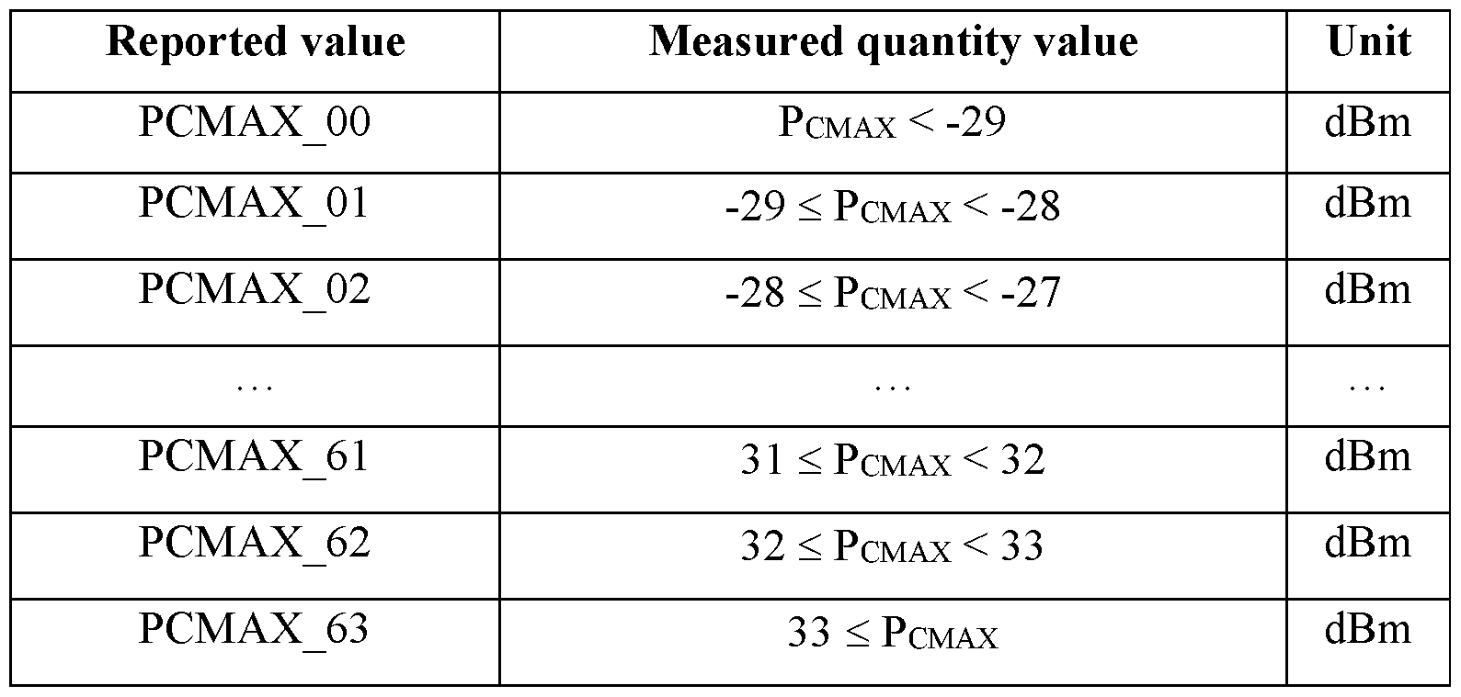

In the 5G wireless MAC (Medium Access Control) layer, the Power Headroom Report (PHR) is a critical element used to manage and optimize the transmission power of User Equipment (UE) during uplink transmissions. It provides information about the amount of additional power the UE can use for uplink transmissions, which helps the network (gNB) in optimizing resource allocation and ensuring efficient use of network resources. Here’s a detailed explanation of PHR in the context of 5G wireless communication:

**1. Purpose of Power Headroom Report (PHR)**

* **Power Management**: The PHR helps in managing the UE’s transmission power by indicating how much more power is available beyond the minimum required for current transmission conditions. This allows for better control and optimization of uplink transmissions.
* **Resource Optimization**: By providing information about power headroom, the PHR enables the network to allocate resources more efficiently and optimize the overall network performance.
* **Interference Management**: Proper use of power headroom helps in managing interference levels, especially in dense network environments, and ensures that the UE’s uplink transmissions do not cause excessive interference to neighboring cells.

**2. Structure of Power Headroom Report (PHR)**

The PHR typically includes the following components:

**a. PHR Header**

* **Identification Fields**: Identifiers to distinguish the PHR from other messages and to indicate which UE it pertains to.
* **Report Type**: Specifies whether the PHR is for an immediate report or periodic report.

**b. Power Headroom Information**

* **Power Headroom Value**: Indicates the amount of additional power available that the UE can use. This value is usually reported in decibels (dB).
* **Transmission Power**: Information about the current uplink transmission power level of the UE.
* **UE Capability**: Optional information about the UE’s power capabilities or any constraints affecting its ability to increase transmission power.

**c. Optional Fields**

* **Additional Parameters**: May include other relevant information or measurements that affect power management, such as the UE’s battery status or specific conditions affecting power headroom.

**3. Generation and Transmission of PHR**

**a. Generation**

1. **Trigger Events**: PHRs can be generated based on various events:
   * **Periodic Reporting**: The UE periodically reports its power headroom as part of regular updates.
   * **Event-Driven Reporting**: The UE generates a PHR in response to specific events, such as significant changes in its power headroom or changes in transmission conditions.
   * **Network Request**: The network (gNB) can request a PHR from the UE if more information about power headroom is needed.
2. **Calculation**: The UE calculates the available power headroom based on its current transmission power, the maximum allowable transmission power, and any power constraints it may be operating under.

**b. Transmission**

1. **Inclusion in MAC PDU**: The PHR is included in a MAC PDU (Protocol Data Unit) sent by the UE to the gNB. It is transmitted over the uplink control channel, typically the PUCCH (Physical Uplink Control Channel).
2. **Acknowledgment**: After receiving the PHR, the gNB may respond with acknowledgments or adjust resource allocations based on the reported power headroom.

**4. Handling PHR by the Network (gNB)**

**a. Resource Allocation**

* **Power Adjustment**: The gNB uses the PHR to determine if additional uplink resources can be allocated to the UE. If the PHR indicates that there is available power headroom, the network may allocate more resources or adjust scheduling to take advantage of this additional capacity.
* **Interference Management**: The gNB uses the information from the PHR to manage interference levels in the network, ensuring that increased transmission power does not lead to excessive interference with other cells or UEs.

**b. Network Optimization**

* **Dynamic Adjustment**: The network can dynamically adjust uplink transmission parameters based on the power headroom reported by multiple UEs, optimizing the overall performance and resource utilization of the network.
* **Quality of Service (QoS)**: By managing power headroom effectively, the network can better meet QoS requirements for different types of services and applications.

**5. Importance of Power Headroom Report**

**a. Efficient Resource Utilization**

* **Enhanced Performance**: By providing information about available power headroom, the PHR enables more efficient use of uplink resources, leading to improved overall network performance.
* **Optimal Resource Allocation**: Helps in optimizing the allocation of uplink resources, which can improve data throughput and reduce latency.

**b. Interference Management**

* **Controlled Interference**: Proper management of power headroom helps in controlling interference levels, which is crucial for maintaining network quality and performance, especially in dense deployments.

**6. Challenges and Considerations**

**a. Accuracy**

* **Accurate Reporting**: Ensuring that the PHR accurately reflects the available power headroom is essential for effective resource allocation and network management.

**b. Timeliness**

* **Real-Time Reporting**: The PHR needs to be reported and processed in a timely manner to ensure that resource allocations are based on the most current information.

**c. Network Overhead**

* **Efficient Handling**: Minimizing the overhead associated with generating and processing PHRs is important to maintain overall network efficiency

**Timing Advance**:

* **Purpose**: Adjusts the timing of the UE’s uplink transmissions to align with the network’s timing.
* **Method**: The gNB sends timing advance commands to the UE, which adjusts its transmission timing accordingly.

**1. Purpose of Timing Advance (TA)**

* **Synchronization**: TA is used to synchronize the transmission timing of the UE with the gNB. This ensures that data sent by the UE arrives at the gNB at the correct time, allowing for accurate reception and processing.
* **Interference Management**: Proper timing alignment helps in minimizing interference between transmissions from different UEs, especially in dense network environments.
* **Efficient Resource Utilization**: Accurate timing ensures that uplink resources are used efficiently and that multiple UEs can share the same frequency spectrum without causing overlap or collisions.

**2. Timing Advance Mechanism**

The Timing Advance mechanism involves several key steps and components:

**a. Timing Offset**

* **Definition**: Timing offset refers to the difference between the expected time of arrival of a signal at the gNB and the actual time it is received. This offset needs to be corrected for proper synchronization.
* **Correction**: The gNB calculates the required Timing Advance based on the timing offset and sends this correction to the UE.

**b. TA Request and TA Command**

1. **TA Request (TA-R)**:
   * **Purpose**: The gNB can send a Timing Advance Request to the UE to adjust its transmission timing.
   * **Transmission**: This request is typically included in a downlink control message, such as a scheduling command, within the MAC PDU.
2. **TA Command (TA-C)**:
   * **Purpose**: The gNB issues a Timing Advance Command to the UE, specifying the amount of timing advance needed to correct the timing offset.
   * **Transmission**: This command is sent to the UE via the downlink control channel (e.g., PDCCH - Physical Downlink Control Channel).

**c. TA Update**

* **Continuous Adjustment**: The UE continuously adjusts its transmission timing based on the Timing Advance Command received from the gNB. This adjustment ensures that subsequent uplink transmissions are synchronized correctly.
* **Periodic Feedback**: The UE may periodically report its timing offset to the gNB to ensure that any drift in timing is corrected.

**3. Timing Advance Calculation**

1. **Measurement**: The gNB measures the time difference between the expected and actual arrival of the UE’s uplink signal. This measurement is used to determine the timing offset.
2. **Calculation**: The gNB calculates the required Timing Advance value based on the measured offset. This value is the amount of time by which the UE needs to advance its transmission timing.
3. **Command Generation**: The Timing Advance Command is generated and sent to the UE, instructing it to adjust its transmission timing by the calculated amount.

**4. Impact on Uplink Communication**

**a. Data Alignment**

* **Proper Reception**: Timing Advance ensures that uplink data from multiple UEs arrives at the gNB at the expected time, allowing for proper decoding and processing.
* **Reduced Overlap**: By aligning transmission timings, the mechanism helps reduce the likelihood of data overlap and collisions in the uplink channel.

**b. Channel Allocation**

* **Efficient Use**: Accurate timing allows for more efficient use of uplink resources, as it helps in managing the timing and scheduling of multiple UEs sharing the same frequency resources.

**5. Handling Timing Advance in Different Scenarios**

**a. Initial Access**

* **Connection Setup**: During the initial connection setup, the UE and gNB perform a Timing Advance procedure to align the UE’s timing with the network’s timing reference.
* **Random Access Procedure**: As part of the Random Access Procedure, the UE may use timing advance to ensure that its random access preamble is properly synchronized with the gNB’s timing.

**b. Mobility Management**

* **Handover**: During handover procedures, Timing Advance is critical for ensuring that the UE’s transmission timing is correctly aligned with the new cell’s timing reference.
* **Cell Change**: When the UE changes cells, the Timing Advance mechanism helps in re-aligning the UE’s transmission timing with the new serving cell.

**6. Challenges and Considerations**

**a. Accuracy**

* **Precision**: Ensuring precise timing is crucial for minimizing errors and interference. Any inaccuracies in timing advance can lead to poor network performance and increased interference.

**b. Delay and Drift**

* **Latency**: Delays in the timing advance process can affect the overall communication performance. It’s important to minimize these delays to ensure timely corrections.
* **Drift**: Continuous adjustments are needed to handle timing drift due to various factors, such as movement of the UE or changes in network conditions.

**c. Network Overhead**

* **Resource Utilization**: Managing timing advance involves additional signaling and processing, which can impact network overhead. Efficient handling is needed to balance this overhead with performance improvements.

**7. Timing Advance in 5G vs. LTE**

* **Enhanced Precision**: 5G introduces improvements in timing precision and synchronization compared to LTE, due to advancements in network architecture and technology.
* **New Use Cases**: The timing advance mechanism in 5G supports new use cases such as ultra-reliable low-latency communication (URLLC) and massive machine-type communication (mMTC), which require high levels of timing accuracy.

**Scell Activation and Deactivation**:

* **Purpose**: Refers to the process of managing secondary cells, similar to the activation and deactivation of Scells.
* **Process**: Involves configuring the UE to use or stop using additional cells as needed.

**1. Concept of Secondary Cells (SCells)**

In 5G, the concept of Secondary Cells (SCells) is integral to carrier aggregation, which allows a UE to simultaneously use multiple carriers to increase data throughput and improve network efficiency.

* **Primary Cell (PCell)**: The PCell is the main serving cell that handles the primary connection with the UE. It is responsible for most of the control signaling and primary data transfer.
* **Secondary Cells (SCells)**: These are additional cells that the UE can utilize to aggregate more bandwidth and enhance data rates. SCells are activated or deactivated dynamically based on network conditions and UE requirements.

**2. SCell Activation**

SCell activation involves the process of enabling a Secondary Cell to start communication with the UE. This process typically includes the following steps:

**a. Triggering SCell Activation**

1. **Network Initiation**: The network (gNB) initiates SCell activation based on various factors such as load balancing, quality of service (QoS) requirements, or user data demand.
2. **UE Request**: In some cases, the UE may request activation of SCells, particularly when it needs to improve throughput or meet specific application requirements.

**b. Activation Procedure**

1. **Scheduling**: The gNB schedules resources for the SCell. This involves configuring the physical layer parameters and setting up the necessary control channels.
2. **Configuration**: The gNB sends configuration information to the UE via signaling messages. This includes details about the SCell’s physical layer settings and the corresponding MAC and RLC (Radio Link Control) parameters.
3. **MAC Layer Setup**:
   * **Control Messages**: The gNB uses MAC Control Elements (CEs) or other signaling messages to instruct the UE to start using the SCell. This typically includes information about the SCell's Physical Downlink Control Channel (PDCCH) and Physical Uplink Control Channel (PUCCH).
   * **Resource Allocation**: The gNB allocates uplink and downlink resources for the SCell, ensuring that the UE can transmit and receive data on the new cell.
4. **Synchronization**: The UE synchronizes with the SCell, which includes aligning timing and frequency with the new cell.
5. **Data Transfer**: Once activated, the UE can start using the SCell for data transmission and reception, effectively increasing the available bandwidth and improving overall data throughput.

**c. Monitoring and Adaptation**

* **Performance Monitoring**: The gNB continuously monitors the performance of the activated SCell, including metrics like signal quality and data throughput.
* **Dynamic Adjustment**: Based on real-time network conditions and UE requirements, the gNB may adjust the configuration or manage the usage of the SCell.

**3. SCell Deactivation**

SCell deactivation is the process of disabling a Secondary Cell when it is no longer needed or when it is required to free up resources. This process involves:

**a. Triggering SCell Deactivation**

1. **Network Decision**: The network may decide to deactivate an SCell based on factors such as reduced data demand, network optimization needs, or resource reallocation.
2. **UE Request**: The UE may request the deactivation of an SCell if it no longer needs the additional bandwidth or if there are issues with the SCell.

**b. Deactivation Procedure**

1. **Resource Release**: The gNB releases the resources allocated for the SCell. This involves removing configurations related to the SCell’s physical layer settings and control channels.
2. **Signaling**: The gNB sends deactivation instructions to the UE via signaling messages, informing the UE to stop using the SCell. This includes details about releasing the allocated uplink and downlink resources.
3. **MAC Layer Adjustment**:
   * **Control Messages**: The gNB uses MAC Control Elements (CEs) or other signaling messages to notify the UE about the deactivation of the SCell.
   * **Reconfiguration**: The UE reconfigures its MAC layer to reflect the removal of the SCell, adjusting its data transfer processes accordingly.
4. **Synchronization Update**: The UE updates its synchronization settings to focus on the remaining cells (e.g., PCell) and adjust its transmission and reception accordingly.

**c. Monitoring and Follow-Up**

* **Status Monitoring**: The network monitors the impact of the SCell deactivation, ensuring that there are no adverse effects on the overall network performance.
* **Resource Management**: The gNB reallocates resources previously used by the deactivated SCell to other cells or users, optimizing network performance.

**4. Impact on Network Performance**

**a. Enhanced Data Rates**

* **Increased Bandwidth**: Activating additional SCells allows the UE to aggregate more bandwidth, leading to higher data transfer rates and improved user experience.

**b. Optimized Resource Utilization**

* **Load Balancing**: SCell activation and deactivation help balance the load across different cells, optimizing resource utilization and maintaining network efficiency.

**c. Quality of Service (QoS)**

* **Service Optimization**: By dynamically managing SCells, the network can better meet QoS requirements for various services and applications, ensuring a consistent and reliable user experience.

**5. Challenges and Considerations**

**a. Signaling Overhead**

* **Management Overhead**: Activating and deactivating SCells involves signaling and configuration overhead. Efficient management is needed to minimize the impact on network resources.

**b. Synchronization Accuracy**

* **Timing and Frequency Alignment**: Ensuring accurate synchronization between the UE and the SCell is crucial for maintaining data integrity and minimizing interference.

**c. Network Complexity**

* **Dynamic Management**: Managing the activation and deactivation of multiple SCells adds complexity to network operations. Efficient algorithms and strategies are required to handle these dynamic changes effectively.

**Timing Advance Report MAC CE**:

* **Purpose**: Provides feedback to the gNB regarding the UE’s timing advance status.
* **Function**: Ensures accurate synchronization between the UE and gNB, improving data transmission efficiency.

**1. Purpose of Timing Advance Report MAC CE**

* **Synchronization**: The Timing Advance Report CE helps in maintaining precise timing synchronization between the UE and the gNB. This synchronization is vital for accurate uplink communication and resource management.
* **Adjustments**: It allows the gNB to request adjustments to the UE’s transmission timing based on the observed timing offset, ensuring that uplink signals from multiple UEs are correctly aligned.
* **Interference Management**: Proper timing alignment helps in minimizing interference between simultaneous uplink transmissions from different UEs, improving overall network performance.

**2. Structure of Timing Advance Report MAC CE**

The Timing Advance Report MAC CE is a specific type of MAC Control Element that is included in the MAC PDU (Protocol Data Unit) sent from the UE to the gNB. It typically includes the following components:

**a. MAC CE Header**

* **Identification**: The header identifies the type of MAC CE being used and may include fields to specify the MAC CE format and length.

**b. Timing Advance Information**

* **TA Value**: This is the key piece of information in the Timing Advance Report CE. It provides the amount of timing advance that the UE needs to apply to its uplink transmissions. This value is usually reported in time units (e.g., in microseconds or symbols).
* **TA Adjustment Request**: The CE may indicate whether the reported TA is a result of a request from the network or if it is a routine report.
* **Additional Parameters**: In some cases, additional parameters may be included to provide context or further details about the timing adjustments.

**3. Generation and Transmission of Timing Advance Report MAC CE**

**a. Generation**

1. **Measurement**: The UE measures the timing offset between its uplink transmissions and the expected arrival time at the gNB. This offset is used to calculate the necessary timing advance.
2. **Report Trigger**: The Timing Advance Report can be triggered by various events:
   * **Periodic Reporting**: The UE periodically reports its timing advance status as part of regular updates.
   * **Network Request**: The gNB can request a Timing Advance Report if it needs updated timing information.
   * **Special Conditions**: The UE may generate a Timing Advance Report in response to specific conditions, such as changes in network conditions or adjustments in scheduling.
3. **MAC CE Preparation**: The UE prepares the Timing Advance Report MAC CE, including the calculated TA value and any other relevant information.

**b. Transmission**

1. **Inclusion in MAC PDU**: The Timing Advance Report MAC CE is included in a MAC PDU that is sent from the UE to the gNB. This is typically transmitted over the uplink control channel (e.g., PUCCH - Physical Uplink Control Channel).
2. **Signaling**: The Timing Advance Report MAC CE is part of the uplink signaling that provides the gNB with the necessary information for timing adjustment.

**4. Handling Timing Advance Report MAC CE by the Network (gNB)**

**a. Processing**

1. **Reception**: The gNB receives the Timing Advance Report MAC CE and extracts the TA value and other information.
2. **Timing Adjustment**: Based on the reported TA, the gNB adjusts the timing for the UE’s uplink transmissions. This ensures that the UE's signals are synchronized correctly with the network.
3. **Resource Management**: The gNB may also adjust resource allocations and scheduling based on the timing information provided in the report.

**b. Feedback and Confirmation**

1. **Acknowledgment**: The gNB may acknowledge the receipt of the Timing Advance Report, confirming that the timing information has been processed.
2. **Further Instructions**: If necessary, the gNB may send further instructions or adjustments to the UE to refine the timing alignment.

**5. Impact of Timing Advance Report MAC CE**

**a. Enhanced Synchronization**

* **Precise Timing**: Ensures that uplink transmissions from multiple UEs are synchronized accurately, leading to improved data integrity and network performance.
* **Reduced Interference**: Proper timing alignment helps in minimizing interference between uplink signals from different UEs, enhancing the overall quality of communication.

**b. Efficient Resource Utilization**

* **Optimal Scheduling**: Accurate timing information allows the gNB to schedule uplink resources more effectively, optimizing bandwidth usage and network efficiency.
* **Load Balancing**: Helps in balancing the load across different cells and users by ensuring that timing adjustments are applied correctly.

**6. Challenges and Considerations**

**a. Accuracy**

* **Measurement Precision**: Ensuring that the timing advance measurements are accurate is crucial for effective synchronization and resource management.

**b. Signaling Overhead**

* **Management**: Handling Timing Advance Report MAC CEs involves signaling overhead, which must be managed efficiently to avoid impacting network performance.

**c. Network Adaptation**

* **Dynamic Adjustments**: The network needs to adapt dynamically to timing changes, which requires robust algorithms and mechanisms for processing and applying timing adjustments.

**Key Differences in 5G Compared to LTE**

* **Enhanced Random Access**: 5G introduces new preamble formats and increased flexibility for random access procedures.
* **Scell and SCG Handling**: While LTE handles secondary cells and cell groups, 5G extends these concepts with more advanced management and configuration.
* **MAC CE Enhancements**: 5G includes additional MAC Control Elements to support new features and improve network performance.