DCMS
Debt collection
Dispute management
Payments
Invoice recoveries
Coorporate Recoveries
Followups
Tasks
Pricing
FAQ
Sign up page icon description
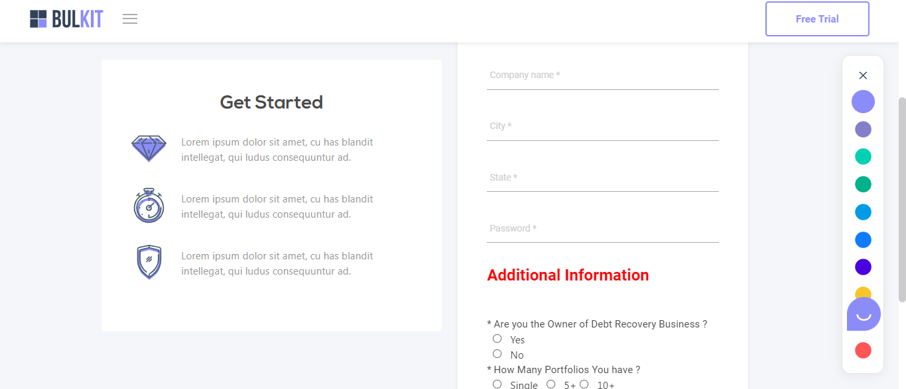
Want to lern more
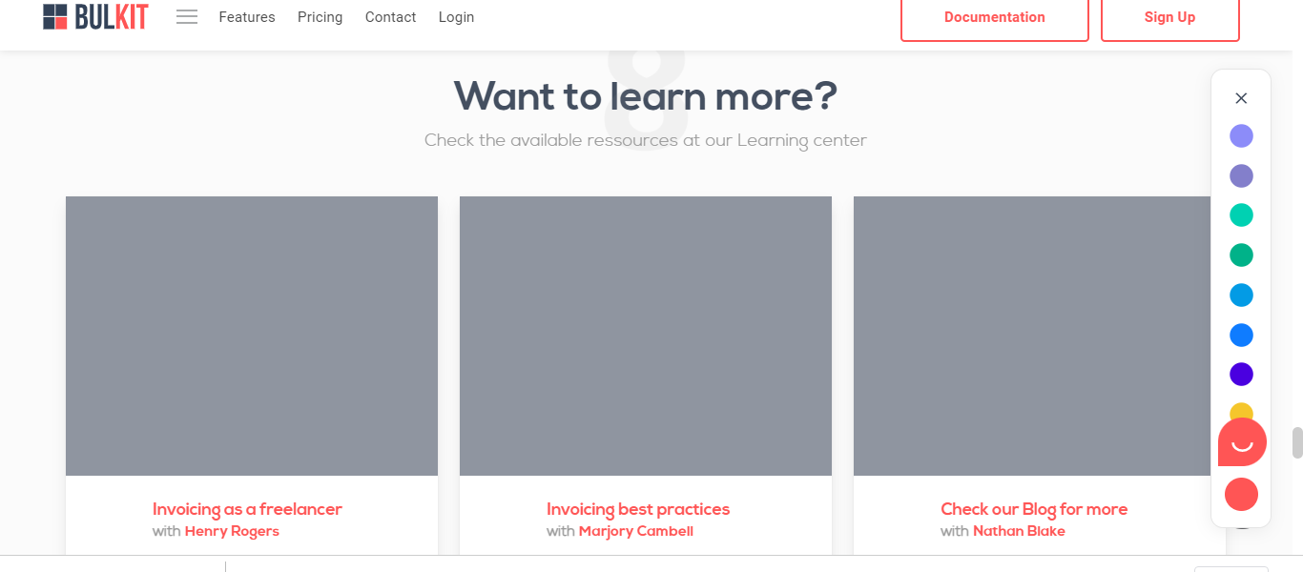caption and image

