**Lesson 1 : Representing Transactions**

**Learning objectives -**

**In this lesson, you’ll be understanding the intense concept of blockchain network and what exactly it means.**

**What is Blockchain?**

The blockchain is similar to a permanent book of records that keeps a log of all transactions that have taken place in chronological order.

Let’s envision a bank transaction in which there are three parties: the sender, the bank, and the recipient. In order to ensure that there are no fraudulent transactions, the bank acts as the central authority between the parties.

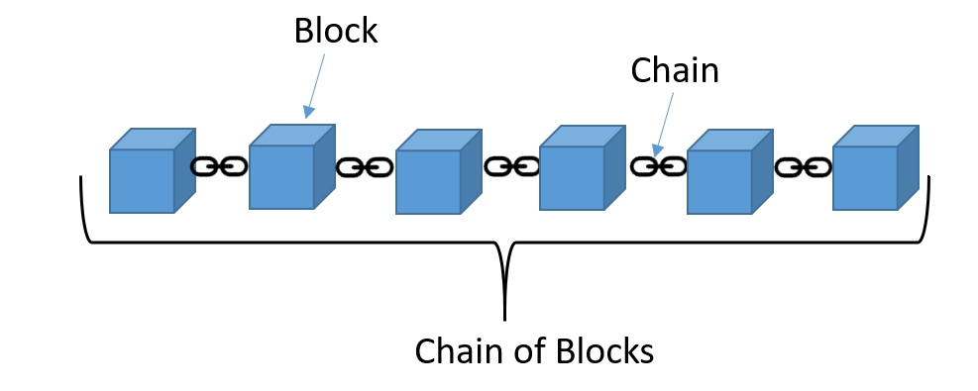

The blockchain also logs transactions between senders and receivers, except there is no bank or central authority. Instead, the blockchain relies on a public network of computers to verify the transaction.

The blockchain is just an accurate, and permanent record of all the transactions that have happened amongst the members in that blockchain’s network. In this analogy, each block in the blockchain represents a transaction, and each transaction is connected to the prior transaction to form the entire connected blockchain.

In the simplest terms, Blockchain can be described as a data structure that holds transactional records and while ensuring security, transparency, and decentralisation. You can also think of it as a chain or records stored in the forms of blocks which are controlled by no single authority.

Once an information is stored on a blockchain, it is extremely difficult to change or alter it. A block is thus a permanent store of records that, once written, cannot be altered or removed hence

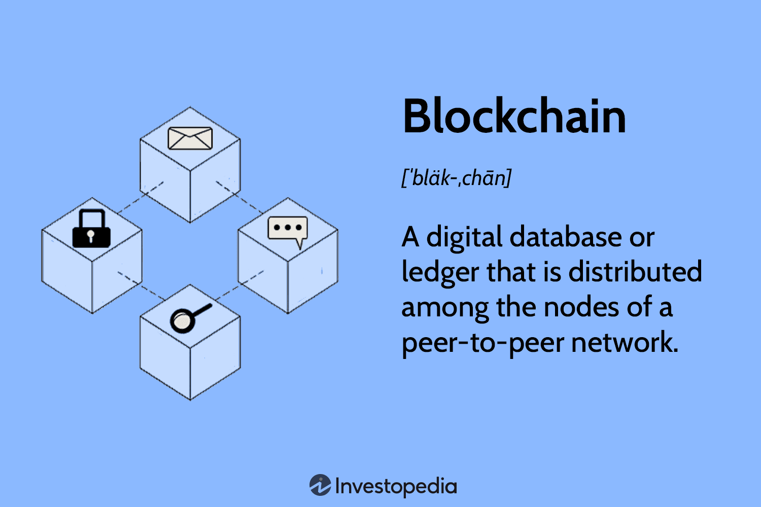

**2. A practical real life example for understanding blockchains:**

In order to understand blockchain better, consider an example where you are looking for an option to send some money to your friend who lives in a different location. A general option that you can normally use can be a bank or via a payment transfer application like PayPal or Paytm. This option involves third parties in order to process the transaction due to which an extra amount of your money is deducted as transferring fee. 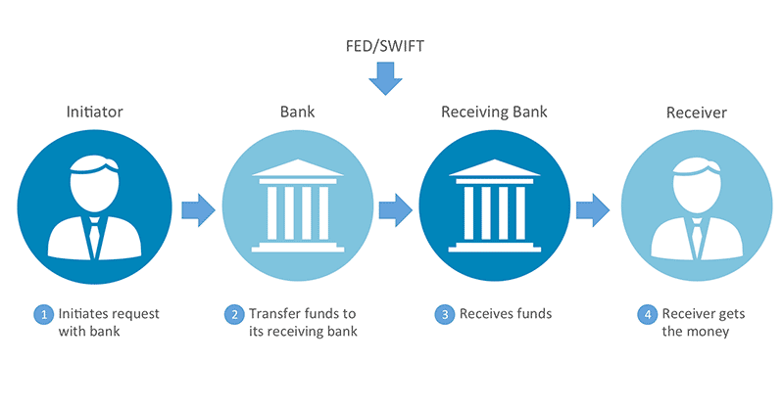

Moreover, in cases like these, you cannot ensure the security of your money as it is highly possible that a hacker might disrupt the network and steal your money. In both the cases, it is the customer who suffers. This is where Blockchain comes in.

Instead of using a bank for transferring money, if we use a blockchain in such cases, the process becomes much easier and secure. There is no extra fee involved as the funds are directly processed by you thus, eliminating the need for a third party. Moreover, the blockchain database is decentralised and is not limited to any single location meaning that all the information and records kept on the blockchain are public and decentralized. Since the information is not stored in a single place, there’s no chance of corruption of the information by any hacker.

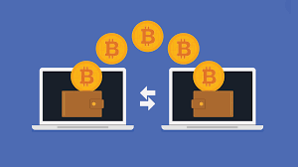

**3.Features of a blockchains:**

**Decentralised** - Blockchains are decentralized in nature meaning that no single person or group holds the authority of the overall network.

In contrast to a centralized architecture, which presents several issues including a single point of failure and problems of scalability, the blockchain uses a decentralized format which somewhat eliminates these risks.

**Immutable** - The immutability property of a blockchain refers to the fact that any data once written on the blockchain cannot be changed. To understand immutability, consider sending email as an example. Once you send an email to a bunch of people, you cannot take it back.

**Transparency** - A blockchain delivers a high level of transparency by sharing transaction details among all participants users involved in those transactions. In a blockchain environment, there is no need for a third party, which improves business friendliness and guarantees a trusted workflow.

**Better security** - Blockchain provides better security because it uses a public key infrastructure that protects against malicious actions to change data. Participating users of the blockchain network place their trust in the integrity and security features of the mechanism. In addition, the blockchain eliminates the single point of failure, which affects the entire system.

**Efficiency** - A blockchain is more efficient than the classical centralized architecture in terms of cost, settlement speed, and risk management.

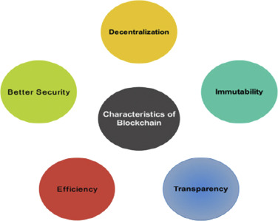

**4. Types of Blockchains :**

Though Blockchain has evolved to many levels since inception, there are two broad categories in which blockchains can be classified majorly i.e. Public and Private blockchains. There are few other types too based on the blend of these two major types.

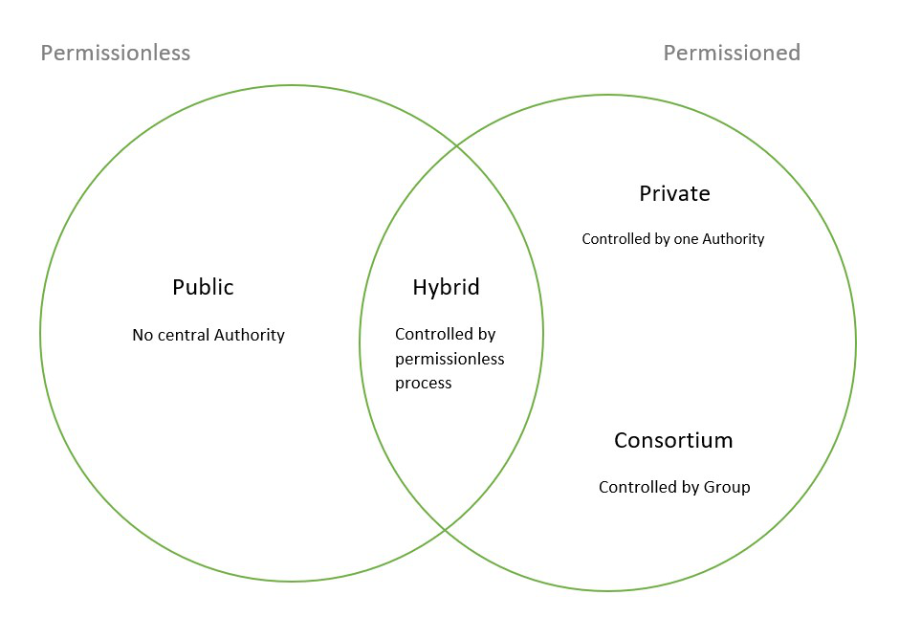

**5.How exactly a block looks like :**

Block can be defined as a square box. Which has three sides,

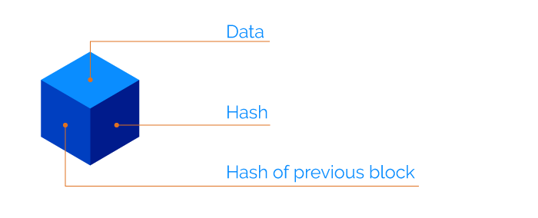

**1. Data 2. Hash code 3. Previous Hash.**

1. Data : Some part of the block contains information which is known as data. This data is nothing but information about sender, receiver and how many coins(money) have been transferred.

2. Hash code : Hash code is nothing but the fingerprint of the block. It is the main security feature available in blockchain which makes blockchain unbreakable.

3. Hash of previous block : Hash of previous block is nothing but information of

previous block. Since each block is tied up to the next block in the chain. Having information about the previous block is mandatory to make the block chain more secure.

If any hacker tries to break into the blockchain then the hacker needs to hack and change the entire blockchain hash code as well as the previous block. And this process is very difficult. Chain is nothing but a sequence of multiple blocks connected together in chain format.



Blockchain technology widely used in cryptocurrency transactions. But what is

cryptocurrency let understand first.

**Cryptocurrency :**

* Cryptocurrency is a form of payment that can be exchanged online for goods and services. Cryptocurrencies work using a technology called blockchain.
* For example, if you sell your phone then you will receive money into your bank account but if you use cryptocurrency to sell your phone you can receive coins which are nothing but money which hold some good value in the market.
* Blockchain is a decentralized technology spread across many computers that manages and records transactions. Decentralized technology means the technology which does not come under any governed authority.
* Cryptocurrency is a great example of blockchain. We have multiple cryptocurrency such as Bitcoin, Ethereum and so on.

As we know now, blockchain technology is widely used in a number of cryptocurrencies. But then why are people so curious about blockchain rather than the traditional banking system?

Well it's simple, because blockchain technology is much more secure and fast than a traditional banking system.

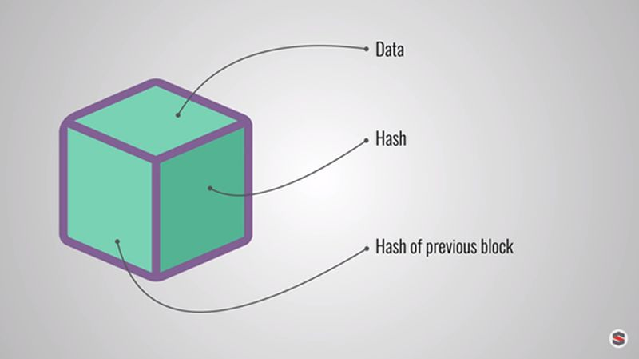

**Key Terms:**

* **Block:** A block is an individual transaction or piece of data that is being stored within the blockchain.
* **Blockchain:** A blockchain is a continuously growing list (“chain”) of records (“block”), called blocks, which are linked chronologically and secured using cryptography.
* **Mempool :** Broadly speaking, a mempool is an organized queue where transactions are stored and sorted before being added to a newly created block. The memory pool holds “fresh” or unconfirmed transactions (stored as individual transactions). The blockchain holds “archived” or confirmed transactions (packaged in “blocks”).

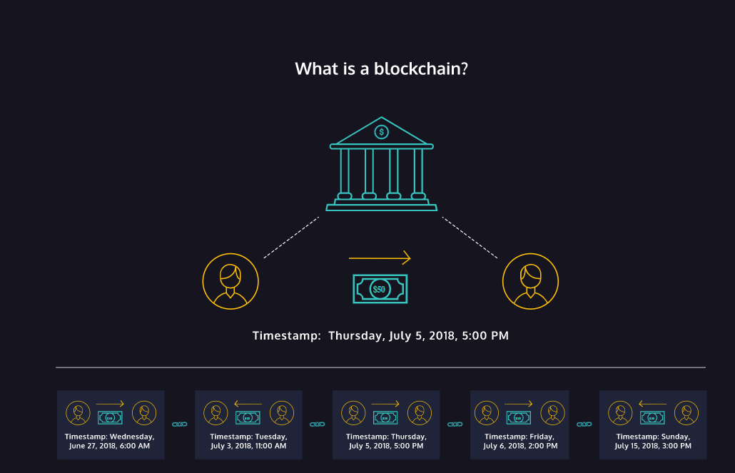

Fig: The image shows how bank transactions can be easily represented in the blockchain. The sender and recipient, as well as the transaction, is stored inside the block and is chained together with other transactions that occurred before and after it.

**Blockchain Programming using Python (Time - 45 min)**

**Class and object** are important concepts of OOP(object oriented programming)

As the name stands, programming languages use objects to make programs easy and reliable.

Let's write a small code and revise the concepts of class and objects a bit -

**Activity to understand classes and objects:**

<https://replit.com/join/rniqrhkwey-priyankajetlea1>

**References:**

https://docs.python.org/3/tutorial/classes.html

[**https://www.geeksforgeeks.org/create-simple-blockchain-using-python/**](https://www.geeksforgeeks.org/create-simple-blockchain-using-python/)

The blockchain is a new way of storing and moving data securely. The data mostly consists of transactions which include messages exchanged between two parties. Before we start creating our blockchain, let’s think of a way to store a transaction like the one shown below:

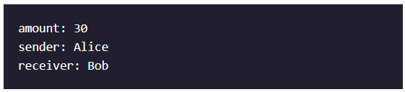

In this example, Alice is trying to transfer 30 units of some currency to Bob. Can you think of a Python data type to best represent the above transaction?

This transaction is best represented in the form of a Python *dictionary*, with keys for the required fields and values specific to the transaction.

These transactions are all stored inside the *mempool*, a pool of transactions that miners reference when selecting the set of transactions they want to verify.

**The second concept in which we will revisit here is that of dictionary-**

**Link to Repl it Project :**

[main.py - Lesson1_Representing_Transactions - Replit](https://replit.com/@JLPythonID/Lesson1RepresentingTransactions#main.py)

Activity 2: [Representing transaction](https://docs.google.com/document/d/1ELK-beIPDJFJmOvw663m6Bs7XlFlvav6oy3N5iho_zQ/edit?usp=sharing)

More Reference : <https://www.section.io/engineering-education/how-to-create-a-blockchain-in-python/>

<https://medium.com/coinmonks/python-tutorial-build-a-blockchain-713c706f6531>

**Homework -**

Write a simple code to create a simple blockchain class.