Groq Models
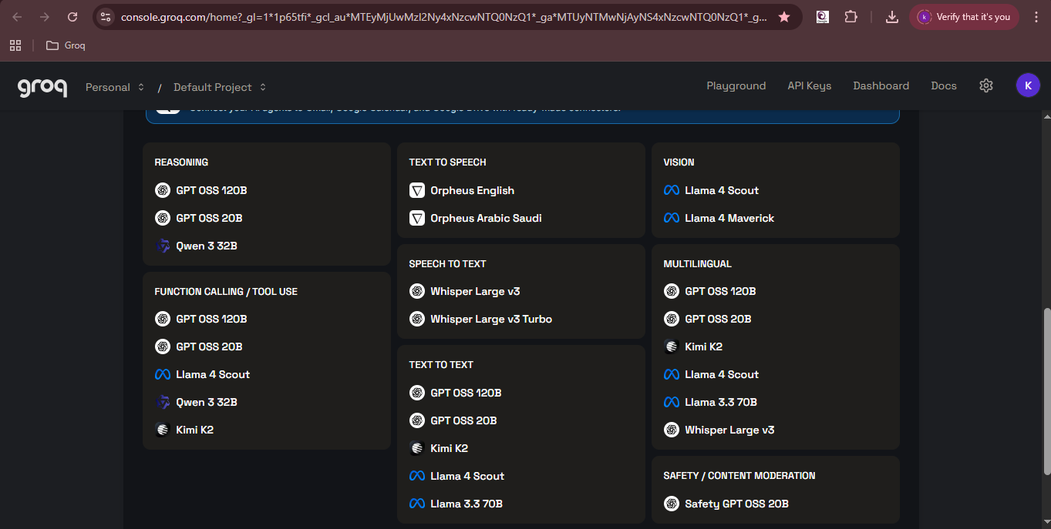

Orpheus English – converts any entered Text to Speech
Orpheus Arabic Saudi - – converts any entered Text to Arabic slang

Whisper Large v3- high-accuracy automatic speech recognition (ASR) and speech translation across 99 languages

Llama 4 Scout - AI model designed by Meta for analysing massive datasets, supporting up to 10 million tokens of context. It is primarily used for summarizing vast documents, performing deep reasoning over extensive codebases, and powering personalized agentic applications
Functional calling
GPT OSS 120B/ Llama 4 Scout /Kimi K2 - high-performance, agentic, and reasoning-intensive applications. It offers chain-of-thought capabilities, function calling

Safety/content Moderation
Safety GPT OSS 20B - AI safety, content classification, and trust & safety applications. It allows users to input custom safety policies to classify text content, providing detailed reasoning (Chain-of-Thought) for its decisions

https://openrouter.ai/models
Google: Gemini 3.1 Pro Preview - 46.8B tokens
OpenAI - gpt-5.2-codex - 400K tokens
Anthropic: Claude Sonnet 4.6 - 217B tokens
qwen/qwen3.5-plus-02-15 - 7.83B tokens
qwen/qwen3.5-397b-a17b - 19.3B tokens

