EAST WEST INSTITUTE OF TECHNOLOGY

SRI RAVIKIRAN CENTER OF EXCELLENCE PROGRAM

# DATA SCIENCE USING PYTHON PROGRAMMING

**Department of Artificial Intelligence and Machine Learning**

**3rd Semester**

**(NAAC ACCREDITED, AFFILIATED TO VTU, BELGAVI AND RECOGNIZED BY THE AICTE, NEW DELHI)**

**2024-25**

**Project Name: IPL Score Prediction**

**Mentor Name: Mr Srinivas**

**Presented By:**

**1.Rakshitha S P[1EW23AI045]**

**2.G Soumya[1EW23AI015]**

**3.Megha Sadashiv Doni[1EW23AI028]**

**4.Sanjana S [1EW23AI051]**

**5.Vaishnavi M[1EW23AI056]**

**Abstract:**

India's most popular sport is cricket and is played across all over the nation in different formats like T20, ODI, and Test. The Indian Premier League (IPL) is a national cricket match where players are drawn from regional teams of India, National Team and also from international team. Many factors like live streaming, radio, TV broadcast made this league as popular among cricket fans. The prediction of the outcome of the IPL matches is very important for online traders and sponsors

**Introduction:**

In the modern era of cricket analytics, where each run and decision can change the outcome, the application of Deep Learning for IPL score prediction stands at the forefront of innovation. This article explores the cutting-edge use of advanced algorithms to forecast IPL score in live matches with unprecedented accuracy. Exploring the analysis of historical data, player statistics, and real-time match conditions, discover how these predictive models are reshaping strategic insights and elevating the excitement of cricket analytics. Whether you’re a cricket aficionado or a data science enthusiast, uncover how this technology is revolutionizing the game’s predictive capabilities and strategic planning**.**

**What is IPL?**

The Indian Premier League (IPL), also known as the TATA IPL for sponsorship reasons, is a men's Twenty20 (T20) cricket league held annually in India.

**Code and output:**

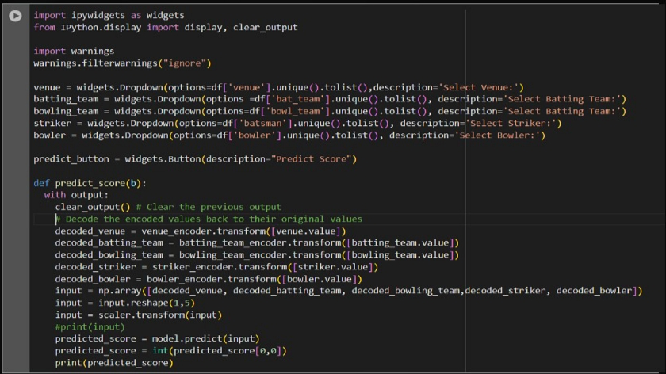

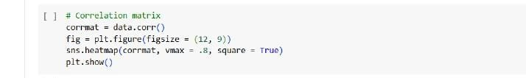

Graph:

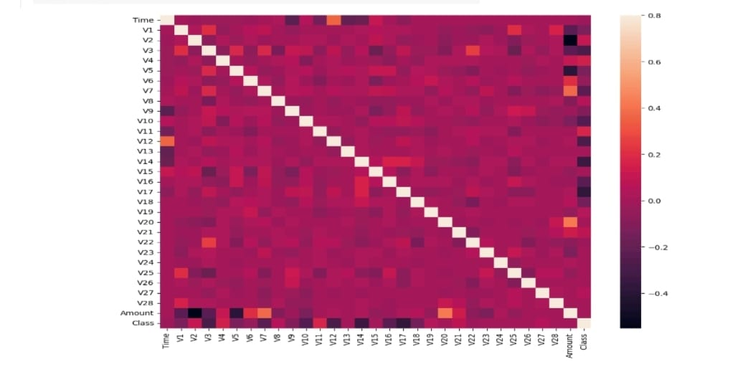

**Conclusion**:

Credit card fraud detection is a set of methods and techniques designed to block fraudulent purchases, both online and in-store. This is done by ensuring that you are dealing with the right cardholder and that the purchase is legitimate.

Thank you