**PROJECT TITLE:**

**CoSupplyChain Sales Analysis**

**NAME: LAKSHMI SREEJA GOTIKA**

**DATE: 07-06-2024**

# TABLE OF CONTENTS

1. Project Overview

1.1 Project Title

1.2 Objective

1.3 Scope

1. Data Source

2.1 Data Description

2.2 Data Fields

2.3 Data Preparation

1. Visualizations

3.1 KMP Chart for Sales Performance

3.2 Bar Chart for Country-Based Sales Analysis

3.3 Pie Chart for Customer Demographics

1. Storytelling

4.1 Slide 1: Title and Introduction

4.2 Slide 2: Sales Performance Overview

4.3 Slide 3: Geographic Distribution of Sales

4.4 Slide 4: Customer Demographics and Order Types

1. Implementation Steps

5.1 Data Loading

5.2 Creating Visualizations

5.3 Developing the Storytelling Presentation

1. Results and Insights

6.1 Key Findings

6.2 Recommendations

1. Conclusion

7.1 Summary

**1. Project Overview**

#### 1.1 Project Title

**Project Title:** CoSupplyChain Sales Analysis

#### 1.2 Objective

The objective of this project is to analyze the CoSupplyChain dataset to gain insights into sales performance, geographical distribution of orders, and customer demographics. This analysis aims to identify key trends and provide actionable insights for business decision-making.

#### 1.3 Scope

* **Data Loading and Preparation:** Importing the CoSupplyChain dataset into Qlik Sense and preparing it for analysis.
* **Visualization Creation:** Developing various charts including KMP charts, bar charts, and pie charts to represent different aspects of the data.
* **Storytelling Presentation:** Compiling the visualizations and insights into a cohesive storytelling format with multiple slides.

### 2. Data Source

#### 2.1 Data Description

The dataset used in this project is the CoSupplyChain dataset, which includes information on sales transactions, customer details, and geographical data. The dataset provides a comprehensive view of sales performance and customer behavior.

#### 2.2 Data Fields

* **Sales Amount:** The total amount of sales for each transaction.
* **Order Date:** The date when the order was placed.
* **Country (Type):** The type of country associated with the order.
* **Country (Order):** The country where the order was placed.
* **Customer State:** The state where the customer is located.
* **Order Type:** The type of order placed by the customer.

#### 2.3 Data Preparation

The dataset was cleaned and prepared for analysis by performing the following steps:

* **Removing Duplicates:** Ensuring that there are no duplicate records in the dataset.
* **Handling Missing Values:** Addressing any missing or incomplete data points.
* **Standardizing Data Formats:** Converting data fields to consistent formats (e.g., date formats).

### 3. Visualizations

#### 3.1 KMP Chart for Sales Performance

* **Objective:** To provide an overview of key sales metrics including total sales, average sales per order, and sales growth.
* **Description:** A Key Metrics Performance (KMP) chart was created to highlight critical sales metrics over the selected period. This chart helps in understanding overall sales performance and identifying trends.
* **Snapshot:** 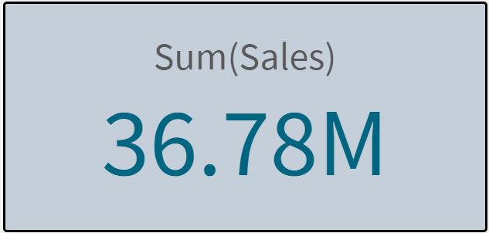

#### 3.2 Bar Chart for Country-Based Sales Analysis

* **Objective:** To analyze the distribution of sales by country.
* **Description:** A bar chart was created to show sales performance across different countries based on order type and country type. This visualization helps in identifying high-performing markets and regions with growth potential.
* **Snapshot:** 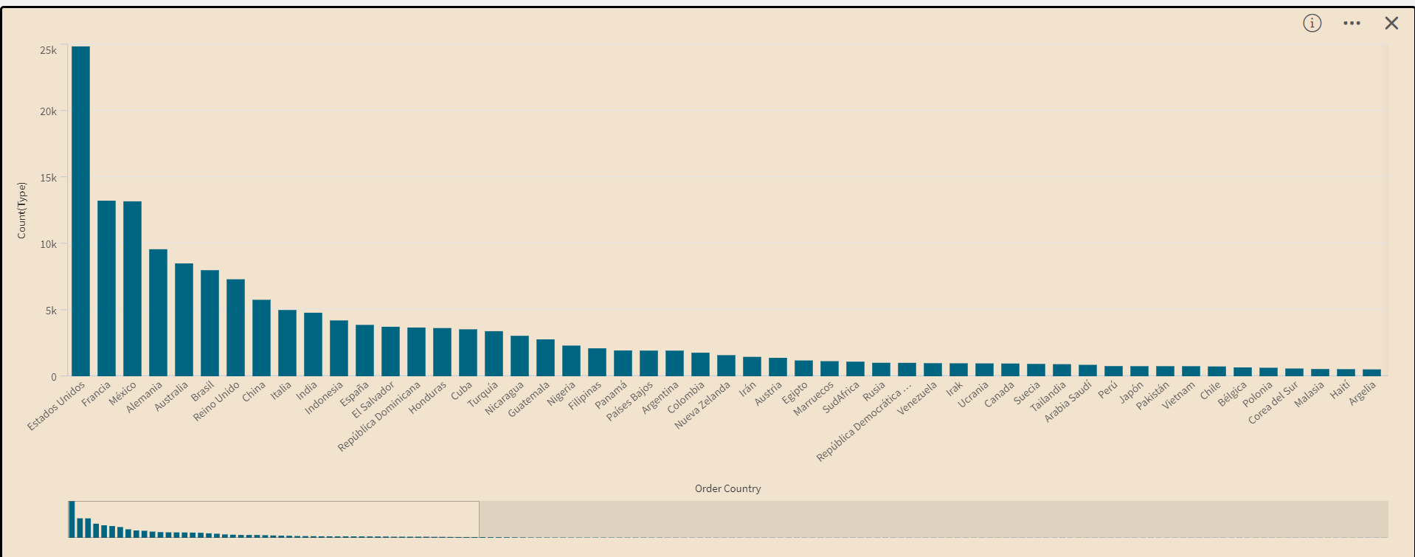

#### 3.3 Pie Chart for Customer Demographics

* **Objective:** To visualize the distribution of customer states and order types.
* **Description:** A pie chart was created to provide insights into customer demographics and their order preferences. This chart helps in understanding the customer base and tailoring marketing strategies accordingly.
* **Snapshot:** 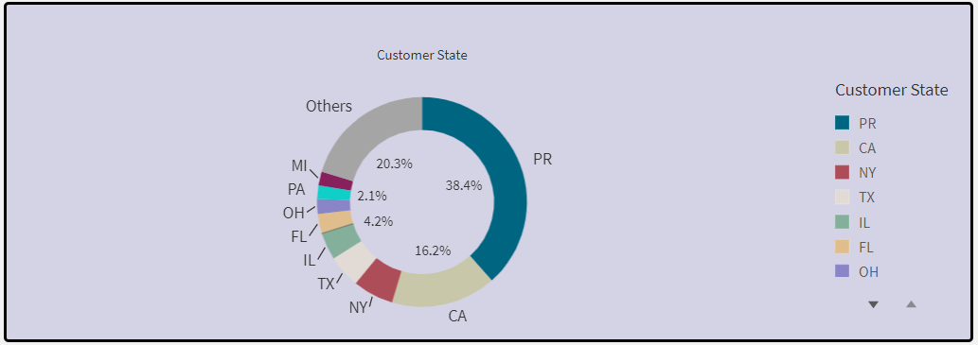

**4. Storytelling**

#### 4.1 Slide 1: Title and Introduction

* **Title:** Overview of CoSupplyChain Sales Analysis
* **Content:** Introduction to the project, objectives, and the importance of the analysis. This slide sets the stage for the detailed analysis presented in the subsequent slides.
* **Snapshot:**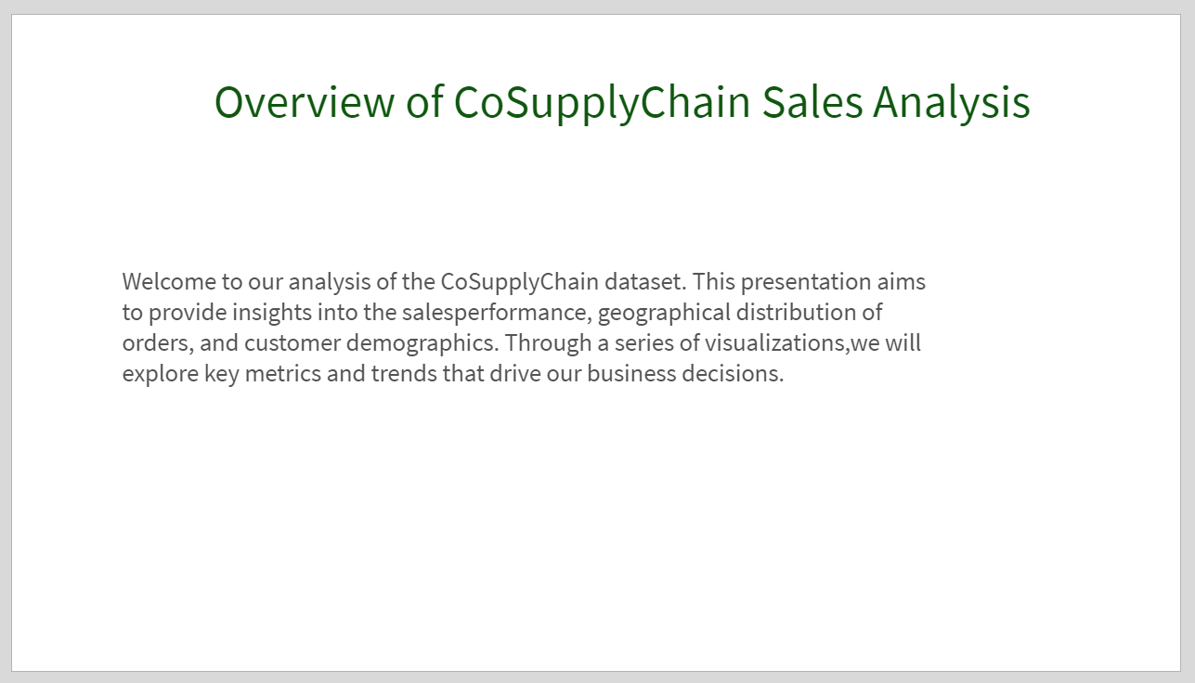

#### 4.2 Slide 2: Sales Performance Overview

* **Title:** Sales Performance Overview
* **Content:** Description of the KMP chart and key sales metrics. This slide provides an overview of the sales performance, highlighting total sales, average sales per order, and sales growth.
* **Snapshot:**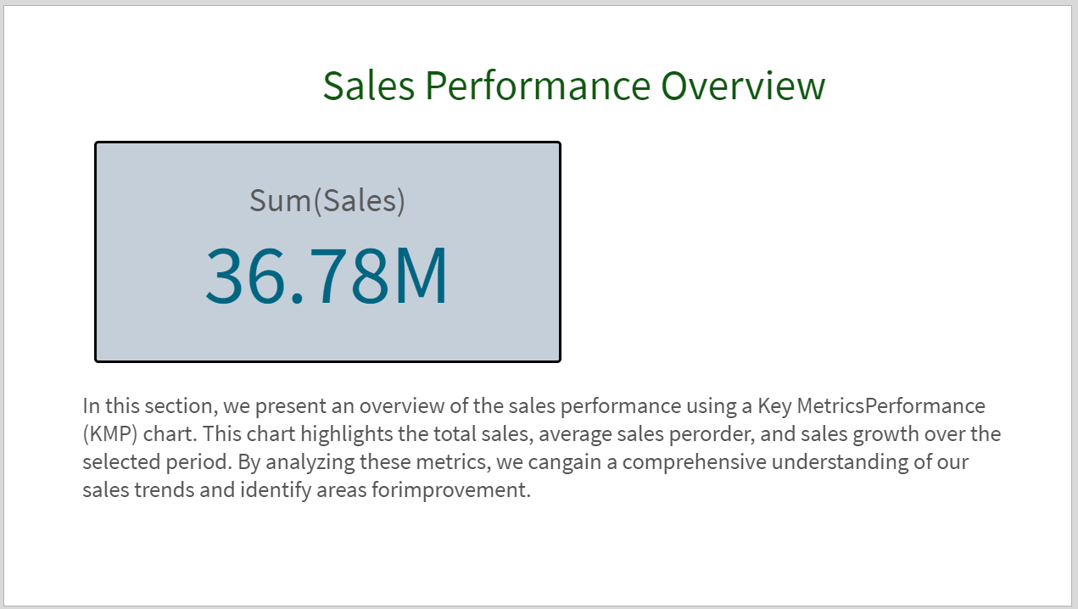

#### 4.3 Slide 3: Geographic Distribution of Sales

* **Title:** Geographic Distribution of Sales
* **Content:** Analysis of the bar chart showing sales distribution by country. This slide discusses the geographical performance, identifying key markets and regions with high sales.
* **Snapshot:**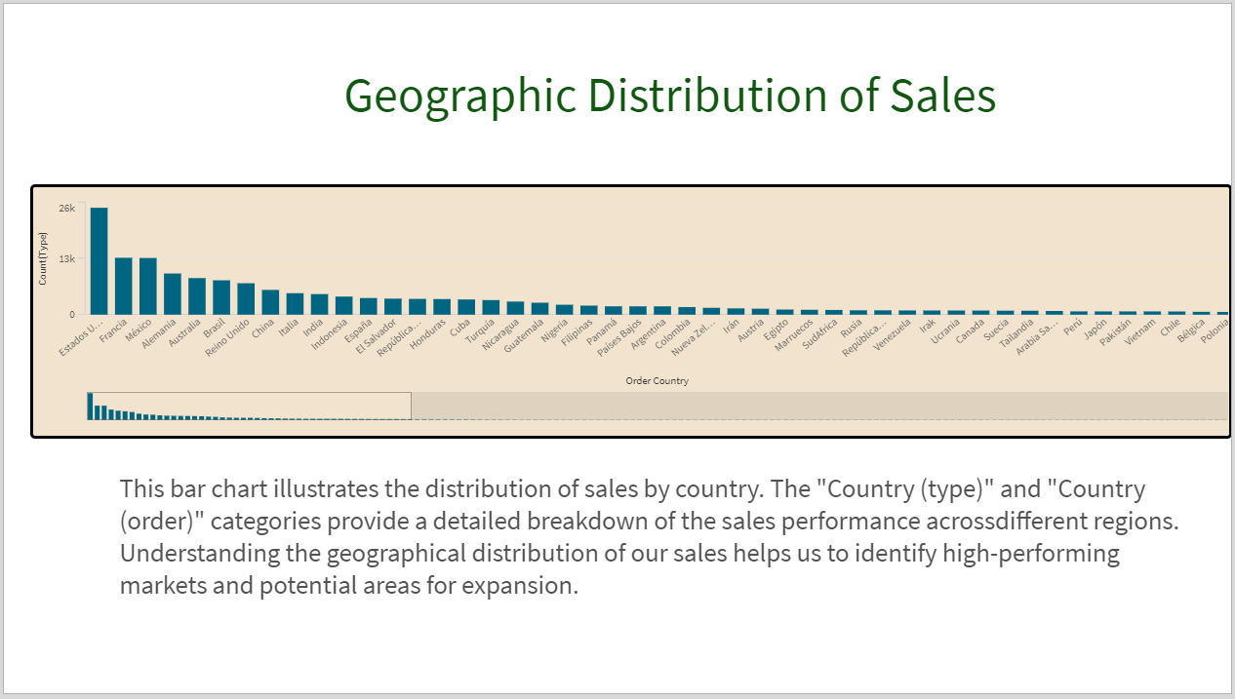

#### 4.4 Slide 4: Customer Demographics and Order Types

* **Title:** Customer Demographics and Order Types
* **Content:** Insights from the pie chart on customer states and order types. This slide provides an understanding of customer demographics and preferences, which can inform marketing and sales strategies.
* **Snapshot:**

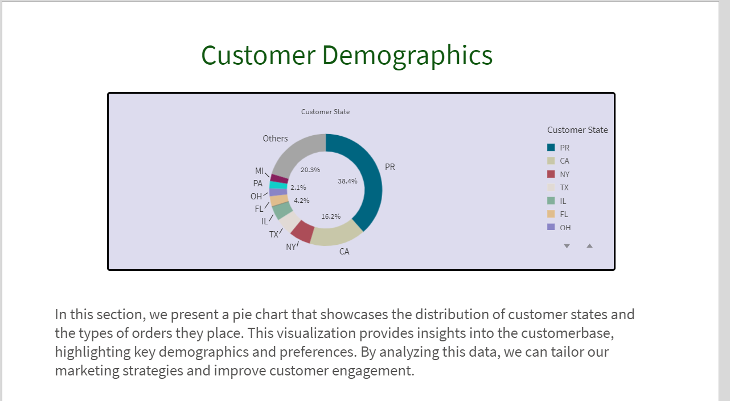

### 5. Implementation Steps

#### 5.1 Data Loading

* **Connect to the Dataset:** Import the CoSupplyChain dataset into Qlik Sense using the Data Load Editor.
* **Data Cleaning:** Perform data cleaning tasks such as removing duplicates and handling missing values.
* **Data Preparation:** Standardize data formats and ensure the dataset is ready for analysis.

#### 5.2 Creating Visualizations

* **KMP Chart:** Use the Sheet View to create a KMP chart for sales performance.
* **Bar Chart:** Create a bar chart to analyze sales by country (type and order).
* **Pie Chart:** Develop a pie chart to visualize customer demographics and order types.
* **Customization:** Customize each chart with appropriate dimensions, measures, and labels to ensure clarity and accuracy.

#### 5.3 Developing the Storytelling Presentation

* **Storytelling Pane:** Navigate to the Storytelling pane in Qlik Sense.
* **Creating Slides:** Create a new story and add four slides to it.
* **Adding Snapshots:** Add snapshots of the charts to the relevant slides.
* **Content Addition:** Include descriptive content for each slide to explain the visualizations and insights.

**6. Results and Insights**

#### 6.1 Key Findings

* **Sales Performance:** Summarize key insights from the KMP chart, such as total sales, average sales per order, and sales growth.
* **Geographical Analysis:** Highlight significant trends observed in the bar chart, such as high-performing countries and regions with growth potential.
* **Customer Demographics:** Discuss key findings from the pie chart, including the distribution of customer states and order types.

#### 6.2 Recommendations

* **Sales Strategies:** Based on the analysis, provide recommendations for improving sales performance, such as targeting high-performing regions or optimizing order types.
* **Marketing Strategies:** Suggest marketing strategies to engage different customer demographics and enhance customer satisfaction.

### 7. Conclusion

#### 7.1 Summary

* Recap the objectives, methods, and key findings of the project. Emphasize the importance of the insights gained and their potential impact on business decisions.