CLINICAL WORKFORCE MANAGEMENT SYSTEM

ORGANIZATION AND SCENARIO DESCRIPTION

ORGANIZATION

“VitalCare Hospitals” is a medium-sized healthcare institution renowned for its unwavering commitment to providing high-quality patient care. With a dedicated workforce of over 3,000 employees, VitalCare Hospitals goes beyond the ordinary in ensuring accessible healthcare for all by strategically operating family health centers across multiple counties. This comprehensive approach guarantees that the broader community can easily access VitalCare's exceptional healthcare services.

At the heart of VitalCare Hospitals is an impressive inpatient unit featuring 540 beds, offering a comforting environment where patients receive care tailored to their unique needs. This extensive capacity ensures that even during peak demand, VitalCare can accommodate patients without compromising the quality of care. However, VitalCare Hospitals' commitment to excellence doesn't stop at the basics. The hospital stands out by offering a wide array of specialty programs that cater to a diverse range of healthcare needs. Among these are state-of-the-art cardiovascular surgeries, which reflect VitalCare's advanced medical capabilities, providing patients with cutting-edge interventions and the highest standard of cardiovascular care. VitalCare Hospitals also leads the way in pharmaceutical care with an expanded 340B pharmacy program. This initiative not only benefits patients by providing cost-effective medications but also contributes to the hospital's financial sustainability and its ability to continue delivering top-tier healthcare services. Another area where VitalCare excels is advanced chronic disease management.

SENARIO

VitalCare Hospitals embarked on a transformative journey, making data and analytics the driving force behind its healthcare management practices. This approach is indispensable for several compelling reasons. Firstly, patient care quality is intricately linked to having the right mix and number of clinical staff available, and the hospital recognizes that data-driven decision-making is paramount in achieving this goal.

Secondly, labor costs represent a substantial portion of the healthcare organization's budget, making the optimization of staffing an essential cost-saving measure. VitalCare Hospitals understands that by using data and predictive analytics to intelligently allocate resources and staff, it can strike the ideal balance between cost-effectiveness and top-tier patient care. Additionally, the hospital is committed to improving staff satisfaction and reducing burnout, recognizing that data-driven insights are instrumental in achieving these objectives. Through AI-based workload monitoring, streamlined work hours, and the automation of routine tasks, the hospital is fostering a work environment where healthcare professionals can deliver exceptional care without experiencing undue stress. This, in turn, elevates the overall patient experience, reinforcing trust in VitalCare Hospitals' commitment to exemplary healthcare services.

PROCESS/SCENARIO/WORKFLOW/OPERATIONS DESCRIPTION

THE DETAILED SCENARIO

Following the height of the COVID-19 pandemic, much like many hospitals across the country, VitalCare Hospitals was confronted with a range of clinical workforce management problems that underscored the need for a comprehensive solution.

Manual Staffing

Prior to the adoption of intelligent solutions, VitalCare relied on manual processes for staffing decisions. This approach often resulted in inefficiencies, as it did not consider the complex and dynamic factors influencing staffing needs, such as patient volume, staff availability, and specific qualifications required for various roles. To address manual staffing decisions, VitalCare Hospitals implemented an advanced workforce management system powered by predictive analytics.

Historical data, including patient admissions, seasonal variations, special events, and local health trends, was collected, and analyzed to create an accurate patient admission forecasting model.

This model allowed for the automated allocation of staff in real-time, matching patient needs with staff schedules to ensure the right healthcare professionals were available when and where needed.

Inconsistent Staffing and Workforce Burnout

The hospital experienced inconsistencies in staffing patterns, leading to unpredictable workloads for its healthcare professionals. This irregular distribution of workload contributed to stress and burnout among the staff, affecting their well-being and overall job satisfaction. The increased stress and burnout among the hospital's staff became a prominent concern, especially after the challenges posed by the COVID-19 pandemic. Prolonged work hours, irregular workloads, and a lack of optimized staffing decisions exacerbated the problem, negatively impacting staff performance and patient care quality.

VitalCare Hospitals tackled inconsistent staffing patterns and workforce burnout through a multi-faceted approach. Implementing a patient flow prediction system using historical data allowed for real-time adjustments to staffing levels during peak hours or unexpected surges in admissions. AI systems monitored work hours and patient-to-staff ratios in real-time. Anomalies and signs of potential burnout triggered alerts to department heads and HR for proactive measures.

Automation of administrative tasks reduced healthcare professionals' workload, allowing them to focus on direct patient care. Expanding telehealth services enabled remote monitoring and consultations, reducing the on-site workload, and extending the reach of the hospital's staff.

Inefficient Resource Allocation

VitalCare Hospitals also grappled with inefficiencies in resource allocation. Critical resources, including medical equipment, supplies, and healthcare personnel, were not consistently available when and where needed. This hampered the hospital's ability to provide seamless patient care and contributed to operational challenges. Efficient resource allocation was achieved through data-driven strategies.

Historical data informed the daily allocation of resources, ensuring they were available when needed, reducing waste, and enhancing operational efficiency. Collaboration with government health agencies and the use of simulated data helped prepare for unexpected surges in patients during pandemics or outbreaks by stockpiling surplus resources and establishing robust response plans.

THE PROCESS

VitalCare Hospitals initiated their operational procedures by acknowledging the critical importance of addressing challenges related to managing their workforce. These challenges primarily stemmed from manual staffing decisions, inconsistent staffing levels, and inefficient resource allocation. To effectively deal with these problems, they embarked on a feasibility assessment, exploring the potential of incorporating advanced technological solutions driven by predictive analytics, artificial intelligence (AI), and automation. This entailed the creation of usage scenarios and user narratives to delineate how their workforce management system should function, ensuring it aligns with the unique needs of their hospital staff.

In the planning and design phase, VitalCare prioritized the development of an architectural blueprint for a customized solution. They meticulously chose the most appropriate technologies and frameworks with the goal of creating a scalable and adaptable architecture capable of handling real-time data and complex staffing scenarios. A key consideration was the user-friendliness of the system, and they focused on designing an intuitive user interface that healthcare professionals and administrators could easily interact with. Furthermore, they integrated design patterns to ensure the system's ease of maintenance and efficiency was a pivotal step.

In the development stage, VitalCare adopted an approach that aligned with the project's demands, applying Agile principles to maintain flexibility in response to changing staffing requirements. They incrementally built the system, starting with essential features and continuously enhancing it to address immediate challenges. This involved selecting the appropriate tools and platforms, including predictive analytics using machine learning, AI, and automation technologies, to construct their workforce management solution.

Quality assurance was a central focus. VitalCare employed a comprehensive testing approach that encompassed both manual and automated testing to guarantee the reliability and accuracy of their workforce management system. Multiple testing levels were conducted to validate the system's performance, including real-time data analysis and stress testing. Additionally, they incorporated elements of Test-Driven Development and Behavior-Driven Development into their development process to enhance the system's quality and ensure alignment with user requirements.

In the deployment phase, VitalCare implemented a strategy that allowed for the gradual introduction of their workforce management system. This approach minimized disruption to existing operations and ensured smooth integration. They carefully assessed the infrastructure, considering where and how the system would be deployed, taking cloud-based solutions into account to handle the data-intensive nature of their staffing optimization system. Continuous Integration and Continuous Deployment played a pivotal role in their deployment process, facilitating real-time adjustments and monitoring.

Sustained maintenance was a priority for VitalCare. They adopted a support model tailored to their specific needs and resources, guaranteeing consistent system performance. A maintenance and update strategy were formulated, including regular updates and enhancements, such as the addition of features like remote monitoring and consultations to expand the system's reach. Integrating monitoring tools and analytics to track staff performance, workload, and resource allocation was vital for proactive measures to prevent burnout and optimize staffing.

Here's how they applied technologies to specific aspects of their operations:

Demand Forecasting: To predict future patient admission rates and department-specific needs, VitalCare uses historical patient admission data, seasonal trends, and departmental records. Machine learning algorithms like time series forecasting models and regression models assist in accurate demand forecasts.

Resource Allocation: Real-time data on patient inflow, historical data on resource usage, and department-specific requirements inform their resource allocation decisions. Optimization algorithms, reinforcement learning, or decision trees help them efficiently allocate resources, such as staff schedules and room assignments, based on real-time demand and historical data.

Staff Performance Analysis: Electronic health records, patient interactions, and workflow data serve as data sources for evaluating individual staff performance. Machine learning algorithms like classification and clustering algorithms, natural language processing (NLP), and sentiment analysis help identify patterns indicating high or low performance and potential burnout risks.

Predictive Maintenance: Sensor data from medical equipment, maintenance logs, and historical failure data are used to predict when medical equipment might fail. Anomaly detection, regression, and deep learning models assist in preventive maintenance.

Patient Flow Optimization: Patient admission and discharge data, staff schedules, and departmental data are used to optimize patient flow. Optimization algorithms, and simulation models are applied to analyze patient flow data, ensuring that patients move through the healthcare system efficiently.

CHOOSING THIS PROCESS

VitalCare Hospitals chose this intelligent workflow over other options due to its meticulous approach to addressing workforce management challenges. This workflow initiated a comprehensive assessment of the issues arising from manual staffing decisions, inconsistent staffing, and inefficient resource allocation. By exploring advanced technology solutions powered by predictive analytics, AI, and automation, VitalCare stayed at the forefront of healthcare management, aligning the system's functionality with the unique needs of their hospital staff.

In the planning and design phase of this workflow, VitalCare placed a strong emphasis on scalability and adaptability, ensuring that the architectural blueprint could handle real-time data and complex staffing scenarios. By prioritizing user-friendliness and integrating design patterns, VitalCare created an intuitive and efficient system for healthcare professionals and administrators. This approach guaranteed the long-term maintainability and efficiency of the workforce management solution.

In the development stage, VitalCare adopted an Agile approach, offering flexibility and responsiveness to changing staffing requirements. Incremental development, starting with essential features and gradually enhancing them, ensured that VitalCare could promptly address immediate challenges and adapt to evolving needs. The use of advanced tools, including predictive analytics, machine learning, AI, and automation technologies, positioned them to leverage cutting-edge resources. The emphasis on quality assurance, including comprehensive testing and integration of Test-Driven Development and Behavior-Driven Development, guaranteed a reliable and user-focused system. With these benefits, this intelligent workflow stood as a well-rounded solution for VitalCare Hospitals.

PROCESS MAP/ARCHITECTURE OR RELEVANT DESIGN OF THE SYSTEM/SOLUTION

THE PROCESS STEPS

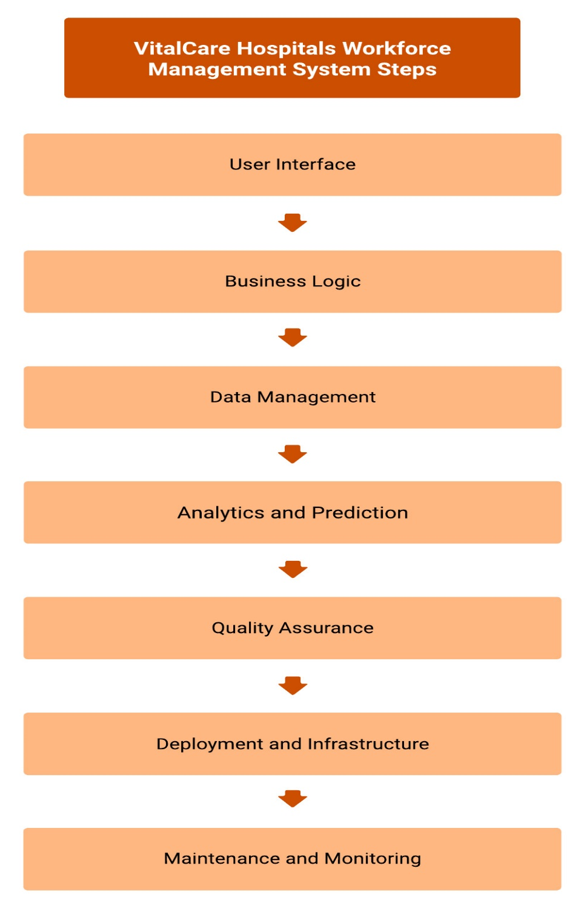

User Interface: This is the front-end of the system, providing a user-friendly interface for healthcare professionals and administrators. It includes web and mobile interfaces for easy interaction.

Business Logic: This layer contains the business logic, where staffing decisions, resource allocation, and data analysis occur. It is responsible for managing the core functionalities of the system.

Data Management: This layer manages the storage and retrieval of data.

* Patient Data: Contains historical patient admission data, electronic health records, and patient interaction information.
* Resource Data: Stores real-time data on patient inflow, staff schedules, and department-specific requirements.
* Equipment Data: Manages sensor data from medical equipment, maintenance logs, and historical failure data.

Analytics and Prediction: This layer processes and analyzes data to support various functionalities.

* Demand Forecasting: Utilizes machine learning algorithms for demand forecasting.
* Resource Allocation: Employs optimization algorithms, reinforcement learning, and decision trees for efficient resource allocation.
* Staff Performance Analysis: Utilizes classification, clustering, NLP, and sentiment analysis algorithms for staff performance evaluation.
* Predictive Maintenance: Employs anomaly detection, regression, and deep learning models for predicting equipment maintenance.
* Patient Flow Optimization: Uses optimization algorithms and simulation models for efficient patient flow.

Quality Assurance: This layer includes manual and automated testing components to ensure system reliability.

* Manual Testing: Involves human testers validating system functionalities.
* Automated Testing: Includes scripts and tools for automated testing.
* Real-time Data Analysis and Stress Testing: Ensures system performance under various conditions.
* Test-Driven and Behavior-Driven Development: Implement TDD and BDD practices to align with user requirements.

Deployment and Infrastructure: Manages system deployment and infrastructure.

* Cloud-based Solutions: Utilizes cloud infrastructure for handling data-intensive operations.
* Continuous Integration and Continuous Deployment: Facilitates real-time adjustments and monitoring during deployment.

Maintenance and Monitoring: Ensures consistent system performance over time.

* Regular Updates: Includes updates and enhancements, such as remote monitoring and consultations.
* Monitoring Tools and Analytics: Integrates monitoring tools and analytics for proactive measures and optimization.

THE MODEL FLOWMAP

This is an example flow map illustrating how automated staffing and efficient resource allocation can be achieved.

COMPARATIVE OUTCOMES ASSESSMENT

THE COMPARISION

Without BI Systems

Manual Staffing: Before implementing BI systems, VitalCare Hospitals relied on manual processes for staffing decisions. This manual approach did not consider dynamic factors like patient volume, staff availability, and specific qualifications needed for various roles.

Manual staffing decisions can also lead to inefficiencies, resulting in higher labor costs due to overstaffing or understaffing. These inefficiencies can strain the hospital's budget.

Inconsistent Staffing and Workforce Burnout: The hospital experienced inconsistent staffing patterns, leading to unpredictable workloads for healthcare professionals. The irregular distribution of workload contributed to staff stress and burnout. That can lead to increased staff turnover, which incurs recruitment and training costs.

Inefficient Resource Allocation: Resources, including medical equipment and personnel, were not consistently available when and where needed. This inefficiency hampered the hospital's ability to provide seamless patient care. Inefficient resource allocation and unpredictable staffing patterns can result in operational inefficiencies. This can lead to waste in terms of resources, including medical equipment and personnel.

With BI Systems

Automated Staffing: With the implementation of BI systems, VitalCare Hospitals now use predictive analytics and historical data to automate staffing decisions. This reduces labor costs by ensuring the right mix and number of clinical staff are available by considering patient volume, seasonal variations, and local health trends striking a balance between cost-effectiveness and high-quality patient care.

Predictable Staffing and Workforce Burnout Mitigation: BI systems enable the hospital to predict patient flow in real-time and adjust staffing levels during peak hours or unexpected surges. AI systems monitor work hours and staff-to-patient ratios, proactively addressing potential burnout. Reduced burnout can lead to lower staff turnover, saving on recruitment and training costs and maintaining an experienced workforce. By doing so, VitalCare Hospitals can achieve cost savings related to staff retention and enhanced operational efficiency.

Efficient Resource Allocation: Data-driven strategies based on historical data inform the daily allocation of resources, ensuring they are available when needed and reducing waste. This also allows for preparedness for unexpected surges in patients during pandemics or outbreaks.

Data-driven resource allocation reduces waste and enhances operational efficiency. Resources are allocated where and when they are needed, minimizing unnecessary expenses.

IMPACTS VARIOUS STAKEHOLDERS

Patients

Easy Appointment Scheduling: Allows patients to book, modify, or cancel appointments online.

Accessible Medical Records: Provides patients with secure access to their personal medical records.

Convenient Prescription Refills: Enables patients to request prescription refills online.

Healthcare Provider

Streamlined Patient Management: Helps providers efficiently organize and track patient information.

Comprehensive EHR Integration: Centralizes patient data, ensuring accurate and up-to-date records.

Video Conferencing Tools: Facilitates seamless communication between healthcare providers via video, audio, and recordings.

Hospital Administration

Integrated Financial Management: Consolidates billing, accounting, and financial reporting.

Staff Scheduling and Management: Streamlines the process of creating and updating staff schedules.

Real-Time Performance Analytics: Monitors key performance indicators for informed decision-making.

Pharmacy Department

Inventory Management: Tracks and optimizes pharmacy stock levels.

Drug Interaction Alerts: Warns pharmacists of potential drug interactions.

Automated Refill Reminders: Sends reminders for medication refills to patients.

Hospital Human Resource Department

Employee Database Management: Maintains up-to-date employee information and records.

Automated Payroll Processing: Streamlines salary calculations and disbursements.

Training and Development Tracking: Monitors employee training progress and certifications.

Finance & Billing

Automated Invoicing: Generates invoices and tracks payments automatically.

Insurance Claims Management: Streamlines the insurance claim submission and approval process.

Budgeting and Cost Analysis: Helps in financial planning and resource allocation.

CONCLUSION

VitalCare Hospitals' strategic adoption of data-driven healthcare management has delivered significant enhancements across multiple aspects of their operations. By leveraging predictive analytics and automation, they have achieved notable improvements in patient care quality, workforce management, and resource allocation. Patients have gained access to streamlined appointment scheduling and secure medical records, while healthcare providers now benefit from more efficient patient management and integrated electronic health records. The hospital administration has experienced improved financial management and staff scheduling, while the pharmacy department has optimized inventory control. Additionally, HR and finance and billing departments have streamlined processes, making this data-driven approach a remarkable success in optimizing healthcare delivery and operational efficiency.