|  |  |  |
| --- | --- | --- |
| Description: Description: SVS COLLEGE 17TH New | **SREE VENKATESWARA COLLEGE OF ENGINEERING**  NAAC ‘A’ Grade Accredited Institution,  An ISO 9001:: 2015 Certified Institution  (Approved by AICTE, New Delhi and Affiliated to JNTU,Anantapur) Northrajupalem (Vi), Kodavaluru(M) , S.P.S.R Nellore (Dt)-524316 |  |

**INTEL UNNATI TRAINING PROGRAM**

**TITLE:DESIGN AND IMPLEMENTATION OF AUTOMATED TELLER MACHINE(FSM) CONTROLLER**

BLOCK DIAGRAM:

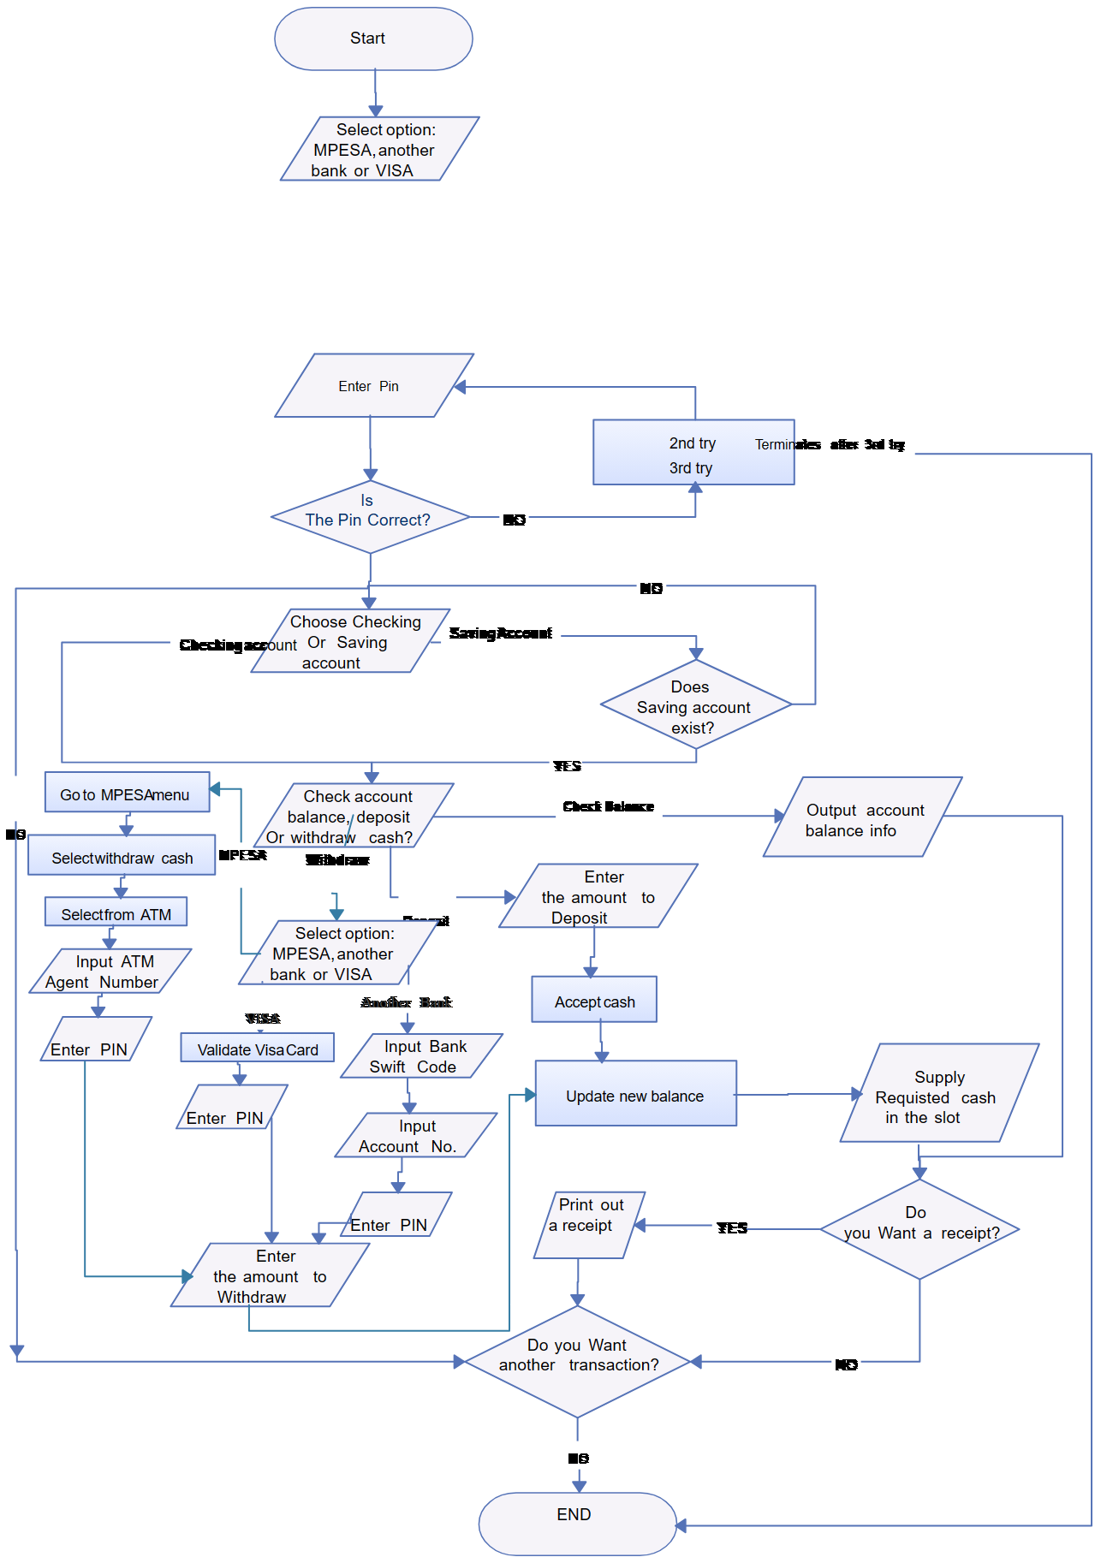

The designed ATM controller FSM should perform the following checks

• Invalid PIN entry (3 times allowed and later it should lock the account for next 24 hours)

• Withdraw

• Deposit

• Old balance and new balance display

• Mini statement for the recent transactions

**Done By: MENTOR**

Team Name: TECH PIRATES Mr. R. Prapulla Kumar

N. Sathya Sai Keerthana Assistant Professor

M. Hema Latha Department of CSE

B. Lakshmi Thanuja