DESIGN AND IMPLEMENTATION OF AUTOMATED TELLER MACHINE (FSM) CONTROLLER – REPORT

**BY TECH-PIRATES TEAM**

# **INTRODUCTION:**

The purpose of this report is to document the implementation and functionality of an ATM Machine Finite State Machine (FSM). The report aims to provide a comprehensive understanding of how the FSM controls the operation of the ATM and handles various transactions such as withdrawals, deposits, balance inquiries, and mini statements. It serves as a documentation of the code implementation, explaining the states, transitions, inputs, outputs, and behaviours of the FSM. Additionally, the report includes a description of the testbench used to verify the functionality of the ATM Machine FSM and presents simulation results for different test scenarios.

The ATM Machine FSM (Finite State Machine) plays a crucial role in controlling the operation of an Automated Teller Machine (ATM). It provides a systematic and organized approach to manage the different states and transitions within the ATM, ensuring proper functionality and user experience. Here are some key reasons for the importance of the ATM Machine FSM:

* State Management
* Transaction Handling
* Error Handling
* User Interface Control
* System Integrity and Security
* Maintainability and Extensibility

The goal of this report is to provide a comprehensive documentation of the implementation and functionality of the ATM Machine Finite State Machine (FSM). The report aims to explain the structure and behaviour of the FSM, including the states, transitions, inputs, outputs, and their significance in controlling the operation of the ATM.

# **ATM:**

ATMs, as known today, are based on a computer system with microprocessor or other programmatic components, with data storage such as Hard disks or semi- conductor memories, as well as special peripherals, such as monitors, cash boxes, card readers, etc., which are operated by industry-specific software. ATMs today are regularly networked with other computers and may also be connected to additional hardware such as local monitoring units such as sensors and cameras, or to server-based network-connected control systems

The designed ATM controller FSM should perform the following checks

* Invalid PIN entry (3 times allowed and later it should lock the account for next 24 hours)
* Withdraw
* Deposit
* Old balance and new balance display
* Mini statement for the recent transactions

**Software Installation:**

Link: <https://www.intel.com/content/www/us/en/software-kit/665990/intel-quartus-prime-lite-edition-design-software-version-18-1-for-windows.html>

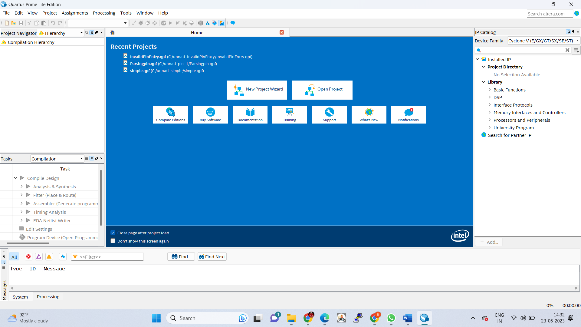

# **STEPS TO IMPLEMENT AUTOMATED TELLER MACHINE:**

* ANALYSIS AND SYNTHESIS:

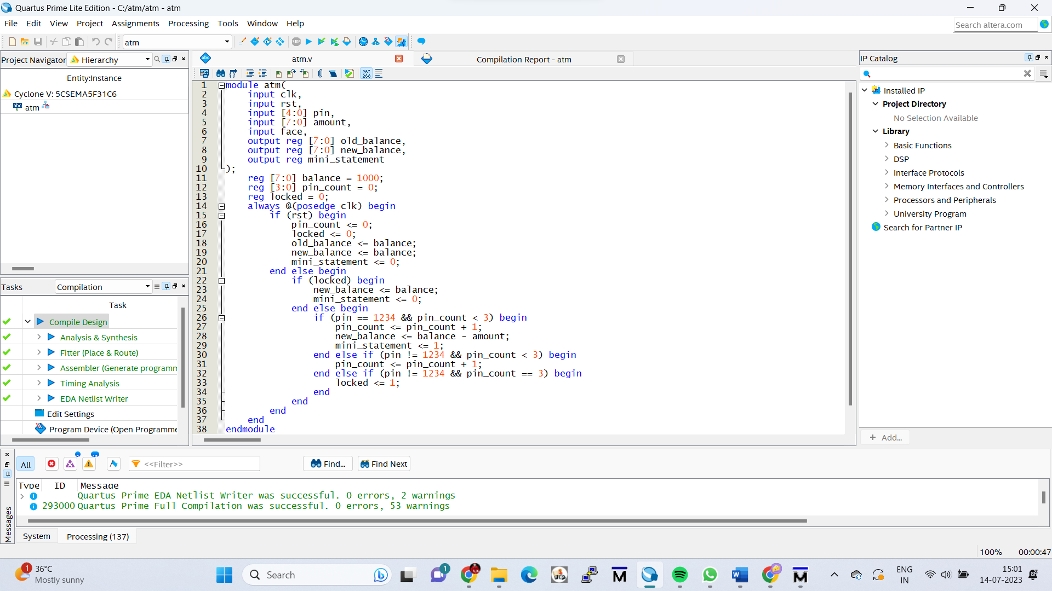

* RTL SIMULATION:

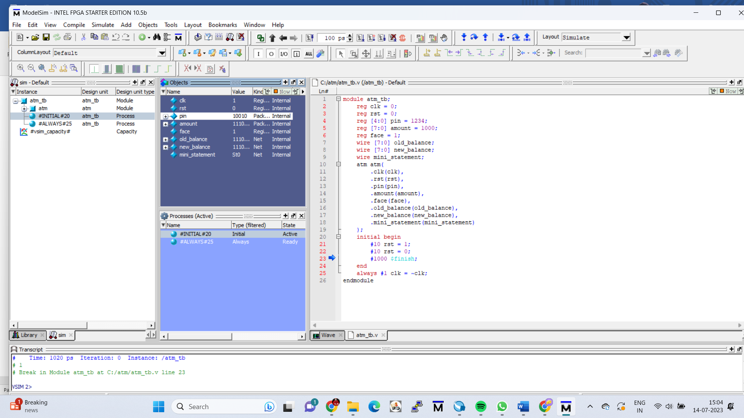

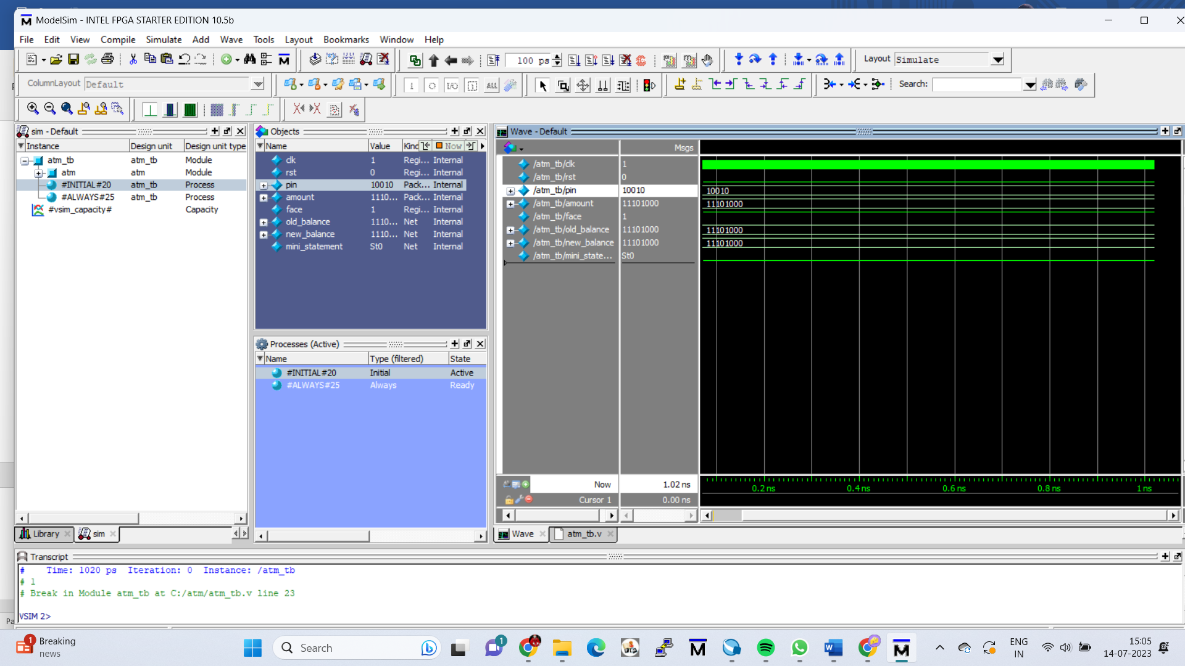

* RTL VIEWER:

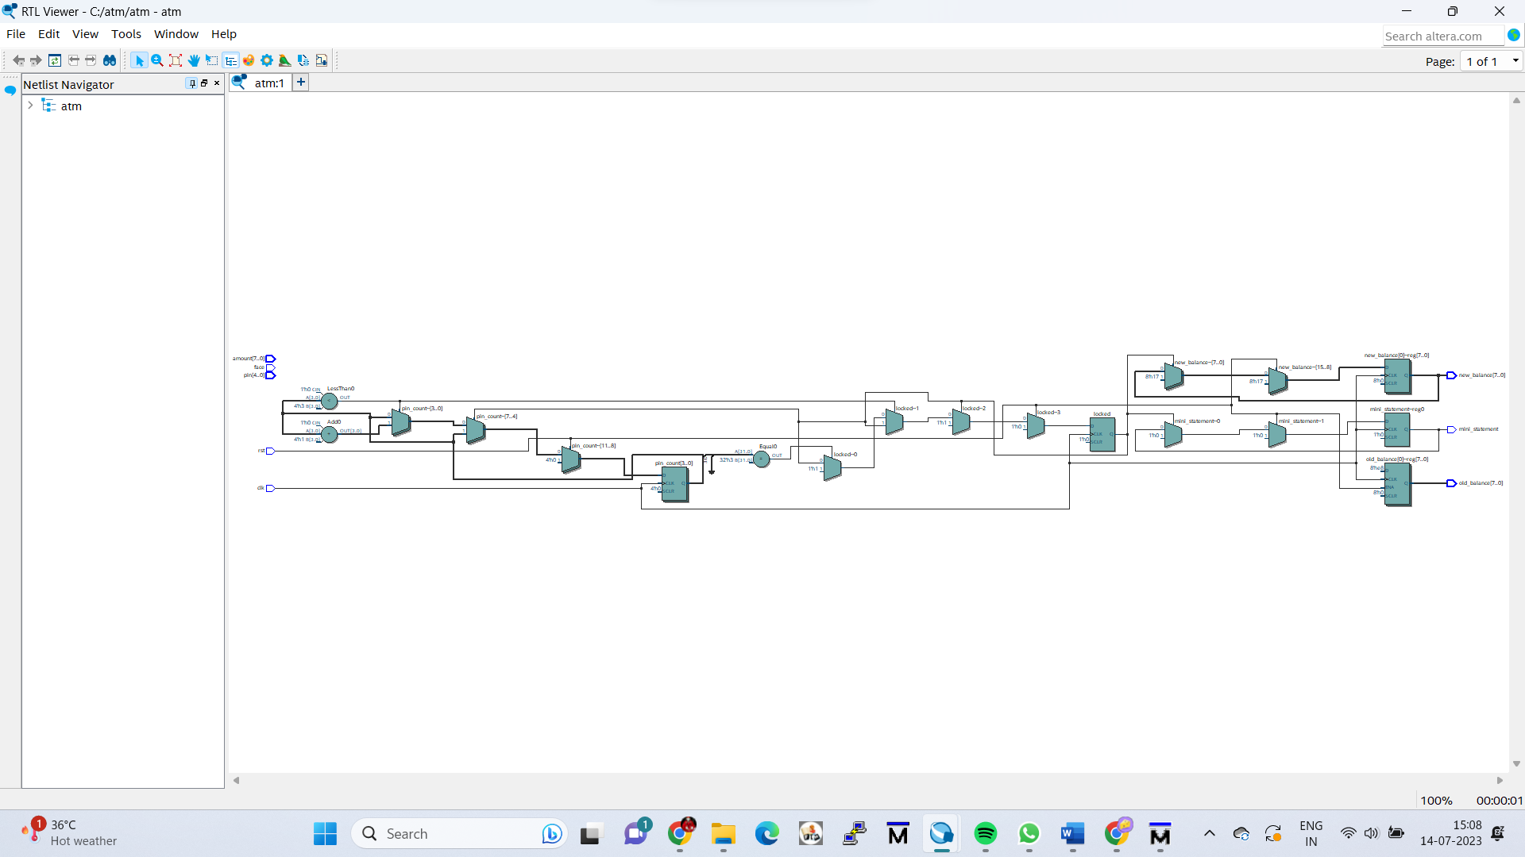

* TECHNOLOGY MAP VIEWER (POST-MAPPING):

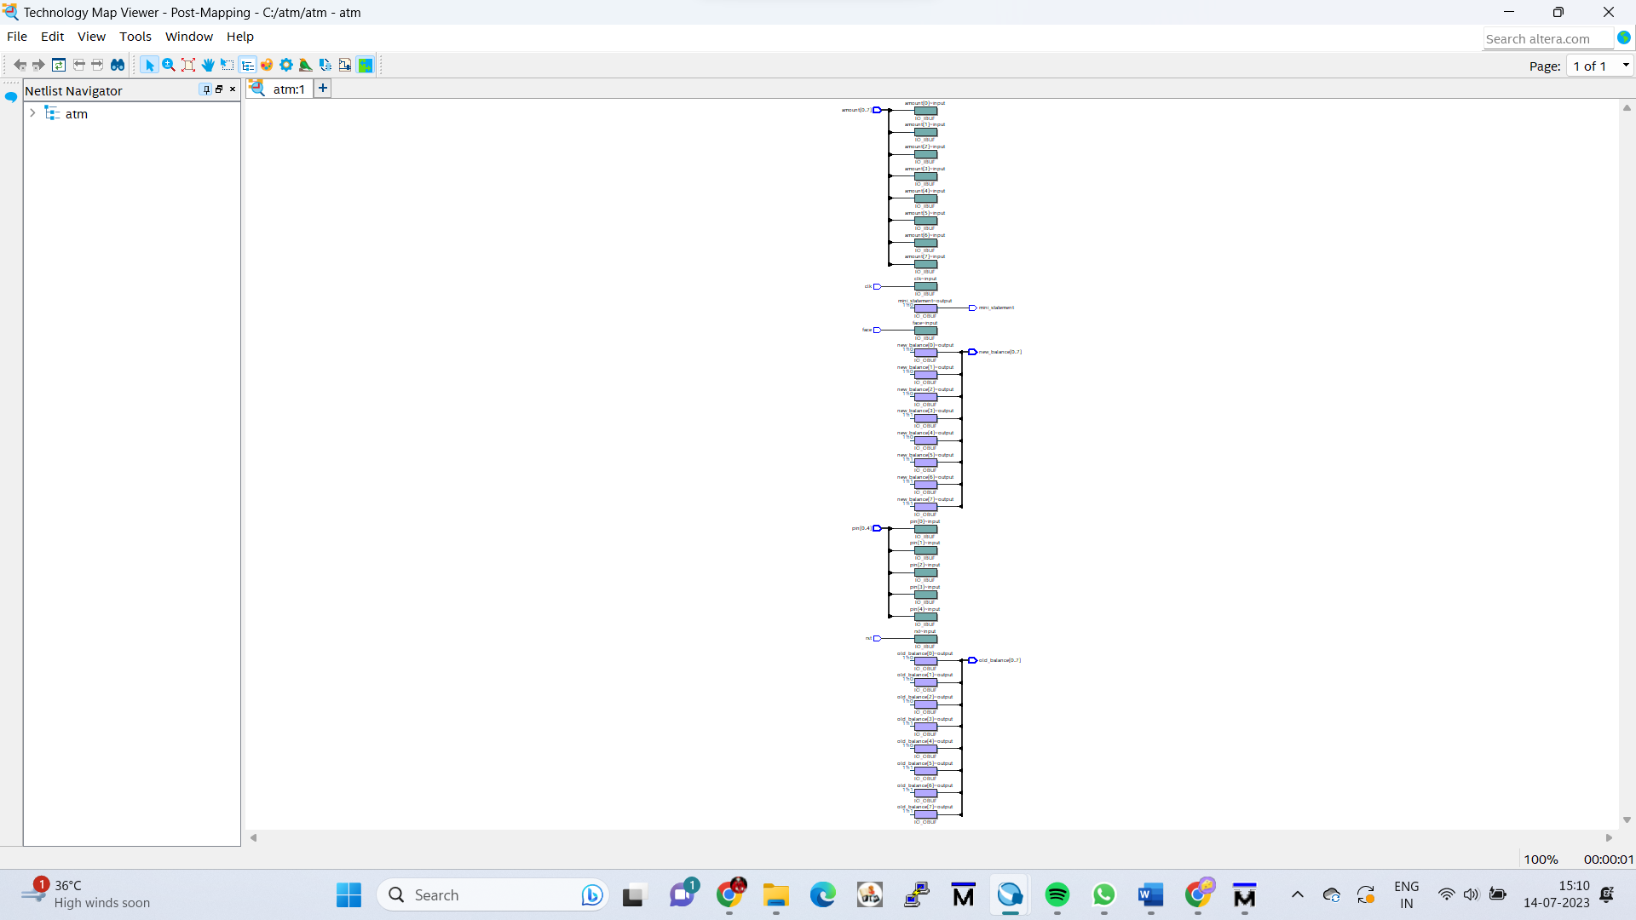

* TECHNOLOGY MAP VIEWER (POST-FITTING)

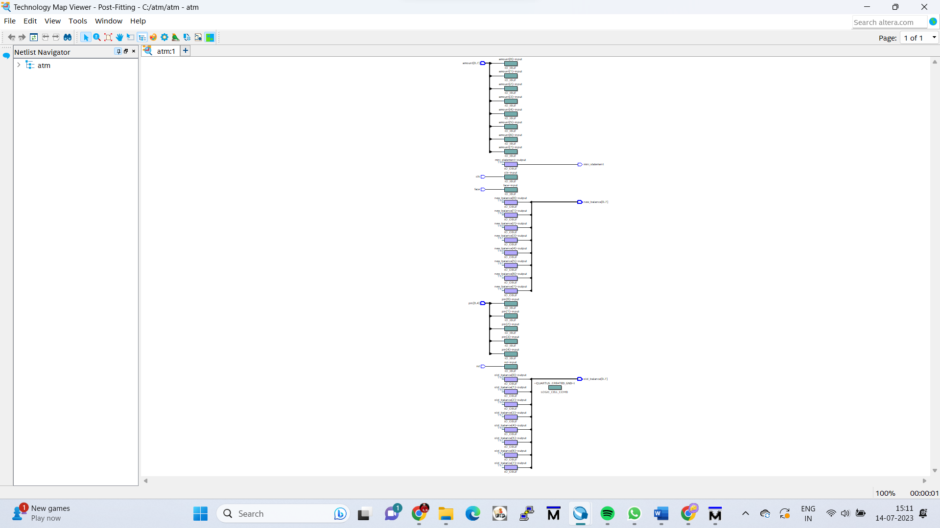

* STATE MACHINE VIEWER:

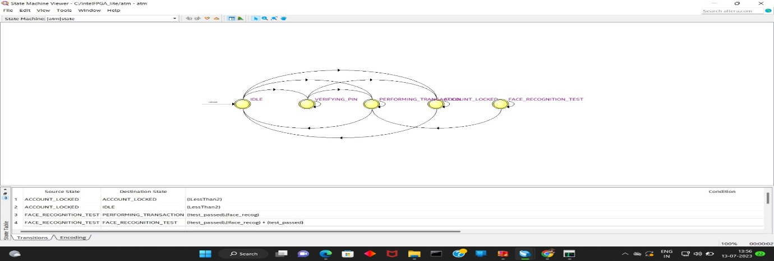

* CHIP PLANNER:

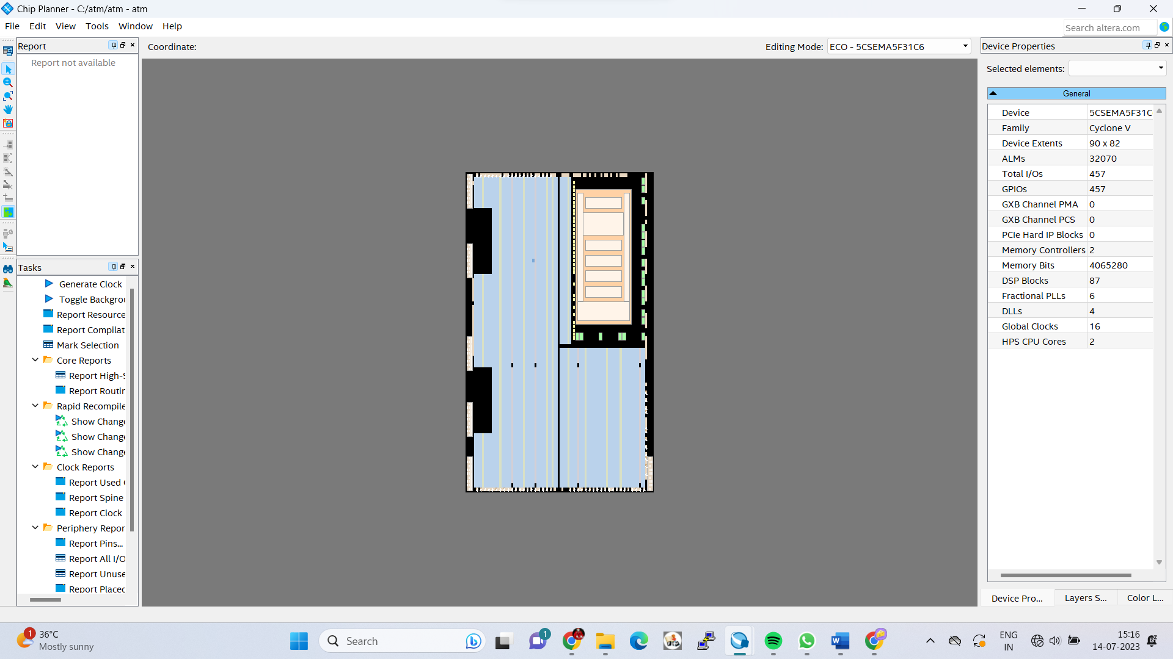

* PIN PLANNER:

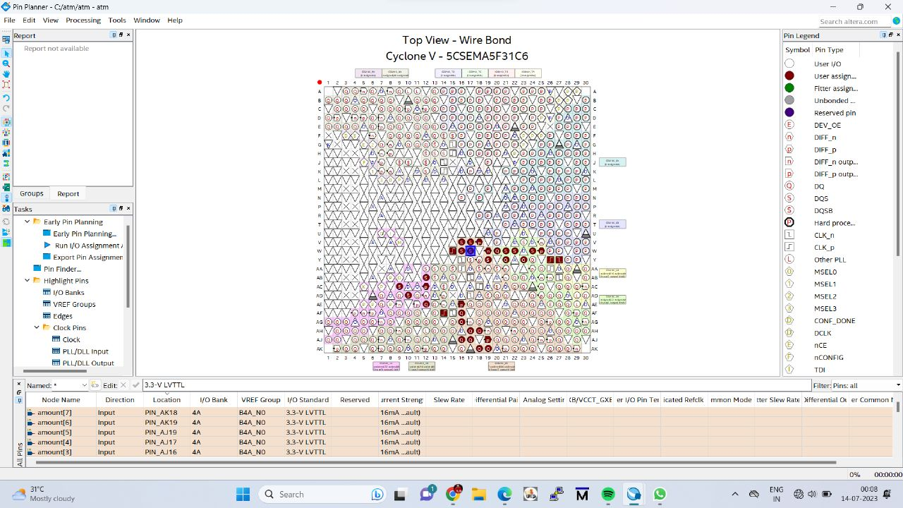

* FILE UPLOADING AT INTEL FPGA LABORATORY

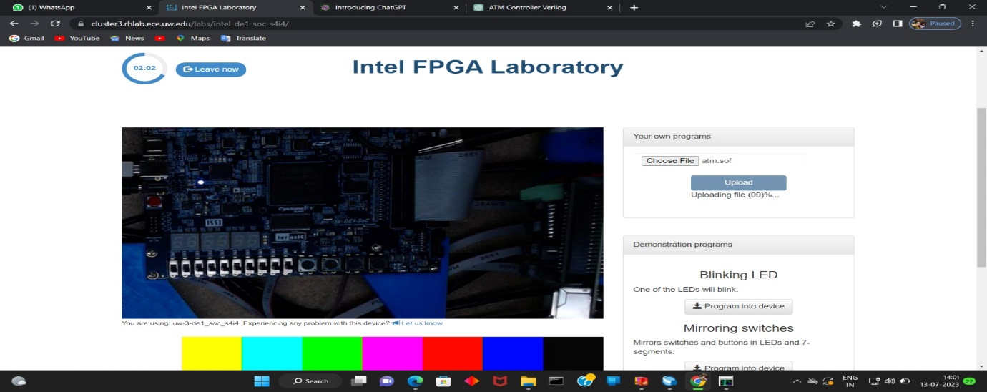

* PROGRAMMING THE DESIGN

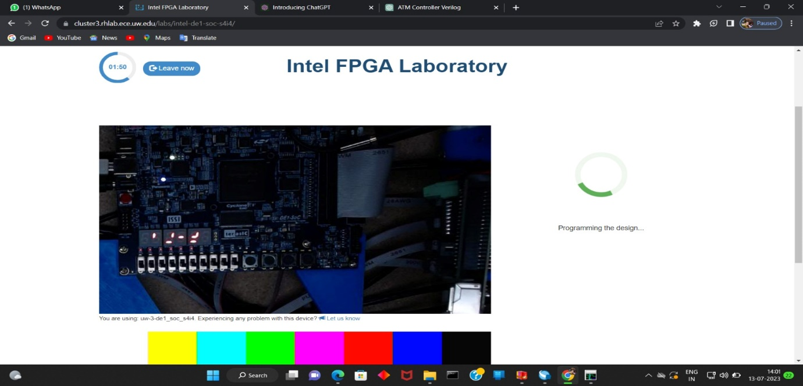

**Done By: MENTOR**

Team Name: TECH PIRATES Mr. R. Prapulla Kumar

N. Sathya Sai Keerthana Assistant Professor

M. Hema Latha Department of CSE

B. Lakshmi Thanuja