# ARCHITECTURE:

## PEER-TO-PEER NETWORK



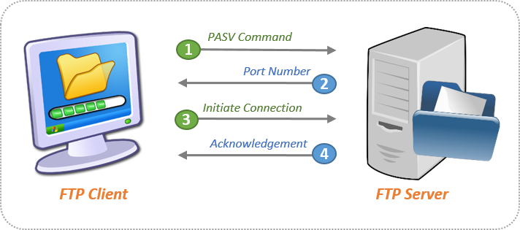

FTP SERVER:

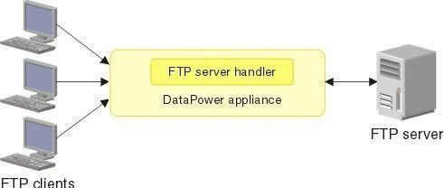

1

File transfer protocol is a way to connect two computers to one another in the safest possible way to help transfer files between two or more points. To put it simply, it’s the means by which files are securely shared between parties.

File Transfer Protocol (FTP) is the standard mechanism provided by TCP/IP for copying a file from one host to another.

Although transferring files from one system to another seems simple and straightforward.

Before transferring, some problems must be dealt with first, such as: two systems may use different file name conventions.

Two systems may have different ways to represent text and data. Two systems may have different directory structures.

All of these problems have been solved by FTP in a very simple and elegant approach.

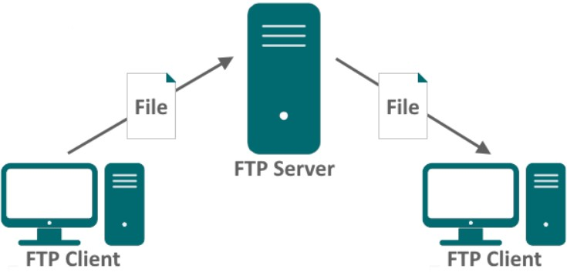

# DEVICES USED in CISCO PACKET TRACER

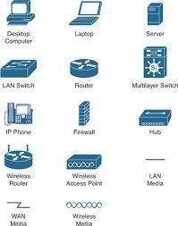

1

# NETWORK DESIGN:

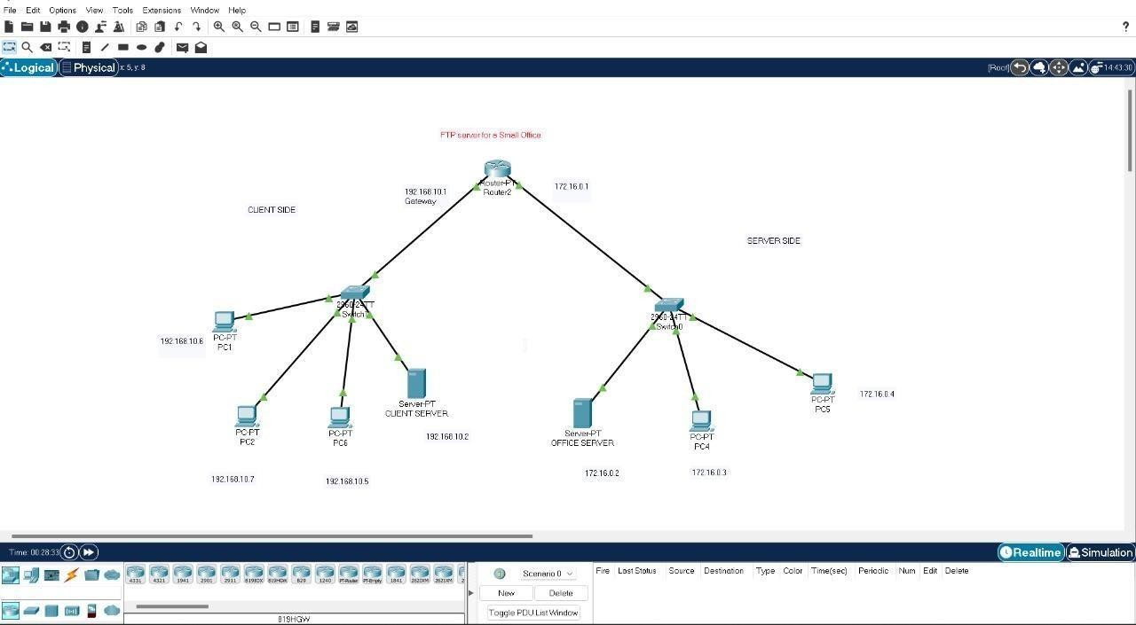

## Maximum CLient Side User -

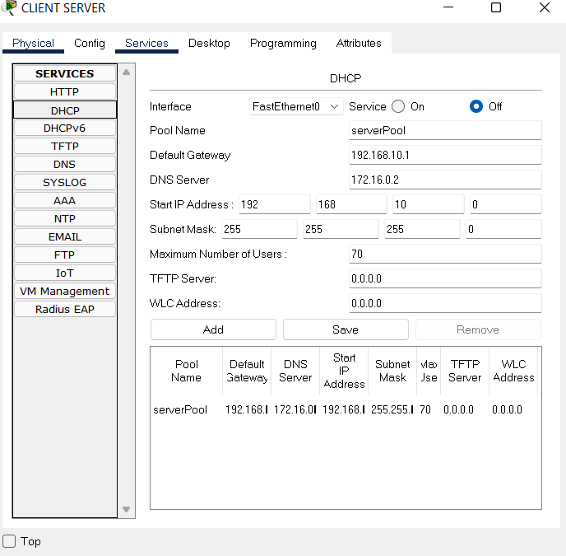

**Maximum Server Side user -**

