# IMPLEMENTATION

## IP CONFIGURATION

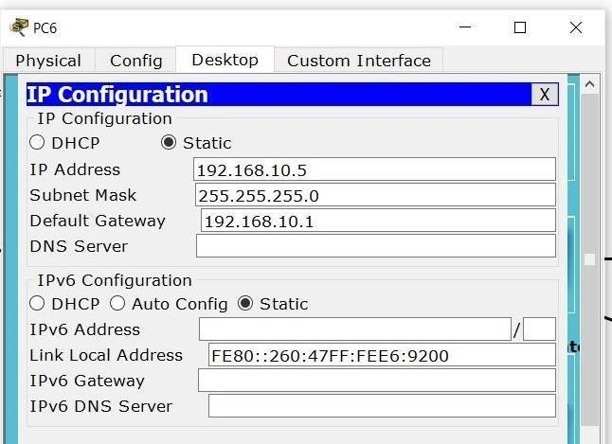

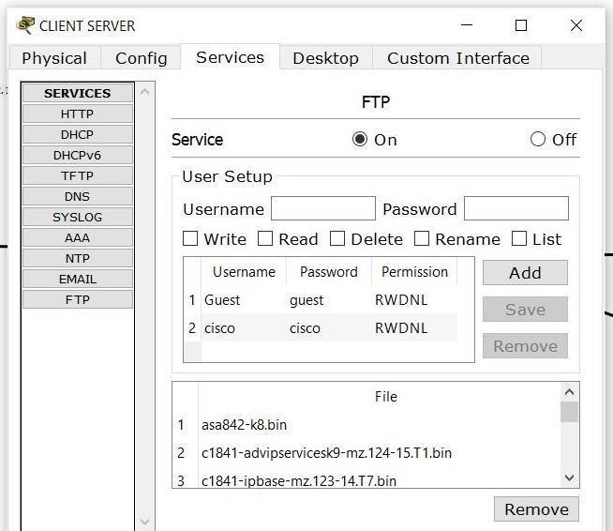

**ping the servers -**

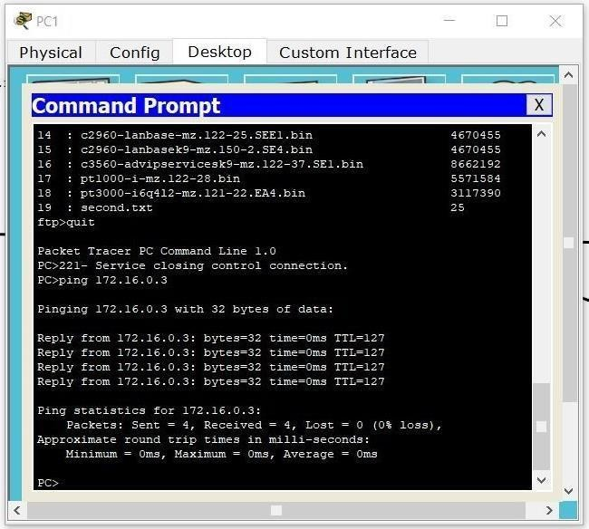

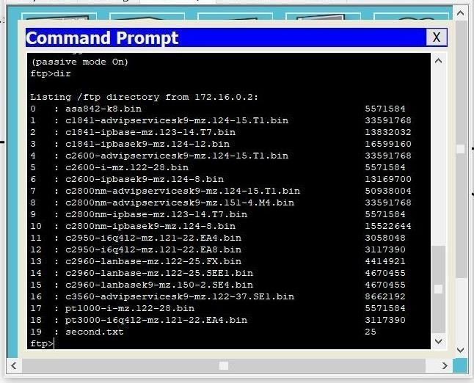

1

## Transfer A file to the server

|  |  |  |  |  |  |
| --- | --- | --- | --- | --- | --- |
| Server side | 172.16.0.  2 | 255.255.2  55.0 | 172.16.0.1 | FTP/HTTPS/ DNS/DHCP | TTL-127  ms/RTT-0s |
|  |  |  |  | etc |  |
| Client side | 192.168.  10.2 | 255.255.2  55.0 | 192.168.10  .1 | FTP only | TTL-255ms/RT  T-1 ms |
| PC 6 | 192.168. | 255.255.2 | 192.168.10 | FTP only | TTL-255ms/RT |
|  | 10.5 | 55.0 | .1 |  | T-1 ms |
| PC 1 | 192.168. | 255.255.2 | 192.168.10 | FTP only | TTL-255ms/RT |
|  | 10.6 | 55.0 | .1 |  | T-1 ms |
| PC 2 | 192.168. | 255.255.2 | 192.168.10 | FTP only | TTL-255ms/RT |
|  | 10.7 | 55.0 | .1 |  | T-1 ms |
| PC 4 | 172.16.0.  3 | 255.255.2  55.0 | 172.16.0.1 | FTP/HTTPS/ DNS/DHCP | TTL-127  ms/RTT-0s |
|  |  |  |  | etc |  |

**FTP Server:**

## entering login details and sending .txt file into client server

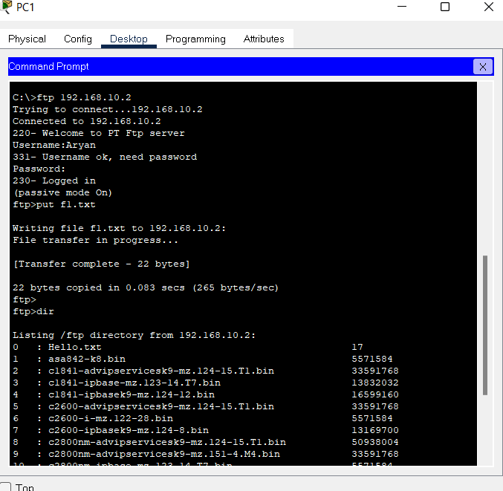

**Server Get Request -**

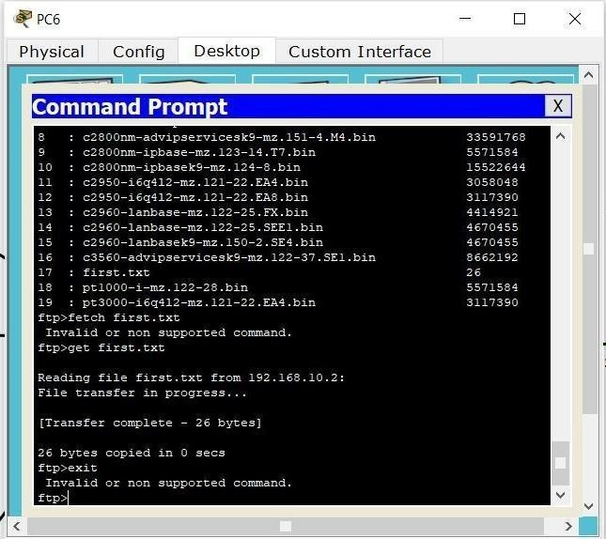

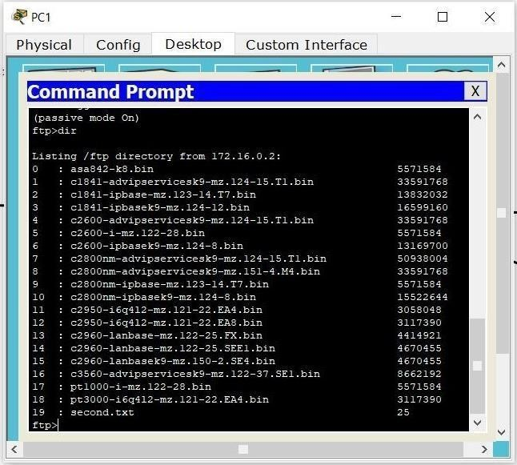

# EXPERIMENT RESULTS & ANALYSIS

## Result:

Extracting files from client side server to pc 5

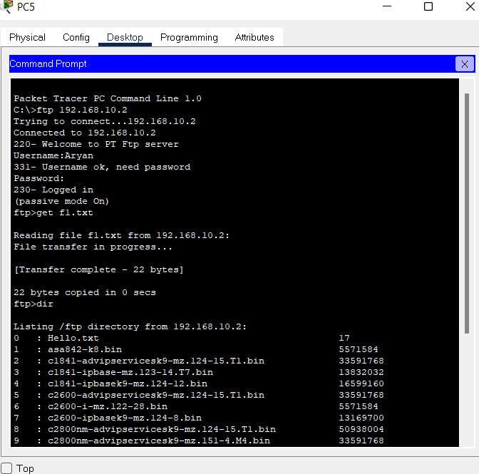

Checking if f1 file was downloaded in pc 5

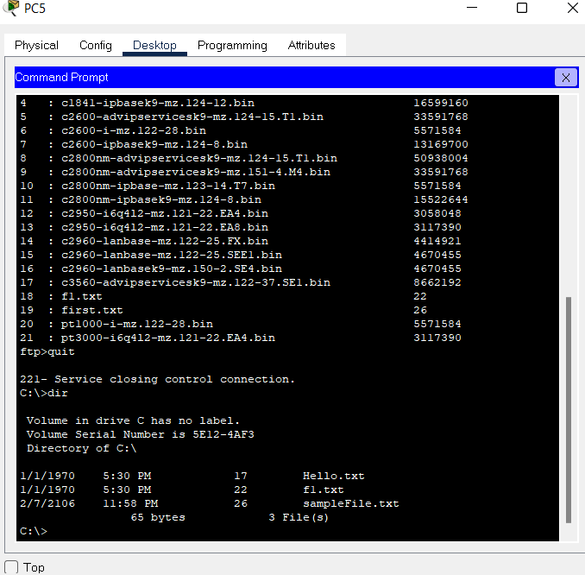

Checking file f1 in server side server -

