AWS

Step 1:(Console>Home)

Choose region as Asia Pacific(Mumbai)

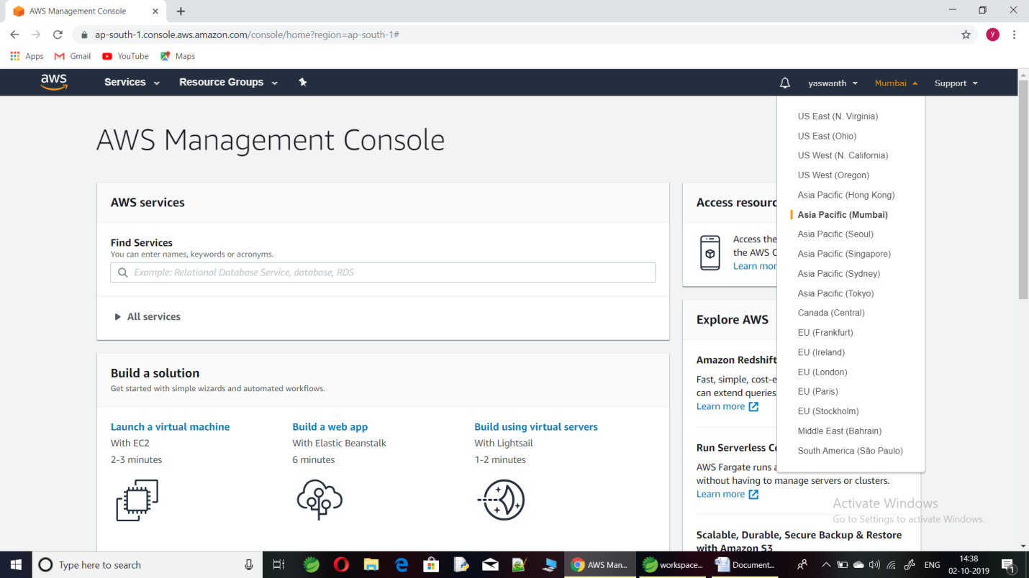

Step 2:

Go to service and search Amazon Elastic Compute Cloud(EC2).

EC2:

It is a platform which is allow to rent Virtual Computer in which run their own application.

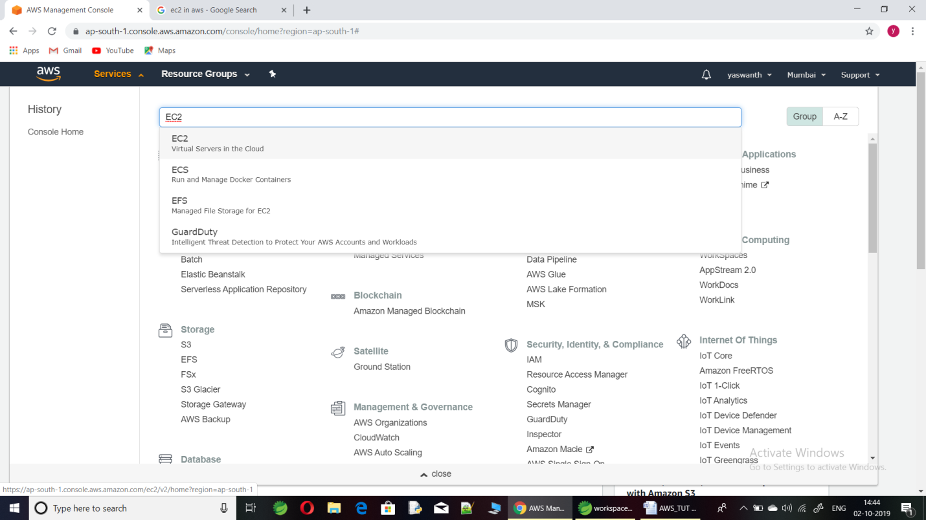

Step 3:(Create instance)

Click launch instance button.

Used for launch Virtual Server.

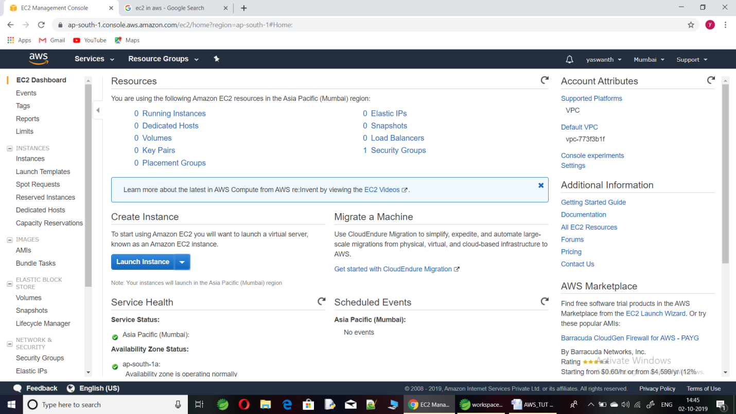

Step 4:

Amazon Machine Image(AMI) is template and it contains software configuration.

Choose Free tier eligible => Default images(Java,MySQL,etc).

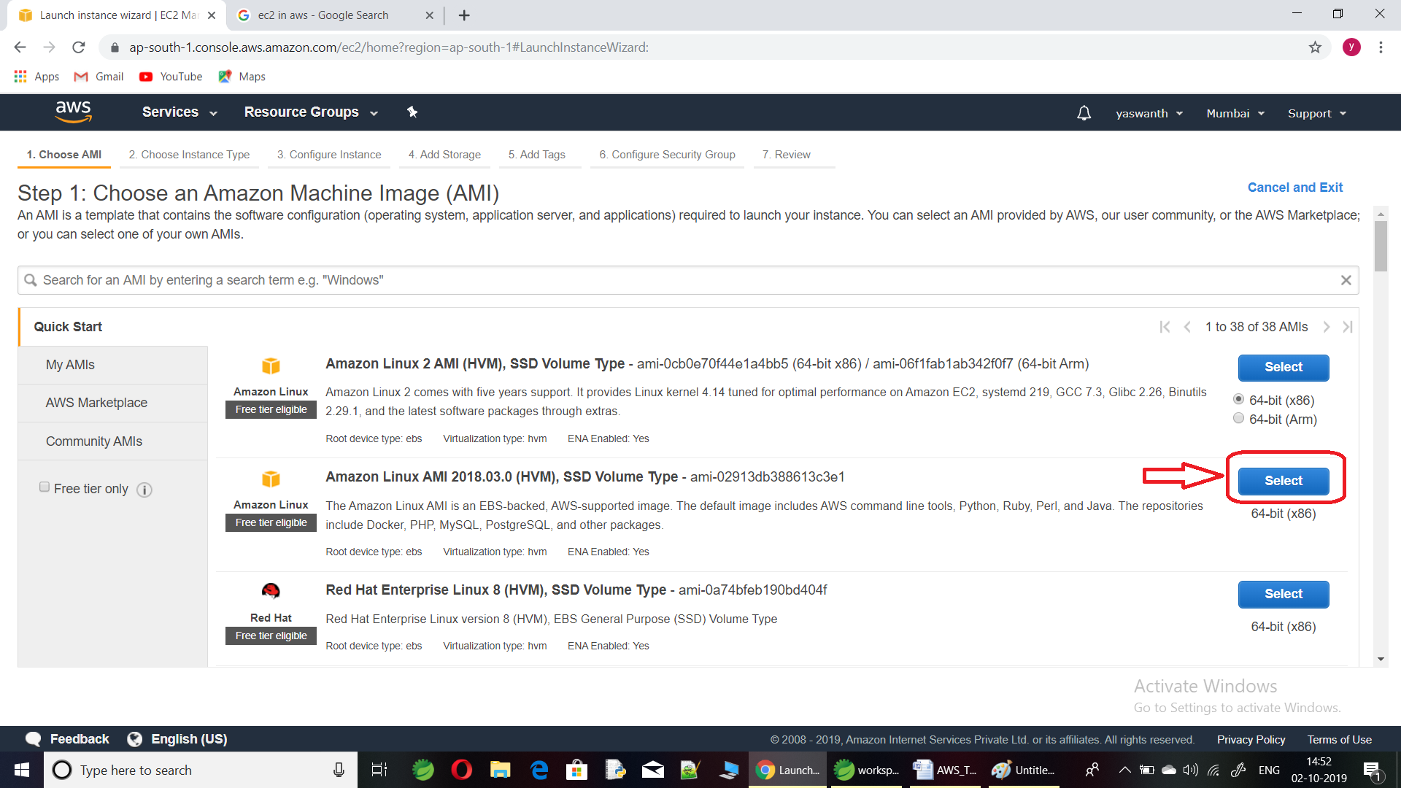

Step 5:

Choose Instance Type as **free tier eligible** and click **Review and Launch** button.

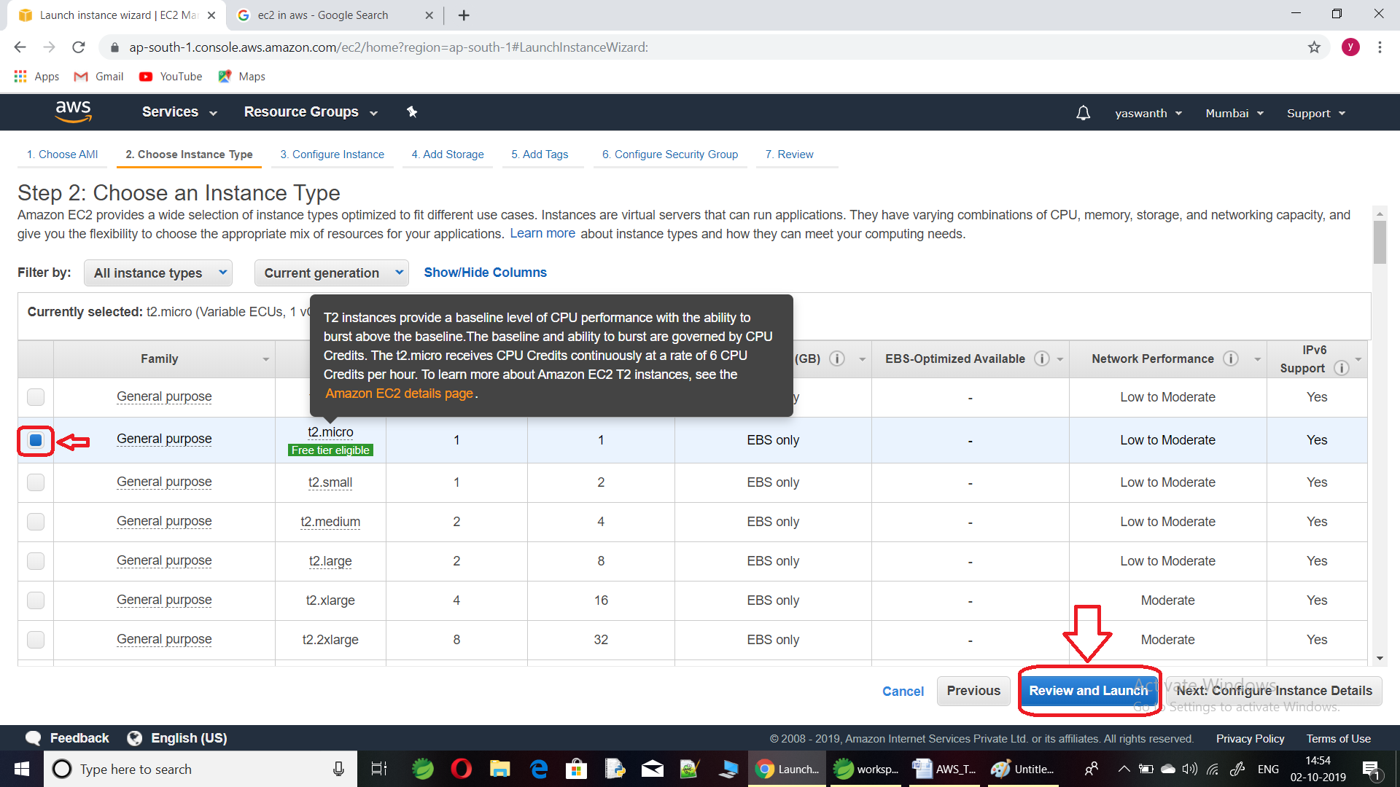

Step 6:

Click **Launch** button.

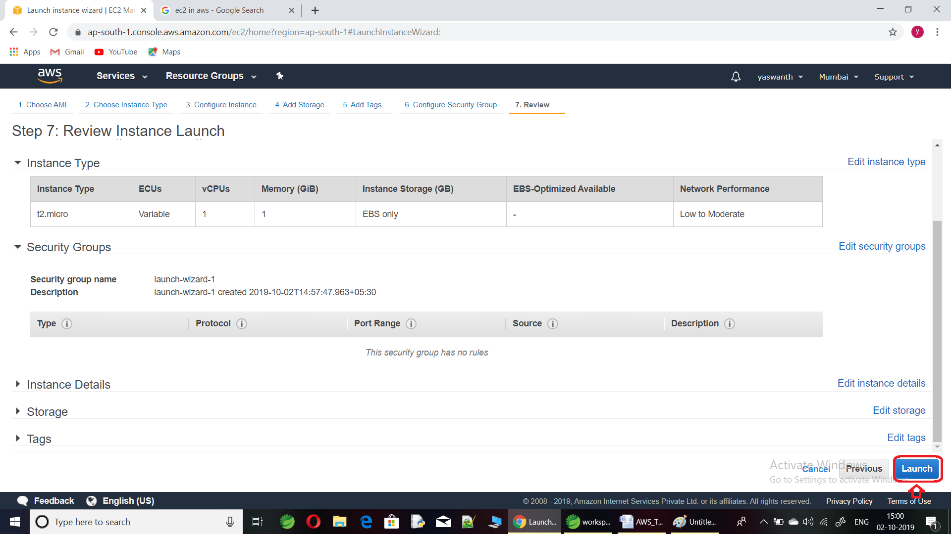

Step 7:

Choose create new pair and give any key pair name.

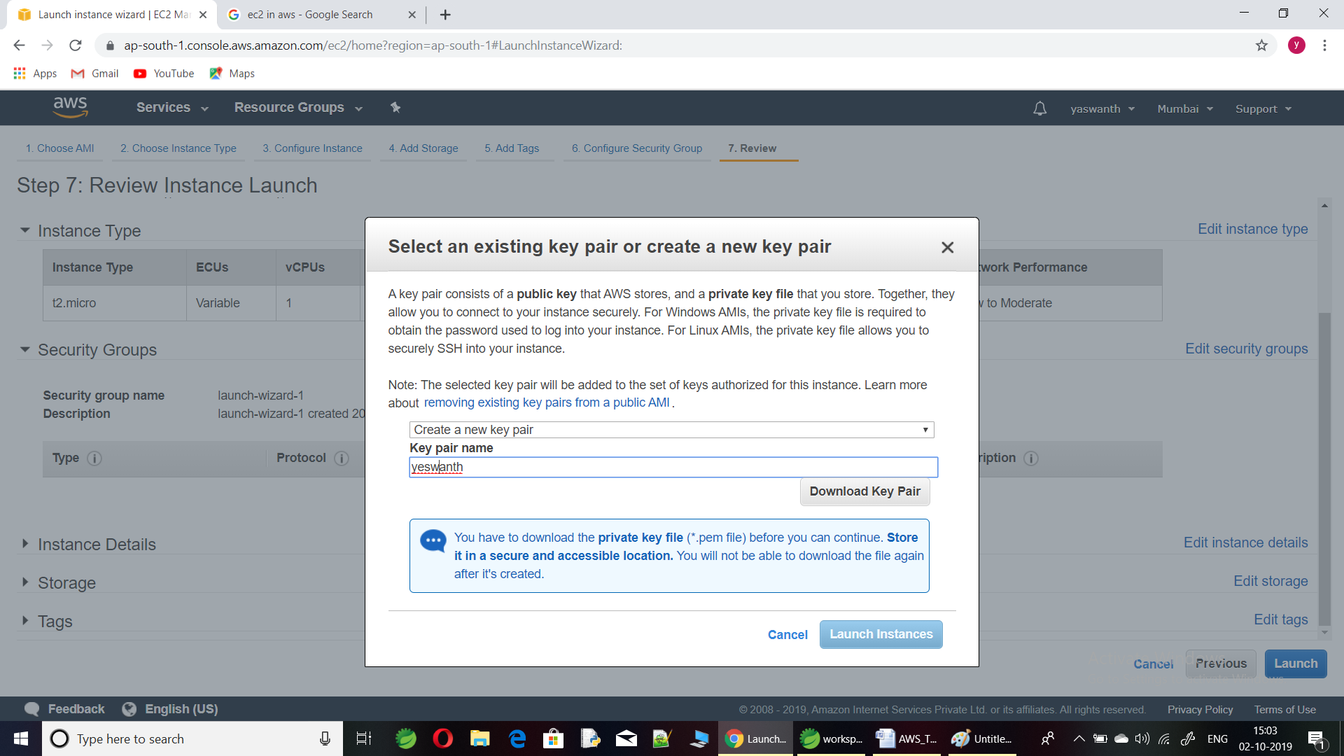

Step 8:

Then download key pair and then **Launch Insatance**.

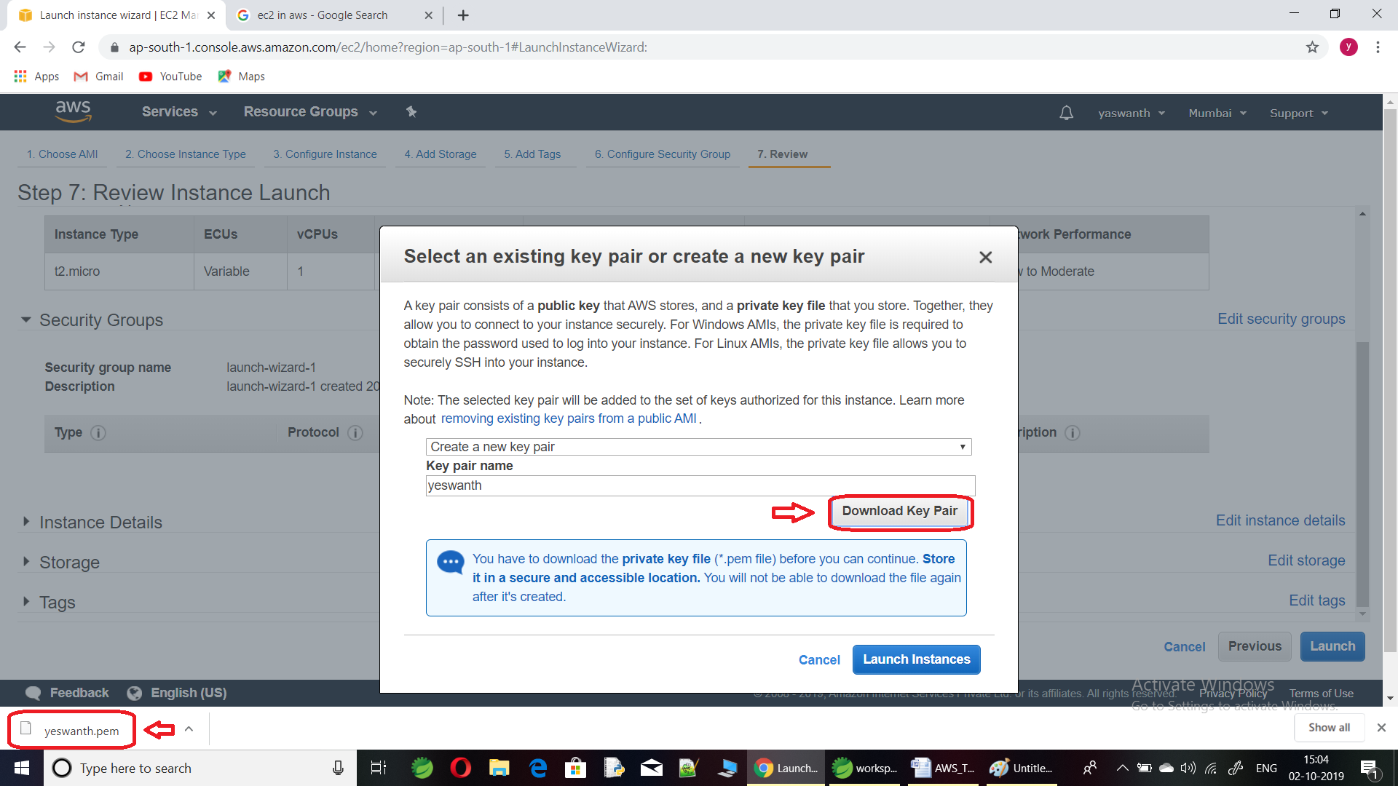

Step 9:

Check launch status and click link shown in image.

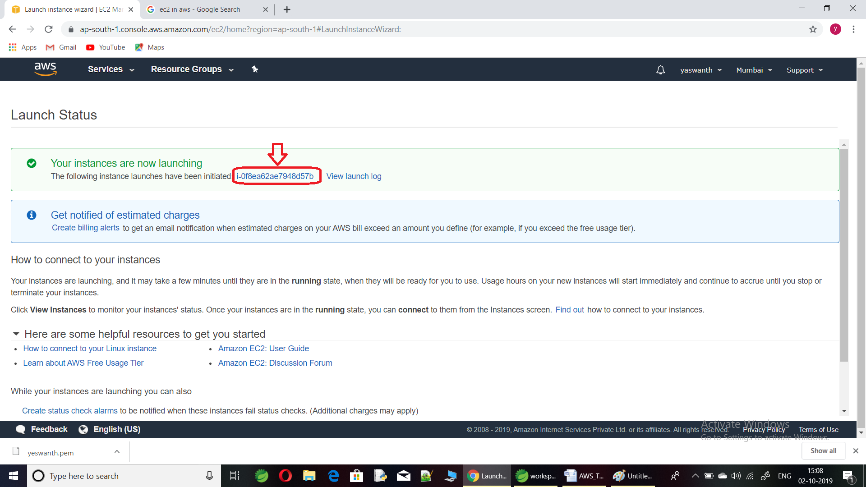

Step 10:

Edit name show in image.

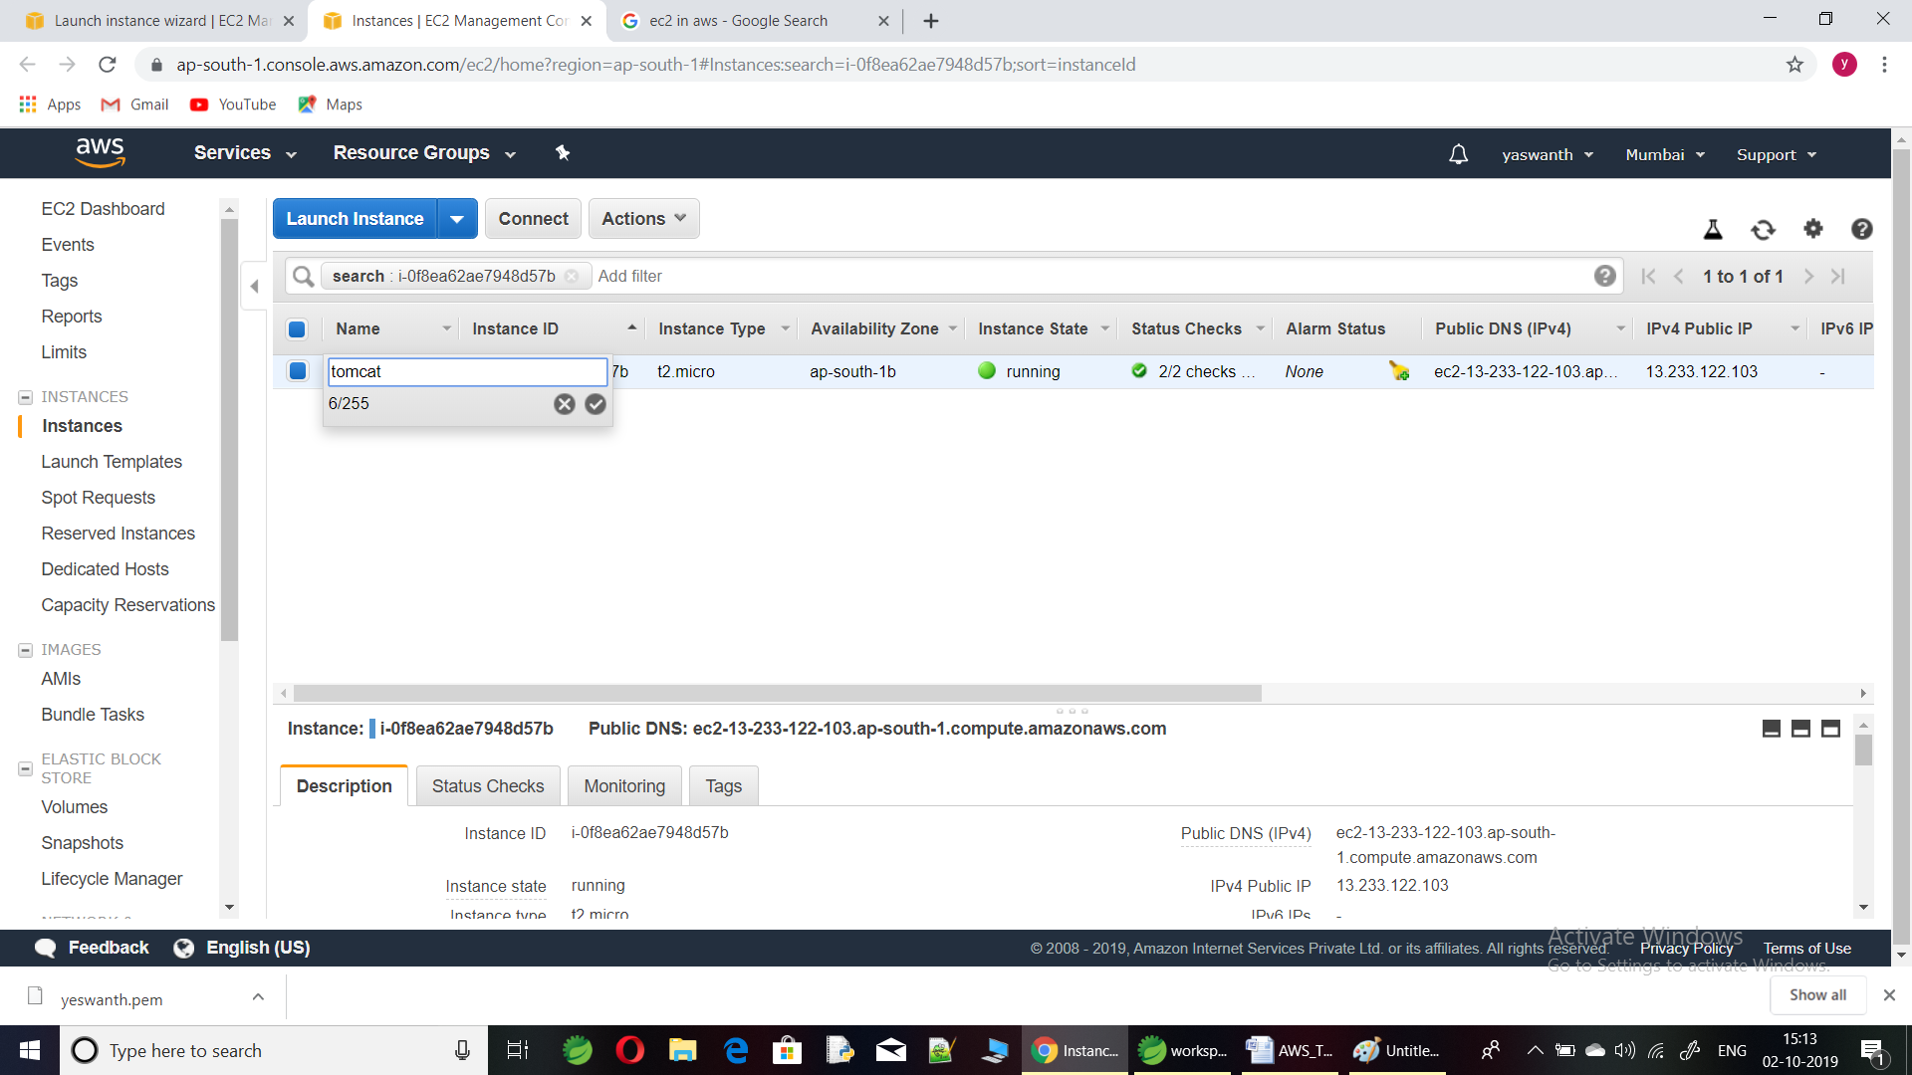

Step 11:

Copy the Public DNS.

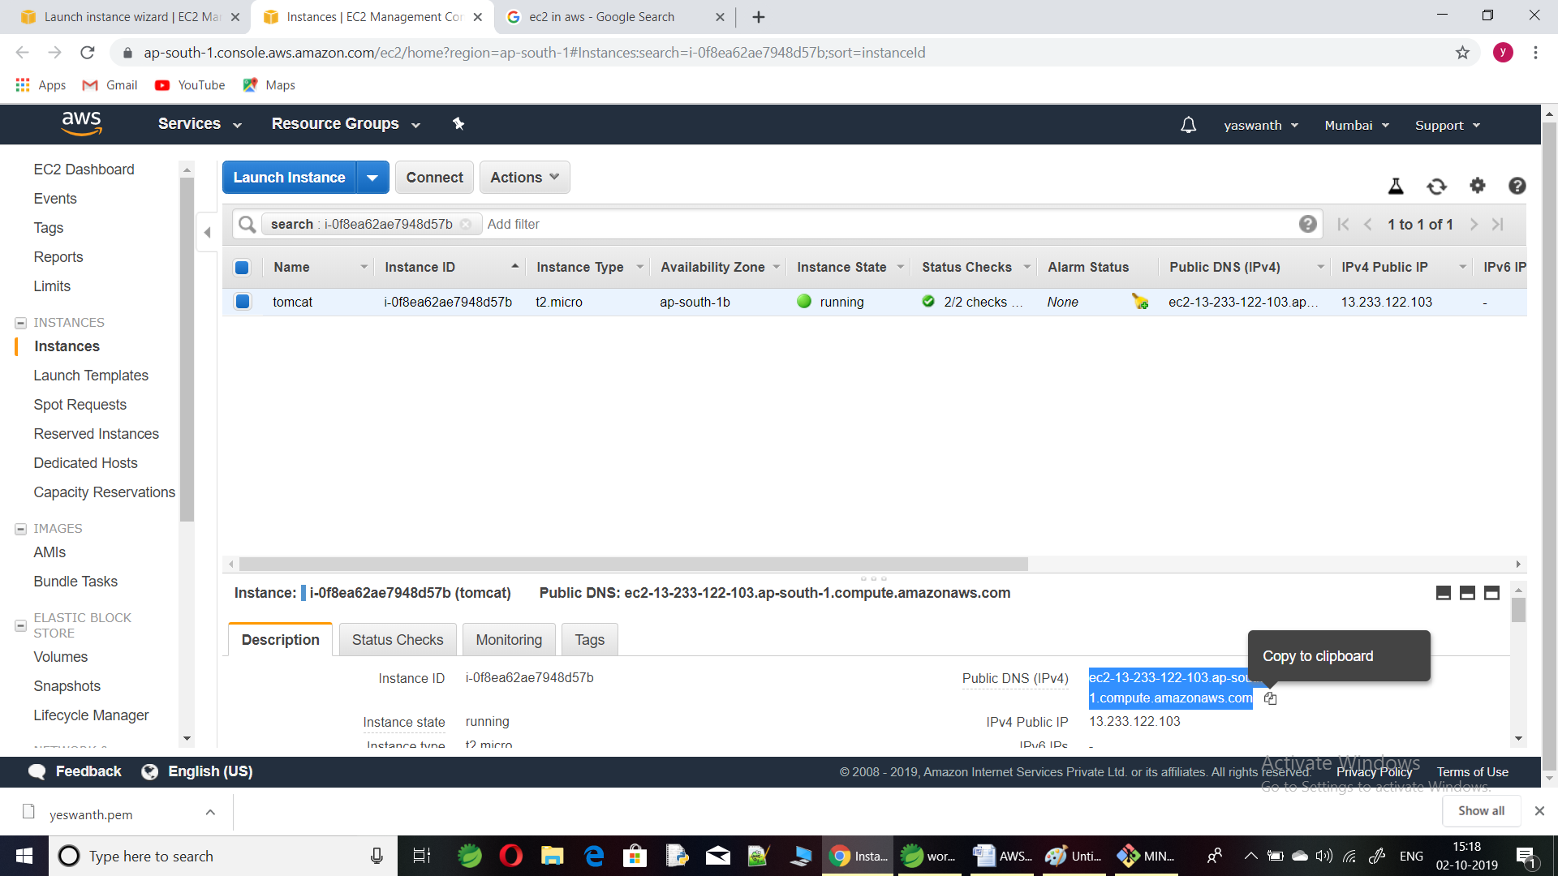

Step 12:

Open cmd or gitbash.

CMD>ssh –i “keypair_name.pem” ec2-user@Public DNS IP4

Are you sure you want to continue connecting (yes/no/[fingerprint])?yes