**Created a map that displays a point for every city in the city_data_df -  Data Frame. The size of the point should be in the humidity in each city.**

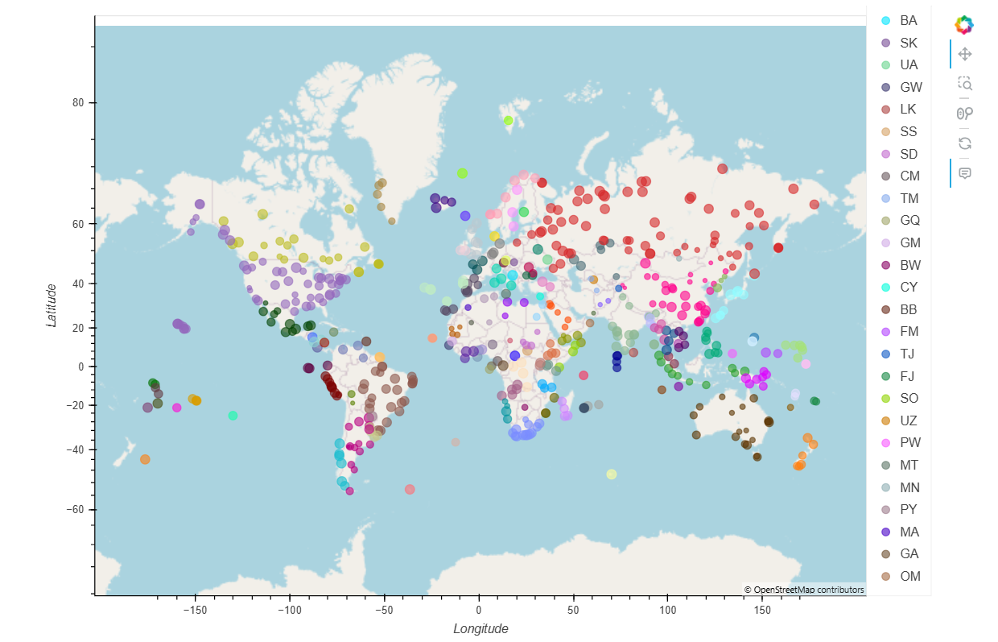

Figure 1

**Information for each city in the Hotel map.**

