## CS5346 Task B1- Visualization with Tableau

**Student Name: Sreelakshmi Edakulathil Chellappan**

**Matriculation Number: A0268357N**

**Tableau Link:** [**Link**](https://public.tableau.com/views/NetflixDataAnalysisusingTableau/Top10genres?:language=en-GB&:sid=&:display_count=n&:origin=viz_share_link)

### **Introduction**

We will be using Tableau to analyze a comprehensive Netflix Dataset that includes information about movies and TV shows spanning several years. Netflix is a highly popular media and video streaming platform, boasting a vast library of over 8,000 titles. As of mid-2021, the platform has garnered a massive subscriber base of over 200 million users worldwide. By delving into this dataset, our objective is to thoroughly examine and visualize different facets of Netflix's content catalog, ultimately uncovering valuable insights about this prominent streaming platform.

### **Dataset**

1. **Data Origin:** The dataset used in this analysis is the Netflix Movies and TV Shows dataset sourced from Kaggle. (Link: [Netflix Dataset](https://www.kaggle.com/datasets/shivamb/netflix-shows))
2. **Dataset Contents**: This tabular dataset consists of listings of all the movies and tv shows available on Netflix, along with details such as - cast, directors, ratings, release year, duration, etc.

I chose this dataset to explore trends in content type, viewer engagement through ratings, and popular genres on Netflix. Understanding these insights can help us:

* Identify viewer preferences: By analyzing rating distribution and popular genres, we can understand what types of content resonate most with viewers.
* Predict future trends: By observing content distribution and genre popularity over time, we can potentially predict future trends and suggest content acquisition or production strategies.

1. **Features:** The dataset contains the following features:

| **Feature Name** | **Description** | **Data Type** |
| --- | --- | --- |
| **show_id** | Unique ID for every Movie / TV Show | Qualitative, Ordinal |
| **type** | Identifier - A Movie or TV Show | Qualitative, Categorical |
| **title** | Title of the Movie / TV Show | Qualitative, Nominal |
| **release_year** | Actual Release year of the movie / show | Quantitative |
| **listed_in** | Genres of the movie / show | Qualitative, Categorical |
| **rating** | TV Rating of the movie / show | Qualitative, Categorical |

### **Purpose of Visualization:**

The purpose of these given visualizations is to provide comprehensive insights into different aspects of the Netflix dataset, allowing stakeholders to make data-driven decisions related to content selection, audience targeting, and platform optimization. They are described in detail below.

1. **Distribution of Movie Ratings on Netflix using Donut Chart**: This visualization aims to showcase the distribution of ratings given to movies on Netflix. It helps understand the overall sentiment and reception of content on the platform. Content creators, producers, and Netflix itself can gain insights into the popularity and audience perception of different titles, which can inform content acquisition decisions and help improve content recommendations.
2. **Content Distribution of Movies vs. TV Shows on Netflix using Stacked Chart**: This visualization explores the proportion of movies compared to TV shows available on Netflix. It provides an understanding of the content composition and preferences on the platform. This insight can be useful for content creators, producers, and viewers to gauge the balance between movies and TV shows, and it can inform decisions related to content production, licensing, and user engagement strategies.
3. **Popular Genres on Netflix: Purpose using Bar Chart**: This visualization aims to identify the most popular genres among movies and TV shows on Netflix. It helps understand the preferences and trends in content consumption. Content creators, producers, and Netflix can use this information to identify popular genres and tailor their content offerings to align with audience preferences, potentially leading to increased viewership and engagement.

**Some of the queries we aim to address includ**e:

1. *What is the distribution of movie ratings (e.g., G, PG, PG-13, R) in the Netflix dataset, and Which rating category has the highest number of movies?*
2. *Have there been any significant changes in the content mix (movies vs. TV shows) over time*
3. *Which genres are the most popular on Netflix?*

### **Visualization:**

1. **Donut Chart showing Movie Rating Distribution**

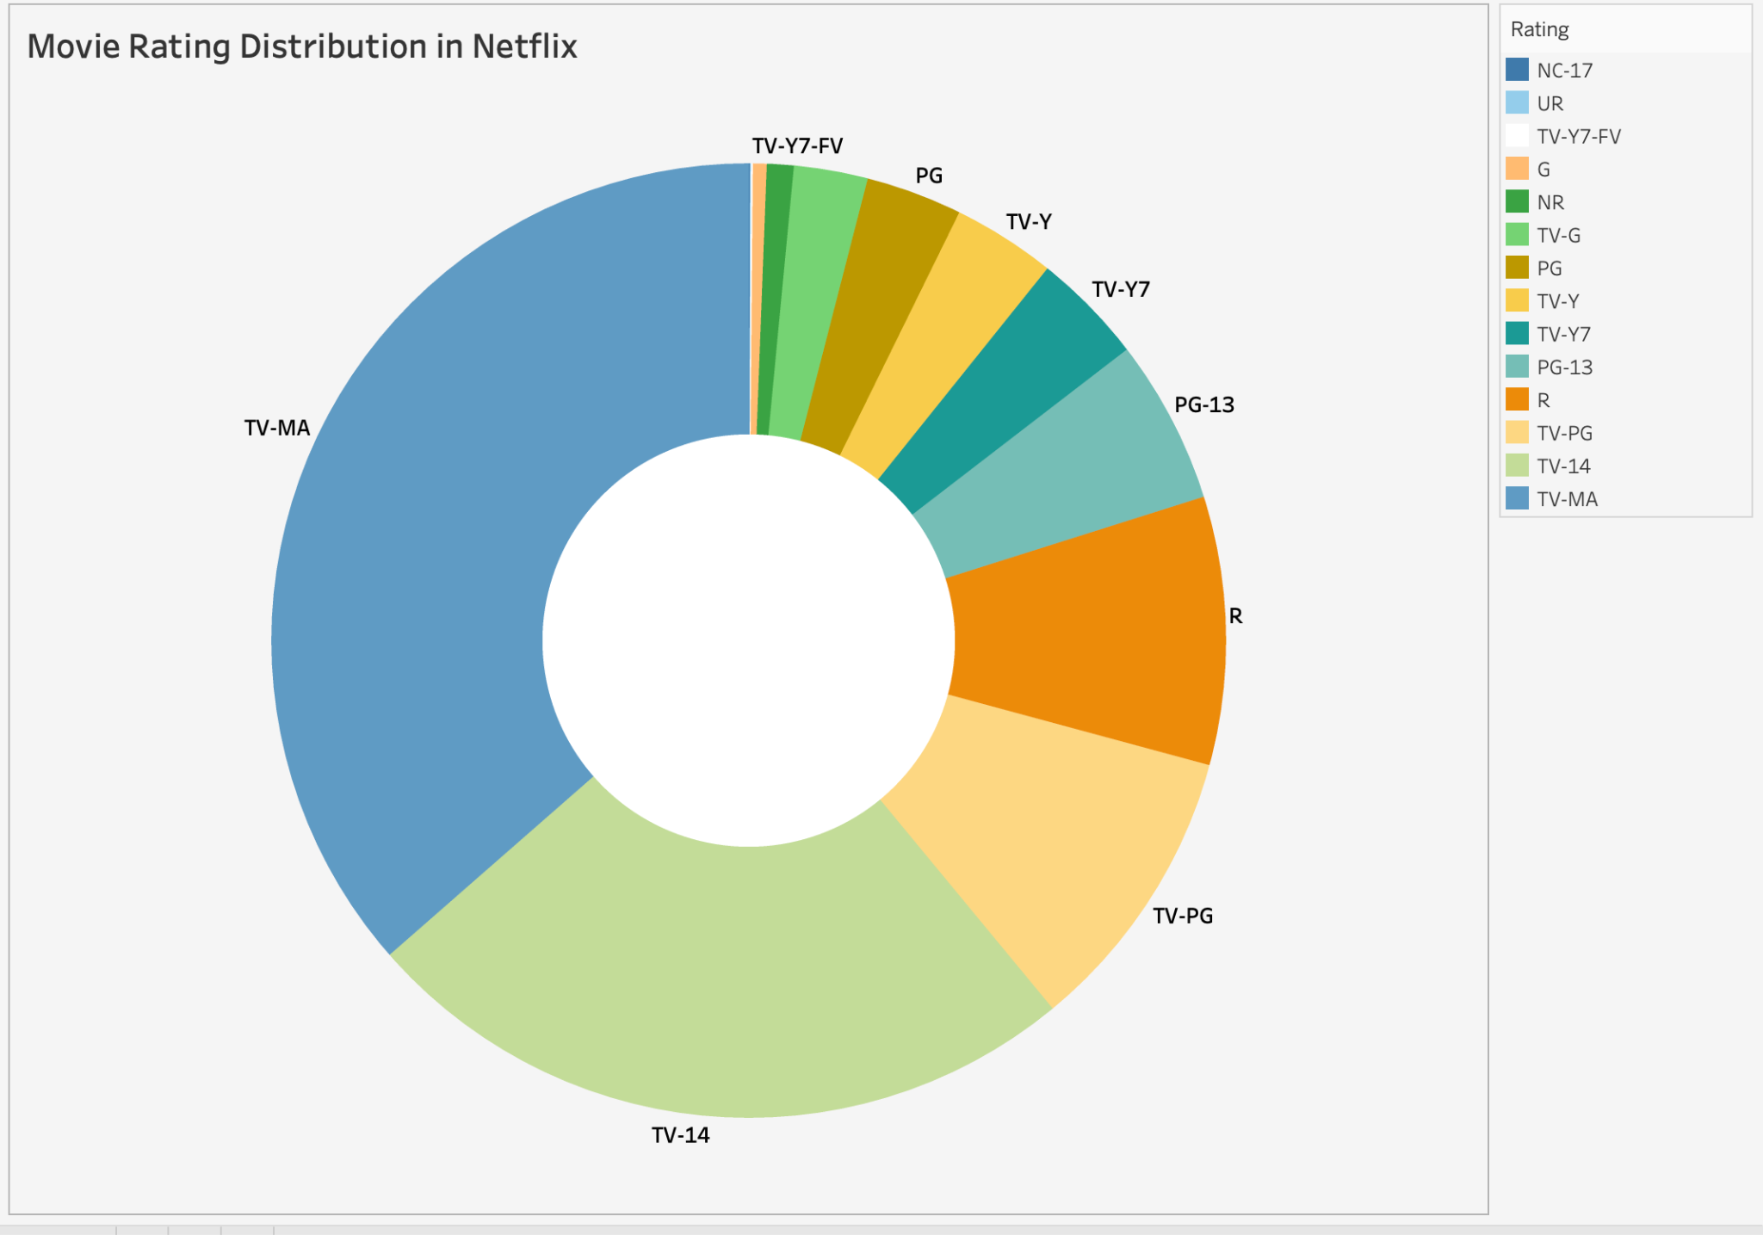

**Figure 1.1**

**Visual Encoding used in the Donut Chart in Figure 1.1**

| **Data** | **Data Type** | **Encoding** | **Description** |
| --- | --- | --- | --- |
| **Movie Rating** | Categorical | Area Size(Slice Size) | The size of each slice in the pie chart represents the proportion of movies with that rating. |
|  |  | Hue (Slice color) | Different colors are assigned to each slice to visually distinguish between movie ratings. |
|  |  | Slice label | Text labels on each slice identify the corresponding MPAA rating. |

**Insights & Findings:**

* The chart shows a higher concentration of ratings for TV-MA(Matured Audience Only shows )with a count of 3,207 compared to NC-17(Not for Children Under 17) shows at a count of 3.
* This implied that Netflix offers more content targeted towards mature audiences compared to content restricted to viewers above 17.

1. **Stacked Chart for Content Distribution (Movie vs. TV Show)**

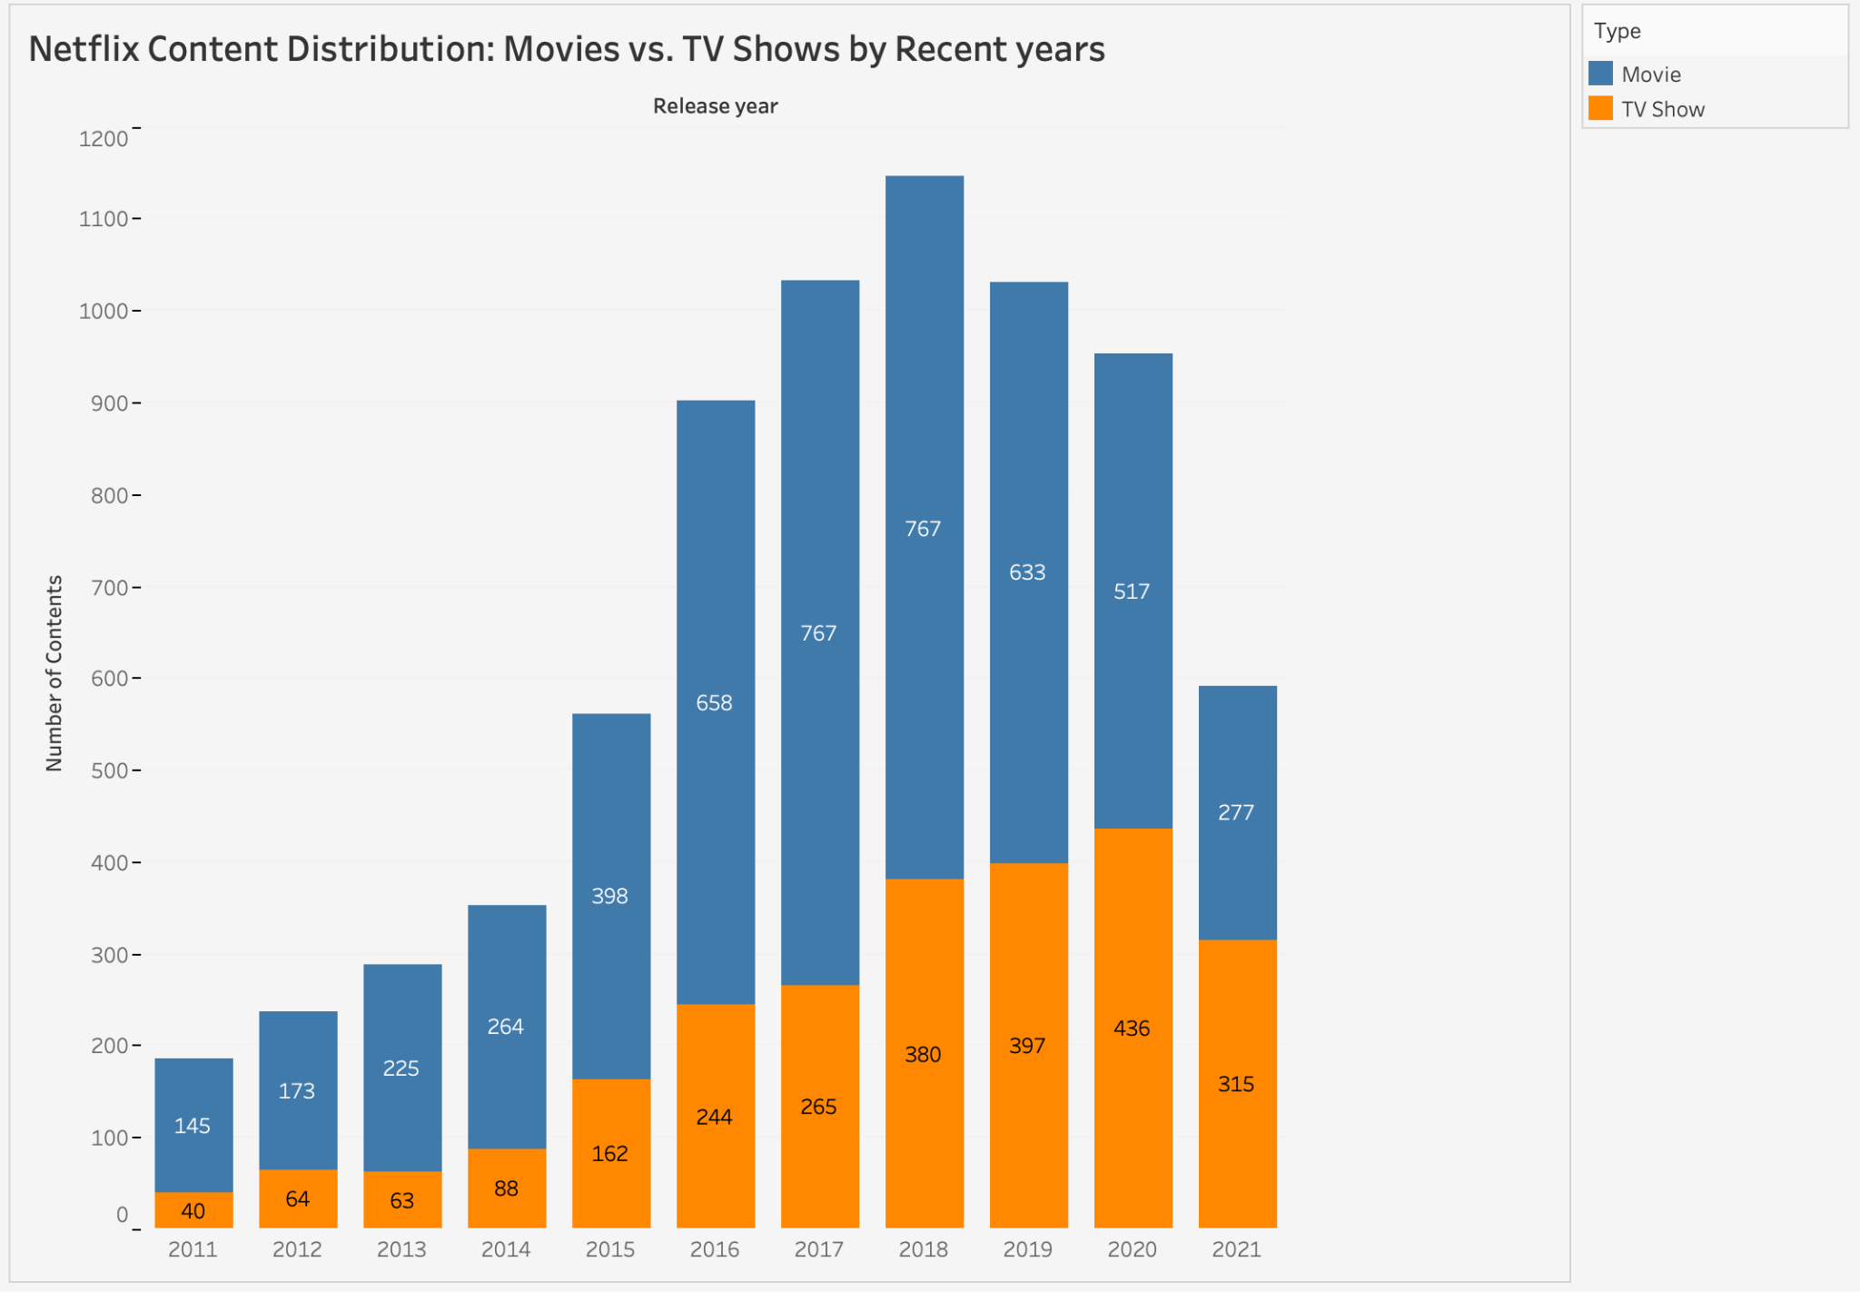

**Figure 1.2**

**Visual Encoding used in the Stacked Chart in Figure 1.2**

| **Data** | **Data Type** | **Encoding** | **Description** |
| --- | --- | --- | --- |
| **Release_year** | Quantitative | Position | Labels on the x-axis representing the years (e.g., 2011, 2012, 2013, etc |
| **Number of Contents** | Quantitative | Length(Bar height) | Y axis. The height of each bar represents the number of movies (blue bars) or TV shows (orange bars) added to Netflix in that particular year. |
| **Content-Type** | Categorical | Color | The color of the bars distinguishes between movies (blue) and TV shows (orange). |

**Insights & Findings:**

* **Increase in Content Over Time:** The graph shows a general upward trend in the number of movies and TV shows added to Netflix over the years from 2011 to 2021. This suggests that Netflix has been consistently adding new content to its library.
* **More Movies than TV Shows:** Movies have consistently held a dominant position in the entertainment industry, surpassing the production of TV shows year after year.
* **Fluctuations:** While there's a general upward trend, the graph also shows some fluctuation in the number of titles added year to year. There might be due to variations in production cycles or licensing deals.

### **Horizontal Bar Chart for Top 10 Genres in Netflix :**

### 

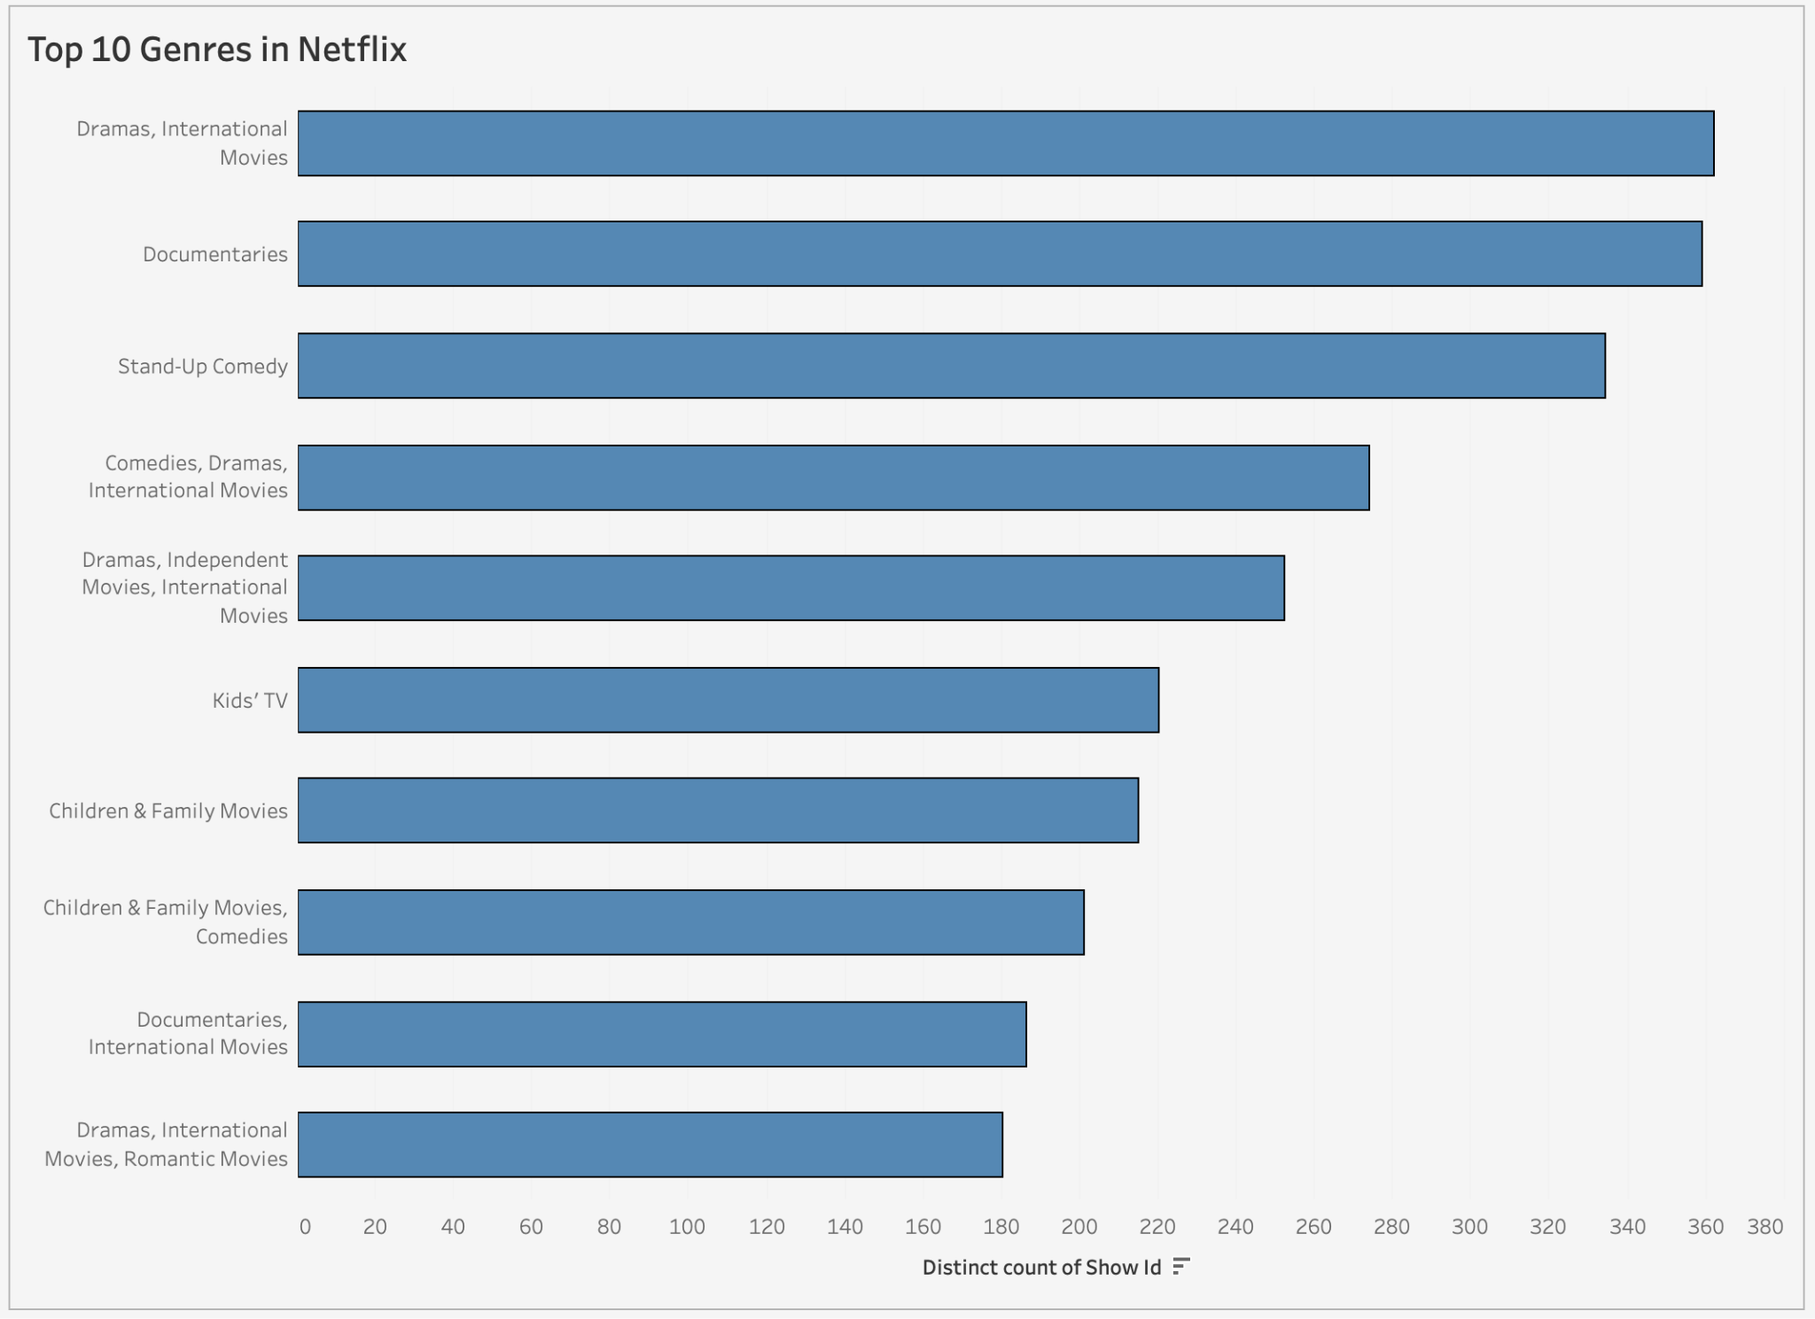

**Figure 1.3**

**Visual Encoding used in the Bar plot in Figure 1.3**

| **Data** | **Data Type** | **Encoding** | **Description** |
| --- | --- | --- | --- |
| **Distinct count of Show ID** | Quantitative | Length | The length of the bar represents the number of shows in that genre on Netflix |
| **Genre** | Categorical | Position | Each category on the Y-axis represents a Genre arranged in descending order. |

**Insights & Findings:**

* The chart shows a high number of entries with "Dramas, International Movies" combined. This implies that viewers prefer viewers prefer Drama, International Movies than other categories
* **Drama dominates:** Dramas appear in a significant number of the top categories, suggesting they're a popular choice for viewers.
* **International Focus:** The presence of "International Movies" in several top categories suggests a strong showing of non-English content.
* **Documentary Strength:** Documentaries occupy a prominent spot, highlighting their popularity on Netflix.
* **Catering to Families:** The presence of Kids' TV and Children & Family categories suggests Netflix places value in content for younger audiences.

### **Query Answers:**

**Query 1:** *What is the distribution of movie ratings (e.g., G, PG, PG-13, R) in the Netflix dataset, and Which rating category has the highest number of movies? [Figure 1.1]*

The data in Figure 1.1 shows the distribution of movie ratings on Netflix. It shows that the rating category TV-MA has the highest number of movies.

**Query 2:** *Have there been any significant changes in the content mix (movies vs. TV shows) over time*

*[Figure 1.2]*

Yes. Figure 1.2 shows an overall increase in content (movies and TV shows) from 2011 to 2021. However, it also indicates year-to-year fluctuations in the number of titles added for both categories. The movie Industry dominates the TV shows count in each year.

**Query 3:**  *Which genres are the most popular on Netflix? [Figure 1.3]*

Figure 1.3 shows that the genre category ‘Dramas, International Movies’ is more popular among viewers.