Ex. No. : 03 Date: 20-02-2026
Register No.: 231701029 Name: Lakshmi narayani V

Wire framing and Prototyping with Figma
Aim
To create wireframes and a functional prototype for a mobile app using Figma. Convert the prototype into a basic Android application.

Procedure:

1️⃣ Create an Android frame (360x800) in Figma and set a light purple background.
2️⃣ Design buttons and input fields using rounded rectangles and consistent colors.
3️⃣ Add text, icons, and images for each screen (Welcome, Login, Dashboard, etc.).
4️⃣ Use Auto Layout (Shift + A) to align and space elements properly.
5️⃣ Duplicate frames to create all app pages and connect them using Prototype mode.• Run the application on an Android emulator or physical device.
Output
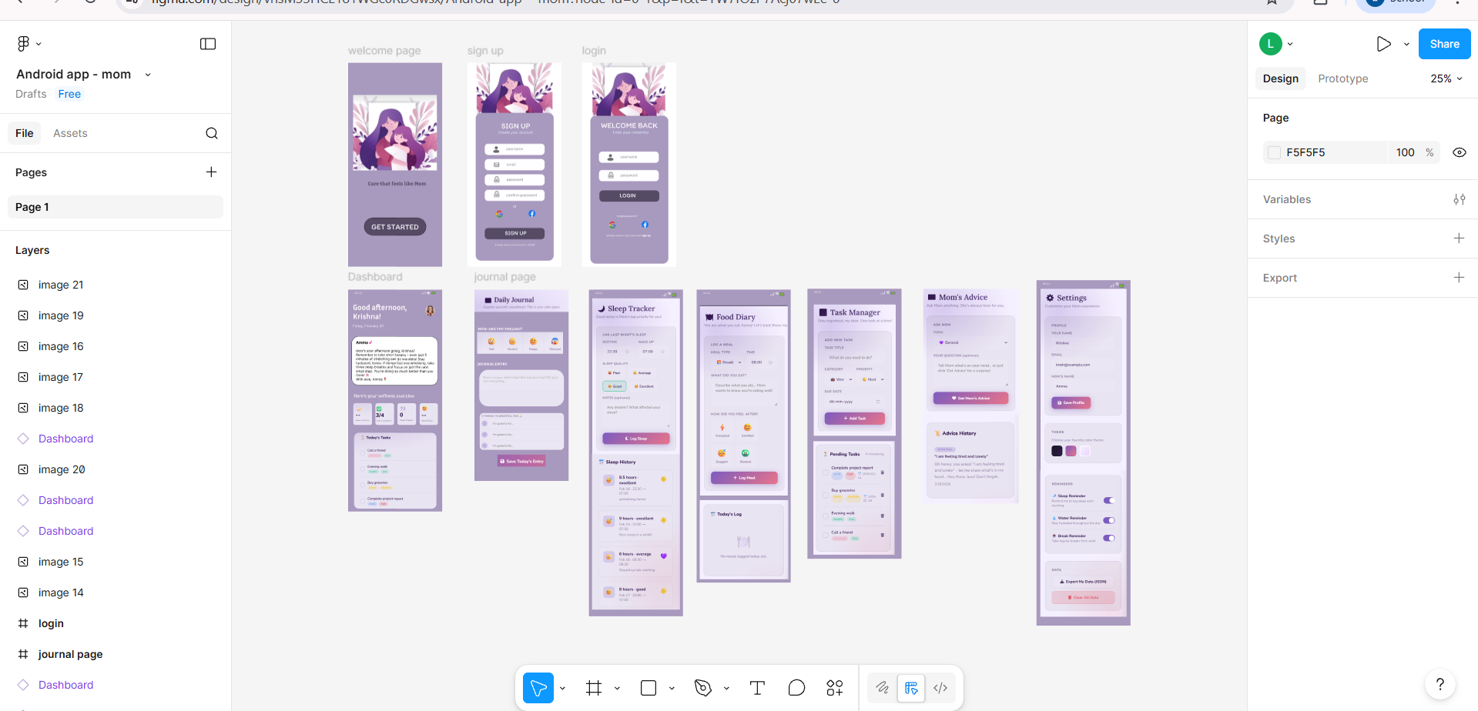
Result:
A complete AI Mom Assistant Android UI design was created in Figma with 10 screens including Welcome, Login, Dashboard, Journal, Sleep Tracker, Food Diary, Task Manager, Advice, and Settings.
The app uses a consistent purple theme, rounded UI components, cards, input fields, and modern mobile layout ready for prototyping.

