Ex. No. : 01A Date: 23-01-2026
Register No.: 231701029 Name: Lakshmi narayani V

GUI Components
Aim
Develop an application to change the font and color of the text and display toast message when the user presses the button.
Procedure:
• Open Android Studio and create a new Android project by selecting Empty Activity.
• Enter the application name as GUI Components and choose Kotlin as the programming language.
• Set the minimum SDK version as required and click Finish.
• Open the AndroidManifest.xml file and ensure that MainActivity is declared as the launcher activity.
• Design the user interface in activity_main.xml using a LinearLayout.
- Add a TextView to display text.
- Add three Button widgets for changing text size, text color, and background color.
• Assign unique IDs to all UI components using android:id.
• Open MainActivity.kt and link the UI components using findViewById().
• Write logic inside setOnClickListener():
- Increase the font size of the TextView when the Change Size button is pressed.
- Change the text color cyclically when the Change Color button is pressed.
- Change the background color of the layout when the Change Background button is pressed.
• Save all files and run the application on an emulator or physical Android device.
• Verify the output by interacting with the buttons.

AndroidManifest.xml
<?xml version="1.0" encoding="utf-8"?>
<manifest xmlns:android="http://schemas.android.com/apk/res/android"
xmlns:tools="http://schemas.android.com/tools">
<application
android:allowBackup="true"
android:dataExtractionRules="@xml/data_extraction_rules"
android:fullBackupContent="@xml/backup_rules"
android:icon="@mipmap/ic_launcher"
android:label="@string/app_name"
android:roundIcon="@mipmap/ic_launcher_round"
android:supportsRtl="true"
android:theme="@style/Theme.Gui_components"
tools:targetApi="31">
<activity
android:name=".MainActivity"
android:exported="true">
<intent-filter>
<action android:name="android.intent.action.MAIN" />
<category android:name="android.intent.category.LAUNCHER" />
</intent-filter>
</activity>
</application>
</manifest>

Activity_main.xml
<LinearLayout xmlns:android="http://schemas.android.com/apk/res/android"
xmlns:tools="http://schemas.android.com/tools"
android:id="@+id/main"
android:layout_width="match_parent"
android:layout_height="match_parent"
android:orientation="vertical"
android:padding="16dp">
<TextView
android:id="@+id/txt1"
android:layout_width="match_parent"
android:layout_height="wrap_content"
android:text="@string/hello"
android:textAlignment="center"
android:textSize="30sp"
/>
<LinearLayout
android:id="@+id/ll"
android:layout_width="wrap_content"
android:layout_height="wrap_content"
android:orientation="horizontal">
<Button
android:id="@+id/b1"
android:layout_width="wrap_content"
android:layout_height="wrap_content"
android:text="@string/changesize"
tools:ignore="ButtonStyle" />
<Button
android:id="@+id/b2"
android:layout_width="wrap_content"
android:layout_height="wrap_content"
android:text="@string/changecolor"
tools:ignore="ButtonStyle" />
<Button
android:id="@+id/b3"
android:layout_width="wrap_content"
android:layout_height="wrap_content"
android:text="@string/changebg"
tools:ignore="ButtonStyle" />
</LinearLayout>
</LinearLayout>

MainActivity.kt
package com.example.gui_components
import android.graphics.Color
import android.os.Bundle
import android.widget.Button
import android.widget.LinearLayout
import android.widget.TextView
import androidx.activity.enableEdgeToEdge
import androidx.appcompat.app.AppCompatActivity
import androidx.core.view.ViewCompat
import androidx.core.view.WindowInsetsCompat
class MainActivity : AppCompatActivity() {
override fun onCreate(savedInstanceState: Bundle?) {
super.onCreate(savedInstanceState)
enableEdgeToEdge()
setContentView(R.layout.activity_main)
val tv1: TextView = findViewById(R.id.txt1)
val csize: Button = findViewById(R.id.b1)
var size = 30f
csize.setOnClickListener {
tv1.textSize = size
size += 10f
}
var count = 0
val ccolor: Button = findViewById(R.id.b2)
ccolor.setOnClickListener {
when (count % 4) {
0 -> tv1.setTextColor(Color.RED)
1 -> tv1.setTextColor(Color.BLUE)
2 -> tv1.setTextColor(Color.GREEN)
else -> tv1.setTextColor(Color.BLACK)
}
count++
}
val cbg: Button = findViewById(R.id.b3)
val xyz: LinearLayout = findViewById(R.id.main)
cbg.setOnClickListener {
xyz.setBackgroundColor(Color.MAGENTA)

Output
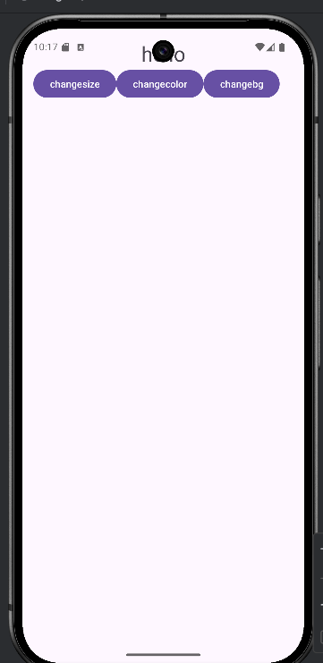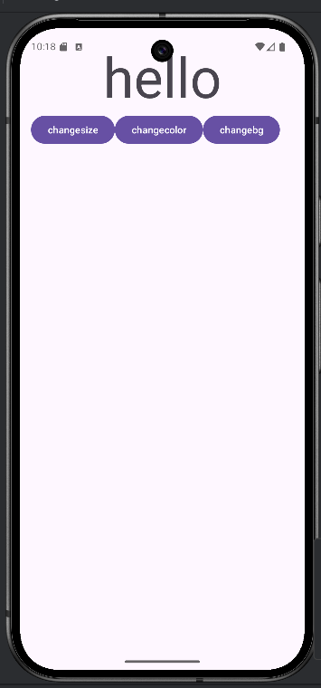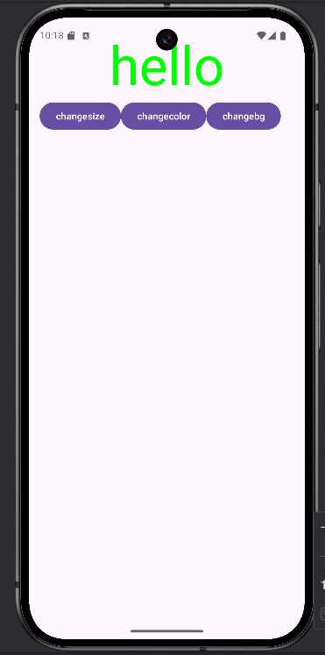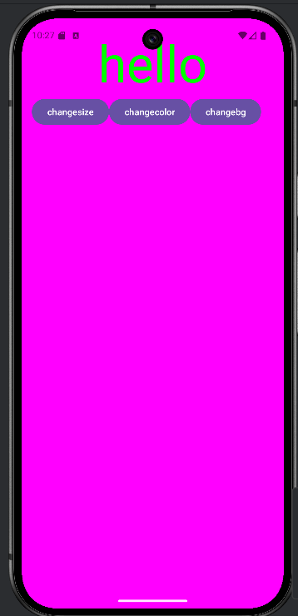
Result:
The Android application was successfully developed and executed.

