Ex. No. : 01B Date: 23-01-2026
Register No.: 231701029 Name: Lakshmi narayani V

Check In & Check Out
Aim
Develop an application for Tech Lounge Check in / Check out App. to count number of students inside the block.
Procedure:
• Open Android Studio and create a new Android project using Empty Activity.
• Enter the application name as Check In–Out and select Kotlin as the programming language.
• Configure the minimum SDK and click Finish to create the project.
• Open the AndroidManifest.xml file and verify that MainActivity is declared as the launcher activity.
• Design the user interface in activity_main.xml using a LinearLayout.
- Add a TextView to display the count value.
- Add two Button components labeled Check In and Check Out.
• Assign appropriate IDs to all UI components for reference in Kotlin code.
• Open MainActivity.kt and connect the UI components using findViewById().
• Implement the button click functionality:
- Increment the count value when the Check In button is pressed.
- Decrement the count value when the Check Out button is pressed.
- Update the TextView with the current count value.
• Save all the files and run the application on an emulator or Android device.
• Observe the displayed output by pressing the buttons.

AndroidManifest.xml
<?xml version="1.0" encoding="utf-8"?>
<manifest xmlns:android="http://schemas.android.com/apk/res/android"
xmlns:tools="http://schemas.android.com/tools">
<application
android:allowBackup="true"
android:dataExtractionRules="@xml/data_extraction_rules"
android:fullBackupContent="@xml/backup_rules"
android:icon="@mipmap/ic_launcher"
android:label="@string/app_name"
android:roundIcon="@mipmap/ic_launcher_round"
android:supportsRtl="true"
android:theme="@style/Theme.Check_inout"
tools:targetApi="31">
<activity
android:name=".MainActivity"
android:exported="true">
<intent-filter>
<action android:name="android.intent.action.MAIN" />
<category android:name="android.intent.category.LAUNCHER" />
</intent-filter>
</activity>
</application>
</manifest>

Activity_main.xml
<?xml version="1.0" encoding="utf-8"?>
<LinearLayout xmlns:android="http://schemas.android.com/apk/res/android"
xmlns:app="http://schemas.android.com/apk/res-auto"
xmlns:tools="http://schemas.android.com/tools"
android:id="@+id/main"
android:orientation="vertical"
android:layout_width="match_parent"
android:layout_height="match_parent"
tools:context=".MainActivity"
android:gravity="center_horizontal"
tools:ignore="ExtraText">
<TextView
android:id="@+id/txt1"
android:layout_width="wrap_content"
android:layout_height="wrap_content"
android:text="@string/_0"
android:textSize="100sp"
android:padding="30dp"
/>
<LinearLayout
android:id="@+id/ll2"
android:layout_width="match_parent"
android:layout_height="wrap_content"
android:orientation="vertical">
<Button
android:id="@+id/b1"
android:layout_width="match_parent"
android:layout_height="match_parent"
android:text="@string/checkin"
android:textSize="40sp"
android:padding="10dp"/>
<Button
android:id="@+id/b2"
android:layout_width="match_parent"
android:layout_height="match_parent"
android:padding="10dp"
android:text="@string/checkingout"
android:textSize="40sp" />
></LinearLayout>
</LinearLayout>

MainActivity.kt
package com.example.check_inout
import android.os.Bundle
import android.widget.Button
import android.widget.TextView
import androidx.activity.enableEdgeToEdge
import androidx.appcompat.app.AppCompatActivity
import androidx.core.view.ViewCompat
import androidx.core.view.WindowInsetsCompat
class MainActivity : AppCompatActivity() {
override fun onCreate(savedInstanceState: Bundle?) {
super.onCreate(savedInstanceState)
enableEdgeToEdge()
setContentView(R.layout.activity_main)
val txt : TextView = findViewById(R.id.txt1)
val enter : Button = findViewById(R.id.b1)
var size=0
enter.setOnClickListener {
size=size+1
txt.text= size.toString()
}
val exit : Button= findViewById(R.id.b2)
exit.setOnClickListener {
size-=1
txt.text=size.toString()
}
}
}

Output
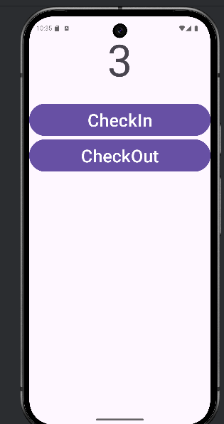
Result:
The Android application was successfully developed and executed.

