Ex. No. : 01C Date: 27-01-2026
Register No.: 231701029 Name: Lakshmi narayani V

BMI Calculator
Aim
Create an app that calculates the Body Mass Index (BMI) based on user input for weight and height in EditText fields. The result is displayed in a TextView after pressing a Button.
Procedure:
• Open Android Studio and create a new Android project using Empty Activity.
• Enter the application name as Calculator_BMI and select Kotlin as the programming language.
• Choose the required minimum SDK and click Finish to create the project.
• Open the AndroidManifest.xml file and declare MainActivity as the launcher activity.
• Design the user interface in activity_main.xml using a LinearLayout.
- Add a TextView to display the application title.
- Add two EditText fields to accept user input for weight and height.
- Add a RadioGroup with RadioButton options to select height units (meters or centimeters).
- Add a Button to perform the BMI calculation.
- Add a TextView to display the calculated BMI result.
• Assign appropriate IDs to all UI components for accessing them in Kotlin code.
• Open MainActivity.kt and link the UI components using findViewById().
• Implement the button click event using setOnClickListener.
• Validate user input to ensure both weight and height values are entered.
• Convert height from centimeters to meters when the corresponding option is selected.
• Calculate the Body Mass Index (BMI) using the formula:
$$BMI=\frac{weight}{height^{2}}$$
• Display the calculated BMI value in the result TextView.
• Run the application on an emulator or Android device.
• Enter weight and height values, select the unit, and press the Calculate BMI button to view the output.

AndroidManifest.xml
<?xml version="1.0" encoding="utf-8"?>
<manifest xmlns:android="http://schemas.android.com/apk/res/android"
xmlns:tools="http://schemas.android.com/tools">
<application
android:allowBackup="true"
android:dataExtractionRules="@xml/data_extraction_rules"
android:fullBackupContent="@xml/backup_rules"
android:icon="@mipmap/ic_launcher"
android:label="@string/app_name"
android:roundIcon="@mipmap/ic_launcher_round"
android:supportsRtl="true"
android:theme="@style/Theme.Calculator_BMI"
tools:targetApi="31">
<activity
android:name=".MainActivity"
android:exported="true">
<intent-filter>
<action android:name="android.intent.action.MAIN" />
<category android:name="android.intent.category.LAUNCHER" />
</intent-filter>
</activity>
</application>
</manifest>

Activity_main.xml
<?xml version="1.0" encoding="utf-8"?>
<LinearLayout xmlns:android="http://schemas.android.com/apk/res/android"
xmlns:app="http://schemas.android.com/apk/res-auto"
xmlns:tools="http://schemas.android.com/tools"
android:id="@+id/main"
android:layout_width="match_parent"
android:layout_height="match_parent"
tools:context=".MainActivity"
android:gravity="center_horizontal"
android:padding="16dp"
android:orientation="vertical">
<TextView
android:id="@+id/topic"
android:layout_width="wrap_content"
android:layout_height="wrap_content"
android:text="@string/bmi_calculator"
android:textAlignment="center"
android:textSize="20sp"
android:padding="20dp"/>
<EditText
android:id="@+id/edWeight"
android:layout_width="match_parent"
android:layout_height="wrap_content"
android:hint="@string/enter_weight_here"
android:inputType="numberDecimal"
android:padding="10dp" />
<EditText
android:id="@+id/edHeight"
android:layout_width="match_parent"
android:layout_height="wrap_content"
android:hint="@string/enter_height_here"
android:inputType="numberDecimal"
android:padding="10dp" />
<RadioGroup
android:id="@+id/rgUnit"
android:layout_width="wrap_content"
android:layout_height="wrap_content"
android:orientation="horizontal"
android:layout_marginTop="10dp">
<RadioButton
android:id="@+id/rbMeters"
android:layout_width="wrap_content"
android:layout_height="wrap_content"
android:text="@string/meters"
android:checked="true" />
<RadioButton
android:id="@+id/rbCentimeters"
android:layout_width="wrap_content"
android:layout_height="wrap_content"
android:text="@string/centimeters" />
</RadioGroup>
<Button
android:id="@+id/btnCalculate"
android:layout_width="wrap_content"
android:layout_height="wrap_content"
android:text="@string/calculate_bmi"
android:layout_marginTop="20dp" />
<TextView
android:id="@+id/tvResult"
android:layout_width="wrap_content"
android:layout_height="wrap_content"
android:text=""
android:textSize="18sp"
android:layout_marginTop="20dp" />
</LinearLayout>

MainActivity.kt
package com.example.calculator_bmi
import android.os.Bundle
import android.widget.Button
import android.widget.EditText
import android.widget.RadioButton
import android.widget.TextView
import android.widget.Toast
import androidx.activity.enableEdgeToEdge
import androidx.appcompat.app.AppCompatActivity
import androidx.core.view.ViewCompat
import androidx.core.view.WindowInsetsCompat
import kotlin.math.roundToInt
class MainActivity : AppCompatActivity() {
override fun onCreate(savedInstanceState: Bundle?) {
super.onCreate(savedInstanceState)
enableEdgeToEdge()
setContentView(R.layout.activity_main)
val etWeight: EditText = findViewById(R.id.edWeight)
val etHeight: EditText = findViewById(R.id.edHeight)
val rbMeters: RadioButton = findViewById(R.id.rbMeters)
val rbCentimeters: RadioButton = findViewById(R.id.rbCentimeters)
val btnCalculate: Button = findViewById(R.id.btnCalculate)
val tvResult: TextView = findViewById(R.id.tvResult)
btnCalculate.setOnClickListener {
if (etWeight.text.isEmpty() || etHeight.text.isEmpty()) {
Toast.makeText(this, "Please enter weight and height", Toast.LENGTH_SHORT).show()
return@setOnClickListener
}
val weight = etWeight.text.toString().toDouble()
var height = etHeight.text.toString().toDouble()
if (rbCentimeters.isChecked) {
height /= 100
}
// BMI calculation
val bmi = weight / (height * height)
val bmiRounded = (bmi * 100).roundToInt() / 100.0
// Display result
tvResult.text = "Your BMI: $bmiRounded"
}
}
}
Output
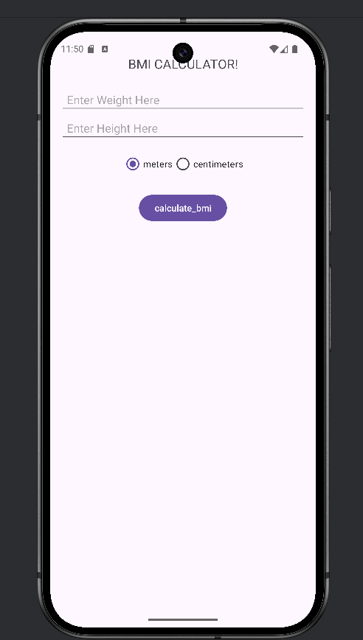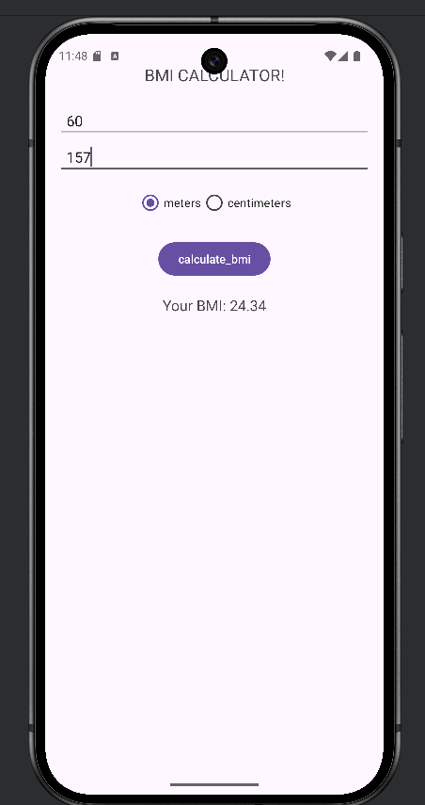

Result:
The Android application was successfully developed and executed.

