Ex. No. : 01D Date: 27-01-2026
Register No.: 231701029 Name: Lakshmi narayani V

Temperature Convertor
Aim
Create an app that converts temperatures between Celsius and Fahrenheit. Users can enter a temperature in an EditText, press a Button to perform the conversion, and see the result in a TextView

Procedure:
• Open Android Studio and create a new Android project using Empty Activity.
• Enter the application name as Temperature Converter and select Kotlin as the programming language.
• Choose the appropriate minimum SDK version and click Finish.
• Open the AndroidManifest.xml file and declare MainActivity as the launcher activity.
• Design the user interface in activity_main.xml using a LinearLayout.
- Add an EditText to allow the user to enter the temperature value.
- Add three Button widgets labeled Celsius, Fahrenheit, and Clear.
- Add a TextView to display the converted temperature or error message.
• Assign proper IDs to all UI components.
• Open MainActivity.kt and link the UI components using findViewById().
• Implement setOnClickListener() for each button:
- Celsius Button: Converts the entered Fahrenheit value into Celsius.
- Fahrenheit Button: Converts the entered Celsius value into Fahrenheit.
- Clear Button: Clears both the input field and the result display.
• Add input validation to check whether the user has entered a temperature value.
• Display a message in the TextView if no input is provided.
• Run the application on an Android emulator or physical device.
• Enter a temperature value, press the respective button, and observe the converted output.

AndroidManifest.xml
<?xml version="1.0" encoding="utf-8"?>
<manifest xmlns:android="http://schemas.android.com/apk/res/android"
xmlns:tools="http://schemas.android.com/tools">
<application
android:allowBackup="true"
android:dataExtractionRules="@xml/data_extraction_rules"
android:fullBackupContent="@xml/backup_rules"
android:icon="@mipmap/ic_launcher"
android:label="@string/app_name"
android:roundIcon="@mipmap/ic_launcher_round"
android:supportsRtl="true"
android:theme="@style/Theme.Temperature_cal"
tools:targetApi="31">
<activity
android:name=".MainActivity"
android:exported="true">
<intent-filter>
<action android:name="android.intent.action.MAIN" />
<category android:name="android.intent.category.LAUNCHER" />
</intent-filter>
</activity>
</application>
</manifest>
</manifest>

Activity_main.xml
<?xml version="1.0" encoding="utf-8"?>
<LinearLayout xmlns:android="http://schemas.android.com/apk/res/android"
xmlns:app="http://schemas.android.com/apk/res-auto"
xmlns:tools="http://schemas.android.com/tools"
android:id="@+id/main"
android:orientation="vertical"
android:gravity="center"
android:layout_width="match_parent"
android:layout_height="match_parent"
tools:context=".MainActivity">
<EditText
android:id="@+id/edTemp"
android:layout_width="match_parent"
android:layout_height="wrap_content"
android:hint="@string/enter_temperature"
android:inputType="numberDecimal"
android:padding="10dp" />
<Button
android:id="@+id/btnCelsius"
android:layout_width="match_parent"
android:layout_height="wrap_content"
android:text="@string/celsius"
android:layout_marginTop="12dp" />
<Button
android:id="@+id/btnFahrenheit"
android:layout_width="match_parent"
android:layout_height="wrap_content"
android:text="@string/farenheit"
android:layout_marginTop="8dp" />
<Button
android:id="@+id/btnClear"
android:layout_width="match_parent"
android:layout_height="wrap_content"
android:text="@string/clear"
android:layout_marginTop="8dp" />
<TextView
android:id="@+id/tvResult"
android:layout_width="wrap_content"
android:layout_height="wrap_content"
android:text=""
android:textSize="18sp"
android:textColor="#0000FF"
android:layout_marginTop="20dp" />
</LinearLayout>

MainActivity.kt
package com.example.temperature_cal
import android.os.Bundle
import android.widget.Button
import android.widget.EditText
import android.widget.TextView
import androidx.activity.enableEdgeToEdge
import androidx.appcompat.app.AppCompatActivity
import androidx.core.view.ViewCompat
import androidx.core.view.WindowInsetsCompat
class MainActivity : AppCompatActivity() {
override fun onCreate(savedInstanceState: Bundle?) {
super.onCreate(savedInstanceState)
enableEdgeToEdge()
setContentView(R.layout.activity_main)
val edTemp: EditText = findViewById(R.id.edTemp)
val btnCelsius: Button = findViewById(R.id.btnCelsius)
val btnFahrenheit: Button = findViewById(R.id.btnFahrenheit)
val btnClear: Button = findViewById(R.id.btnClear)
val tvResult: TextView = findViewById(R.id.tvResult)
btnCelsius.setOnClickListener {
if (edTemp.text.isEmpty()) {
tvResult.text = "Please enter the temperature"
} else {
val f = edTemp.text.toString().toDouble()
val c = (f - 32) * 5 / 9
tvResult.text = c.toString()
}
}
btnFahrenheit.setOnClickListener {
if (edTemp.text.isEmpty()) {
tvResult.text = "Please enter the temperature"
} else {
val c = edTemp.text.toString().toDouble()
val f = (c * 9 / 5) + 32
tvResult.text = f.toString()
}
}
btnClear.setOnClickListener {
edTemp.text.clear()
tvResult.text = ""
}}}

Output
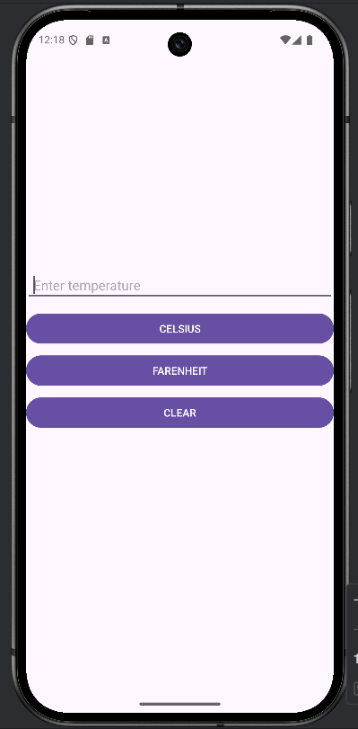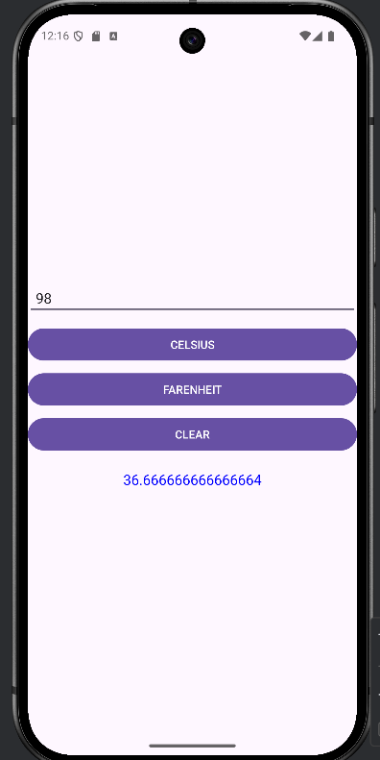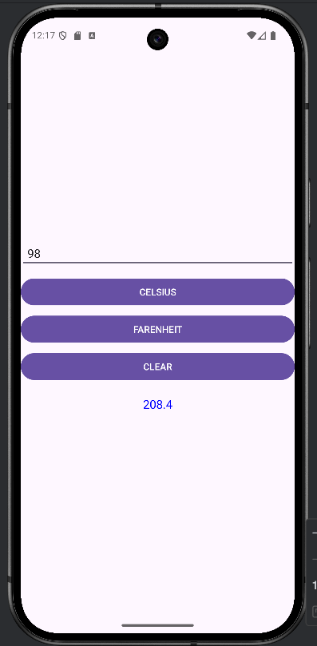

Result:
The Android application was successfully developed and executed.

