

**ScholarSphere**

**Software Requirements Specification**

**Revision History**

|  |  |  |  |
| --- | --- | --- | --- |
| **DATE** | **VERSION** | **DESCRIPTION** | **AUTHOR** |
| 03/12/2024 | Version 1.0 | Draft report |  |

**Table of Contents**

1. Introduction 4
   1. Purpose 5
   2. Scope 5
   3. Definitions, Acronyms and Abbreviations 5
2. Overall Description 6
3. Specific Requirements 8
   1. Functionality 8
      1. Logon Capabilities 8
      2. Mobile Devices 8
      3. Alerts 9
   2. Usability 9
   3. Reliability 9
      1. Availability 9
      2. Mean Time Between Failures (MTBF) 9
      3. Mean Time to Repair (MTTR) 9
      4. Accuracy 9
      5. Bugs or Defect Rate 9
      6. Access Reliability 9
   4. Performance 10
      1. Response Time 10
      2. Administrator/Website Manager Response 10
      3. Throughput 10
      4. Capacity 10
      5. Resource Utilization 10
   5. Supportability 10
      1. Internet Protocols 10
      2. Information Security Requirement 11
      3. Maintenance 11
      4. Standards 11
4. Supporting Information 11

**Software Requirements Specification**

# Introduction

Maintaining a record or a log individually and managing the data of multiple research publications and journals manually is a tedious and time draining process. Many people work together to update and provide details for journals and research publications. It is very difficult to update or quote citations for journals manually when several hundreds of journals and research publications exist. It is very difficult to detect plagiarism without citation, falsification, and misinterpretation manually. It will consume too much time as a whole for managing and update various research publications and journals as a whole.

Hence, the motive is to develop a web portal for managing journals and publications published by students and staffs in the institution. The portal allows the users to list, compare and categorize the research publications and journals published over the years. The main function of this website is for easy access of research journals, their relevant statistics, and other features all in one place.

**1.1**  Purpose

The purpose of **Software Requirements Specification (SRS)** document is to describe the external behavior of the ScholarSphere. Requirements Specification defines and describes the operations, interfaces, performance, and quality assurance requirements of the ScholarSphere. The document also describes the nonfunctional requirements such as the user interfaces. It also describes the design constraints that are to be considered when the system is to be designed, and other factors necessary to provide a complete and comprehensive description of the requirements for the software. The Software Requirements Specification (**SRS**) captures the complete software requirements for the system, or a portion of the system. Requirements described in this document are derived from the Vision Document prepared for the ScholarSphere.

**1.2** **Scope**

The Software Requirements Specification captures all the requirements in a single document. The ScholarSphere that is to be developed contains records of all research publications and journals with along with information such as author, date of publish and type of publication/journal. Login credentials of staff and students are stored. The ScholarSphere is supposed to have the following features.

* + The product provides members access to records of all research publications.  
    It provides logon feature to users.
  + The system contains information about user such as name, department, qualification (staff or student) and list of journals published by the user.  
    The system provides the members with the option to check their account and/or change their options like password of the account whenever needed.
  + The system lets the website manager(s) to add/remove records of any research publication and maintain its catalogue. They can add/remove any member according to their discretion.
  + The system provides a comprehensive list of all publications which can be filtered by author, name, date, type of publication etc.
  + The system provides visual statistical information about research journals published over a period of time based on category and field of research. This information can be tailor-made to show information about research journals published by a specific author.
  + The system keeps track of the citations that a publication which can be viewed subsequently.

**1.3**  **Overview**

The SRS will give a detailed description of the ScholarSphere portal.   
This document will provide the gist of the requirements, overview of the characteristics and constraints of the system. The upcoming sections will contain: -

***1.5.1 Section 2:*** This section of the SRS will provide the general factors that affect the product and its requirements. It provides the background for those requirements.

***1.5.2 Section 3:*** This section of SRS contains all the system software requirements mentioned in previous section in detail sufficient enough to enable designers to design the system to satisfy the requirements and testers to test if the system satisfies those requirements.

# Overall Description

* + **Product Perspective**

The ScholarSphere is a package to be used by students and staff of this institution to access the catalog of published material efficiently. This web portal provides easy access to research publications, journals and their pertinent information all in one place which would be otherwise difficult to do so directly without aid. The catalog of published research material of all categories and types are updated regularly by the website managers.

Statistical information about published material over the years, relevant information about an individual research paper such as citations, type of publication (Thomson Reuters etc.), other papers by the author can be viewed by the user.

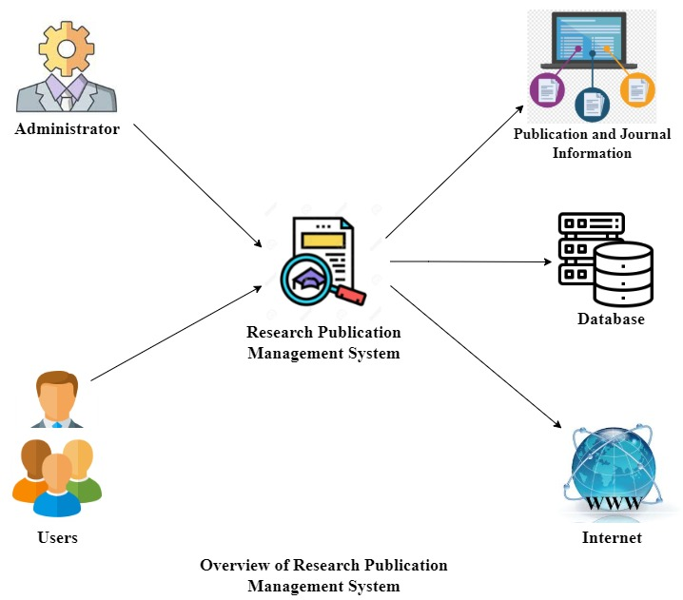

***Overview of the proposed system***

* + **Product Functions**

The ScholarSphere provides an extensive catalog of research papers published along with comprehensive information about each research paper. The main features of this system are addressed in the product description. The users (members) and managers of the website are provided with different services by the system.

* + The members are provided with a catalog of research publications that is constantly updated by the manager.
* The members are able search for research papers using name of paper, field of research, type of publication (conference, journal), type of journal (Thomson Reuters), name of author etc. Supplementary information about a given paper such as citations, other papers published in that category, other papers published by the author.
* The members are able to search authors of published research papers, view their details and their catalog of published material.
* The members are provided with the amenity to check their account information and change the account information.
* The website manager is provided with the interface to add/remove records of research paper(s) and edit their information, add/remove records of author(s) and fill in/edit their details.
* The website manager is provided with the provision to add/remove members and grant/revoke member permissions.
* The system uses the institution’s database to validate the users’ identity to provide logon facility to the users.
  + **User characteristics**

The users of the ScholarSphere are the members which is inclusive of students and staff, and the website manager/administrator who maintain the system. The members and managers need to have a basic knowledge requirement of computer knowledge and internet access. The administrators of the system to have more knowledge of the internals of the system and is able to rectify the small problems that may arise due to disk crashes, power failures and other catastrophes to maintain the system. The proper user interface, user's manual, online help and the guide to install and maintain the system must be sufficient to educate the users on how to use the system without any problems.

* + **Constraints**
  + The information of all the users must be stored in a database that is accessible by the ScholarSphere.
  + The university information security system must be compatible with the Internet applications.  
    The ScholarSphere is connected to the university computer and is running all 24 hours a day.
* The users access the ScholarSphere from any computer that has Internet browsing capabilities and an Internet connection.
* The billing system is connected to the ScholarSphere and the database used by the billing system must be compatible with the interface of the ScholarSphere.
* The users must have their correct usernames and passwords to enter into the ScholarSphere.
* **Assumptions and dependencies**
* The users have sufficient knowledge of computers.
* The University computer should have Internet connection and Internet server capabilities.
* The users know the English language, as the user interface will be provided in English.
* The product can access the university student database.

1. **Specific Requirements**

This section describes in detail all the functional requirements.

**3.1**  **Functionality**

***3.1.1 Logon Capabilities***

The ScholarSphere provides the users with logon capabilities.  
  
***3.1.2 Mobile Devices***

The ScholarSphere also supports mobile devices along with desktop access.

***3.1.3 Alerts***

The ScholarSphere gives a notification to the website manager or administrator in case of any issues.

**3.2**  **Usability**

* The interface of this portal is user-friendly and self-explanatory.
* It is very easy to access the portal as it uses web browser as an interface.
* It can be accessed from the internet or it’s derivative technologies.
* The ScholarSphere runs 24 hours a day.

**3.3**  **Reliability**

The ScholarSphere provides complete reliability due to the importance of data and the damages incorrect or incomplete data can do.

***3.3.1***  ***Availability***  
The ScholarSphere is completely accessible for free, 24hours a day and 365 days a year.

***3.3.2***  ***Mean Time Between Failures (MTBF)***  
The ScholarSphere is created and developed in such a manner that it rarely fails or fails once in a year.

***3.3.3***  ***Mean Time to Repair (MTTR)***  
The ScholarSphere is developed in such a manner that even if it fails, it will get recovered within 5-6 hours.

***3.3.4*** ***Accuracy***  
The accuracy of this portal works based on the accuracy of speed at which the users use the ScholarSphere.

***3.3.5***  ***Maximum Bugs or Defect Rate***  
Nothing.

***3.3.6***  ***Access Reliability***  
The portal provides complete access reliability.

**3.4**  **Performance**

***3.4.1*** ***Response Time***

The user will be able to download the information from the website within 2 minutes even the website is under maintenance. The information is refreshed every two minutes. The access time for a mobile device should be less than a minute. The system shall respond to the member in not less than two seconds from the time of the request submittal. The system shall be allowed to take more time when doing large processing jobs.

***3.4.2*** ***Administrator Response***

The system shall take negligible time delay to provide service to the administrator.

***3.4.3*** ***Throughput***

The number of transactions is directly dependent on the number of users, the users may be the Administrator, Students, Professors and also the people who use the website for checking-out information regarding Research publications.

***3.4.4*** ***Capacity***

The system is capable of handling 100 users at a time.

***3.4.5*** ***Resource Utilization***

The resources are modified according to the user requirements and also according to the Researches requested by the users.

**3.5**  **Supportability**

The system designers shall take in to considerations the following supportability and technical limitations.  
  
***3.5.1***  ***Internet Protocols***  
The system shall comply with the TCP/IP protocol standards and shall be designed accordingly.

***3.5.2***  ***Information Security Requirement***  
The system shall support the SSNCE information security requirements and use the same standard as the SSNCE information security requirements.  
  
***3.5.3***  ***Maintenance***  
The maintenance of the system shall be done as per the maintenance contract.

***3.5.4***  ***Standards***  
The coding standards and naming conventions will be as per the standards.

1. **Supporting Information**

The use-case storyboards or the user-interface prototypes are not available. The appendices are not to be considered as part of the requirements.