**Table of Contents**

|  |  |  |  |
| --- | --- | --- | --- |
| **Sr.No** | **Date** | **Practicals** | **Signature** |
| 1 | 30.03.2024 | **Practical No.1**  Create blockchain with 3 blocks and hence display the entire blockchain, hash value and timestamp of each block. |  |
| 2 | 5.04.2024 | **Practical No.2**  Create a smart Contract and Implement & demonstrate the use of solidity programming.   1. Create a smart contract for Counter. 2. Create a smart contract for Calculator. 3. Create a smart contract for Increment and decrement operator. |  |
| 3 | 8.04.2024 | **Practical No.3**  Create a Smart Contract in solidity program to demonstrate array and its types. |  |
| 4 | 11.04.2024 | **Practical No.4**   1. Solidity program to demonstrate Comparison operators. 2. Solidity program to demonstrate Logical operators. 3. Solidity program to demonstrate Assignment operators. 4. Solidity program to demonstrate Ternary operators. 5. Solidity program to demonstrate Bitwise operators. |  |
| 5 | 16.04.2024 | **Practical No.5**  Create smart contract in Loops using Solidity Programming.   1. Create a Smart contract for loop. 2. Create a Smart contract while loop. |  |

|  |  |  |  |
| --- | --- | --- | --- |
| 6 | 21.04.2024 | **Practical No. 6**   1. Create a smart contract to demonstrate Mathematical function. 2. Create a smart contract to demonstrate Function overloading. |  |
| 7 | 10.05.2024 | **Practical No.7**  Create a Smart contract using Solidity programming.  1.Implementation of Interface &  2.Inheritance using solidity programming. |  |
| 8 | 15.05.2024 | **Practical No.8**  Create smart contract for Selection of candidate in election. |  |
| 9 | 24.05.2024 | **Practical No.9**  Write a solidity program to create an array of role no.& create a smart contract where it checks the value of roll no.s & perform AND operation with today's date DD and if the result is even display a message " Student is ALLOWED." else display "DENIED". |  |
| 10 | 29.05.2024 | **Practical No.10**  Write a solidity program to find the sum of an array of ten numbers using loop the numbers are expected to be taken from the user, create a smart contract to find the AND operation of odd positioned numbers and OR operation of even positioned numbers including 0th index. Hence find the product of the results and also identify whether the result is the part of array or not. |  |

**We are using the Remix IDE to perform in Solidity Programming.**

**Steps to perform:**

1. **Open Remix:**

Open any browser and type

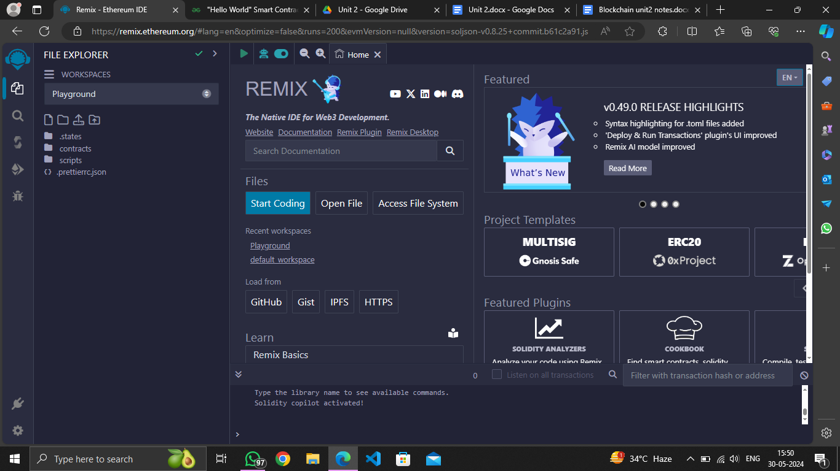

**[https://remix.ethereum.org](https://remix.ethereum.org  )**

[](https://remix.ethereum.org  )

1. **Create New Files:**

* Click on the “file explorer” icon onto the left side bar (indicated by blue arrow in the above picture).
* Select Solidity in the Environment and click + symbol right to the browser.
* In the "File Explorer" pane, create new files by any name such as HelloWorld.sol. It will look like this:

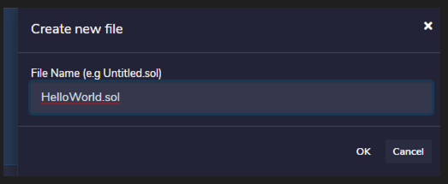

1. **Compile the Contracts:**

* Click on the "Solidity Compiler" tab.
* Ensure the appropriate compiler version (between 0.6.12 and 0.9.0) is selected.
* Click the "Compile" button for each contract.

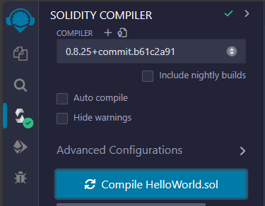

1. **Deploy the Contracts:**

* Click on the "Deploy & Run Transactions" tab.
* Ensure "JavaScript VM" is selected in the "Environment" dropdown for a local blockchain simulation.
* Deploy each contract by selecting it and clicking the "Deploy" button.

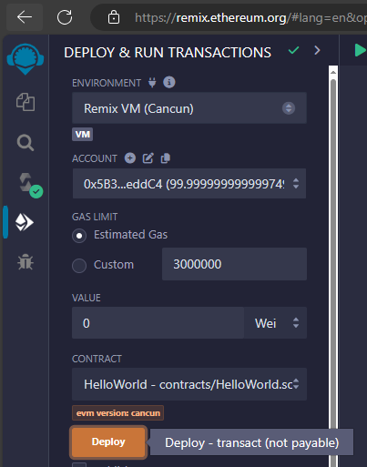

1. **Interact with the Contracts**

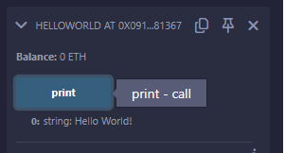

HelloWorld.sol

// SPDX-License-Identifier: MIT

pragma solidity >=0.6.12 <0.9.0;

contract HelloWorld {

  /**

   * @dev Prints Hello World string

   */

  function print() public pure returns (string memory) {

    return "Hello World!";

  }

}

**Solidity Programming**

Solidity is an object-oriented and high-level language for implementing Smart contracts. Solidity is a curly-bracket language designed to target the Ethereum Virtual Machine(EVM), It is influenced by C++, Python, and JavaScript. Solidity is statically typed and supports inheritance, libraries, and complex user-defined types among features. With this, you can create contracts for users such as voting, crowdfunding, blind auctions, and multi-signature wallets.

**SPDX License Identifier:**

**// SPDX-License-Identifier:** MIT: This specifies the license under which the contract is distributed. MIT is a permissive open-source license.

**Pragma Directive:**

pragma solidity >=0.6.12 <0.9.0;: Specifies that the Solidity compiler version should be between 0.6.12 (inclusive) and 0.9.0 (exclusive).

**Contract Definition:** contract name { ... }: Defines the smart contract namee.

**Practical No:1**

**Aim:- Create blockchain with 3 blocks and hence display the entire blockchain, hash value and timestamp of each block.**

**Code:**

// SPDX-License-Identifier: MIT

pragma solidity >=0.6.12 <0.9.0;

contract SimpleStorage {

    uint256 private storedData;

    event DataStored(uint256 data);

    function set(uint256 x) public {

        storedData = x;

        emit DataStored(x);

    }

    function get() public view returns (uint256) {

        return storedData;

    }

}

**Output:**

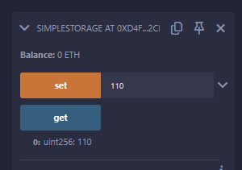

**Practical No:2**

**Aim- Create a Smart Contract and Implement & demonstrate the use of solidity programming.**

1. **Create a Smart Contract for Counter.**
2. **Create a Smart Contract for Calculator.**
3. **Create a Smart Contract for Increment & Decrement operator.**

**a) Create a Smart Contract for Counter.**

**Code:**

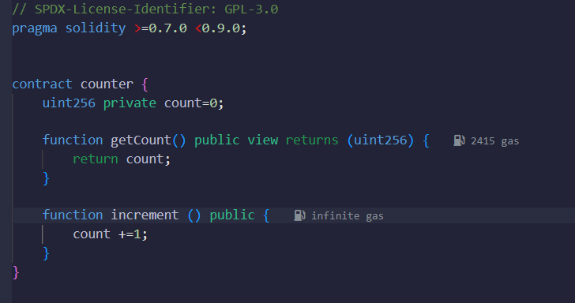

**Output:**

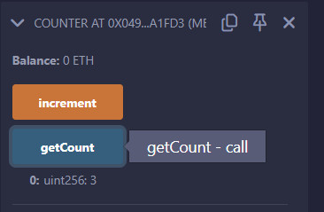

**b) Create a Smart Contract for Calculator.**

**Code:**

// SPDX-License-Identifier: GPL-3.0

pragma solidity >=0.8.2 <0.9.0;

/**

 * @title Storage

 * @dev Store & retrieve value in a variable

 * @custom:dev-run-script ./scripts/deploy_with_ethers.ts

 */

contract Storage {

    uint256 number1;

    uint256 number2;

    function store1(uint256 num) public {

        number1 = num;

    }

    function store2(uint256 num) public {

        number2 = num;

    }

    /**

     * @dev Return value

     * @return value of 'number'

     */

    function addition() public view returns (uint256){

        return number1+number2;

    }

     function subtract() public view returns (uint256){

        return number1+number2;

    }

    function Multiplication() public view returns (uint256){

        return number1*number2;

    }

    function Division() public view returns (uint256){

        return number1/number2;

    }

    function Percentage() public view returns (uint256) {

        return number1*number2 / 100;

    }

}

**Output:**

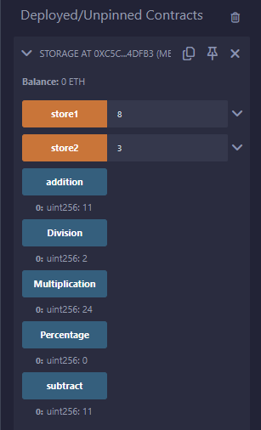

**c) Create a Smart Contract for Increment and Decrement operator.**

**Code:**

// SPDX-License-Identifier: GPL-3.0

pragma solidity >=0.8.2 <0.9.0;

/**

 * @title Storage

 * @dev Store & retrieve value in a variable

 * @custom:dev-run-script ./scripts/deploy_with_ethers.ts

 */

contract Increment_DecrementExample {

    uint256 inc;

    uint256 dec;

    function store1(uint256 num) public {

        inc = num;

        dec = num;

    }

    function increment() public{

         inc= inc + 1 ;

    }

    function deccremnt() public{

         dec= dec - 1 ;

    }

     function getincrement() public view returns (uint256){

        return inc;

    }

      function getdecrement() public view returns (uint256){

        return dec;

    }

}

**Output:**

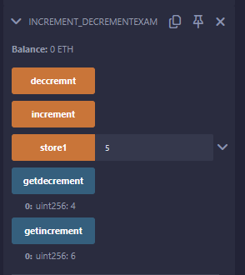

**Another Way for Increment Operator.**

// SPDX-License-Identifier: GPL-3.0

pragma solidity >=0.8.2 <0.9.0;

/**

 * @title Storage

 * @dev Store & retrieve value in a variable

 * @custom:dev-run-script ./scripts/deploy_with_ethers.ts

 */

contract Storage {

    int16 number;

     function store(int16 num) public {

        number = num;

    }

    function increment() public{

        number++;

    }

    function counter() public view returns (int16){

        return number;

    }

    function message() public pure returns (string memory) {

        return "Counter Implemented Sucessfully";

    }

}

**Output:**

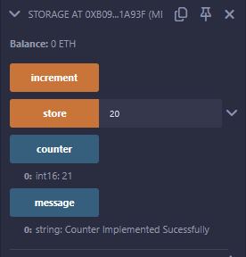

**Practical No: 3**

**Aim: Create a Smart Contract in solidity program to demonstrate array and its types.**

**Code:**

// SPDX-License-Identifier: GPL-3.0

pragma solidity >=0.8.6 <0.9.0;

// Creating a contract

contract Types {

    // Declaring state variables

    // of type array

    uint[6] data1;

    // Defining function to add

    // values to an array

    function array_example() public returns (

    int[5] memory, uint[6] memory){

        int[5] memory data

        = [int(50), -63, 77, -28, 90];

        data1

        = [uint(10), 20, 30, 40, 50, 60];

        return (data, data1);

  }

}

**Output:**

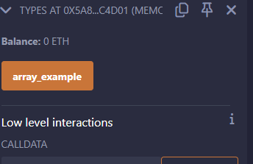

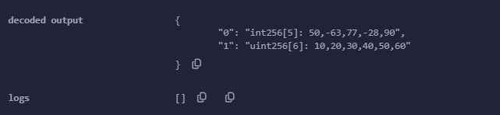

**Practical No: 4**

**Aim: Create a Smart Contract for Operators in solidity Programming**

1. **Solidity program to demonstrate Assignment operators.**
2. **Solidity program to demonstrate Comparison operators.**
3. **Solidity program to demonstrate Logical operators.**
4. **Solidity program to demonstrate Ternary operators.**

**Code:**

// SPDX-License-Identifier: MIT

pragma solidity ^0.8.0;

contract OperatorExample {

    uint256 public comparisonResult;

    bool public logicalResult;

    uint256 public assignmentResult;

    uint256 public ternaryResult;

    function comparison(uint256 a, uint256 b) public {

        if (a == b) {

            comparisonResult = 0; // Equal

        } else if (a > b) {

            comparisonResult = 1; // Greater Than

        } else {

            comparisonResult = 2; // Less Than

        }

    }

    function logical(bool a, bool b) public {

        logicalResult = (a && b) || (!a && !b); // Logical XOR

    }

    function assignment(uint256 a) public {

        assignmentResult = a;

        assignmentResult += 10; // Addition Assignment

        assignmentResult *= 2;  // Multiplication Assignment

        assignmentResult /= 3;  // Division Assignment

    }

    function ternary(uint256 a, uint256 b) public {

        ternaryResult = (a > b) ? a : b; // Ternary Operator

    }

}

**Output:**

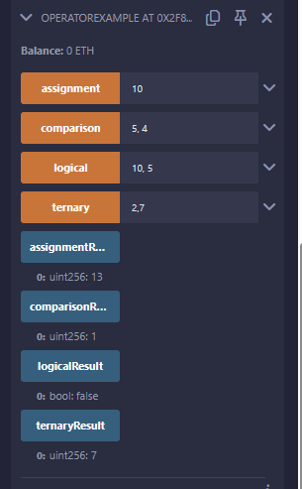

**Practical No: 5**

**Aim: Create a Smart Contract for Loops in Solidity programming**

1. **Create a smart contract for loop**
2. **Create a smart contract for while loop**

**Code:**

// SPDX-License-Identifier: MIT

pragma solidity >=0.6.12 <0.9.0;

// Creating a contract

contract Loops {

    //for loop

    uint256 private result =0;

    function forloop(uint256 number)public returns(uint256){

        for(uint256 i=1;i<=number;i++){

            result += i;

        }

        return result;

    }

        function getforloop() public view returns (uint256){

        return result;

    }

     //while loop

    uint256 private result2=0;

    function whileloop(uint256 number)public returns(uint256){

    uint256 i =1;

    while(i <= number){

        result2 +=i;

        i++;

    }

    return result2;

    }

    function getwhileloop() public view returns (uint256){

        return result2;

    }

}

**Output:**

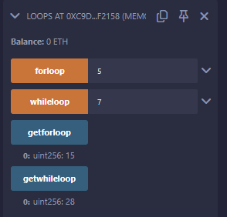

**Practical No: 6**

**Aim: Create smart contract to perform a Mathematical Function & Function Overloading using solidity Programming.**

1. **Create a smart contract to demonstrate Mathematical function.**
2. **Create a smart contract to demonstrate Function overloading.**

**Code:**

1. **Function Overloading**

// SPDX-License-Identifier: MIT

pragma solidity ^0.8.0;

contract OverloadingExample {

    // Function with one parameter

    function add(uint256 a) public pure returns (uint256) {

        return a + 1;

    }

    // Overloaded function with two parameters

    function add(uint256 a, uint256 b) public pure returns (uint256) {

        return a + b;

    }

    // Another overloaded function with two parameters of different types

    function add(uint256 a, uint256 b, uint256 c) public pure returns (uint256) {

        return a + b + c;

    }

}

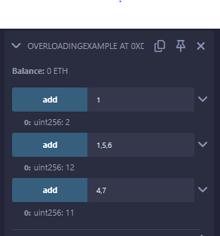

1. **Mathematical Function(Fibonacci Sequence and Factorial function)**

**Code:**

// SPDX-License-Identifier: MIT

pragma solidity ^0.8.0;

contract FibonacciMath {

    // Function to calculate the nth Fibonacci number

    function fibonacci(uint256 n) public pure returns (uint256) {

        if (n == 0) return 0;

        if (n == 1) return 1;

        uint256 a = 0;

        uint256 b = 1;

        uint256 c;

        for (uint256 i = 2; i <= n; i++) {

            c = a + b;

            a = b;

            b = c;

        }

        return b;

    }

     // Function to calculate the factorial of a number

    function factorial(uint256 n) public pure returns (uint256) {

        if (n == 0) return 1;

        uint256 result = 1;

        for (uint256 i = 1; i <= n; i++) {

            result *= i;

        }

        return result;

    }

}

**Output:**

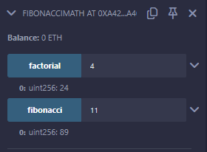

**Practical No: 7**

**Aim: Create a Smart Contract for Implementation of Interface & Inheritance in solidity programming.**

1. **Implementation of Interface**

**Code:**

**InterfaceExample.sol**

// SPDX-License-Identifier: GPL-3.0

pragma solidity >=0.8.6 <0.9.0;

//initialize the interface

interface InterfaceExample{

    // Functions having only

    // declaration not definition

    function getStr(

    ) external view returns(string memory);

    function setValue(

    uint _num1, uint _num2) external;

    function add(

    ) external view returns(uint);

}

**Interface_sol.sol**

// SPDX-License-Identifier: GPL-3.0

pragma solidity >=0.8.6 <0.9.0;

/// @title A contract for demonstrate the working of the interface

/// @author Jitendra Kumar

/// @notice For now, this contract just show how interface implements in the smart contract

import "./InterfaceExample.sol";

// Contract that implements interface

contract MyContract is InterfaceExample{

    // Private variables

    uint private num1;

    uint private num2;

    // Function definitions of functions

    // declared inside an interface

    function getStr() public view virtual override returns(string memory){

        return "number";

    }

    // Function to set the values

    // of the private variables

    function setValue(

    uint _num1, uint _num2) public virtual override{

        num1 = _num1;

        num2 = _num2;

    }

    // Function to add 2 numbers

    function add(

    ) public view virtual override returns(uint){

        return num1 + num2;

    }

}

contract call{

    //Creating an object

    InterfaceExample obj;

    constructor(){

        obj = new MyContract();

    }

    // Function to print string

    // value and the sum value

    function getValue(

    ) public returns(string memory,uint){

        obj.setValue(10, 16);

        return (obj.getStr(),obj.add());

    }

}

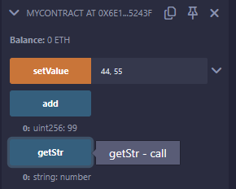

1. **Inheritance**

**Code:**

// SPDX-License-Identifier: MIT

pragma solidity >=0.6.12 <0.9.0;

// Solidity program to demonstrate Interface and Inheritance

// Defining an interface

interface IParent {

    function setValue(uint _a, uint _b) external;

    function getValue() external view returns (uint);

}

// Defining a base contract

contract Parent {

    uint internal sum;

    // Function to set the value of sum

    function setValue(uint _a, uint _b) external virtual {

        sum = _a + _b;

    }

}

// Defining a derived contract that inherits from Parent and implements IParent

contract Child is Parent, IParent {

    // Override function to set the value of sum from both Parent and IParent

    function setValue(uint _a, uint _b) external override(Parent, IParent) {

        sum = _a + _b;

    }

    // Override function to get the value of sum from IParent

    function getValue() external view override returns (uint) {

        return sum;

    }

}

// Defining a calling contract

contract Caller {

    // Creating Child contract object

    Child cc = new Child();

    // Function to call setValue and getValue functions

    function testInheritance() public returns (uint) {

        cc.setValue(10, 20);

        return cc.getValue();

    }

}

**Output:**

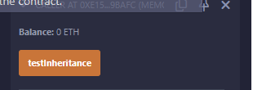

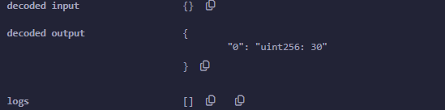

**Practical No: 8**

**Aim: Create smart contract for Selection of candidate in election.**

**Code:**

// SPDX-License-Identifier: MIT

pragma solidity ^0.8.0;

contract Election {

    // Owner of the contract

    address public owner;

    // Election states

    enum ElectionState { Created, Voting, Ended }

    ElectionState public state;

    // Candidate struct

    struct Candidate {

        uint id;

        string name;

        uint voteCount;

    }

    // Voter struct

    struct Voter {

        bool authorized;

        bool voted;

        uint vote;

    }

    // Candidates

    mapping(uint => Candidate) public candidates;

    uint public candidatesCount;

    // Voters

    mapping(address => Voter) public voters;

    uint public totalVotes;

    // Events

    event ElectionStarted();

    event ElectionEnded();

    event VoterAuthorized(address voter);

    event VoteCast(address voter, uint candidateId);

    // Modifiers

    modifier ownerOnly() {

        require(msg.sender == owner, "Only owner can call this function");

        _;

    }

    modifier inState(ElectionState _state) {

        require(state == _state, "Invalid state for this action");

        _;

    }

    constructor() {

        owner = msg.sender;

        state = ElectionState.Created;

    }

    // Function to add a candidate

    function addCandidate(string memory _name) public ownerOnly inState(ElectionState.Created) {

        candidatesCount++;

        candidates[candidatesCount] = Candidate(candidatesCount, _name, 0);

    }

    // Function to authorize a voter

    function authorizeVoter(address _voter) public ownerOnly inState(ElectionState.Created) {

        voters[_voter].authorized = true;

        emit VoterAuthorized(_voter);

    }

    // Function to start the election

    function startElection() public ownerOnly inState(ElectionState.Created) {

        state = ElectionState.Voting;

        emit ElectionStarted();

    }

    // Function to end the election

    function endElection() public ownerOnly inState(ElectionState.Voting) {

        state = ElectionState.Ended;

        emit ElectionEnded();

    }

    // Function to vote

    function vote(uint _candidateId) public inState(ElectionState.Voting) {

        require(voters[msg.sender].authorized, "You are not authorized to vote");

        require(!voters[msg.sender].voted, "You have already voted");

        require(_candidateId > 0 && _candidateId <= candidatesCount, "Invalid candidate ID");

        voters[msg.sender].voted = true;

        voters[msg.sender].vote = _candidateId;

        candidates[_candidateId].voteCount++;

        totalVotes++;

        emit VoteCast(msg.sender, _candidateId);

    }

    // Function to get the winner

    function getWinner() public view inState(ElectionState.Ended) returns (string memory winnerName) {

        uint maxVotes = 0;

        uint winningCandidateId = 0;

        for (uint i = 1; i <= candidatesCount; i++) {

            if (candidates[i].voteCount > maxVotes) {

                maxVotes = candidates[i].voteCount;

                winningCandidateId = i;

            }

        }

        winnerName = candidates[winningCandidateId].name;

    }

}

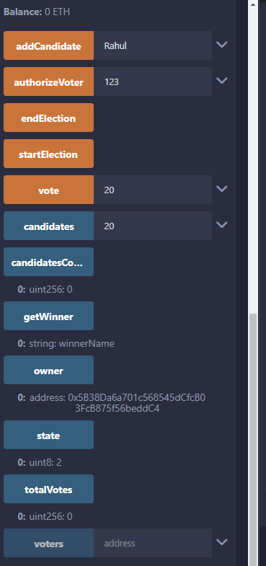

**Practical No: 9**

**Aim:** **Write a solidity program to create an array of role no.& create a smart contract where it checks the value of roll no.s & perform AND operation with today's date DD and if the result is even display a message " Student is ALLOWED." else display "DENIED".**

**Code:**

// SPDX-License-Identifier: GPL-3.0

pragma solidity ^0.8.2;

contract allowDenyStudent {

    uint256[] public arr = [1,2,3,4,5,6,7,8,9,10];

    uint256 public rollNumber;

    uint256 public DD;

    function setRollNumber(uint256 _rollNumber) public {

        rollNumber = arr[_rollNumber];

    }

    function setDD(uint256 _DD) public {

        DD = _DD;

    }

    function arrayChecker() public view returns (string memory) {

        string memory finalOutput ;

        uint256 operation = rollNumber & DD;

        if (operation % 2 == 0) {

            finalOutput = 'student is allowed.';

        }else {

            finalOutput = 'student is denied.';

        }

        return finalOutput;

    }

}

**Output:**

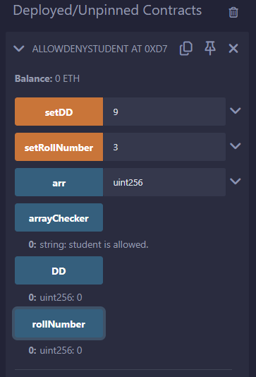

**Practical No: 10**

**Aim: - Write a solidity program to find the sum of an array of ten numbers using loop the numbers are expected to be taken from the user, create a smart contract to find the AND operation of odd positioned numbers and OR operation of even positioned numbers including 0th index. Hence find the product of the results and also identify whether the result is the part of array or not.**

**Code:**

// SPDX-License-Identifier: GPL-3.0

pragma solidity >=0.8.6 <0.9.0;

import "hardhat/console.sol";

contract allowDenyStudent {

    uint256[10] public rollNumbers;

    function setRollNumber (uint _index,uint _rollNumber) public {

        rollNumbers[_index] = (_rollNumber);

    }

    function seperatingEvenOdd() public {

    for (uint i=0; i<rollNumbers.length; i++) {

        if(i %2 == 0) {

            evenPositioned.push(rollNumbers[i]);

        } else {

            oddPositioned.push(rollNumbers[i]);

        }}}

    uint[] public evenPositioned;

    uint[] public oddPositioned;

    function OR_AND_Operation() public {

        uint resultOfOR = evenPositioned[0];

        for (uint i=1;i<evenPositioned.length; i++) {

            resultOfOR = resultOfOR | evenPositioned[i];

        }

        uint resultofAND = oddPositioned[0];

        for (uint i=1;i<oddPositioned.length; i++) {

            resultofAND = resultofAND & oddPositioned[i];

        }

        productofresults = resultOfOR = resultofAND;

    }

    uint256 public productofresults;

    function checkProductOfResults() public view returns (bool) {

    bool result;

    for (uint i=0; i<rollNumbers.length; i++) {

            result = (productofresults == rollNumbers [i]) ? true : false;

        }

        return result;

    }

}

**Output:**

