**Data Structures & Algorithms**

**Exercise 2: Exercise 2: E-commerce Platform Search Function**

**Code:**

public class Main {

class Product {

int id;

String name;

String category;

Product(int id, String name, String category) {

this.id = id;

this.name = name;

this.category = category;

}

public void printDetails() {

System.out.println(id);

System.out.println(name);

System.out.println(category);

}

}

void searchByName(Product[] products, String name) {

boolean found = false;

for (Product p : products) {

if (p.name.equalsIgnoreCase(name)) {

p.printDetails();

found = true;

break;

}

}

}

void example() {

Product[] items = {

new Product(1, "Laptop", "Electronics"),

new Product(2, "Mobile", "Electronics"),

new Product(3, "Shoes", "Fashion")

};

searchByName(items, "Mobile");

}

public static void main(String[] args) {

new Main().example();

}

}

**Output:**

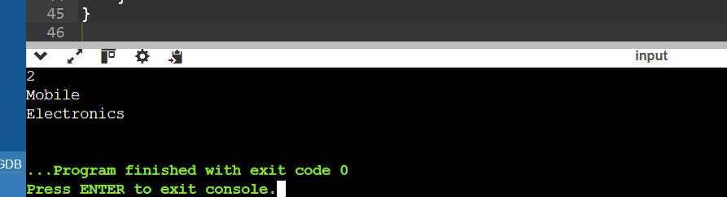

**Exercise 7: Exercise 7: Financial Forecasting**

**Code:**

public class Main {

int calculate(int amount, int rate, int years) {

if (years == 0) {

return amount;

}

return calculate(amount, rate, years - 1) * (1 + rate);

}

void run() {

int Amount = 1000;

int Rate = 2;

int Years = 4;

int result = calculate(Amount, Rate, Years);

System.out.println("No of years:" + Years);

System.out.println("Results: Rs."+result);

}

public static void main(String[] args) {

new Main().run();

}

}

**Output:**

