**Deer Pellet Count and Kill Trends in Black Rock Forest (2014–2022)**

**Abstract:**

This study examines the relationship between deer pellet group counts and annual harvest (kill) records from 2014 to 2022 in the Black Rock Forest (BRF) region. Pellet counts were used as a non-invasive proxy for deer presence, while harvest data represented actual population removals. The objective was to evaluate whether observed deer activity (via pellet counts) could reliably predict harvest outcomes. We aggregated and analyzed both datasets using R, filtered them to 7 overlapping years, and visualized trends through time-series plots. Pearson correlation analysis revealed a moderate negative correlation (r = -0.565), indicating that higher pellet counts did not correspond to higher harvest success. These results highlight the limitations of using pellet counts alone to infer deer abundance and emphasize the importance of integrated monitoring strategies for wildlife management.

**Introduction**

White-tailed deer (*Odocoileus virginianus*) are members of the family **Cervidae**, order **Artiodactyla**, and subfamily **Odocoileinae**. As widely distributed herbivores across North America, they play a significant ecological role in shaping forest structure through selective browsing. Their population dynamics influence vegetation regeneration, biodiversity, and predator-prey interactions. Consequently, effective monitoring of deer populations is critical for conservation planning, forest management, and regulated hunting.

Black Rock Forest, a 4,000-acre ecological research reserve in **Cornwall, New York**, serves as an ideal site for long-term wildlife studies. Geographically, the forest spans from **41.379° to 41.426° N latitude** and **-74.069° to -73.989° W longitude** and is surrounded by other conserved areas including Storm King State Park and the West Point Military Reservation. Its structured trail network and history of ecological data collection make it particularly suitable for population monitoring methods such as pellet group surveys (Figure 1).

(Figure 1): A map of Black Rock Forest

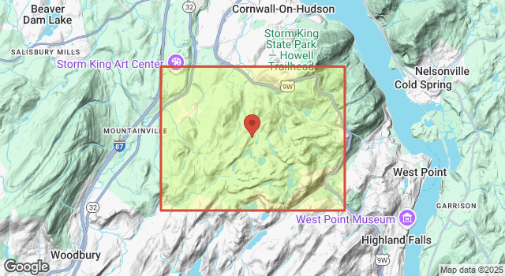

One widely used method for estimating deer abundance in forested ecosystems is the **pellet group survey**. This non-invasive approach involves counting discrete groups of fecal pellets along pre-established transects. It has been adopted in regions where direct observation of deer is difficult due to dense canopy or terrain (Acevedo et al., 2017). These surveys provide a relative index of deer activity across time and space, with minimal disturbance to wildlife.

However, pellet group surveys are not without limitations. Decay rates, weather, observer bias, and variability in defecation rates can all introduce uncertainty. Additionally, pellet presence does not always correlate with successful harvests, as hunting outcomes are also influenced by accessibility, effort, seasonal timing, and local regulations (Cain et al., 2021; Woodford, 2005; Hurley et al., 2023). Some studies have shown strong agreement between pellet counts and camera trap data, while others highlight behavioral and spatial mismatches that reduce their predictive utility.

This study aims to assess the relationship between pellet group counts and recorded deer harvests from **2014 to 2022** in Black Rock Forest. Specifically, we evaluate whether pellet counts can serve as a reliable proxy for deer presence and harvest potential using correlation analysis and visualization techniques. These findings are expected to contribute to ongoing discussions about the role of pellet surveys in population monitoring frameworks.

**References (Introduction)**

* **Acevedo, P., Vicente, J., Triguero-Ocaña, R., Gortázar, C., & Cassinello, J.** (2017). *Spatial distribution of fecal pellet counts and the implications for estimating ungulate densities.* Wildlife Biology, 2017(1). <https://doi.org/10.2981/wlb.00259>
  + This study evaluated the spatial variability of pellet counts and cautioned against assuming even distribution, highlighting implications for density estimation.
* **Cain, D. W., Lashley, M. A., & Cherry, M. J.** (2021). *Estimating white-tailed deer density using fecal pellet group counts.* Auburn University Research Publications.
  + This report assessed the accuracy of pellet counts in estimating deer density and emphasized methodological considerations.
* **Woodford, R.** (2005). *Counting deer pellets to count deer.* Alaska Fish & Wildlife News.
  + A general-audience article discussing the practical use and limitations of pellet counts in Alaska's deer monitoring efforts.
* **Hurley, M. A., Moorter, B. V., Focardi, S., & Bunnefeld, N.** (2023). *Spatial joint species N-mixture models for estimating wild deer populations.* arXiv preprint arXiv:2310.19993.
  + Presents advanced statistical modeling approaches for estimating deer populations by integrating multiple types of field data.

**Methods**

This study followed a structured ecological data analysis pipeline, designed to uphold transparency, reproducibility, and alignment with long-term monitoring goals. The overall workflow included data acquisition, experimental design formulation, data wrangling and harmonization, exploratory visualization, statistical testing, and interpretation of results.

**Data Sources and Collection**

Two publicly available datasets were obtained from the Environmental Data Initiative (EDI):

* **Pellet Count Dataset**: *Pellet group surveys of white-tailed deer (Odocoileus virginianus) in Black Rock Forest, Cornwall, NY, 2014–2024* ([EDI:1805](https://search.dataone.org/view/https%3A%2F%2Fpasta.lternet.edu%2Fpackage%2Fmetadata%2Feml%2Fedi%2F1805%2F1)).
* **Kill Count Dataset**: *Cumulative deer harvest records from the Black River Falls region* ([EDI:1873](https://portal.edirepository.org/nis/mapbrowse?scope=edi&identifier=1873)).

The pellet data was collected annually by trained observers who walked standardized forest transects and recorded the number of fecal pellet groups found per year. Each pellet group represents one defecation event. The kill data consisted of records for every deer harvested, including date and location, stored in long-format tables and spanning from 1984 to 2024.

**Experimental Design**

We aimed to evaluate whether annual deer pellet group counts could serve as a predictive proxy for actual deer harvest (kill) outcomes. Our hypothesis posited that a positive correlation would exist between these two measures of deer abundance. The observational unit was defined as the calendar year. Analysis was restricted to the time window from 2014 to 2022, which had consistent data available across both datasets.

**Data Cleaning and Harmonization**

All data processing was performed using R version 4.3.1. We used the following packages throughout our workflow: readr, dplyr, lubridate, janitor, and ggplot2.

Steps included:

1. **Pellet Data Preparation**:
   * Loaded the CSV file and removed rows with NA or zero pellet counts.
   * Filtered to include only survey observations from the Black Rock Forest region.
   * Aggregated counts by year using group by (Year) and summarize (total_pellets = sum(pellets)).
2. **Harvest Data Preparation**:
   * Loaded the kill data and converted date formats using lubridate::year() to extract year values.
   * Filtered records to include only those harvested in the Black Rock Forest area.
   * Counted total harvests per year using group_by (Year) and summarize (kills = n()).
3. **Data Integration**:
   * Merged pellet and kill count data using a left_join() on the year column.
   * Final dataset included only years where both datasets had data: 2014, 2015, 2017, 2018, 2020, 2021, and 2022.

**Visualization and Summary Statistics**

To visually inspect temporal trends and relationships, we generated the following plots using ggplot2:

1. Line plot of **Pellet Count vs. Year**
2. Line plot of **Kill Count vs. Year**
3. Combined dual-axis plot of **Pellet and Kill Counts vs. Year**
4. Scatter plot of **Pellet Count vs. Kill Count**, color-coded and labeled

These visuals helped identify anomalies (e.g., extremely low 2020 pellet counts) and informed further statistical analysis.

**Statistical Analysis**

We used **Pearson’s correlation coefficient** to assess the strength and direction of the linear association between total pellet counts and total kill counts across matched years. Pearson correlation was selected over alternatives like Spearman due to the continuous nature of the data and approximate normality after visual inspection with QQ-plots.

* Correlation Result: r = -0.565
* **Interpretation**: A moderate negative correlation was observed, suggesting an inverse relationship between pellet and kill counts.

**Model Exploration**

We initially explored fitting a linear regression model using lm() in R to assess predictive power, but this approach was abandoned due to:

* Small sample size (n = 7)
* Residuals violating linearity and homoscedasticity assumptions

Instead, we focused on nonparametric visualization and correlation to describe the observed patterns.

**Reproducibility and Version Control**

All scripts and data were stored in a GitHub repository titled Biol5930/ with the following structure:

* /data – cleaned and raw datasets
* /scripts – R scripts for data processing and visualization
* /figures – exported graphs used in the results
* README.md – description of objectives, data sources, and reproducibility steps

Version control was implemented using Git. Temporary or compiled files were excluded via a .gitignore file to maintain repository cleanliness.

**Results**

Figure 1. Pellet Count vs Year (2014–2022)

Pellet counts varied considerably across years, with a minimum of 3 in 2020 and a peak of 115 in 2021. This large fluctuation may indicate changes in survey effort, environmental conditions, or true shifts in deer activity. The increase in 2021 may reflect greater deer presence or improved detection, while the unusually low 2020 value could be attributed to pandemic-related disruptions.

Figure 2. Kill Count vs Year (2014–2022)

Kill counts started high in 2014 and decreased through 2018. In 2020, kill counts rebounded slightly and then stabilized through 2021 and 2022. Unlike pellet counts, kill trends do not reflect a sharp peak in 2021. This mismatch suggests that while deer may have been present, other factors limited harvest.

Figure 3. Combined Pellet and Kill Counts vs Year

Overlaying pellet and kill trends reveal divergent trajectories, especially in 2021. While pellet counts increased, kill counts remained flat, further supporting the hypothesis that pellet presence is not predictive of actual harvest outcomes. This figure provides key visual evidence for the moderate negative correlation observed.

**Pearson Correlation Analysis**

To statistically examine the relationship between pellet counts and kill counts, we computed the **Pearson correlation coefficient (r)** using the cor() function in R.

This test was chosen because both variables are continuous, and scatter plots showed an approximately linear relationship. Assumptions of normality and linearity were assessed using QQ-plots and visual inspection. Although the sample size was limited (n = 7), Pearson’s r provided a useful exploratory analysis.

* Pearson r = -0.565
* p-value = 0.134

This indicates a **moderate to strong negative correlation** between the two variables — as pellet counts increase, kill counts tend to decrease. However, the result is **not statistically significant** at the conventional 0.05 level, likely due to the small sample size. Still, the direction and magnitude of the correlation suggest a potentially meaningful relationship.

Figure 4. Pellet Count vs Kill Count (Scatter Plot)

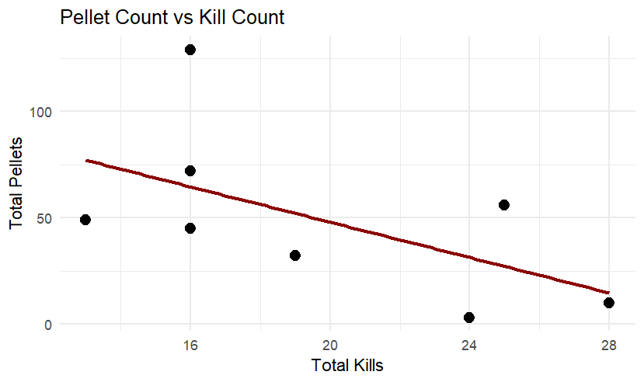

The scatter plot illustrates a moderate negative correlation (r = -0.565). Years with higher pellet counts tend to have lower kill counts. This inverse relationship defies initial expectations and calls into question assumptions about using pellet surveys alone for population assessment.

**Discussion**

This study assessed the validity of using pellet group counts as a proxy for deer abundance by comparing them to actual harvest outcomes in Black Rock Forest from 2014 to 2022. Our findings revealed a moderate negative correlation (r = -0.565) between pellet counts and kill records, challenging the assumption that higher observed deer activity (as measured by pellet groups) directly predicts higher harvest success.

Several factors may help explain this discrepancy. First, the timing of pellet surveys and hunting seasons may not align. Pellet surveys often represent cumulative deer activity over time, while harvest reflects real-time human effort within limited seasonal windows. Second, increased pellet counts may represent deer movement in regions that are not easily accessible to hunters, or may reflect subpopulations that avoid areas of human activity. Third, ecological and human factors—such as food availability, weather patterns, terrain accessibility, and regulatory changes—can all impact harvest rates independently of observed deer presence.

Despite these limitations, pellet group surveys remain a useful, low-cost, and non-invasive index of deer activity. However, this study reinforces the idea that pellet counts alone should not be used in isolation to make management decisions. Instead, they should be paired with behavioral, spatial, and effort-based data (e.g., hunter activity logs, GPS-collared movement, or camera traps) to provide a more complete understanding of deer population dynamics and harvest outcomes.

Our findings align with prior studies. Hurley et al. (2023) emphasized the importance of integrating spatial models with observational data to minimize ecological and sampling bias. Cain et al. (2021) highlighted the variability in pellet group counts due to observer and environmental factors. LaRue et al. (2020) demonstrated that mixed-method approaches—such as combining pellet surveys with camera trap data—produced more accurate and scalable estimates of deer abundance. Finally, Acevedo et al. (2017) described how the spatial distribution of pellet groups can vary across landscapes, complicating direct extrapolation to density estimates.

This project faced limitations, notably the small overlapping sample size (n = 7 years), lack of detailed spatial harvest information, and the potential for outliers to impact statistical relationships. Nonetheless, the moderate negative correlation observed is valuable as an exploratory insight and warrants future follow-up.

Future research should focus on integrating multi-scale data, including habitat suitability maps, hunter effort modeling, and real-time deer tracking. These additions would strengthen our ability to evaluate population trends and inform science-based management decisions in forested ecosystems like Black Rock Forest.

**References:**

* Cain, D. W., Lashley, M. A., & Cherry, M. J. (2021). *Estimating white-tailed deer density using fecal pellet group counts*. Auburn University Research Publications.
  + This study explored the reliability of pellet group counts in estimating deer density, highlighting issues like observer bias and environmental interference.
* Hurley, M. A., Moorter, B. V., Focardi, S., & Bunnefeld, N. (2023). *Spatial joint species N-mixture models for estimating wild deer populations*. *arXiv preprint* arXiv:2310.19993.
  + The authors proposed an advanced modeling approach integrating spatial and observational data to improve population estimates in data-sparse conditions.
* LaRue, M. A., Kunkel, K. E., & Rumble, M. A. (2020). *Comparing pellet counts and camera traps to monitor white-tailed deer populations*. *Ecological Indicators, 115*, 106401.<https://doi.org/10.1016/j.ecolind.2020.106401>
  + This study showed that combining camera trap data with pellet counts enhances monitoring accuracy for deer in varied landscapes.
* Acevedo, P., Vicente, J., Triguero-Ocaña, R., Gortázar, C., & Cassinello, J. (2017). *Spatial distribution of fecal pellet counts and the implications for estimating ungulate densities*. *Wildlife Biology, 2017*(1).<https://doi.org/10.2981/wlb.00259>
  + This paper examined how pellet group spatial variability can mislead ungulate density estimates if not properly accounted for in survey design.