EXPERIMENT 7

DATA VISUALIZATION USING TABLEAU

Aim:
To connect, analyze, visualize, and create interactive dashboards using Tableau for effective business intelligence and data analytics.
Sample Dataset:
Artist Streaming Dataset

Algorithm 1:
Connecting Data Source
Step 1 Open Tableau Desktop
Step 2 Select Connect
Step 3 Choose Text File
Step 4 Browse Dataset
Step 5 Open Dataset
Step 6 Verify Imported Data
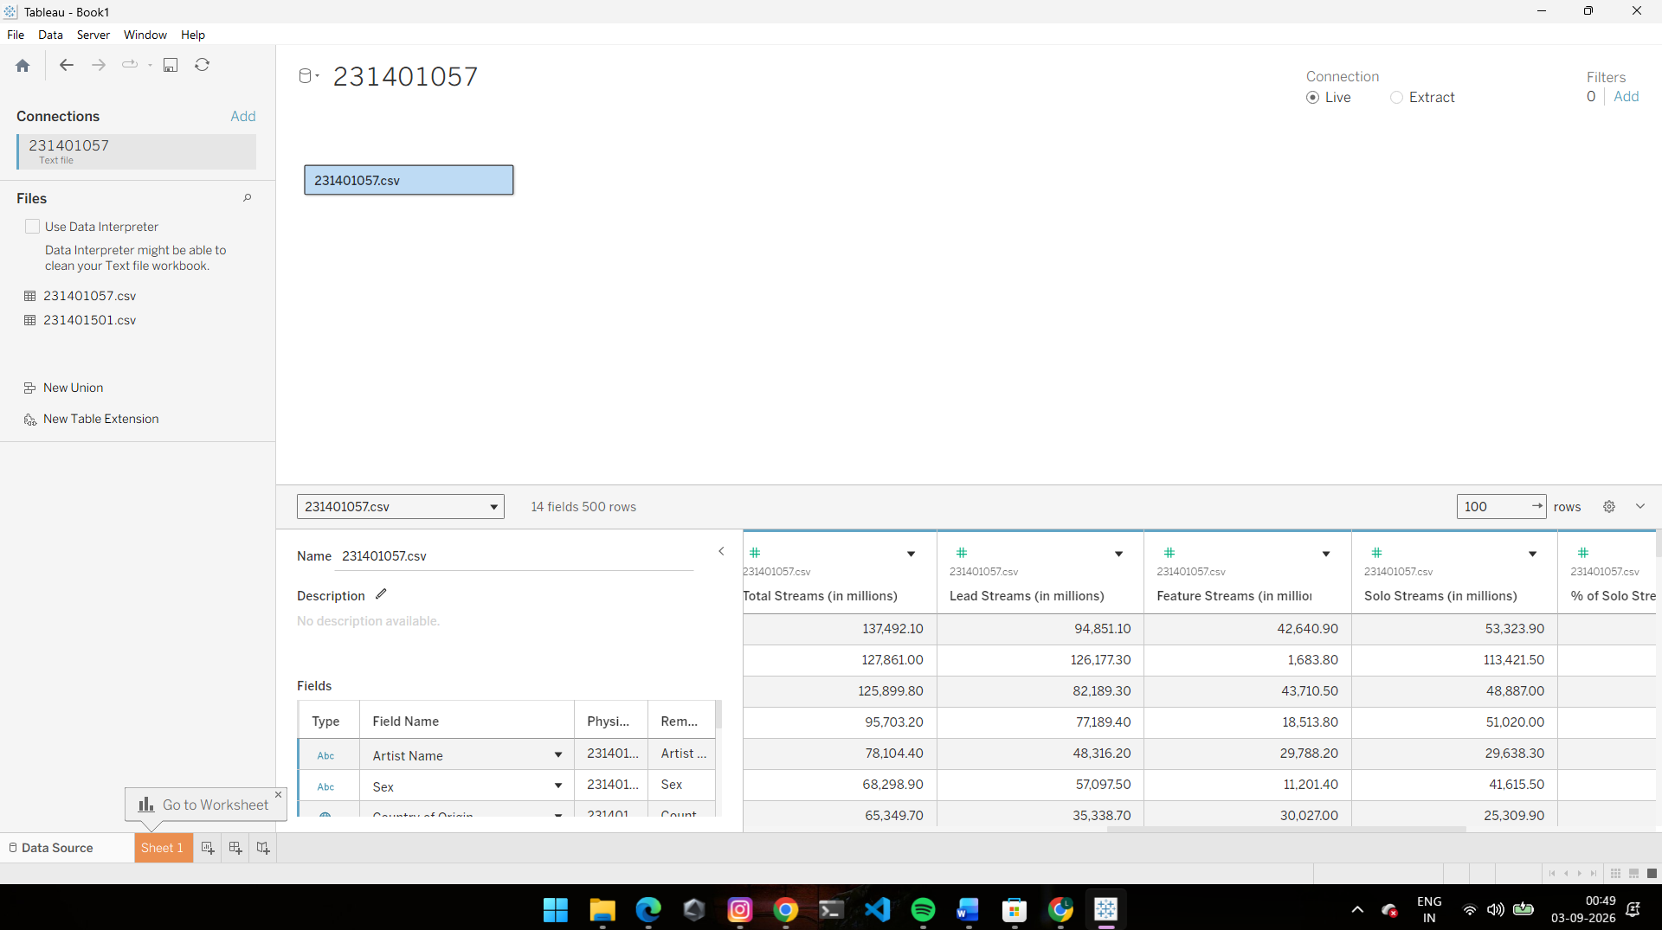

Algorithm 2:
Creating Worksheet
Step 1 Open Sheet 1
Step 2 Drag Primary Genre to Columns
Step 3 Drag Total Streams (in millions) to Rows
Step 4 Select Visualization
Step 5 Analyze Results

Output:
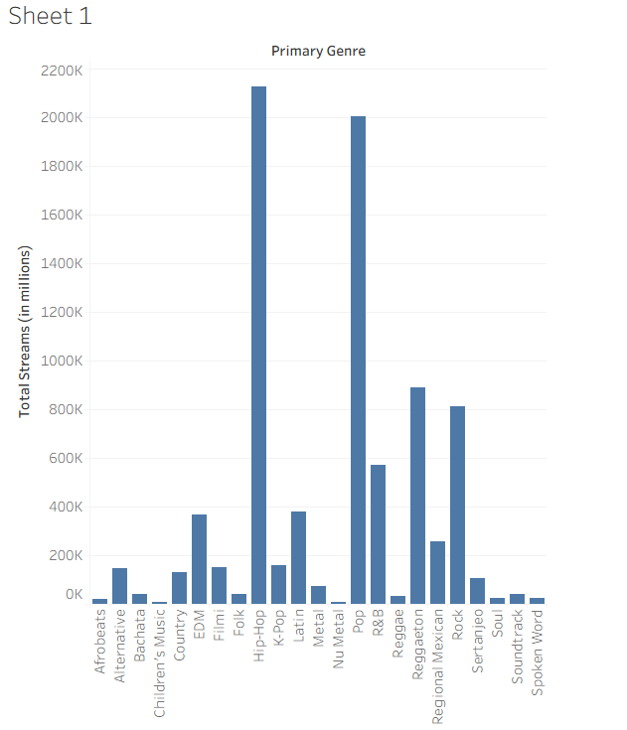

Algorithm 3:
Bar Chart Creation
Step 1 Drag Primary Genre → Columns
Step 2 Drag Total Streams (in millions) → Rows
Step 3 Select Bar Chart
Step 4 Apply Labels
Step 5 Format Visualization

Output:
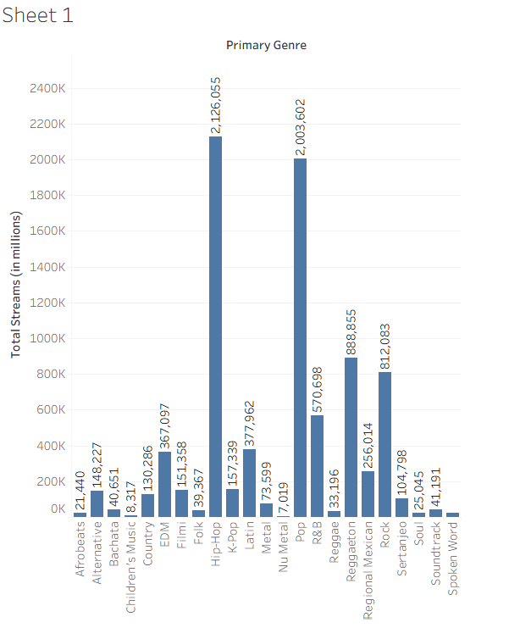

Algorithm 4:
Pie Chart Creation
Step 1 Drag Primary Genre
Step 2 Drag Total Streams (in millions)
Step 3 Select Pie Chart
Step 4 Show Labels
Step 5 Analyze Distribution

Output:
Genre-wise Stream Contribution
Contribution of genres to total streams.
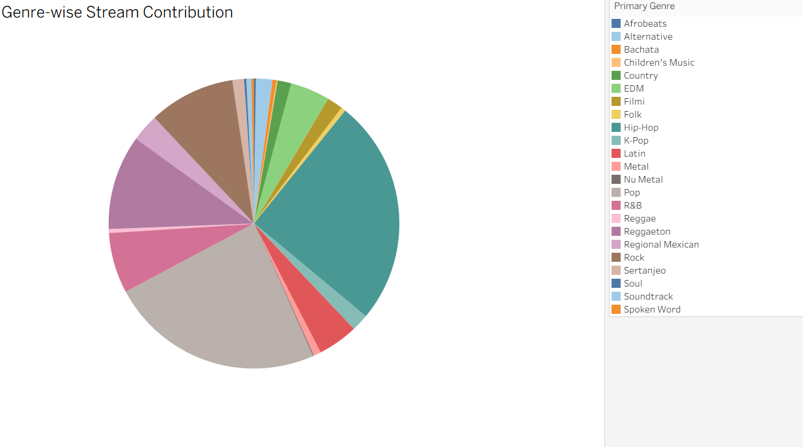
Hip-Hop contributes the highest share of total streams, approximately 25.28%.

Algorithm 5:
Line Chart Creation
Step 1 Drag Artist Name
Step 2 Drag Total Streams (in millions)
Step 3 Select Line Chart
Step 4 Apply Formatting

Output:
Artist Streaming Trend
Streams trend among artists.
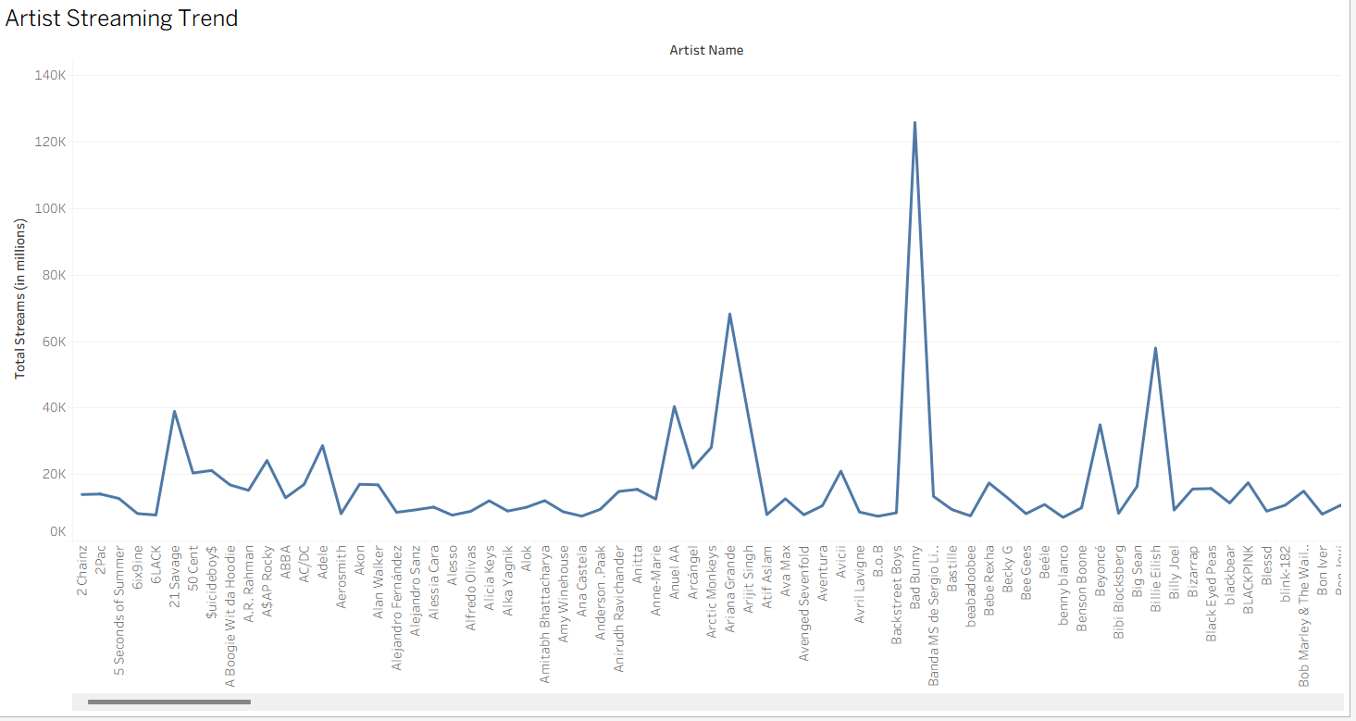

Algorithm 6:
Creating Calculated Field
Objective
Calculate Percentage
Streams Formula (Total Streams / Total Streams) * 100
Procedure
Analysis → Create Calculated Field
Name: Percentage Streams
Formula: [Total Streams (in millions)] / { FIXED : SUM([Total Streams (in millions)]) } * 100

Output:
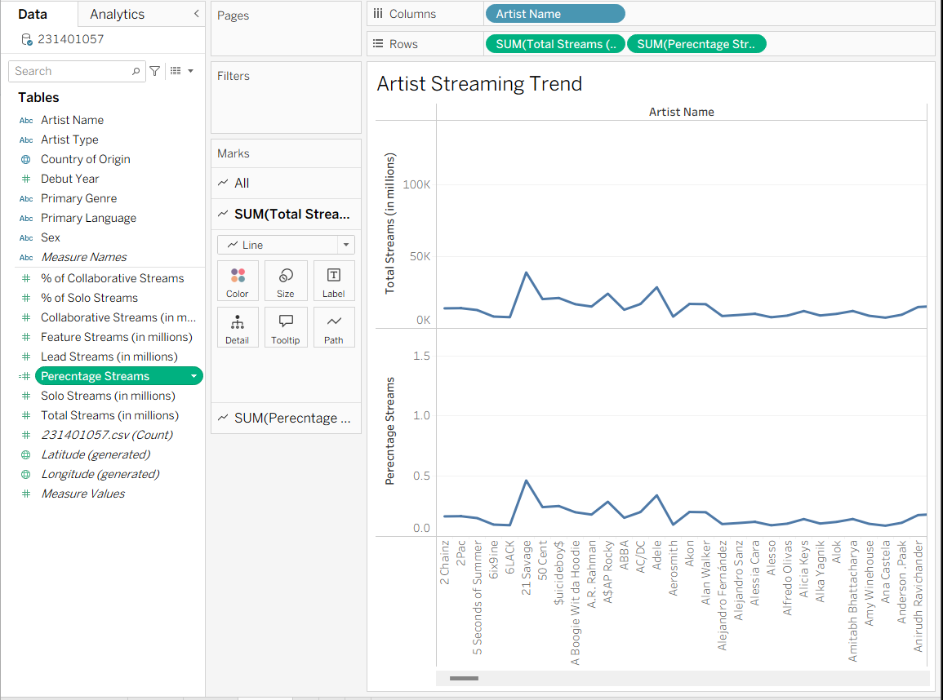

Algorithm 7:
Applying Filters
Step 1 Drag Primary Genre to Filters
Step 2 Select Primary Genre
Step 3 Apply Filter
Step 4 Observe Updated Charts
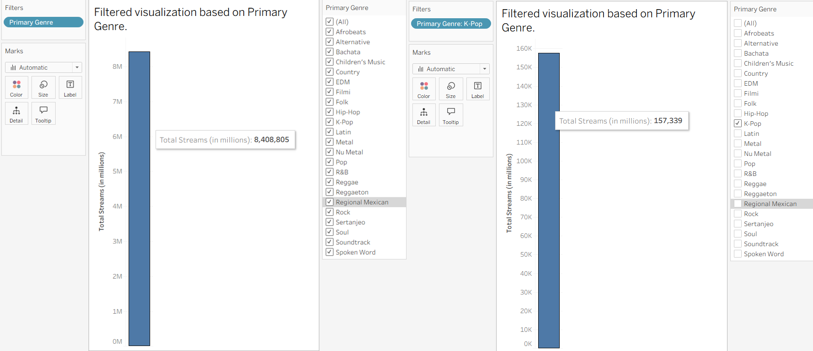

Algorithm 8:
Creating Parameter
Step 1 Create Parameter
Step 2 Specify Minimum Streams
Step 3 Apply Parameter
Step 4 Display Matching Records

Output:
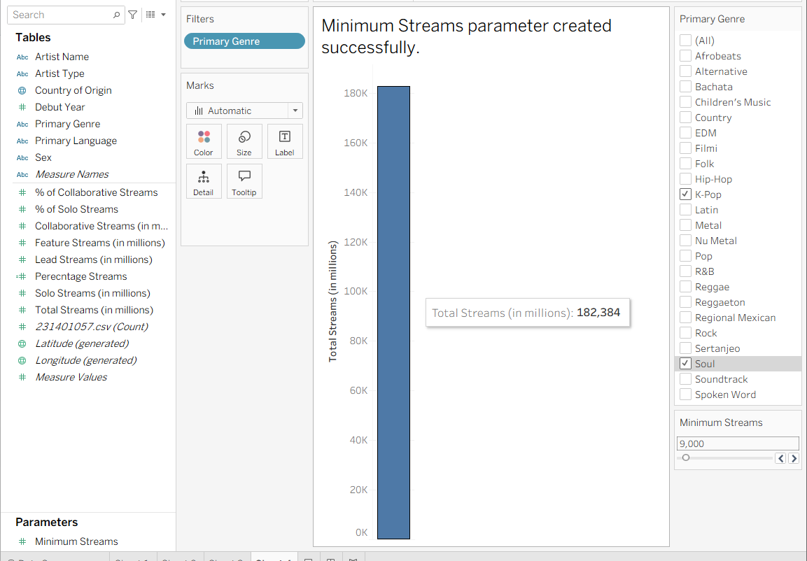

Algorithm 9:
Dashboard Creation
Step 1 Create Multiple Worksheets
Step 2 Select Dashboard
Step 3 Drag Worksheets
Step 4 Arrange Components
Step 5 Add Filters
Step 6 Save Dashboard

Output:
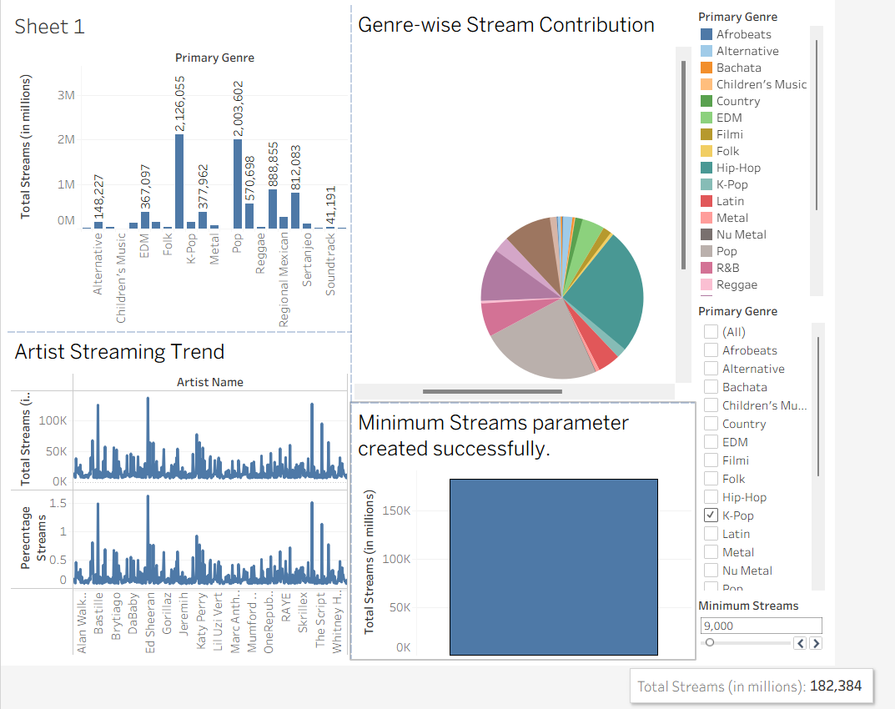

Result:
Thus, Tableau was used successfully to connect the artist streaming dataset, create worksheets, apply filters and parameters, generate visualizations, and build dashboards for data analysis.

