EXPERIMENT 6
DATA VISUALIZATION USING POWER BI
Aim
To import, transform, analyze, and visualize data using Power BI Desktop and create interactive dashboards and reports for decision-making.
Software Requirements
• Microsoft Power BI Desktop
• Microsoft Excel
• CSV Dataset
• Windows Operating System
Algorithm 1
Importing Data into Power BI
Step 1
Open Power BI Desktop.
Step 2
Select Home → Get Data.
Step 3
Choose Text/CSV.
Step 4
Browse and select the dataset file 231401057.csv.
Step 5
Click Load.
Step 6
Verify that the artist streaming dataset is imported correctly in Power BI.
Dataset used: Artist Streaming Dataset (500 records, 14 fields).
Important fields include Artist Name, Country of Origin, Primary Genre, Artist Type, Debut Year, Total Streams (in millions), Lead Streams (in millions), Feature Streams (in millions), Solo Streams (in millions), and Collaborative Streams (in millions).

Algorithm 1 – Output
Imported Dataset
The artist streaming dataset was successfully imported into Power BI.
Artist Name | Country of Origin | Primary Genre | Total Streams (in millions)
Drake | Canada | Hip-Hop | 137,492.1
Taylor Swift | United States | Pop | 127,861.0
Bad Bunny | United States | Reggaeton | 125,899.8
The imported data contains artist, demographic, genre, debut-year, and streaming-related attributes.
Algorithm 2
Data Transformation using Power Query
Step 1
Select Transform Data.
Step 2
Open Power Query Editor.
Step 3
Check the dataset and remove duplicate records if present.
Step 4
Check for null or missing values and handle them appropriately.
Step 5
Verify and rename columns where necessary; retain the dataset field names used for visualization.
Step 6
Select Close & Apply to load the transformed data into Power BI.
Output
Cleaned artist streaming dataset loaded successfully into Power BI.

Algorithm 3
Creating a Bar Chart
Step 1
In Report View, select the Clustered Column Chart visualization.
Step 2
Drag Primary Genre → X-axis.
Step 3
Drag Total Streams (in millions) → Y-axis.
Step 4
Open Format visual and set the chart title to Total Streams by Genre.
Output Visualization
Total Streams by Genre
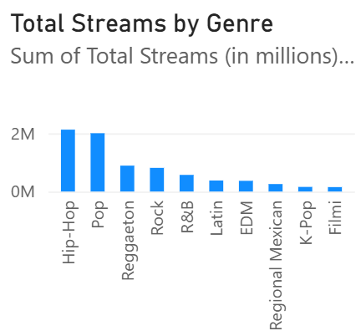

Interpretation
Hip-Hop has the highest total streams among the genres in the dataset (2,126,055.1), while Nu Metal has the lowest total streams (7,018.9).

Algorithm 4
Creating a Pie Chart
Step 1
Select the Pie Chart visualization.
Step 2
Drag Primary Genre → Legend.
Step 3
Drag Total Streams (in millions) → Values.
Step 4
Enable Detail labels/Data labels and set the chart title to Genre-wise Stream Contribution.
Output Visualization
Genre-wise Stream Contribution
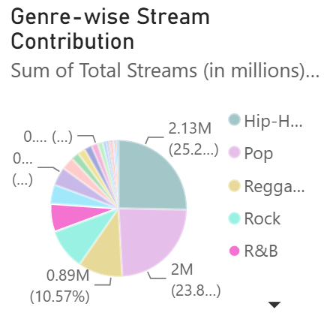

Interpretation
The pie chart shows the percentage contribution of each genre to total streams. Hip-Hop contributes the largest share, approximately 25.28% of the total.

Algorithm 5
Creating a KPI Card
Step 1
Select the Card visualization.
Step 2
Drag Total Streams (in millions) → Values.
Step 3
Apply formatting and set the title to Total Streams KPI.
DAX Formula
Total Streams
Total Streams = SUM('231401057'[Total Streams (in millions)])
DAX Measure
Total Streams = SUM('231401057'[Total Streams (in millions)])
Output
KPI card displaying the sum of Total Streams. The uploaded screenshot shows 570.70K under its current filter context.
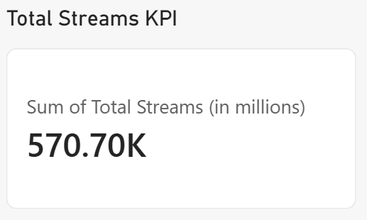

Algorithm 6
Creating Slicers
Step 1
Select the Slicer visualization.
Step 2
Drag Country of Origin → Field.
Step 3
Enable Single select if only one country should be selected at a time.
Step 4
Select a country and verify that the KPI and other visuals update according to the selected filter.
Output
Country of Origin slicer used to filter the Power BI visuals. The screenshot shows United States selected, with the KPI updating to 385.53K.
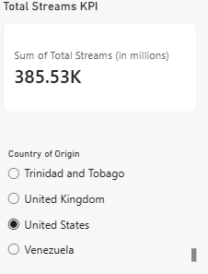

Algorithm 7
Creating DAX Calculations
Average Streams
Average Streams = AVERAGE('231401057'[Total Streams (in millions)])
Maximum Streams
Maximum Streams = MAX('231401057'[Total Streams (in millions)])
Minimum Streams
Minimum Streams = MIN('231401057'[Total Streams (in millions)])
Output
Measure | Value
Average Streams | 16,817.61
Maximum Streams | 137,492.10
Minimum Streams | 6,972.00
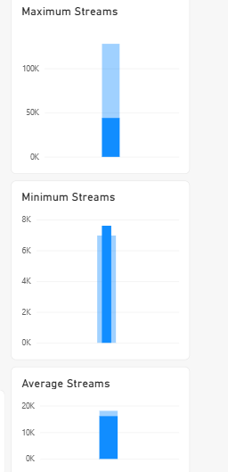

Algorithm 8
Creating Dashboard
Step 1
Use the previously created KPI Card.
Step 2
Use the previously created Bar Chart.
Step 3
Use the previously created Pie Chart.
Step 4
Use the previously created Country of Origin Slicer.
Step 5
Arrange the existing visuals neatly on the report canvas without overlapping.
Step 6
Test the slicer to confirm that the visuals respond to the selected country, then save the Power BI file.
Dashboard Layout
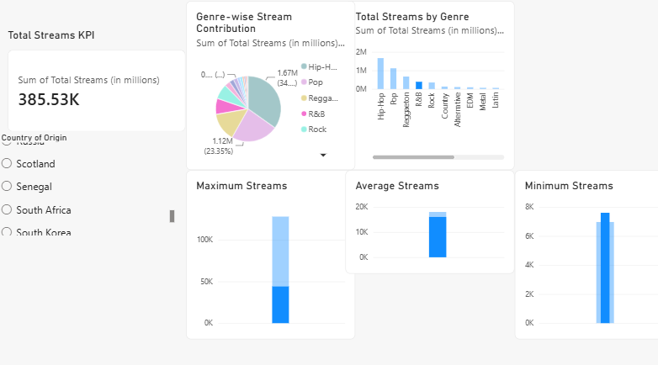

Result:
Data visualization using Power BI has been done successfully using the artist streaming dataset.

