AIM:
To install Python, configure Jupyter Notebook, understand the notebook environment, execute Python programs, create Markdown cells, and use basic Jupyter Notebook features for Data Analytics applications.

ALGORITHM:
- Download Python from the official Python website.
- Run the Python installer, select "Add Python to PATH", and complete the installation.
- Verify that Python is installed successfully.
- Open Command Prompt and install Jupyter Notebook.
- Launch Jupyter Notebook to open the Notebook Dashboard.
- Create a new Python 3 notebook from the dashboard.
- Rename the notebook.
- Create Code and Markdown cells.
- Execute the cells using Shift + Enter.
- Observe the output.

PROGRAM:
print("Welcome to Music Data Analytics Lab")

a = 50
b = 25

print("Addition =",a+b)
print("Subtraction =",a-b)
print("Multiplication =",a*b)
print("Division =",a/b)

name = "Taylor Swift"
dept = "Pop"
cgpa = 9.2

print("Name:",name)
print("Department:",dept)
print("CGPA:",cgpa)

import numpy as np
a = np.array([100,200,300,400,500])
print(a)
print("Mean =",np.mean(a))
print("Sum =",np.sum(a))

import pandas as pd
data = {
'Name':['Taylor Swift','Ed Sheeran','The Weeknd'],
'Streams':[9500,8500,9000]
}
df = pd.DataFrame(data)
print(df)

import matplotlib.pyplot as plt
x=[1,2,3,4,5]
y=[100,200,150,250,300]
plt.plot(x,y)
plt.title("Sample Music Streams Line Graph")
plt.xlabel("Artist Number")
plt.ylabel("Total Streams")
plt.show()
OUTPUT:
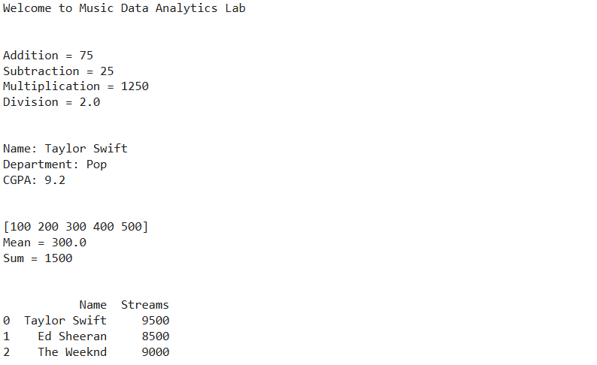
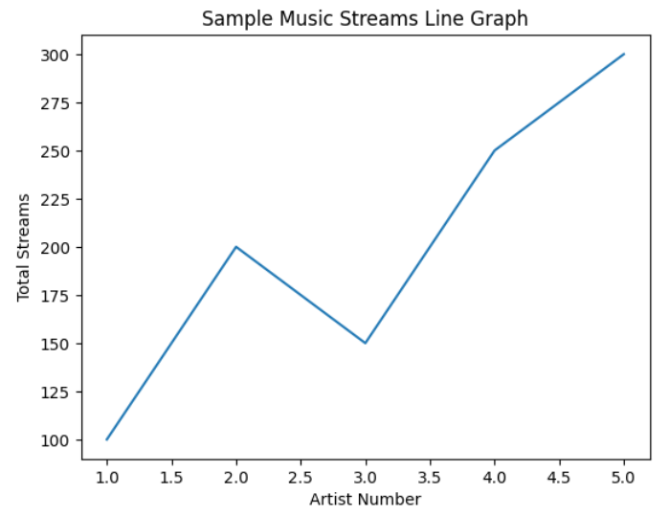

RESULT:

