AIM:
To install Python, configure Jupyter Notebook, understand the notebook environment, execute Python programs, create Markdown cells, and use basic Jupyter Notebook features for Data Analytics applications.
ALGORITHM:
- Download Python from the official Python website.
- Run the installer, enable "Add Python to PATH", and complete the installation.
- Verify that Python is installed successfully.
- Install Jupyter Notebook using the Python package manager.
- Launch Jupyter Notebook and open the Notebook Dashboard.
- Create a new Python 3 notebook.
- Rename the notebook.
- Create Code and Markdown cells.
- Enter the required code or text in the cells.
- Execute the cells and observe the output.
- Save the notebook.
PROGRAM:
import pandas as pd
df = pd.read_csv("231401057.csv")
print(df)
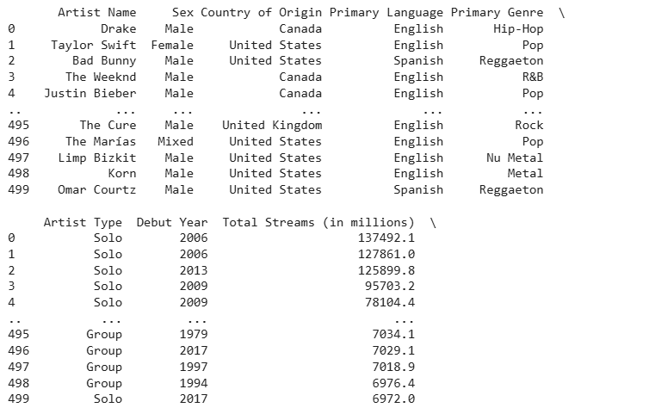

print(df.head())
print(df.info())
print(df.describe())
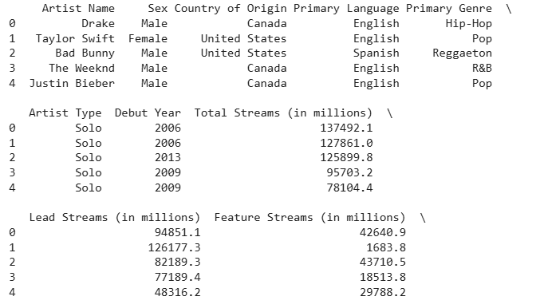
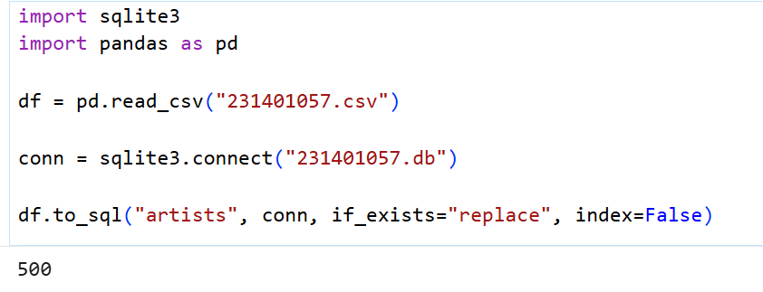
import sqlite3
import pandas as pd
conn = sqlite3.connect("231401057.db")
query = "SELECT * FROM artists"
df = pd.read_sql(query, conn)
print(df)
conn.close()
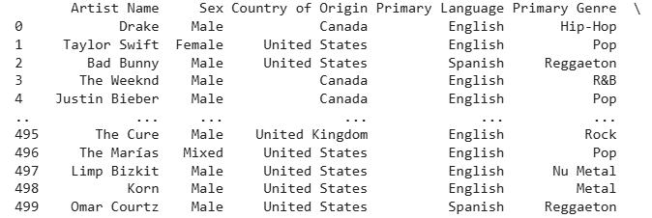
df.to_csv("231401057_export.csv", index=False)
df.to_excel("231401057_export.xlsx", index=False)
df.to_json("231401057_export.json", orient="records")
import sqlite3
conn = sqlite3.connect("231401057.db")
df.to_sql("artists", conn, if_exists="replace", index=False)
conn.close()
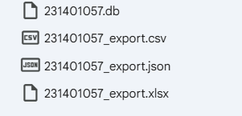
url = "231401057.csv"
df = pd.read_csv(url)
print(df.head())
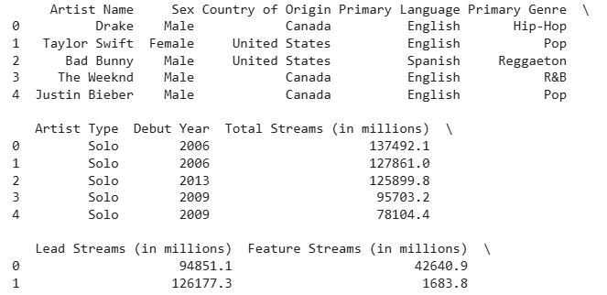
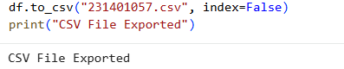

RESULT:
Thus, data was successfully imported from CSV, Excel, SQL, and Web sources using Pandas, and exported into different formats. The imported data was analyzed and visualized successfully.

