AIM:
To perform data inspection, filtering, grouping, aggregation, descriptive statistical analysis, and correlation analysis using Pandas and visualize the results using Matplotlib.
ALGORITHM:
- Import the dataset.
- Display the dataset.
- Check the dataset dimensions and data types.
- Generate a summary of the dataset.
- Filter the data based on the required condition and display the filtered records.
- Sort the data using the required column and display the sorted result.
- Perform statistical analysis by calculating the mean, median, mode, and standard deviation of numerical columns.
- Group the data using the required column and calculate the average values using aggregation.
- Perform correlation analysis between numerical columns.
- Display and interpret the results.

PROGRAM:

import pandas as pd
df = pd.read_csv("231401057.csv")
print(df.head())

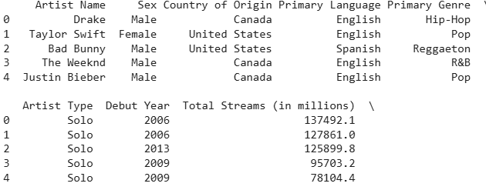

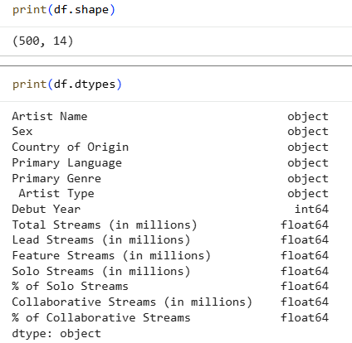
high_streams = df[df["Total Streams (in millions)"] > 50000]
print(high_streams)
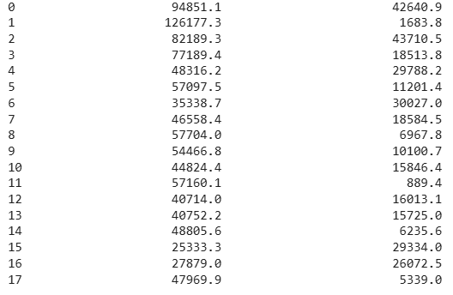
solo_artists = df[df["Artist Type"] == "Solo"]
print(solo_artists)
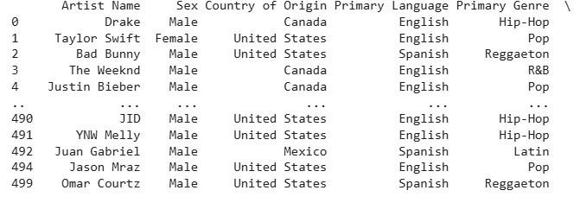
sorted_df = df.sort_values(
by="Total Streams (in millions)",
ascending=False
)
print(sorted_df)
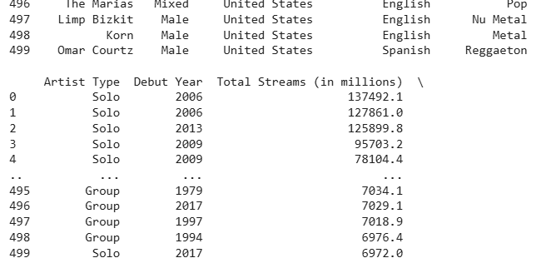
import pandas as pd
import matplotlib.pyplot as plt
sorted_df = df.sort_values(by="Total Streams (in millions)", ascending=False)
plt.figure(figsize=(12,5))
plt.bar(range(len(sorted_df)), sorted_df["Total Streams (in millions)"])
plt.title("Total Streams Ranking")
plt.xlabel("Artists (Sorted)")
plt.ylabel("Total Streams (in millions)")
plt.show()
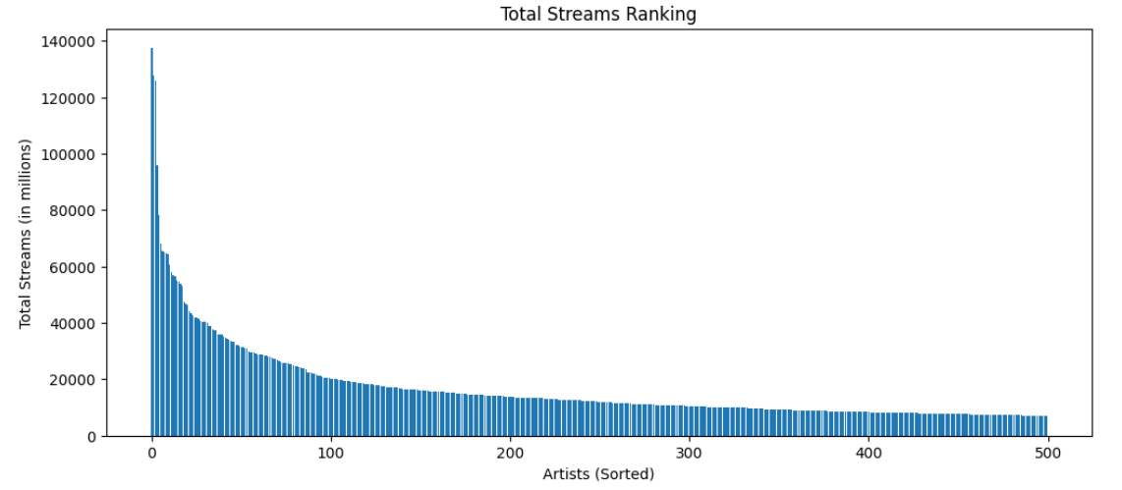
print("Mean =", df["Total Streams (in millions)"].mean())
print("Median =", df["Total Streams (in millions)"].median())
print("Mode =",df["Total Streams (in millions)"].mode())
print("Standard Deviation =", df["Total Streams (in millions)"].std())
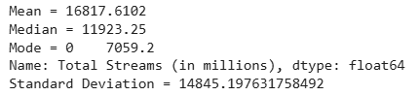
print(df.describe())
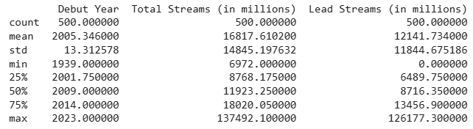

RESULT:
Thus, data inspection, filtering, sorting, descriptive statistical analysis, grouping, aggregation, and correlation analysis were successfully performed using Pandas. The analytical results were visualized and interpreted successfully.

