EXPERIMENT 7B

DATA VISUALIZATION USING TABLEAU

Aim:
To connect, analyze, visualize, and create interactive dashboards using Tableau for effective business intelligence and data analytics.
Sample Dataset:
Artist Streaming Dataset

Algorithm 1:
Connecting Data Source
Step 1: Open Tableau Desktop
Step 2: Select Connect
Step 3: Choose Text File
Step 4: Browse Dataset
Step 5: Open Dataset
Step 6: Verify Imported Data
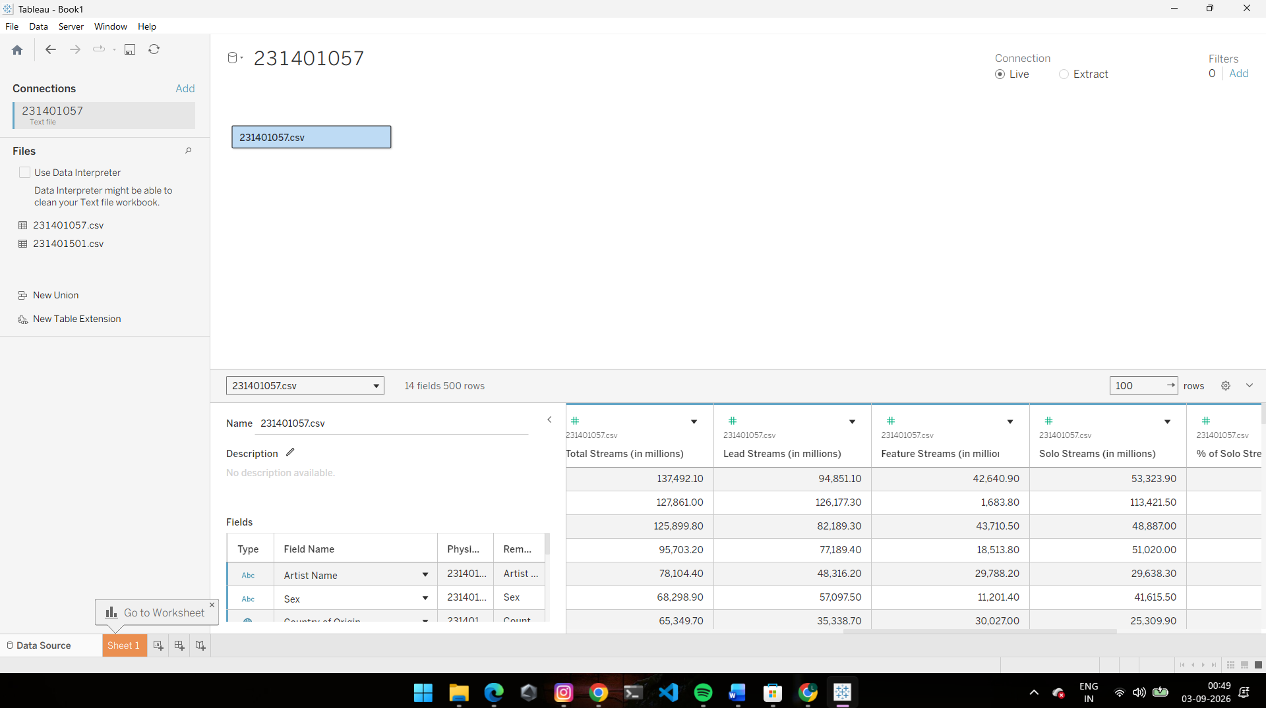

Algorithm 2:
Step 1: Open a new worksheet.
Step 2: Drag Primary Genre → Rows.
Step 3: Drag Total Streams (in millions) → Columns.
Step 4: Select Bar Chart visualization.
Step 5: Apply data labels.
Step 6: Analyze total streams across different genres.

Output:
Total Streams by Genre bar chart.
The bar chart compares total streams across different primary genres.
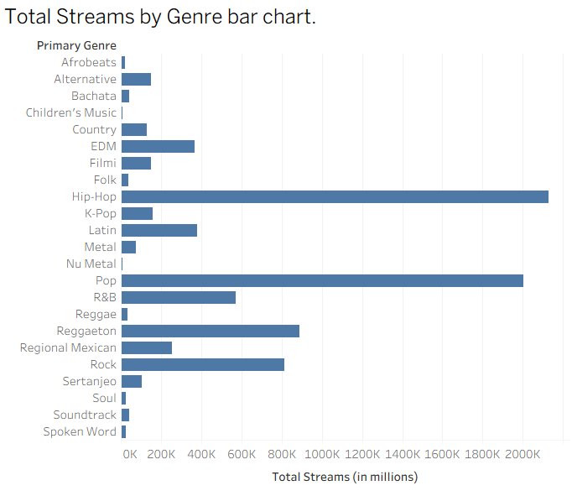

Algorithm 3:
Step 1: Create a new worksheet.
Step 2: Drag Primary Genre → Rows.
Step 3: Drag Total Streams (in millions) → Columns.
Step 4: Select Bar Chart.
Step 5: Apply data labels.
Step 6: Format the visualization.

Output:
Total Streams by Genre bar chart.
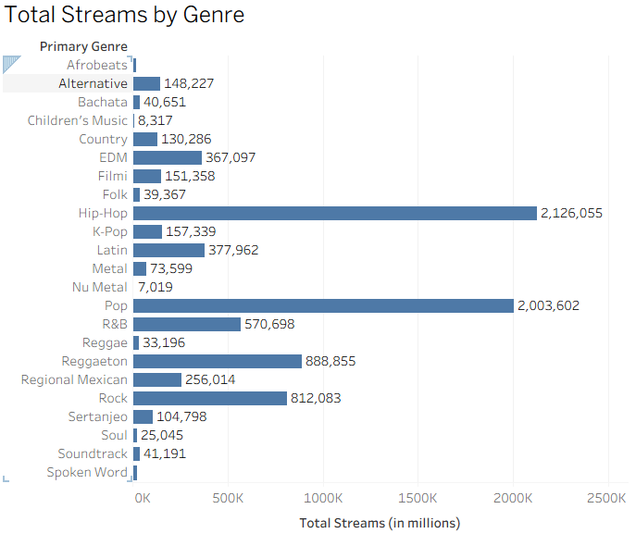

Algorithm 4:
Step 1: Create a new worksheet.
Step 2: Select Pie Chart.
Step 3: Drag Primary Genre → Color.
Step 4: Drag Total Streams (in millions) → Angle.
Step 5: Drag Total Streams (in millions) → Label.
Step 6: Analyze the contribution of each genre.

Output:
Genre-wise Stream Contribution pie chart.
The pie chart represents the contribution of each genre to total streams.
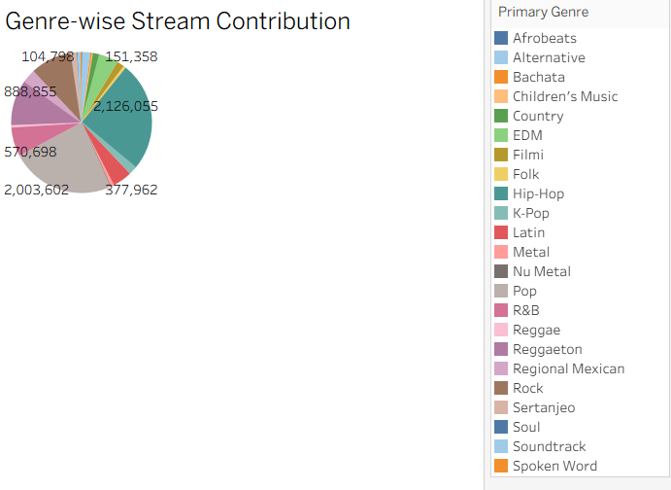

Algorithm 5:
Step 1: Create a new worksheet.
Step 2: Drag Debut Year → Columns.
Step 3: Drag Total Streams (in millions) → Rows.
Step 4: Select Line Chart.
Step 5: Apply appropriate formatting.

Output:
Total Streams Trend by Debut Year line chart.
The line chart Shows the variation in total streams over different debut years.
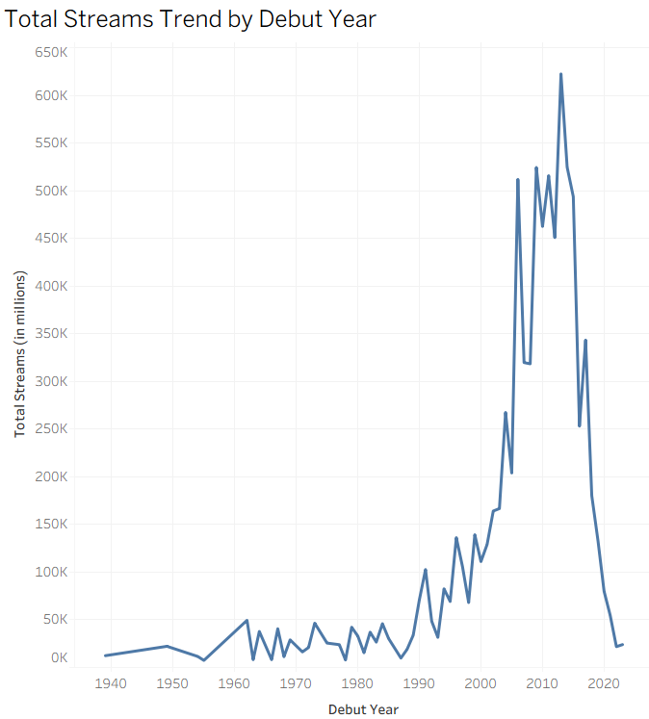

Algorithm 6:
Creating Calculated Field
Objective
To calculate stream percentage from Total Streams.
Stream Percentage = SUM(Total Streams (in millions)) / WINDOW_SUM(SUM(Total Streams (in millions)))
Step 1: Select Analysis → Create Calculated Field.
Step 2: Enter the name Stream Percentage.
Step 3: Enter the formula:
SUM([Total Streams (in millions)]) / WINDOW_SUM(SUM([Total Streams (in millions)]))
Step 4: Click OK.
Step 5: Use Stream Percentage in the visualization.
Step 6: Format the value as required.

Output:
Stream Percentage calculated field.
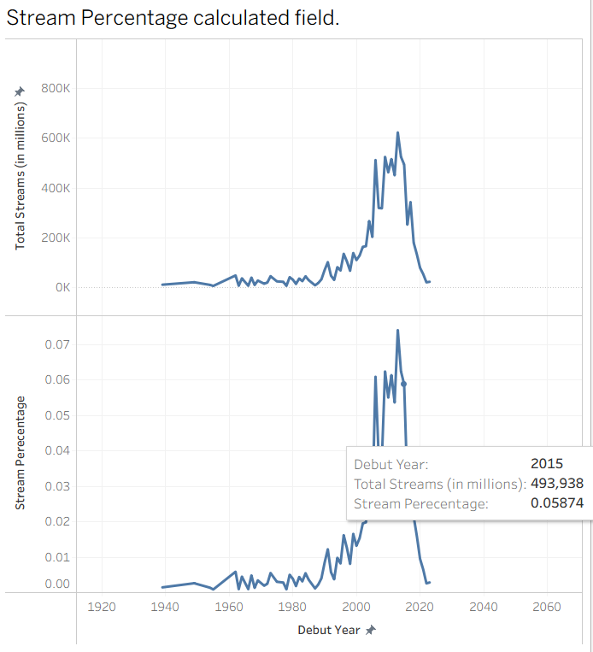

Algorithm 7:
Step 1: Select the required worksheet.
Step 2: Drag Primary Genre → Filters.
Step 3: Select the required genre.
Step 4: Apply the filter.
Step 5: Observe the updated visualization.

Output:
Filtered visualization based on Primary Genre.
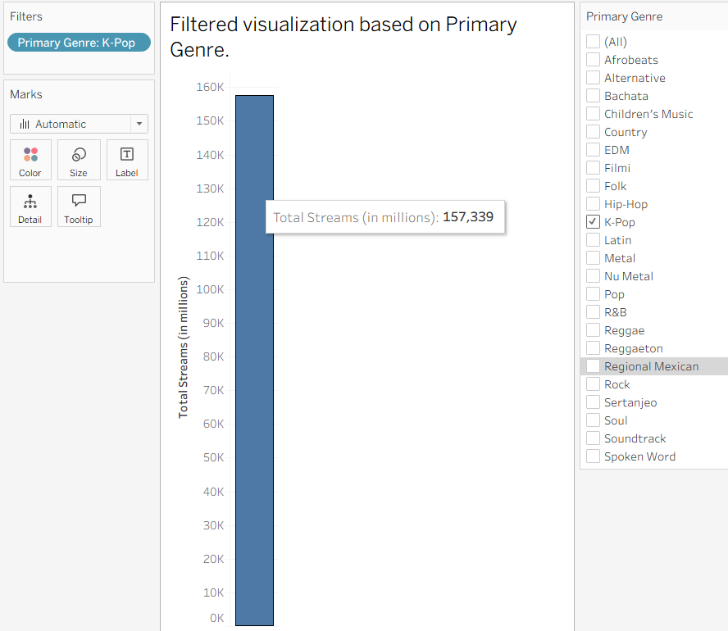

Algorithm 8:
To analyze records based on a user-defined minimum stream value.
Step 1: Select Analysis → Create Parameter.
Step 2: Name the parameter Minimum Streams.
Step 3: Set the data type and allowable range.
Step 4: Create the parameter control.
Step 5: Apply the minimum stream value.
Step 6: Display the parameter control.
Step 7: Change the minimum stream value and observe the updated visualization.

Output:
Interactive Minimum Streams Parameter.
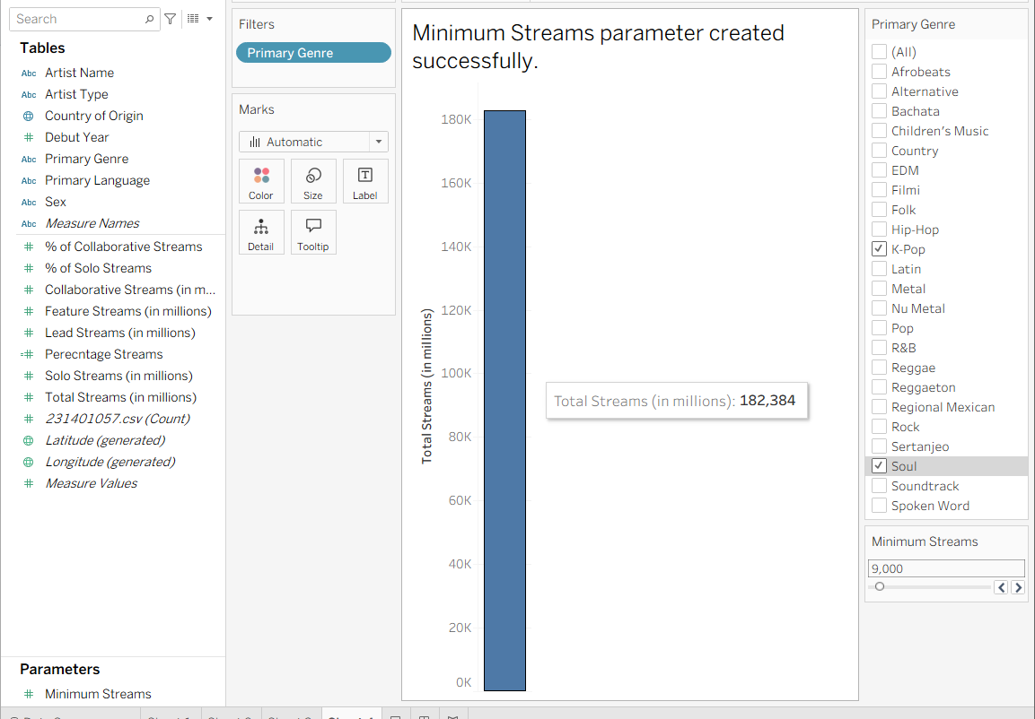

Algorithm 9:
Step 1: Create the required worksheets.
Step 2: Select Dashboard → New Dashboard.
Step 3: Drag the worksheets onto the dashboard.
Step 4: Arrange the visualizations appropriately.
Step 5: Add the Primary Genre Filter and Minimum Streams Parameter.
Step 6: Format the dashboard.
Step 7: Save the dAshboard.

Output:
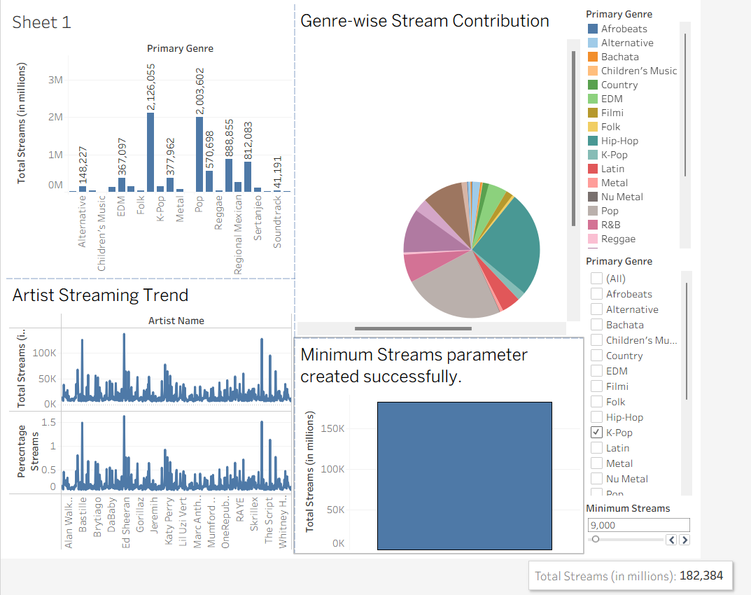

Result:
Thus, Tableau was used successfully to connect the artist streaming dataset, create worksheets, apply filters and parameters, generate visualizations, and build dashboards for data analysis.

