**Blinkit Analysis**

**SQl Queries**

1. "Write an SQL query to update the Item_Fat_Content column in the blinkit_data table so that 'LF' and 'low fat' are changed to 'Low Fat', 'reg' is changed to 'Regular', and all other values remain unchanged."

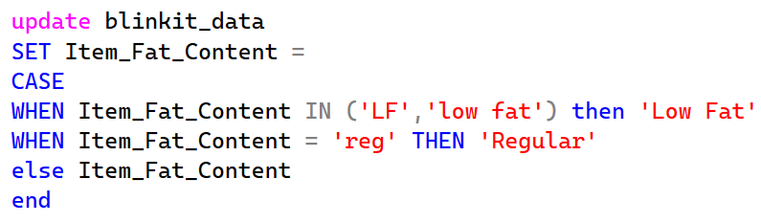

1. "Write an SQL query to calculate the total sales from the blinkit_data table, convert the result into millions, and round it to 2 decimal places."

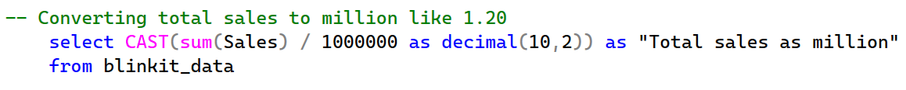

**FOR KPIs**

1. 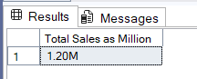Write an SQL query to calculate the total sales from the blinkit_data table, convert the result into millions with **two decimal places**, and display it followed by the letter M (e.g., 1.20M). Name the output column **Total Sales as Million**.
2. 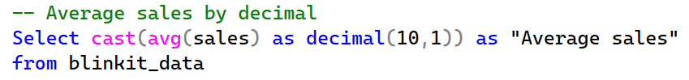Average sales of blinkit data
3. Total count of items

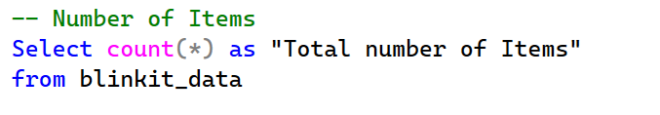

1. The average customer rating for items sold.

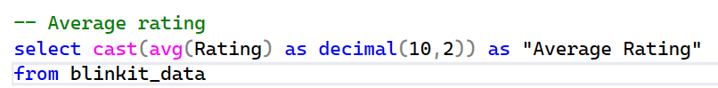

**Granular Requirements**

1. Total Sales by Fat Content:

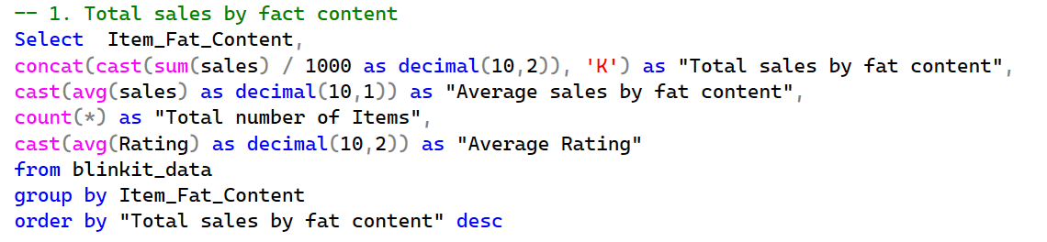

1. Total Sales by Item Type:

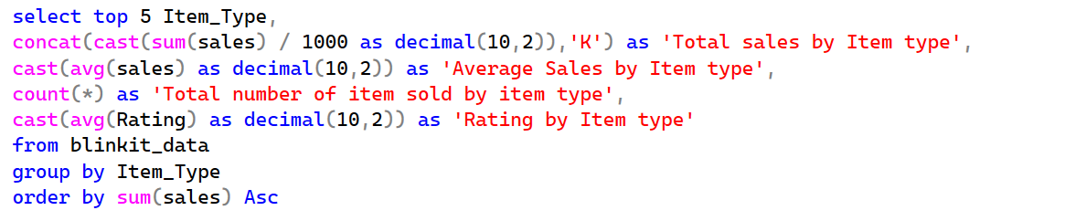

1. Fat Content by Outlet for Total Sales:

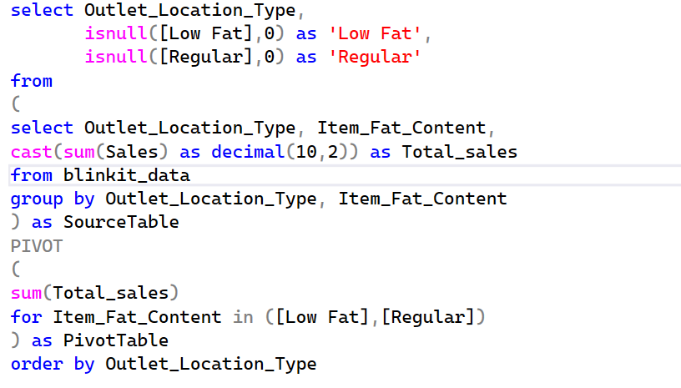

1. Total Sales by Outlet Establishment:

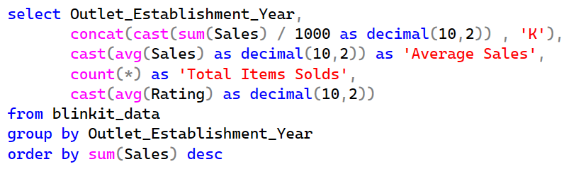

**Chart’s Requirements**

1. Percentage of Sales by Outlet Size:

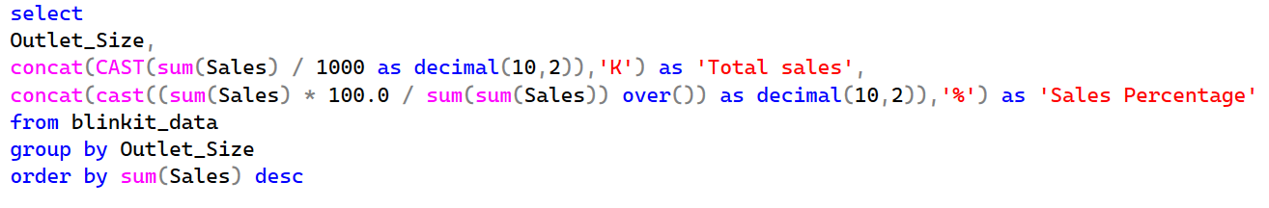

1. Sales by Outlet Location:

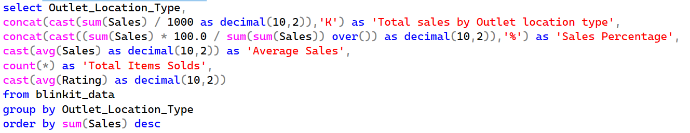

1. All Metrics by Outlet Type:

