**Git Practical**

Done by: Lakshmishreya Bapatuyeruguti

Create one repository for practical and provide the link of it for review.

Work on below points:

1. Pull and Merge difference

* Make example of pull request and two branch merge event.

1. Rebase

* Try to rebase feature branch with master branch

1. Change commit message

* Commit push on commit in feature branch and then change commit message

1. cherry pick

* Pick some commits from feature branch to master branch

1. Drop commit

* Remove some commit from feature branch.

---------------------------------------Performed Commands ---------------------------------------------------

**1. Pull and Merge difference**

* checkedout to main branch and merged buttonfeature branch with it using command:

-> **git merge buttonfeature**

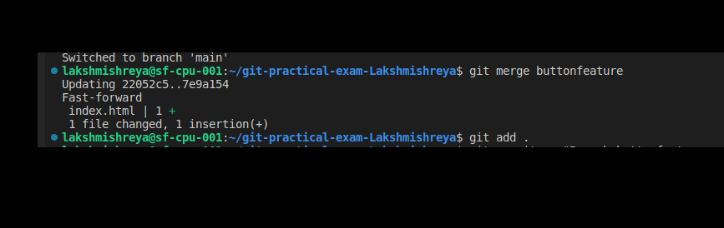

* Made a pull request to another repository by forking and cloning the project and making some changes:
* Made changes and pushed it to forked repository using command:

-> **git push origin main**

* went to github and made a pull request

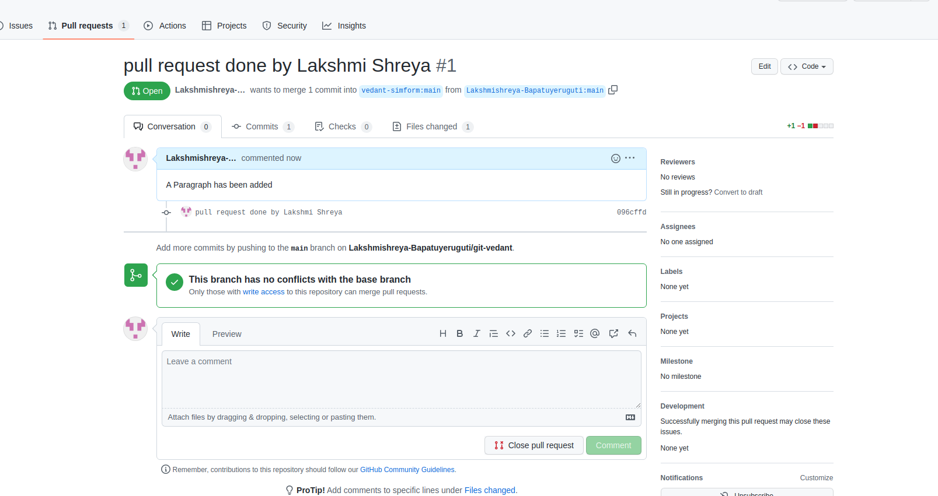

**2. Rebase**

* Tried rebasing a feature branch with main branch using commands:

-> **git checkout main**

-> **git rebase feature**

  
**3. Change commit message**

* Changed one of the commit message from feature branch using interactive rebase commands:

-> **git rebase -i HEAD~2**

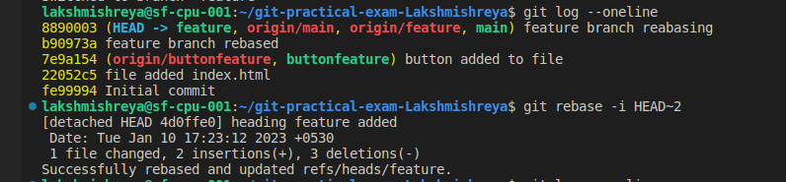

* A default editor opens up and the word 'pick' is changed to **'reword'** before the commit hash.

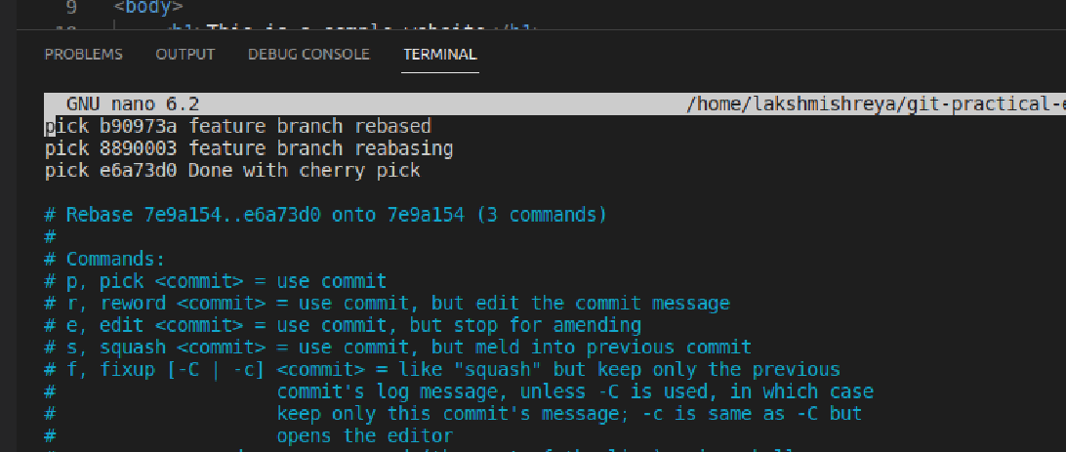

* After saving and exit, now opens another window in which we can enter the new commit message.

**4. cherry pick**

* Picked few commits from feature branch to main branch after switching to main branch using commands:

->**git cherry-pick [hashofcommit]**



* Cherry picked commit now got added to index.html file in main branch

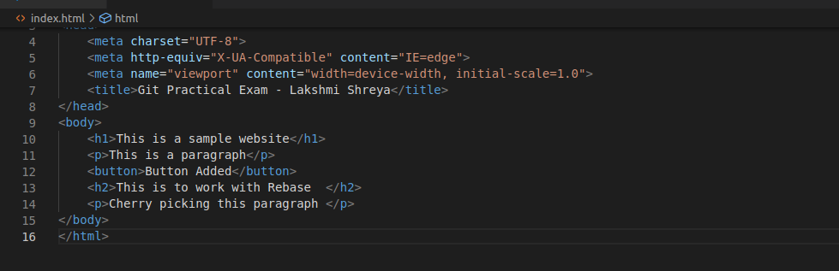

**5.Drop commit**

* derpped or removed a commit from feature branch using command

-> **git reabse -i HEAD~3**



* A default editor opens up and word 'pick' is changed to **'drop'** before the commits hash to delete commit.

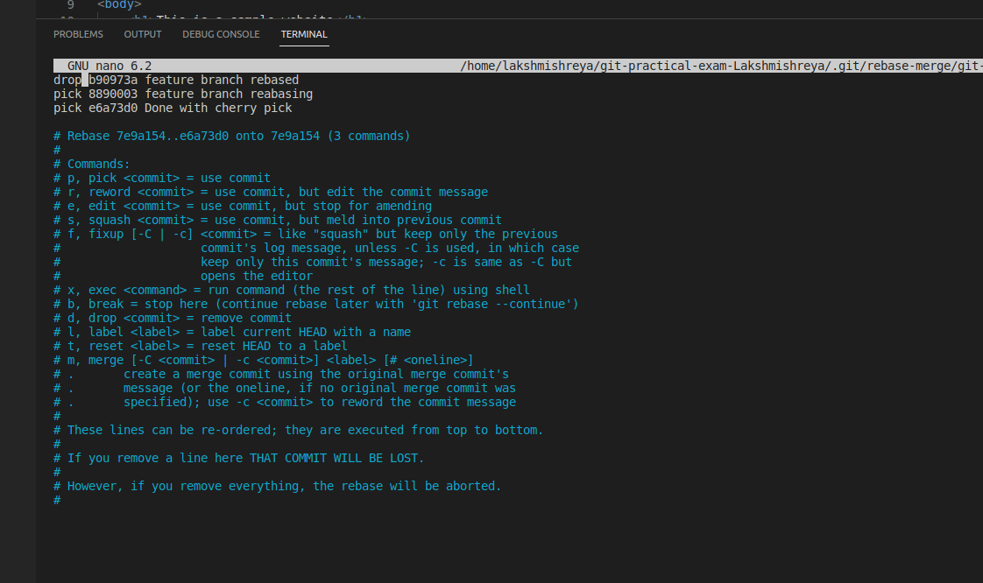

* save and exit from the default editor. check git log and you will see the commit got dropped/deleted.

