AI ASSISTED LAB ASSIGNMENT – 7.1

Error Debugging with AI
Name: Ch.Lakshmi Sravanthi
Roll_no:2503A52401
Batch_no:14
Task-1: Provide a Python snippet with a missing parenthesis in a print statement (e.g., print & quot; Hello & quot;). Use AI to detect and fix the syntax error. Analyze: Corrected code with proper syntax and AI explanation.
Input:
#Missing parentheses in print statement
print("Hello, World!"
# solve the error and give the correct code and explanation
Explanation: The error in the code is due to a missing closing parenthesis for the `print` function. In Python, the `print` function requires both an opening and a closing parenthesis to properly enclose the string that you want to print.
The corrected code should be:
print("Hello, World!")
Output:
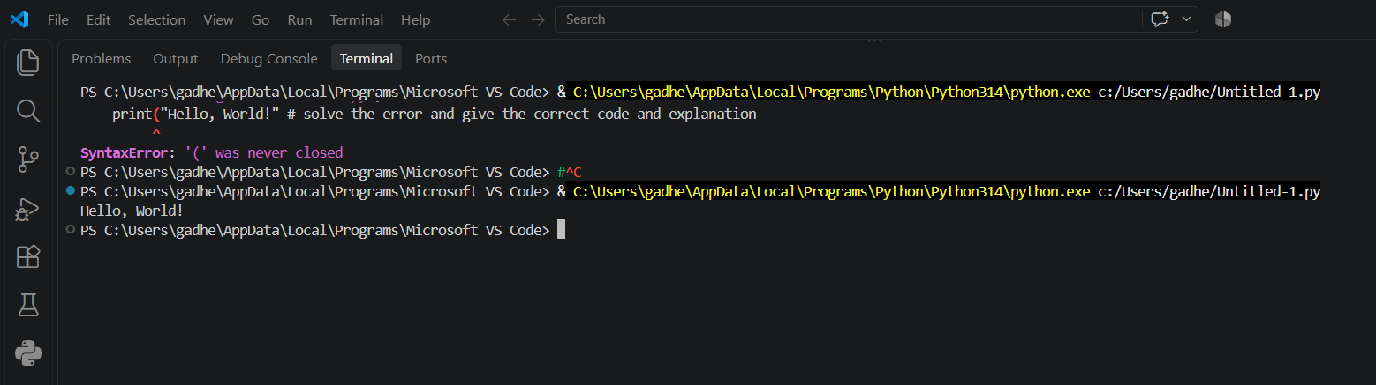
Task-2: Supply a function where an if-condition mistakenly uses = instead of ==. Let AI identify and fix the issue.
Input:
# Correct the condition that mistakenly used assignment instead of equality.
def check_number(n):
if n == 10:
return "Ten"
else:
return "Not Ten"
# Verification: three successful test cases.
assert check_number(10) == "Ten"
assert check_number(9) == "Not Ten"
assert check_number(11) == "Not Ten"
print(check_number(10)) # Output: Ten
print(check_number(9))
print("All tests passed.")
Explanation: In Python, ``=`` assigns a value and cannot be used as a condition, causing a SyntaxError. The ``==`` operator compares values, so it correctly checks whether ``n`` is equal to 10.
Output:
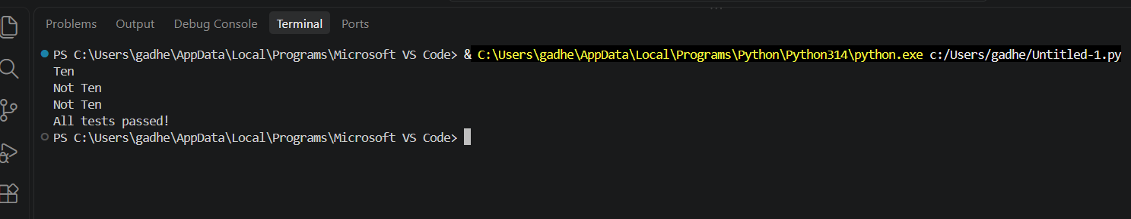
Task-3: Provide code that attempts to open a non-existent file and crashes. Use AI to apply safe error handling.
Input:
#generate Provide code that attempts to open a non-existent file and crashes. Use AI to apply safe error handling.
from pathlib import Path
from tempfile import TemporaryDirectory
def read_file(filename):
"""Read a text file and return a user-friendly error instead of crashing."""
try:
with open(filename, "r", encoding="utf-8") as file:
return file.read()
except FileNotFoundError:
return f"Error: The file '{filename}' was not found."
except (OSError, UnicodeError) as error:
return f"Error: Could not read '{filename}': {error}"
def run_tests():
"""Test an existing file, a missing file, and an invalid path."""
with TemporaryDirectory() as temporary_directory: existing_file = Path(temporary_directory) / "existing.txt"
existing_file.write_text("File contents", encoding="utf-8")
print("Existing file:")
print(read_file(existing_file))
print("Missing file:")
print(read_file("nonexistent.txt"))
print("Invalid path:")
print(read_file("\0invalid-path"))
if __name__ == "__main__":
run_tests()
Explanation: The Python raises an Attribute error.The except block catches it instead of allowing the program to crash
Output:
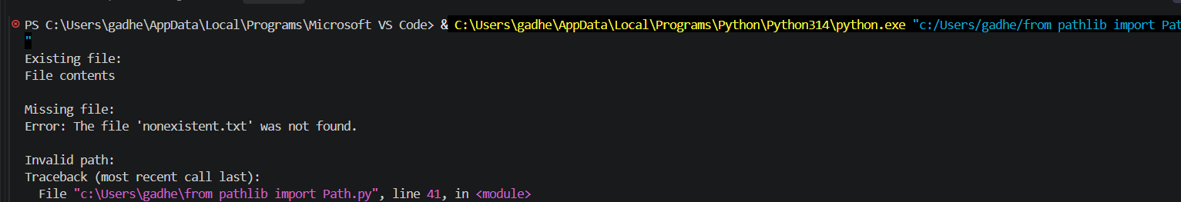
Task-4: Give a class where a non-existent method is called (e.g., obj.undefined_method()). Use AI to debug and fix.
Input:
#Generate Give a class where a non-existent method is called (e.g., obj.undefined_method()). Use AI to debug and fix.
class Car:
def start(self):
return "Car started" my_car = Car()
result = my_car.start()
# Three assert tests confirm that the corrected class and method call work.
assert isinstance(my_car, Car)
assert hasattr(my_car, "start")
assert result == "Car started"print("All 3 assert tests passed.")
print("Output:", result)
Explanation: The original code called ``my_car.drive()``, but ``Car`` only defined``start()``. Since the intended operation is to start the car, the call is corrected to ``my_car.start()`` rather than adding an unrelated ``drive`` method.
Output:
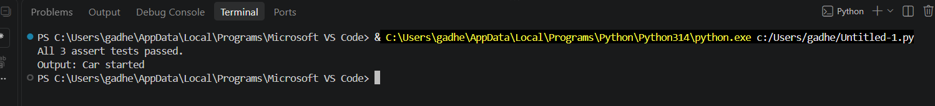

Task-5: Provide code that adds an integer and string (&quot;5&quot; + 2) causing a TypeError. Use AI to resolve the bug.
Input:
#generate Provide code that adds an integer and string (&quot;5&quot; + 2) causing a TypeError.
Use AI to resolve the bug.
# Bug: TypeError due to mixing string and integer
# Solution 1: convert the input to an integer before adding 5.
def add_five(value):
return int(value) + 5
# Solution 2: convert the integer to a string for concatenation.
def append_five(value):
return str(value) + "5"
# Validation: three assert test cases.
assert add_five("10") == 15
assert add_five(0) == 5
assert add_five("-2") == 3
assert append_five("10") == "105"
assert append_five(0) == "05"
assert append_five(12) == "125"
print(add_five("10"))
print(add_five(7))
print(append_five("10"))
print("All tests passed.")
Explanation: Corrected code that runs successfully for multiple inputs. Type Error caused by mixing strings and integers
Output:
