Lab Experiment9: Documentation Generation -Automatic
documentation and code comments
Name:Ch.Lakshmi Sravanthi
Roll no:2503A52401
Batch:14

Problem 1:
Consider the following Python function:
def find_max(numbers):
return max(numbers)
Task:
Write documentation for the function in all three formats:
(a) Docstring
(b) Inline comments
(c) Google-style documentation

• Critically compare the three approaches. Discuss the
advantages, disadvantages, and suitable use cases of each
style.
• Recommend which documentation style is most effective
for a mathematical utilities library and justify your
answer.
(a)Docstring
INPUT:
def find_max(numbers):
"""
Find and return the largest number from a list.

Args:
numbers (list): A list of numeric values.

Returns:
int or float: The largest value in the list.
"""
return max(numbers)

numbers = [10, 25, 15, 40, 30]
print("Maximum:", find_max(numbers))
OUTPUT:
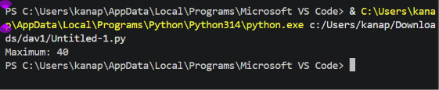
(b) Inline comments
INPUT:
def find_max(numbers):
# Find the largest number in the given list
maximum = max(numbers)

# Return the largest number
return maximum

numbers = [10, 25, 15, 40, 30]
print("Maximum:", find_max(numbers))
OUTPUT:
(c) Google-style documentation
INPUT:
def find_max(numbers):
"""Find the maximum value in a list.

Args:
numbers (list): A list containing numeric values.

Returns:
int or float: The maximum value in the list.

Raises:
ValueError: If the list is empty.
"""
if not numbers:
raise ValueError("The list cannot be empty.")

return max(numbers)

numbers = [10, 25, 15, 40, 30]
print("Maximum:", find_max(numbers))
OUTPUT:

Problem 2: Consider the following Python function:
def login(user, password, credentials):
return credentials.get(user) == password
Task:
1. Write documentation in all three formats.
2. Critically compare the approaches.
3. Recommend which style would be most helpful for new
developers onboarding a project, and justify your choice.

1.
INPUT:

def login(user, password, credentials):
"""
Check whether the username and password are valid.

Args:
user (str): Username entered by the user.
password (str): Password entered by the user.
credentials (dict): Dictionary containing usernames and passwords.

Returns:
bool: True if credentials are valid, otherwise False.
"""
return credentials.get(user) == password

credentials = {
"admin": "1234",
"student": "abcd"
}

print(login("admin", "1234", credentials))
print(login("student", "wrong", credentials))
OUTPUT:
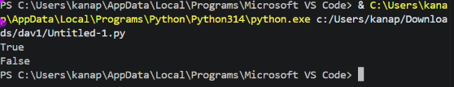
2.
INPUT:
def login(user, password, credentials):
# Get the password stored for the given username
stored_password = credentials.get(user)

# Compare stored password with entered password
return stored_password == password

credentials = {
"admin": "1234",
"student": "abcd"
}

print(login("admin", "1234", credentials))

OUTPUT:
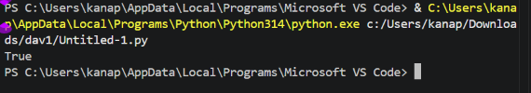
3.
INPUT:
def login(user, password, credentials):
"""Validate a user's login credentials.

Args:
user (str): Username entered by the user.
password (str): Password entered by the user.
credentials (dict): Dictionary containing user credentials.

Returns:
bool: True if the credentials match; otherwise False.
"""
return credentials.get(user) == password

credentials = {
"admin": "1234",
"student": "abcd"
}

print("Login 1:", login("admin", "1234", credentials))
print("Login 2:", login("student", "wrong", credentials))

OUTPUT:
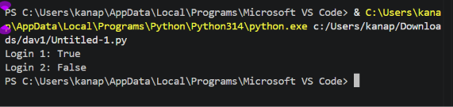
Problem 3: Calculator (Automatic Documentation Generation)
Task: Design a Python module named calculator.py and
demonstrate automatic documentation generation.
Instructions:
1. Create a Python module calculator.py that includes the
following functions, each written with appropriate docstrings:
o add(a, b) – returns the sum of two numbers
o subtract(a, b) – returns the difference of two numbers
o multiply(a, b) – returns the product of two numbers
o divide(a, b) – returns the quotient of two numbers
2. Display the module documentation in the terminal using
Python’s documentation tools.
3. Generate and export the module documentation in HTML

format using the pydoc utility, and open the generated HTML
file in a web browser to verify the output.
INPUT CODE:
"""
Calculator Module

This module provides basic arithmetic operations.
"""

def add(a, b):
"""Return the sum of two numbers.

Args:
a (int or float): First number.
b (int or float): Second number.

Returns:
int or float: Sum of a and b.
"""
return a + b

def subtract(a, b):
"""Return the difference between two numbers.

Args:
a (int or float): First number.
b (int or float): Second number.

Returns:
int or float: Difference between a and b.
"""
return a - b

def multiply(a, b):
"""Return the product of two numbers.

Args:
a (int or float): First number.
b (int or float): Second number.

Returns:
int or float: Product of a and b.
"""
return a * b

def divide(a, b):
"""Return the quotient of two numbers.

Args:
a (int or float): First number.
b (int or float): Second number.

Returns:
int or float: Quotient of a and b.

Raises:
ValueError: If b is zero.
"""
if b == 0:
raise ValueError("Cannot divide by zero.")

return a / b

# Testing the functions
print("Addition:", add(10, 5))
print("Subtraction:", subtract(10, 5))
print("Multiplication:", multiply(10, 5))
print("Division:", divide(10, 5))

OUTPUT:
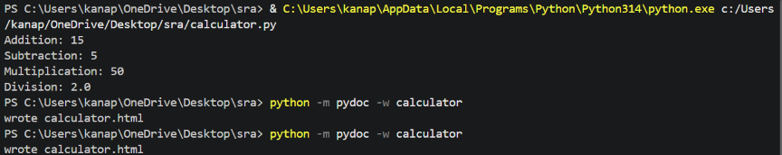
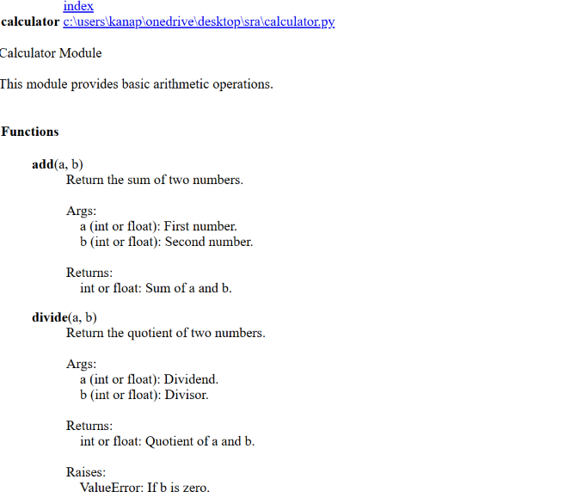

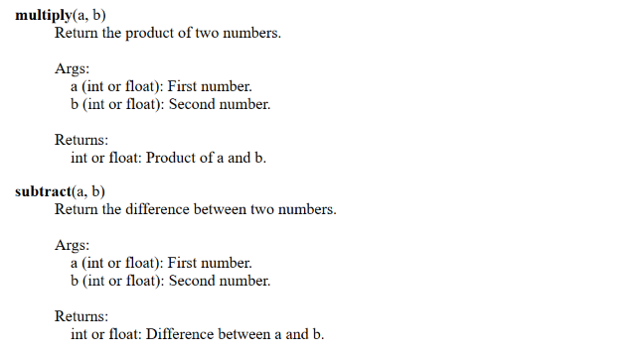

Problem 4: Conversion Utilities Module
Task:
1. Write a module named conversion.py with functions:
o decimal_to_binary(n)
o binary_to_decimal(b)
o decimal_to_hexadecimal(n)
2. Use Copilot for auto-generating docstrings.
3. Generate documentation in the terminal.
4. Export the documentation in HTML format and open it in a
browser.

INPUT CODE:
"""
Conversion Utilities Module

This module provides functions for number conversion.
"""

def decimal_to_binary(n):
"""Convert a decimal number to binary.

Args:
n (int): Decimal number.

Returns:
str: Binary representation of the number.
"""
return bin(n)[2:]

def binary_to_decimal(b):
"""Convert a binary number to decimal.

Args:
b (str): Binary number.

Returns:
int: Decimal representation of the binary number.
"""
return int(b, 2)

def decimal_to_hexadecimal(n):
"""Convert a decimal number to hexadecimal.

Args:
n (int): Decimal number.

Returns:
str: Hexadecimal representation of the number.
"""
return hex(n)[2:].upper()

# Testing the functions
print("Decimal to Binary:", decimal_to_binary(25))
print("Binary to Decimal:", binary_to_decimal("11001"))
print("Decimal to Hexadecimal:", decimal_to_hexadecimal(255))

OUTPUT:
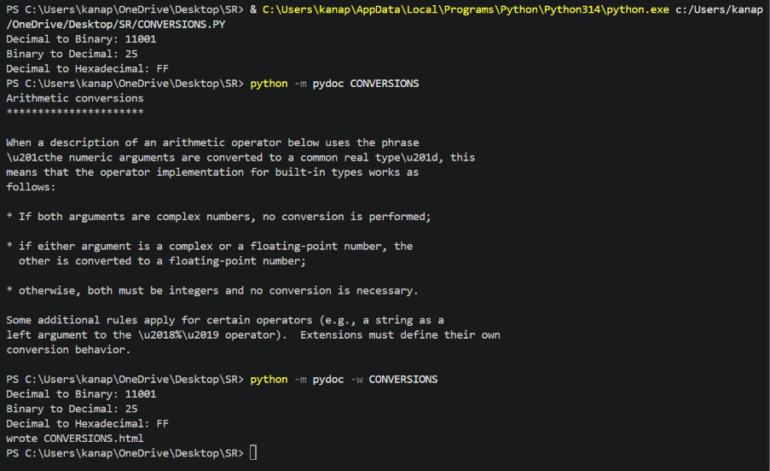
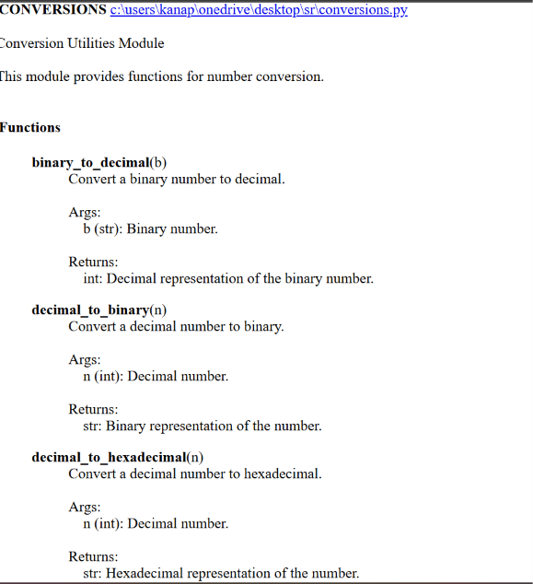

Problem 5 – Course Management Module
Task:
1. Create a module course.py with functions:
o add_course(course_id, name, credits)
o remove_course(course_id)
o get_course(course_id)
2. Add docstrings with Copilot.
3. Generate documentation in the terminal.
4. Export the documentation in HTML format and open it in a
browser.
OUTPUT:
