AI-Based Code Completion: Working with
suggestions for classes, loops, conditionals
LAB-6.1
NAME: Ch.Lakshmi Sravanthi
ROLL.NO:2503A52401
Task Description #1 (AI-Based Code Completion for Loops)
Task: Use an AI code completion tool to generate a loop-based
program.
Prompt:
“Generate Python code to print all even numbers between 1 and N
using a loop.”
Expected Output:
AI-generated loop logic.
Identification of loop type used (for or while).
Validation with sample inputs.
PROMPT:
Generate a Python program to print all even numbers between 1 and N.
Use a loop and conditional statement to check whether each number is even.
INPUT CODE:
n = int(input("Enter N: "))

print("Even numbers between 1 and", n, "are:")

for i in range(1, n + 1):
if i % 2 == 0:
print(i, end=" ")
OUTPUT:
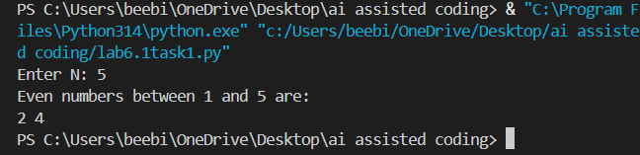
Task Description #2 (AI-Based Code Completion for Loop with
Conditionals)
Task: Use an AI code completion tool to combine loops and
conditionals.

Week3 -
Monday

Prompt:
“Generate Python code to count how many numbers in a list are even
and odd.”
Expected Output:
AI-generated code using loop and if condition.
Correct count validation.
Explanation of logic flow.
PROMPT:
Generate a Python program to count even and odd numbers in a list.
Use a loop and if-else condition to classify the numbers.
INPUT CODE:
numbers = [10, 15, 20, 25, 30, 35]

even_count = 0
odd_count = 0

for num in numbers:
if num % 2 == 0:
even_count += 1
else:
odd_count += 1

print("List:", numbers)
print("Even numbers count:", even_count)
print("Odd numbers count:", odd_count)
OUTPUT:
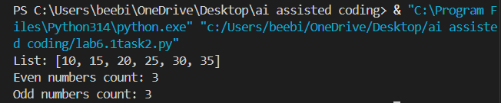
Task Description #3 (AI-Based Code Completion for Class

Attributes Validation)
Task: Use an AI tool to complete a Python class that validates user
input.
Prompt:
“Generate a Python class User that validates age and email using
conditional statements.”
Expected Output:
AI-generated class with validation logic.
Verification of condition handling.
Test cases for valid and invalid inputs.
PROMPT:
Generate a Python class named User.
Validate the user's age and email using conditional statements.
Display whether the entered details are valid or invalid.
INPUT CODE:
class User:
def __init__(self, age, email):
self.age = age
self.email = email

def validate(self):
if self.age >= 18:
age_valid = True
else:
age_valid = False

if "@" in self.email and "." in self.email:
email_valid = True
else:
email_valid = False

if age_valid and email_valid:
print("Valid user details")
else:
print("Invalid user details")

print("Age valid:", age_valid)
print("Email valid:", email_valid)

age = int(input("Enter age: "))
email = input("Enter email: ")

user = User(age, email)
user.validate()
OUTPUT:
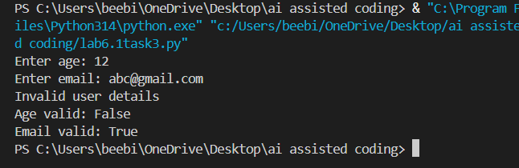
Task Description #4 (AI-Based Code Completion for Classes)
Task: Use an AI code completion tool to generate a Python class for
managing student details.
Prompt:
“Generate a Python class Student with attributes (name, roll number,
marks) and methods to calculate total and average marks.”
Expected Output:
AI-generated class code.
Verification of correctness and completeness of class
structure.
Minor manual improvements (if needed) with justification.
PROMPT:
Generate a Python class Student with name, roll number, and marks.
Add methods to calculate the total and average marks.
Display all student details and results.
INPUT CODE:
class Student:
def __init__(self, name, roll_number, marks):
self.name = name
self.roll_number = roll_number
self.marks = marks

def calculate_total(self):
return sum(self.marks)

def calculate_average(self):
return self.calculate_total() / len(self.marks)

def display(self):
total = self.calculate_total()
average = self.calculate_average()

print("Student Name:", self.name)
print("Roll Number:", self.roll_number)
print("Marks:", self.marks)
print("Total Marks:", total)
print("Average Marks:", average)

name = input("Enter student name: ")
roll_number = input("Enter roll number: ")

marks = []
for i in range(3):
mark = float(input("Enter mark " + str(i + 1) + ": "))
marks.append(mark)

student = Student(name, roll_number, marks)
student.display()
OUTPUT:
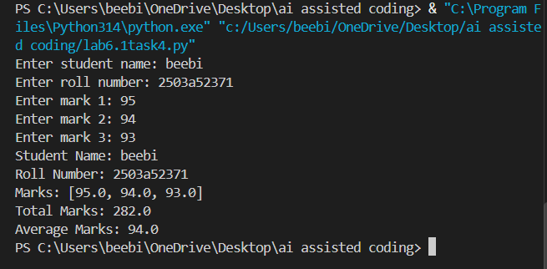
Task Description# 5 (AI-Assisted Code Completion Review)
Task: Use an AI tool to generate a complete Python program using
classes, loops, and conditionals together.
Prompt:
“Generate a Python program for a simple bank account system using
class, loops, and conditional statements.”
Expected Output:
Complete AI-generated program.
Identification of strengths and limitations of AI suggestions.
Reflection on how AI assisted coding productivity.
PROMPT:
Generate a simple Python bank account program using a class.
Use a loop and conditional statements for deposit, withdrawal, balance check, and exit.
Display appropriate messages for each operation.
INPUT CODE:
class BankAccount:
def __init__(self, name, balance):
self.name = name
self.balance = balance

def deposit(self, amount):
if amount > 0:
self.balance += amount
print("Amount deposited successfully.")
else:
print("Invalid deposit amount.")

def withdraw(self, amount):
if amount > 0 and amount <= self.balance:
self.balance -= amount
print("Amount withdrawn successfully.")
else:
print("Insufficient balance or invalid amount.")

def check_balance(self):
print("Current balance:", self.balance)

name = input("Enter account holder name: ")
balance = float(input("Enter initial balance: "))

account = BankAccount(name, balance)

while True:
print("\n--- Bank Menu ---")
print("1. Deposit")
print("2. Withdraw")
print("3. Check Balance")
print("4. Exit")

choice = int(input("Enter your choice: "))

if choice == 1:
amount = float(input("Enter deposit amount: "))
account.deposit(amount)

elif choice == 2:
amount = float(input("Enter withdrawal amount: "))
account.withdraw(amount)

elif choice == 3:
account.check_balance()

elif choice == 4:
print("Thank you for using the bank system.")
break

else:
print("Invalid choice.")
OUTPUT:
