SECOND REVIEW PROJECT REPORT

DriftSentinel Predictive Early Warning System for Concept Drift in Data Streams
Laksh Raj
Registration No. 23BDS0109
Team member 2 ______________________________
Team member 3 ______________________________
Repository: https://github.com/Lakshraj99/Drift-sentinel
80%+ implementation completed; full working prototype with dashboard, experiments, tests, and CI is ready.
Prepared for faculty review • September 2026

Abstract
Concept drift changes the relationship between streaming inputs and outcomes, causing deployed models to lose accuracy. Conventional detectors such as ADWIN, DDM, and KSWIN react after statistical evidence accumulates; DriftSentinel instead asks whether drift will begin within the next five batches. The system converts online-classifier behaviour, rolling statistics, PSI, and confidence signals into sequences for Logistic Regression, GRU, LSTM, and Transformer models. Chronological, leakage-controlled experiments use deterministic SEA abrupt and gradual streams and the verified INSECTS abrupt-balanced stream; Elec2 is retained for streaming analysis but excluded from event scoring because authoritative onset labels are unavailable. Evaluation separates probabilistic PR-AUC from binary alarms and measures strict pre-onset coverage, lead time, false alarms, missed drift, causal recovery, and adaptation cost. GRU provides the strongest predictive warning coverage, but with high false alarms and reset cost. Reactive detectors are more conservative. The result is a reproducible prototype, dashboard, tests, and CI pipeline.
Keywords: concept drift, data streams, early warning, GRU, online learning, adaptation

1 Introduction
Streaming machine-learning systems operate under changing data distributions. A classifier that is adequate at deployment can degrade when the input distribution or the mapping between inputs and labels changes. Most operational drift detectors announce change after it becomes statistically visible. That is useful for diagnosis, but it may be too late to prepare retraining, route traffic, or increase human oversight.
DriftSentinel frames early warning as supervised sequence prediction. At batch t, the binary target equals one only when a verified drift onset lies in (t, t+5]. The matching evaluation window is [onset−5, onset), so an alert six batches before an onset receives no early-warning credit. This alignment prevents inflated lead time and coverage.
The main conclusion is deliberately qualified: GRU produced the best strict warning coverage among the predictive models, but it also generated many false alarms and costly adaptations. Logistic Regression demonstrates that the engineered rolling features contain useful signal. ADWIN and DDM remain operationally conservative, with low false-alarm rates but limited pre-drift coverage.

2 Literature Review
Author and year | Method | Key idea | Limitation | Relevance
Gama et al., 2014 | Survey | Detection and adaptation taxonomy | Early warning not central | Problem framing
Gama et al., 2004 | DDM | Online error statistics | Reactive; label-dependent | Baseline
Bifet and Gavaldà, 2007 | ADWIN | Adaptive mean-change windows | Evidence follows change | Baseline
Raab et al., 2020 | KS test | Window distribution comparison | Alarm, not prediction | KSWIN
Souza et al., 2020 | INSECTS | Controlled real drift streams | Few verified event streams | Benchmark
Cho et al., 2014 | GRU | Gated recurrent modelling | Sparse event supervision | Predictor
Vaswani et al., 2017 | Transformer | Attention-based modelling | Data-hungry | Predictor

3 Research Gaps
- Most drift detectors are reactive; strict prediction before onset is less studied.
- Early-warning studies rarely jointly audit lead time, event coverage, false alarms, missed drift, and adaptation cost.
- Deep sequence models need direct comparison with simple supervised baselines under identical chronological splits.
- Verified, labelled real-world drift-event streams remain limited, so event truth and provenance must be explicit.
- Recovery claims need causal stream replay; a confidence proxy is not equivalent to post-alert accuracy recovery.

4 Objectives
- Build a reproducible rolling-window feature pipeline from online classifier error, confidence, distribution, and detector signals.
- Predict whether drift onset will occur within the next five batches without future leakage.
- Compare Logistic Regression, GRU, LSTM, and Transformer with ADWIN, DDM, and KSWIN.
- Measure F1, predictive PR-AUC, lead time, strict coverage, FAR, missed drift, recovery, and adaptation cost.
- Provide a Streamlit dashboard, automated tests, CI, and documented reproduction commands.

5 Proposed Methodology
The raw stream is processed in temporal order by an online classifier. For each batch, DriftSentinel calculates rolling performance and distribution signals, including PSI and confidence summaries. A sequence builder presents only historical windows to each predictive model. Thresholds are selected on validation data and then frozen for test evaluation. When an alert occurs, the causal replay experiment adapts the classifier using only labels available at that time.
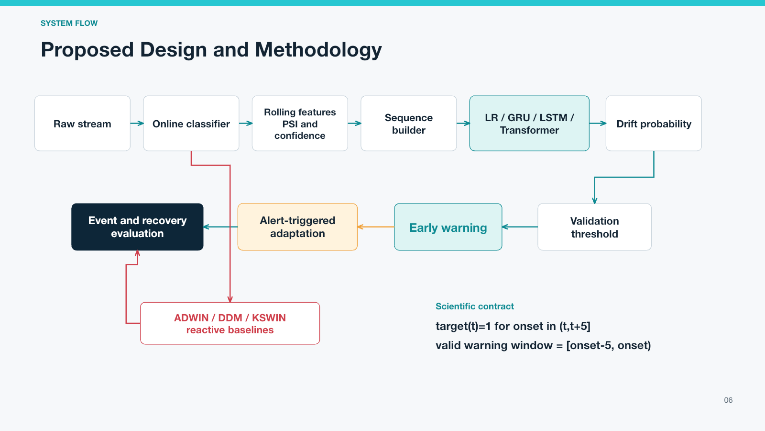
Figure 1. DriftSentinel methodology and the five-batch target and warning contract.
ADWIN, DDM, and KSWIN run as reactive baselines. Their outputs are binary alarms, not calibrated scores. Event matching is one-to-one: an alert can match at most one onset and an onset can receive credit from at most one eligible alert.

6 Dataset Description
Dataset | Source | Events | Usage | Notes
SEA abrupt | Deterministic generator | 10 | Train/val/test | Multiple abrupt episodes
SEA gradual | Deterministic generator | 10 | Train/val/test | Multiple gradual episodes
INSECTS abrupt-balanced | Verified mirror | 5 | Train/val/test | SHA-256 documented
Elec2 | River | 0 verified | Analysis only | No onset truth; excluded

6.1 Chronological Class and Event Audit
Dataset | Split | Rows | Seq. | Positive | Negative | Events
SEA abrupt | train | 356 | 347 | 30 | 317 | 6
SEA abrupt | validation | 119 | 119 | 10 | 109 | 2
SEA abrupt | test | 119 | 119 | 10 | 109 | 2
SEA gradual | train | 356 | 347 | 30 | 317 | 6
SEA gradual | validation | 119 | 119 | 10 | 109 | 2
SEA gradual | test | 119 | 119 | 10 | 109 | 2
INSECTS | train | 577 | 568 | 10 | 558 | 2
INSECTS | validation | 158 | 158 | 5 | 153 | 1
INSECTS | test | 315 | 315 | 10 | 305 | 2
Elec2 | train | 495 | 486 | 0 | 486 | 0
Elec2 | validation | 135 | 135 | 0 | 135 | 0
Elec2 | test | 270 | 270 | 0 | 270 | 0

A supervised event model is not reported as a meaningful trained predictor for Elec2 because its training split has no positive targets. The final event benchmark therefore uses the two SEA streams and INSECTS.

6.2 Dataset Plan Mismatch
The original proposal listed Electricity, Airlines, Forest CoverType, and USENET. The Phase 1 repository actually contained Elec2, INSECTS abrupt-balanced, and SEA. The final reproducible benchmark follows streams that were available and whose event truth could be verified or deterministically generated; it does not claim that all four proposal datasets were evaluated.

7 Implementation Details
Phase 1 produces auditable batches, rolling features, and reactive detector outputs. Phase 2 trains Logistic Regression, GRU, LSTM, and Transformer models on chronological sequences. Phase 3 performs strict event matching, threshold trade-off analysis, causal recovery replay, and reset-cost analysis. The Streamlit dashboard exposes overview, drift timeline, model comparison, threshold trade-off, recovery and adaptation, and research-finding views.
- Target horizon and warning eligibility are both exactly five batches.
- Train, validation, and test remain chronological; scaling and threshold selection use no test information.
- Validation selects each predictive threshold; the selected checkpoint is restored before test inference.
- Causal replay warm-starts an adapted classifier with at most 300 previously labelled rows; future rows are never used.
- The audited suite contains 43 passing tests, and repository CI is passing.

8 Evaluation Metrics
Metric | Definition
F1 | Harmonic mean of precision and recall on batch targets.
PR-AUC | Area under the precision–recall curve for continuous predictive probabilities only.
Warning lead time | Credited alert-to-onset distance within [onset−5, onset).
Warning coverage | Fraction of events with a valid pre-onset warning.
Batch FAR | Fraction of negative target batches that are alarmed.
Missed drift rate | One minus coverage under one-to-one matching.
Recovery batches | Time until rolling accuracy reaches 95% of the pre-drift baseline.
Recovery coverage | Fraction of events recovering within observation.
Adaptations per 100 | Alert-triggered resets per 100 evaluated batches.

ADWIN, DDM, and KSWIN expose binary alarms in this benchmark, so their PR-AUC is N/A rather than compared with probability-based neural PR-AUC.

9 Results and Analysis
The table reports macro means across the three event-scored datasets. These are dataset-level means, not pooled event counts and not seed standard deviations; seed variation is reported separately in generated experiment tables.
Method | F1 | PR-AUC | Lead | Coverage | FAR | Miss | Adapt/100
Logistic Regression | 0.1068 | 0.0909 | 0.00 | 0.0000 | 0.6652 | 1.0000 | 2.3592
GRU | 0.1345 | 0.1039 | 1.83 | 0.3889 | 0.4972 | 0.6111 | 3.6415
LSTM | 0.1222 | 0.0843 | 0.44 | 0.0556 | 0.7199 | 0.9444 | 1.6890
Transformer | 0.0797 | 0.1020 | 0.11 | 0.0556 | 0.3086 | 0.9444 | 1.3425
ADWIN | 0.0370 | N/A | 1.33 | 0.1667 | 0.0199 | 0.8333 | 1.9670
DDM | 0.0513 | N/A | 0.67 | 0.1667 | 0.0083 | 0.8333 | 0.8777
KSWIN | 0.0000 | N/A | 0.00 | 0.0000 | 0.0087 | 1.0000 | 0.8466

9.1 Main Findings
GRU achieved the strongest strict pre-drift warning coverage among predictive models: 0.3889 with a mean lead time of 1.83 batches. This gain is not free: its false-alarm rate was 0.4972 and it triggered 3.6415 adaptations per 100 batches, the highest rate in the comparison. The result supports GRU as the best warning-oriented model here, not as a universally superior operational choice.
Logistic Regression obtained macro F1 0.1068 and PR-AUC 0.0909. It did not cover a test event at the selected strict threshold, but its non-trivial discrimination shows that current rolling statistics contain useful signal. ADWIN and DDM produced much lower FAR, 0.0199 and 0.0083, while each covered only 0.1667 of events. Pooled aggregation yields a different view: Logistic Regression F1 is 0.1423 and GRU F1 is 0.1358, showing why pooled and macro summaries must remain separate.

9.2 Transformer Audit
No implementation bug was found in checkpoint restoration, masking, sequence dimensions, positional encoding, or logits and sigmoid usage. Training positives were sparse and highly imbalanced: SEA used 30 positive versus 317 negative targets (positive weight 10.57), while INSECTS used 10 positive versus 558 negative targets (positive weight 55.8). The low F1 is therefore reported as genuine underperformance under sparse supervision, not corrected through outcome-driven tuning.
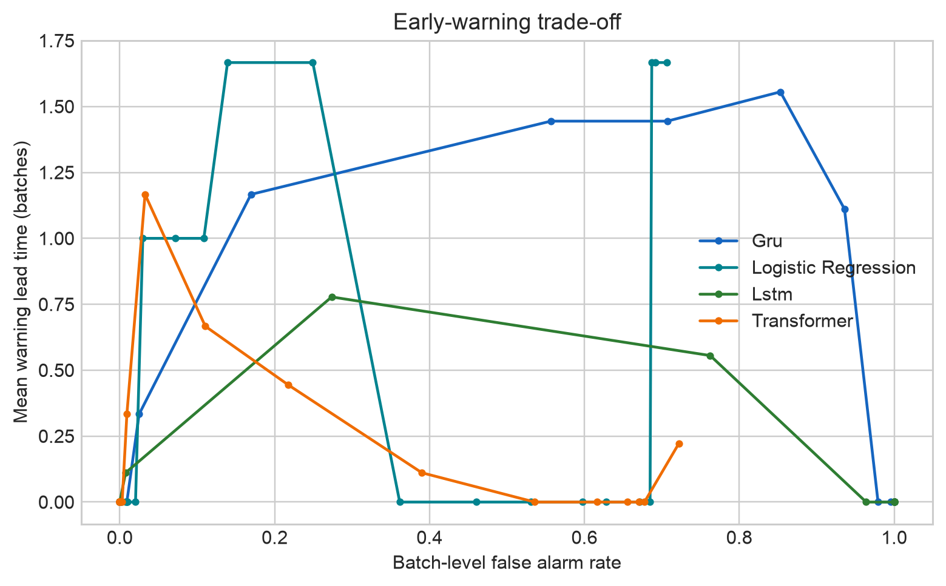
Figure 2. Warning lead time and false-alarm trade-off.
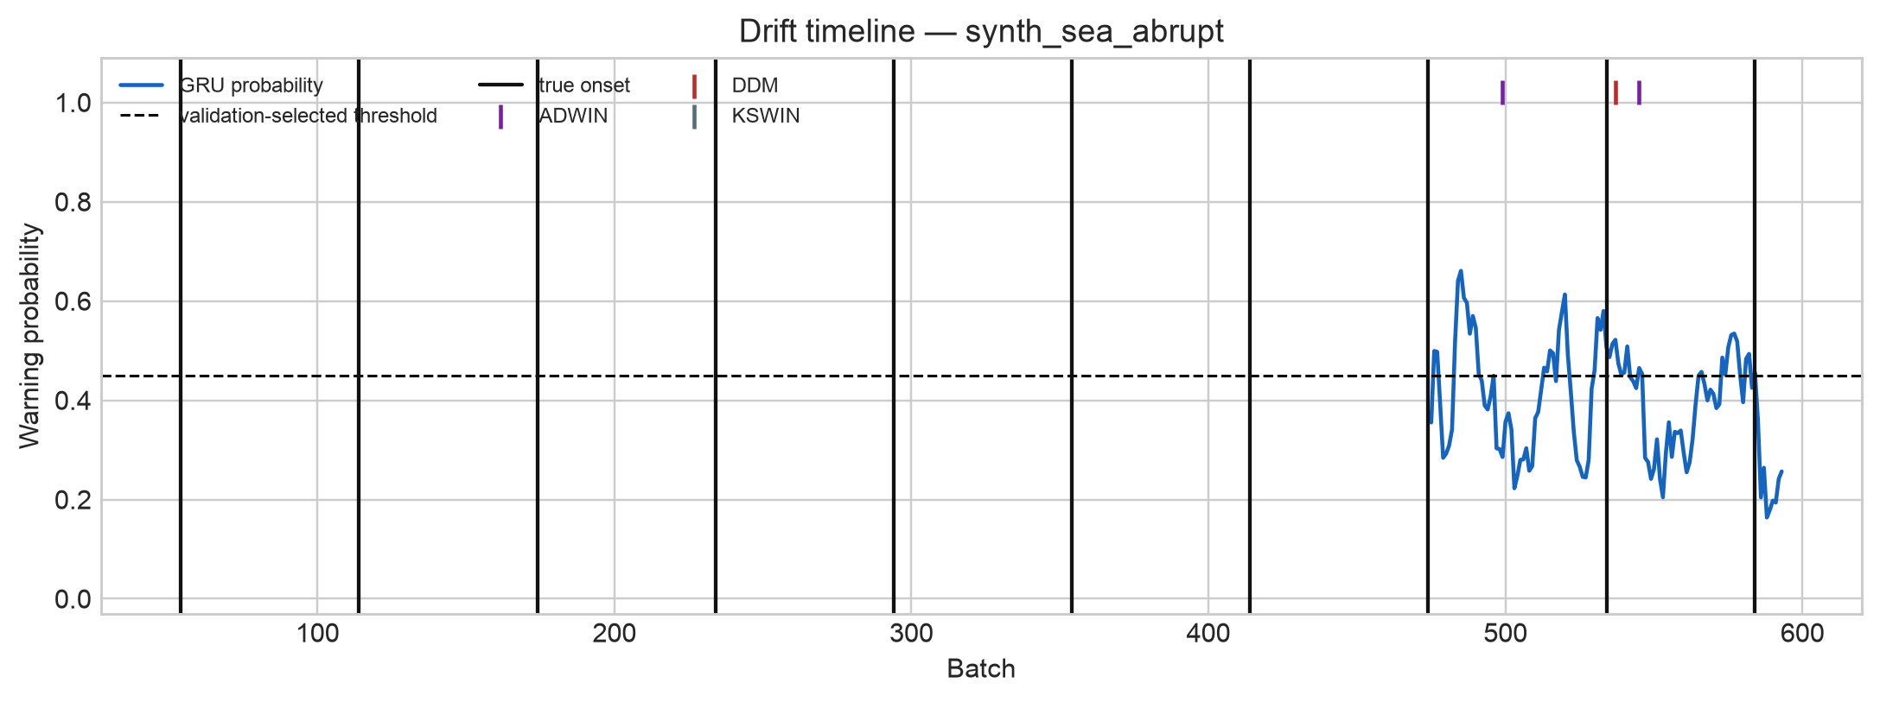
Figure 3. Representative SEA abrupt drift timeline under the strict five-batch warning definition.
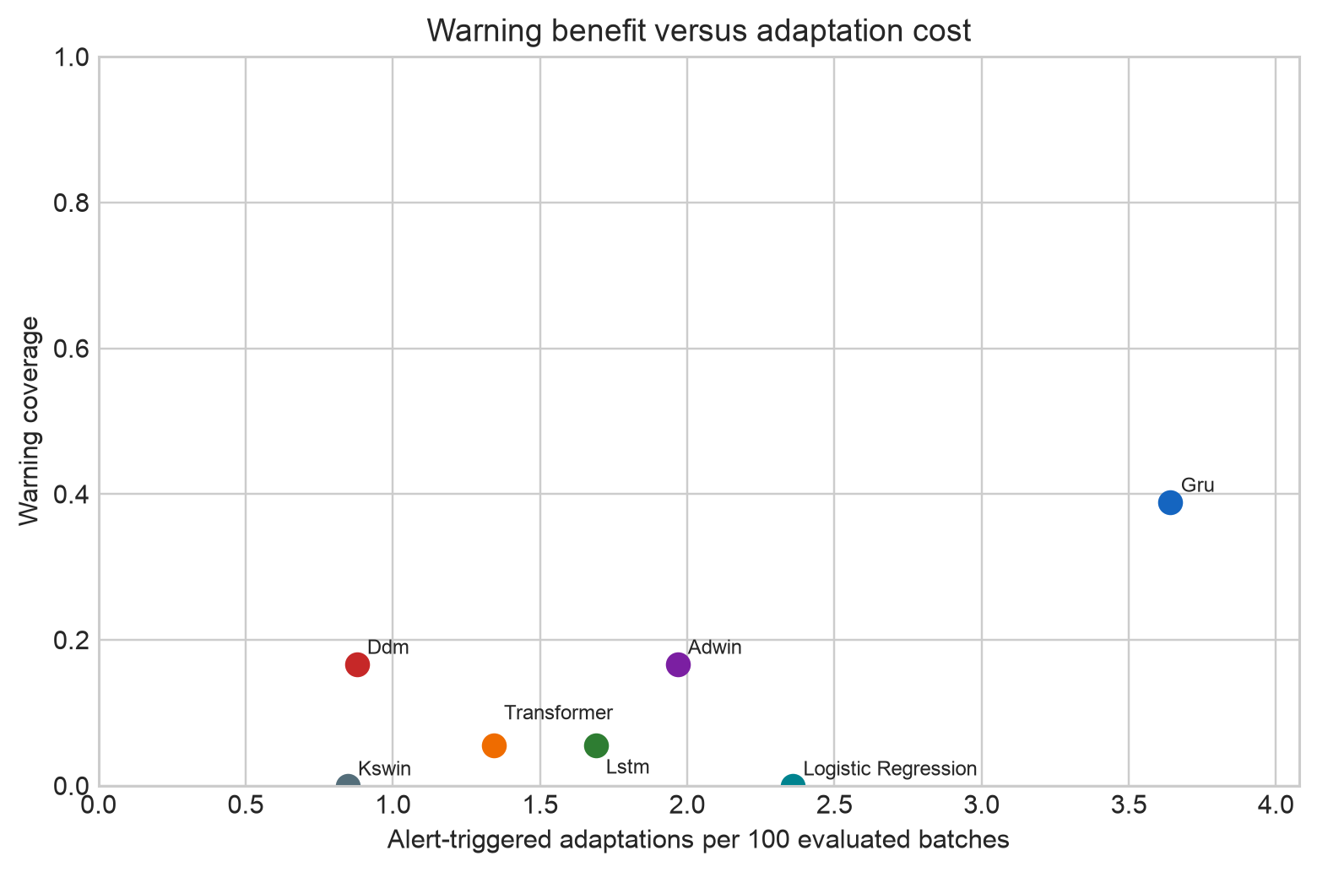
Figure 4. Alert-triggered adaptation cost measured as resets per 100 batches.

9.3 Recovery Replay
Recovery is implemented as actual alert-triggered classifier adaptation, not a confidence proxy. Raw streams are replayed causally. At each alert, the classifier is reset and warm-started from at most 300 previously labelled observations; only information available by that batch is used. Recovery occurs when rolling accuracy returns to 95% of the pre-drift baseline. In the pooled reset audit, 60 of 67 GRU resets were false, for adaptation precision 0.1045. DDM was more conservative, with about 0.904 resets per 100 batches in the pooled view.

10 Applications
- Financial fraud model monitoring.
- Industrial IoT sensor streams.
- Demand forecasting and inventory systems.
- Network intrusion detection.
- Recommendation systems and other continuous-learning services.
DriftSentinel is a research prototype and evaluation framework. It is not presented as a production deployment or safety-critical decision system.

11 Tangible Outcome Plan
The selected tangible outcome is a conference paper on predictive concept-drift early warning. The planning target is the 2027 4th International Conference on Intelligent and Cloud Computing (ICoICC 2027), an IEEE technically co-sponsored conference. This is a proposed target only: the work has not been submitted or accepted, and the call, indexing, eligibility, and faculty approval must be rechecked before communication. Venue: https://icoicc.org.in/
Date | Plan
September 2026 | Freeze evidence, figures, and dashboard demo.
October 2026 | Prepare the 4–6 page manuscript and reproducibility note.
November 2026 | Complete internal faculty review.
December 2026 | Revise, verify venue requirements, and obtain approval.
By 31 January 2027 | Submit to ICoICC 2027 if suitable and approved.
After peer review | Respond to comments and communicate the revised version.

12 Limitations
- The event-scored benchmark has three streams and 25 mapped events; broader real-world validation is needed.
- Synthetic SEA episodes provide controlled truth but cannot represent every operational drift.
- Elec2 lacks authoritative onset labels and is excluded from event claims.
- False alarms and adaptation costs remain high for the strongest warning model.
- Predictive PR-AUC and binary detector alarms answer different questions and are not directly comparable.
- Production latency, governance, and domain-specific economic cost have not been studied.

13 Conclusion and Future Work
DriftSentinel demonstrates that strict pre-onset prediction is feasible but difficult under sparse event supervision. GRU provides the best predictive event coverage, while ADWIN and DDM trade coverage for substantially lower FAR. Logistic Regression confirms that rolling statistics contain signal, and Transformer weakness reflects available supervision rather than an identified software defect. Future work should add verified event-labelled streams, calibrate utility against domain costs, study self-supervised representations, and combine conservative reactive alarms with predictive probabilities.

References
[1] J. Gama et al., ‘A survey on concept drift adaptation,’ ACM Computing Surveys, vol. 46, no. 4, 2014, doi: 10.1145/2523813.
[2] J. Gama et al., ‘Learning with drift detection,’ in SBIA 2004, pp. 286–295, doi: 10.1007/978-3-540-28645-5_29.
[3] A. Bifet and R. Gavaldà, ‘Learning from time-changing data with adaptive windowing,’ in SIAM ICDM, 2007, doi: 10.1137/1.9781611972771.42.
[4] C. Raab et al., ‘Reactive soft prototype computing for concept drift streams,’ Neurocomputing, vol. 416, 2020, doi: 10.1016/j.neucom.2019.11.111.
[5] V. M. A. Souza et al., ‘Challenges in benchmarking stream learning algorithms with real-world data,’ Data Mining and Knowledge Discovery, vol. 34, 2020, doi: 10.1007/s10618-020-00698-5.
[6] K. Cho et al., ‘Learning phrase representations using RNN encoder–decoder for statistical machine translation,’ arXiv:1406.1078, 2014.
[7] S. Hochreiter and J. Schmidhuber, ‘Long short-term memory,’ Neural Computation, vol. 9, no. 8, 1997, doi: 10.1162/neco.1997.9.8.1735.
[8] A. Vaswani et al., ‘Attention is all you need,’ in NeurIPS 30, 2017.
[9] J. Montiel et al., ‘River: machine learning for streaming data in Python,’ Journal of Machine Learning Research, vol. 22, no. 110, 2021.
[10] J. Gama, Knowledge Discovery from Data Streams. CRC Press, 2010.

