Practical - 01

Title: To study the LEX Tool.
Outcome:
- To understand the working of the LEX tool.
- To implement lexical analysis using pattern matching.
Objectives:
- To study the basics of LEX tool.
- To write LEX programs for different inputs.
- To identify tokens such as keywords, identifiers, numbers, etc.
- To understand pattern matching using regular expressions.

Nomenclature:
Term | Description
LEX | A tool used to generate lexical analyzers.
Token | The smallest unit of a program such as keyword, identifier, operator, etc.
Pattern | A rule or regular expression used to match input strings.
yytext | A predefined variable that stores the matched string.
yylex() | A function generated by LEX used to perform lexical analysis.
yywrap() | A function that indicates the end of input to the lexer.
Identifier | A name given to variables, functions, etc.
Keyword | Reserved words in programming languages (e.g., int, if, else).
Operator | Symbols used to perform operations (e.g., +, -, *, /).
Delimiter | Special symbols used to separate elements (e.g., ; , { }).

Assumptions:
- Input is given through keyboard.
- Only valid numeric input is considered where required.
- LEX tool is properly installed.
Dependencies:
- Flex (LEX tool)
- GCC Compiler

Code/ Pseudo Code:
- Title: Write a lex program to print “Hello World”.
Code:
%{
#include<stdio.h>
%}
%%
\n { printf("Welcome"); }
%%
int main(){
yylex();
return 0;
}
int yywrap(){
return 1;
}

Output:
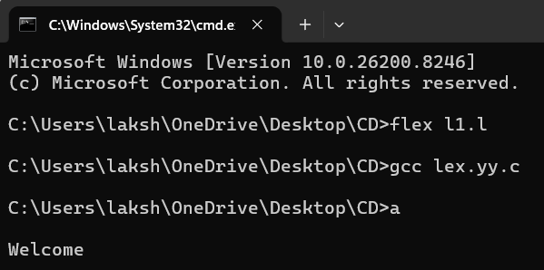

- Title: Write a lex program to print “By By” if user gives input “Hello” while rest of input print Invalid.

Code:
%{
#include<stdio.h>
%}
%%
"Hello" { printf("By By");}
.* { printf("Invalid");}
%%

int main(){
printf("Enter Input: ");
yylex();
return 0;
}
int yywrap(){
return 1;
}
Output:
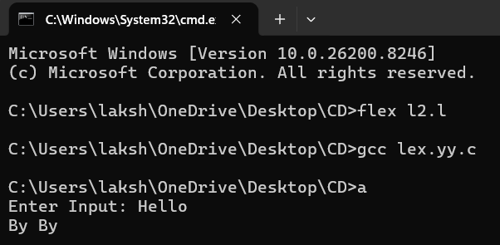
Test Cases:
Input | Output
hello | Invalid
hii | Invalid

- Title: Write a lex program to print “Odd/Even” numbers.
Code:
%{
#include<stdio.h>
#include<stdlib.h>
%}
%%

[0-9]+ {
int n = atoi(yytext);
if(n%2==0)
printf("Even\n");
else
printf("Odd\n");
}
%%

int main(){
yylex();
return 0;
}

int yywrap(){
return 1;
}

Output:
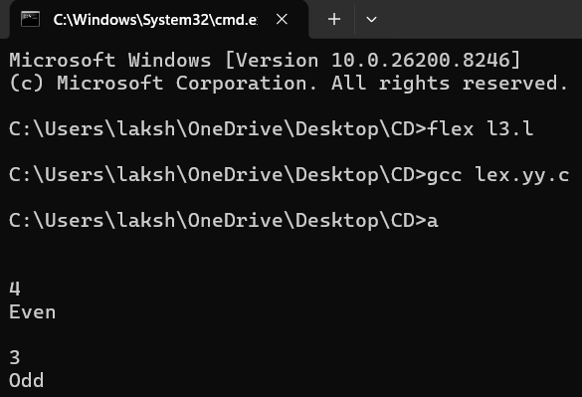

- Title: Write a lex program to display “keyword”, “word”, number, Identifier, Operator Special Characters.
Code:
%{
#include<stdio.h>
#include<stdlib.h>
%}

%%
"int"|"float"|"char"|"if"|"else" { printf("Keyword: %s\n", yytext); }

[0-9]+ { printf("Number: %s\n", yytext); }

[a-zA-Z_][a-zA-Z0-9_]* { printf("Identifier: %s\n", yytext); }

[+\-*/=] { printf("Operator: %s\n", yytext); }

[{}();,] { printf("Special Character: %s\n", yytext); }

[ \t\n]+ ; /* ignore whitespace */

. { printf("Unknown: %s\n", yytext); }
%%

int main() {
yylex();
return 0;
}
int yywrap() {
return 1;
}

Output:
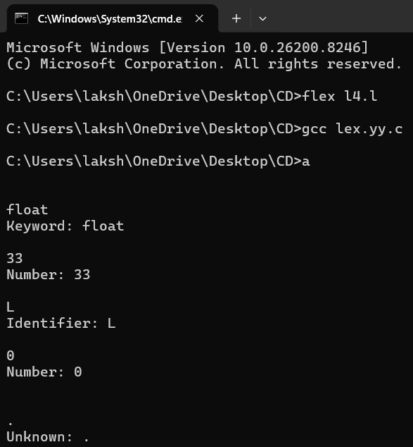

- Title: Write a lex Program to display Input as it is.
Code:
%{
#include<stdio.h>
%}

%%
.|\n { printf("%s", yytext); }
%%

int main() {
printf("Enter input: ");
yylex();
return 0;
}

int yywrap() {
return 1;
}

Output:
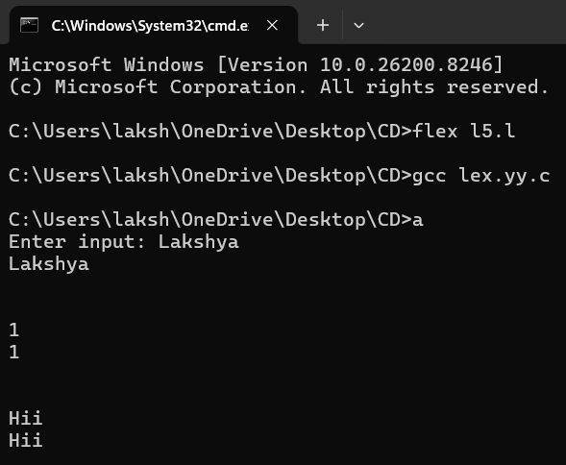
- Title: Write a lex Program to display table of any number.
Code:
%{
#include<stdio.h>
#include<stdlib.h>
%}
%%
[0-9]+ {
int num = atoi(yytext);
printf("Table of %d:\n", num);
for(int i = 1; i <= 10; i++) {
printf("%d x %d = %d\n", num, i, num*i);
}
}
%%
int yywrap() { return 1; }
int main() { yylex(); }

Output:
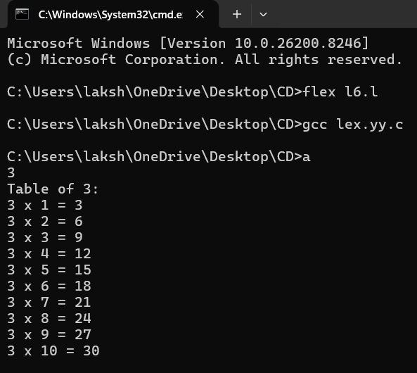
Result Analysis:
All the LEX programs were successfully executed. The outputs matched the expected results and demonstrated proper lexical analysis and pattern matching.
Advantages:
- Reduces manual effort in writing lexical analyzers.
- Efficient and fast processing of input.
- Easy to use with YACC.
- Supports powerful pattern matching using regular expressions.
References:
- Lex & Yacc – John R. Levine, Tony Mason, Doug Brown
- GNU Project – Flex (Fast Lexical Analyzer Generator) Documentation
- Flex Official Manual
- GeeksforGeeks – Articles on LEX Tool and Lexical Analysis
- TutorialsPoint – LEX Programming Tutorials
Quiz Questions:
- What is the main purpose of LEX?
- Syntax analysis
- Lexical analysis
- Code optimization
- Code generation

- What does yytext represent in LEX?
- Input file
- Output buffer
- Matched string
- Token type

- Which function is used to start lexical analysis in LEX?
- main()
- yyparse()
- yylex()
- yywrap()

- Which symbol is used to separate sections in a LEX program?
- ;;
- %%
- ##
- &&

- Which of the following is an identifier?
  - 123abc
  - int
  - var_1
  - +

Viva Questions:
- What is lexical analysis and why is it important?
- Explain the structure of a LEX program.
- What is the difference between LEX and YACC?
- What is the role of yywrap() function?
- How does LEX recognize different tokens?

Practical - 02

Title: To study the YACC tool.
Outcome:
- To understand syntax analysis using YACC.
- To implement parsers for given languages.

Objectives:
- To study YACC tool.
- To design grammars for specific languages.
- To validate strings using context-free grammar.

Nomenclature:
Term | Description
YACC | Yet Another Compiler Compiler (Parser Generator)
Parser | Checks syntax of input
Grammar | Set of production rules
Token | Input symbol passed from LEX
yyparse() | Function that performs parsing
yyerror() | Function to handle errors

Solution:
Assumptions:
- Input is provided by user.
- Grammar is correctly defined.
- LEX is used with YACC where required.

Dependencies:
- YACC / Bison
- Flex
- GCC Compiler

Code/ Pseudo Code:
- Title: Write a YACC program for the language 𝐿= 𝑎^{n} b^{n}
Code: (.l File)
%{
#include "f1.tab.h"
%}

%%
a return 'a';
b return 'b';
\n return 0;
%%

int yywrap() {
return 1;
}

Code: (.y File)
%{
#include<stdio.h>
#include<stdlib.h>

int yylex();
int yyerror(char *s);
%}

%%
S : 'a' S 'b'
|
;
%%

int main() {
printf("Enter string:\n");
yyparse();
printf("Valid String\n");
return 0;
}

int yyerror(char *s) {
printf("Invalid String\n");
return 0;
}

Output:
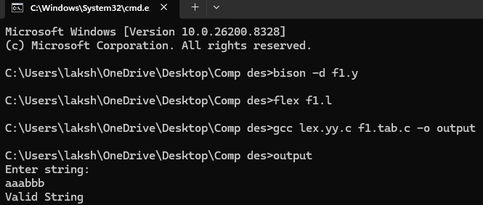

- Title: Write a YACC program for the language 𝐿= 𝑎(𝑎+𝑏)*, 𝐿= 𝑎(𝑎+𝑏)*b
Code: (.l File)
%{
#include "f2.tab.h"
%}

%%
a return 'a';
b return 'b';
\n return 0;
%%

int yywrap() {
return 1;
}

Code: (.y File)
%{
#include<stdio.h>
#include<stdlib.h>

int yylex(void);
int yyerror(char *s);
%}

%%
S : 'a' S 'b'
|
;
%%

int main() {
printf("Enter string:\n");

if(yyparse() == 0)
printf("Valid String\n");

return 0;
}

int yyerror(char *s) {
printf("Invalid String\n");
return 0;
}

Output:
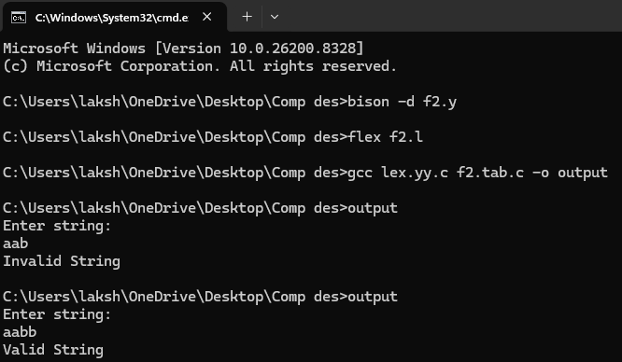

- Title: Write a YACC program for the language 𝐿= 𝑎^{n}𝑏^{n} | 𝑛≥10
Code: (.l File)
%{
#include "f3.tab.h"
%}

%%
a return 'a';
b return 'b';
\n return 0;
%%

int yywrap() {
return 1;
}

Code: (.y File)
%{
#include<stdio.h>
#include<stdlib.h>

int yylex(void);
int yyerror(char *s);

int count = 0;
%}

%%
S : A B {
if(count >= 10)
printf("Valid String\n");
else
printf("Invalid String\n");
}
;

A : 'a' A { count++; }
| 'a' { count++; }
;

B : 'b' B
| 'b'
;
%%

int main() {
printf("Enter string:\n");
yyparse();
return 0;
}

int yyerror(char *s) {
printf("Invalid String\n");
return 0;
}

Output:
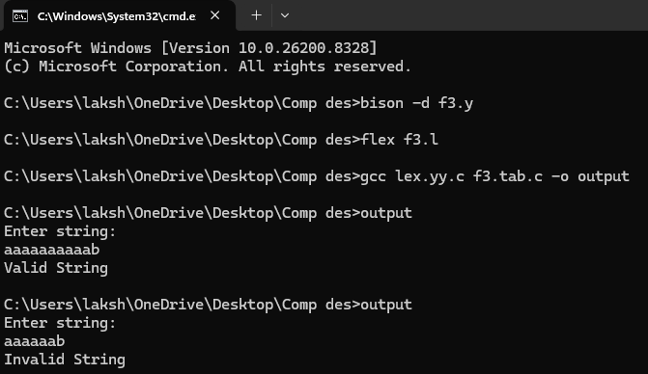

- Title: Write a YACC program to check whether the given arithmetic expression is valid or not?
Code: (.l File)
%{
#include "f4.tab.h"
%}

%%
[0-9]+ return NUM;
[+\-*/()] return yytext[0];
\n return 0;
[ \t] ;
%%

int yywrap() {
return 1;
}

Code: (.y File)
%{
#include<stdio.h>
#include<stdlib.h>

int yylex(void);
int yyerror(char *s);
%}

%token NUM

%%
E : E '+' T
| E '-' T
| T
;

T : T '*' F
| T '/' F
| F
;

F : '(' E ')'
| NUM
;
%%

int main() {
printf("Enter arithmetic expression:\n");

if(yyparse()==0)
printf("Valid Expression\n");

return 0;
}

int yyerror(char *s) {
printf("Invalid Expression\n");
return 0;
}

Output:
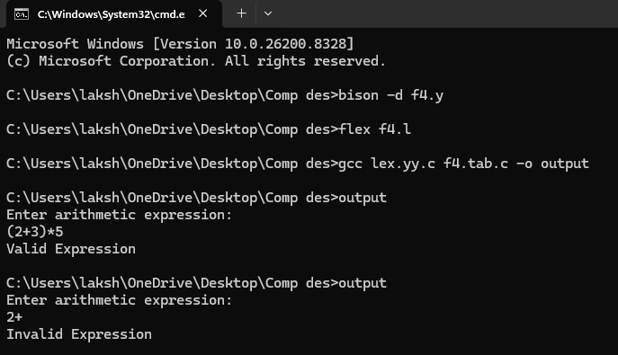

Result Analysis:
All programs successfully parsed input strings and validated them according to defined grammar rules.

Advantages:
- Automates parser generation
- Reduces manual errors
- Easy integration with LEX

References:
- Compilers: Principles, Techniques, and Tools
- Lex & Yacc
- GNU Bison Documentation

Quiz Questions:
- What is YACC used for?
- Lexical analysis
- Syntax analysis
- Code execution
- Debugging

- Which function performs parsing?
- yylex()
- yyparse()
- main()
- yywrap()

- What does grammar define?
- Tokens
- Syntax rules
- Output
- Memory

- Which tool works with YACC?
- Flex
- Python
- Java
- HTML

- What is parser output?
- Tokens
- Parse tree
- Variables
- Loop

Viva Questions:
- What is YACC?
- What is parsing?
- Difference between LEX and YACC?
- What is grammar?
- What is shift-reduce parsing?

Practical - 03

Title: Write a program to implement Lexical Analyzer to recognize few patterns of C.

Outcome: To understand the working of lexical analyzer and recognize tokens used in C language.

Objectives:
- To study lexical analysis phase of compiler.
- To identify keywords, identifiers, operators, numbers, and special symbols.
- To implement token recognition using LEX tool.

Nomenclature:
Term | Description
Lexical Analyzer | Converts input stream into tokens
Token | Smallest meaningful unit
Keyword | Reserved word in C
Identifier | User-defined variable/function name
Operator | Symbol performing operations
Special Character | Symbols like ;, {}, ()
yytext | Stores matched lexeme
yylex() | Performs lexical analysis

Solution:
A lexical analyzer is implemented using LEX tool to recognize different patterns of C language such as keywords, identifiers, numbers, operators, and special characters.

Assumptions:
- Input is valid C-like syntax.
- Flex compiler is installed.
- Tokens are separated properly.

Dependencies:
- Flex Tool
- GCC Compiler
- Command Prompt / Terminal

Code/ Pseudo Code:
%{
#include<stdio.h>
%}

%%
"int"|"float"|"char"|"if"|"else"|"while"|"for" { printf("Keyword : %s\n", yytext); }

[0-9]+ { printf("Number : %s\n", yytext); }

[a-zA-Z_][a-zA-Z0-9_]* { printf("Identifier : %s\n", yytext); }

[+\-*/=<>] { printf("Operator : %s\n", yytext); }

[{}();,] { printf("Special Character : %s\n", yytext); }

[ \t\n] ;

. { printf("Unknown : %s\n", yytext); }

%%

int main()
{
printf("Enter C statement:\n");
yylex();
return 0;
}

int yywrap()
{
return 1;
}

Output:
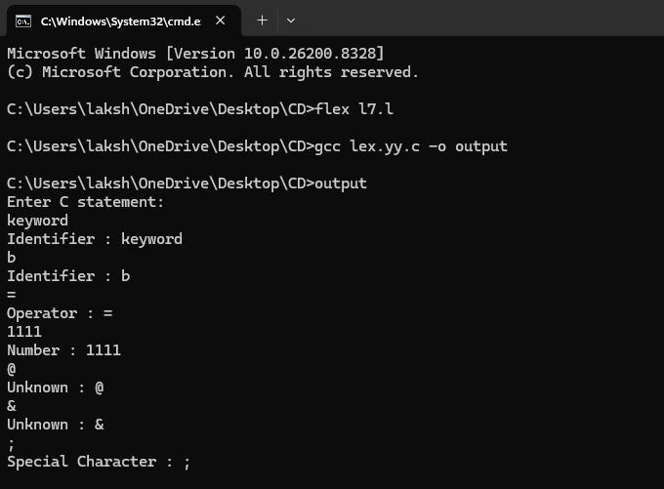

Result Analysis:
The lexical analyzer successfully recognized different tokens of C language such as keywords, identifiers, operators, numbers, and special characters.

Advantages:
- Fast token recognition
- Reduces complexity of parsing
- Helps in compiler construction
- Easy implementation using LEX

References:
- Compilers: Principles, Techniques, and Tools
- Lex & Yacc
- Flex Documentation

Quiz Questions:
- What is the function of lexical analyzer?
  - Code Optimization
  - Token Recognition
  - Parsing
  - Linking

- Which function performs lexical analysis in LEX?
  - yyparse()
  - yywrap()
  - yylex()
  - main()

- Which of the following is an identifier?
- int
- 123abc
- total_1
- +

- Which symbol is used for section separation in LEX?
- ##
- %%
- ;;
- &&

- Which phase comes after lexical analysis?
- Linking
- Parsing
- Execution
- Loading

Viva Questions:
- What is lexical analysis?
- Define token and lexeme.
- What is the role of LEX tool?
- What are identifiers in C?
- What is the use of yytext?

Practical - 04

Title: Write a program to implement the Recursive Descent Parser.

Outcome: To understand the working of recursive descent parsing technique and implement a parser for a given grammar.

Objectives:
- To study top-down parsing technique.
- To implement recursive descent parser using C language.
- To validate strings using grammar rules.

Nomenclature:
Term | Description
Parser | Checks syntax of input string
Recursive Descent Parser | Top-down parser using recursive procedures
Grammar | Set of production rules
Non-Terminal | Variable used in grammar
Terminal | Actual input symbol
Production Rule | Rule defining derivation
Parsing | Process of syntax checking

Solution:
A recursive descent parser is implemented using C language for the grammar:
E → E + T | T
T → T * F | F
F → (E) | id
The parser checks whether the given expression is valid according to the grammar.

Assumptions:
- Input expression contains valid symbols.
- Input length is limited.
- Grammar does not contain ambiguity.

Dependencies:
- GCC Compiler
- Turbo C / VS Code / Dev C++

Code/ Pseudo Code:
#include<stdio.h>
#include<string.h>

char input[100];
int i = 0;
int error = 0;

void E();
void T();
void F();

void E()
{
T();

while(input[i] == '+')
{
i++;
T();
}
}

void T()
{
F();

while(input[i] == '*')
{
i++;
F();
}
}

void F()
{
if(input[i] == '(')
{
i++;
E();

if(input[i] == ')')
i++;
else
error = 1;
}

else if(input[i] == 'i' && input[i+1] == 'd')
{
i = i + 2;
}

else
{
error = 1;
}
}

int main()
{
printf("Enter expression:\n");
scanf("%s", input);

E();

if(error == 0 && input[i] == '\0')
printf("Valid String\n");
else
printf("Invalid String\n");

return 0;
}

Output:
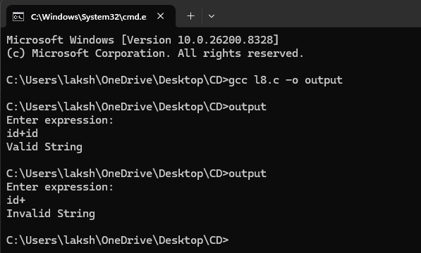

Result Analysis:
The recursive descent parser successfully validated arithmetic expressions according to the given grammar using recursive functions.

Advantages:
- Simple implementation
- Easy to understand
- Efficient for small grammars
- Useful in compiler design

References:
- Compilers: Principles, Techniques, and Tools
- Compiler Design
- Compiler Design Notes

Quiz Questions:
- Recursive descent parser is which type of parser?
- Bottom-up
- Top-down
- Shift-reduce
- Operator precedence

- Which concept is used in recursive descent parser?
- Looping
- Recursion
- Sorting
- Linking

- Which grammar is suitable for recursive descent parser?
- Ambiguous grammar
- Left recursive grammar
- Non-left recursive grammar
- Regular grammar

- What does parser check?
- Syntax
- Speed
- Memory
- Linking

- Recursive descent parser uses:
- Stack only
- Recursive functions
- Arrays only
- Trees only

Viva Questions:
- What is recursive descent parser?
- What is top-down parsing?
- What is left recursion?
- Difference between top-down and bottom-up parsing?
- Why left recursion is removed in recursive descent parser?

Practical - 05

Title: Write a program to implement the Computation of FIRST and FOLLOW of variables of grammar.

Outcome: To understand and compute FIRST and FOLLOW sets of grammar variables used in compiler design.

Objectives:
- To study FIRST and FOLLOW concepts.
- To compute FIRST set of non-terminals.
- To compute FOLLOW set of non-terminals.
- To understand predictive parsing.

Nomenclature:
Term | Description
FIRST | Set of symbols that appear first in derivation
FOLLOW | Set of symbols that appear immediately after non-terminal
Non-Terminal | Variable in grammar
Terminal | Actual input symbol
Grammar | Set of production rules
Production | Rule defining derivation

Solution: A C program is implemented to compute FIRST and FOLLOW sets for given grammar productions.

Assumptions:
- Grammar is context free.
- Productions are entered correctly.
- Non-terminals are uppercase letters.

Dependencies:
- GCC Compiler
- C Programming Environment

Code/ Pseudo Code:
#include<stdio.h>
#include<ctype.h>
#include<string.h>

int n;
char production[10][10];
char first[10];
char follow[10];

void findFirst(char c)
{
int i, j;

for(i = 0; i < n; i++)
{
if(production[i][0] == c)
{
if(!isupper(production[i][3]))
{
printf("%c ", production[i][3]);
}

else
{
findFirst(production[i][3]);
}
}
}
}

void findFollow(char c)
{
int i, j;

if(production[0][0] == c)
{
printf("$ ");
}

for(i = 0; i < n; i++)
{
for(j = 3; j < strlen(production[i]); j++)
{
if(production[i][j] == c)
{
if(production[i][j+1] != '\0')
{
if(!isupper(production[i][j+1]))
{
printf("%c ", production[i][j+1]);
}

else
{
findFirst(production[i][j+1]);
}
}
}
}
}
}

int main()
{
int i;
char c;

printf("Enter number of productions:\n");
scanf("%d", &n);

printf("Enter productions:\n");

for(i = 0; i < n; i++)
{
scanf("%s", production[i]);
}

printf("Enter variable to find FIRST and FOLLOW:\n");
scanf(" %c", &c);

printf("FIRST(%c) = { ", c);
findFirst(c);
printf("}\n");

printf("FOLLOW(%c) = { ", c);
findFollow(c);
printf("}\n");

return 0;
}

Output:
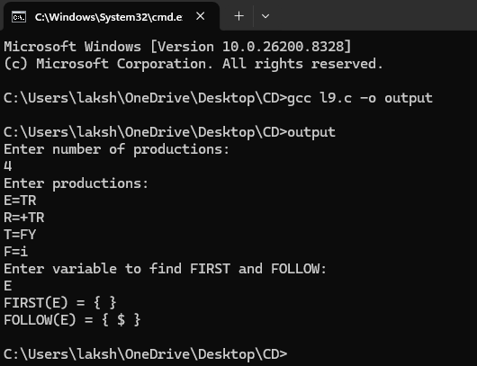

Result Analysis: The program successfully computed FIRST and FOLLOW sets for the given grammar variables.

Advantages:
- Useful for predictive parser construction
- Helps remove ambiguity
- Important in compiler design
- Simplifies syntax analysis

References:
- Compilers: Principles, Techniques, and Tools
- Compiler Design
- Compiler Design Notes

Quiz Questions:

- FIRST set contains:
- Last symbols
- First symbols
- Operators only
- Variables only
- FOLLOW set contains:
- Previous symbols
- Next symbols
- Numbers only
- Keywords only

- Which symbol is used in FOLLOW of start symbol?
- #
- $
- @
- &

- FIRST and FOLLOW are used in:
- Linking
- Parsing
- Loading
- Execution

- Grammar variables are also called:
- Tokens
- Operators
- Non-terminals
- Identifiers

Viva Questions:
- What is FIRST set?
- What is FOLLOW set?
- Why are FIRST and FOLLOW important?
- What is a non-terminal?
- What is predictive parsing?

Practical - 06

Title: Write a program to implement Operator Precedence Parser.

Outcome: To understand the working of operator precedence parsing technique and implement it using C language.

Objectives:
- To study operator precedence parsing.
- To understand shift-reduce parsing.
- To parse arithmetic expressions using precedence relations.

Nomenclature:
Term | Description
Operator Precedence Parser | Parser based on operator priorities
Shift | Push input symbol into stack
Reduce | Replace symbols using grammar rule
Stack | Temporary storage for parsing
Handle | Substring matching production rule
Parsing | Syntax checking process

Solution: An operator precedence parser is implemented using stack operations to perform shift and reduce actions according to operator precedence rules.

Assumptions:
- Input expression is valid arithmetic expression.
- Operators used are +, *, (, ) and id.
- Grammar is operator precedence grammar.

Dependencies:
- GCC Compiler
- C Programming Environment

Code/ Pseudo Code:
#include<stdio.h>
#include<string.h>

char stack[50], input[50];
int top = -1;
int i = 0;

void reduce()
{
int len;

while(1)
{
len = strlen(stack);

if(len >= 2 &&
stack[len-2] == 'i' &&
stack[len-1] == 'd')
{
stack[len-2] = 'E';
stack[len-1] = '\0';
}

else if(len >= 3 &&
stack[len-3] == 'E' &&
(stack[len-2] == '+' || stack[len-2] == '*') &&
stack[len-1] == 'E')
{
stack[len-3] = 'E';
stack[len-2] = '\0';
stack[len-1] = '\0';
}

else
{
break;
}
}
}

int main()
{
printf("Enter expression:\n");
scanf("%s", input);

while(input[i] != '\0')
{
stack[++top] = input[i];
stack[top+1] = '\0';

reduce();

i++;
}

reduce();

if(strcmp(stack, "E") == 0)
printf("Valid Expression\n");
else
printf("Invalid Expression\n");

return 0;
}

Output:
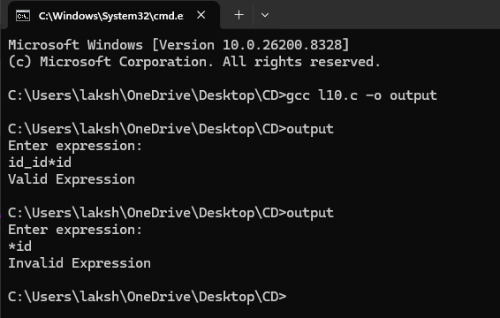

Result Analysis: The operator precedence parser successfully performed shift and reduce operations and validated arithmetic expressions according to precedence rules.

Advantages:
- Simple precedence handling
- Efficient expression parsing
- Easy implementation
- Useful in compiler construction

References:
- Compilers: Principles, Techniques, and Tools
- Compiler Design
- Compiler Design Notes

Quiz Questions:
- Operator precedence parser is based on:
  - Keywords
  - Operator priorities
  - Variables
  - Arrays
- Which operation pushes symbol into stack?
  - Reduce
  - Shift
  - Parse
  - Match
- Which data structure is mainly used?
  - Queue
  - Tree
  - Stack
  - Graph
- Which parsing technique is used in operator precedence parser?
  - Top-down
  - Bottom-up
  - Recursive
  - Predictive
- Which operators are commonly used in precedence parsing?
  - + and *
  - if and else
  - while and for
  - int and float

Viva Questions:
- What is operator precedence parser?
- What is shift operation?
- What is reduce operation?
- Difference between top-down and bottom-up parsing?
- What is handle in parsing?

Practical - 07

Title: Write a program to check data types.

Outcome: To understand how different data types are identified and checked in C programming.

Objectives:
- To study different data types in C.
- To identify integer, float, character, and string data types.
- To implement datatype checking using conditional statements.

Nomenclature:

Term | Description
Data Type | Defines type of data stored
Integer | Stores whole numbers
Float | Stores decimal values
Character | Stores single character
String | Collection of characters
ASCII | Numeric representation of character

Solution: A C program is implemented to check whether the entered value is integer, float, character, or string.

Assumptions:
- User enters valid input.
- Input length is within limit.
- Special symbols are ignored.

Dependencies:
- GCC Compiler
- C Programming Environment

Code/ Pseudo Code:
#include<stdio.h>
#include<string.h>
#include<ctype.h>

int main()
{
char input[100];
int i, flagInt = 1, flagFloat = 0;

printf("Enter value:\n");
scanf("%s", input);

if(strlen(input) == 1 && isalpha(input[0]))
{
printf("Character Data Type\n");
}

else
{
for(i = 0; input[i] != '\0'; i++)
{
if(input[i] == '.')
{
flagFloat = 1;
}

else if(!isdigit(input[i]))
{
flagInt = 0;
}
}

if(flagInt == 1 && flagFloat == 0)
{
printf("Integer Data Type\n");
}

else if(flagFloat == 1)
{
printf("Float Data Type\n");
}

else
{
printf("String Data Type\n");
}
}

return 0;
}

Output:
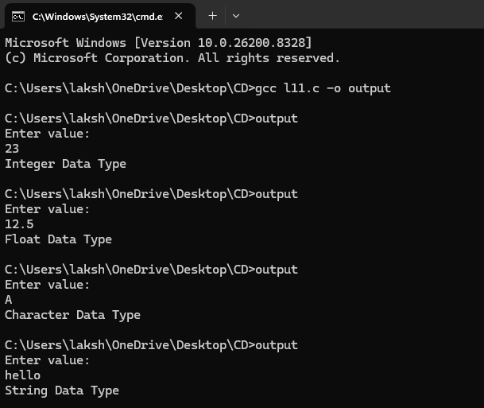

Result Analysis: The program successfully identified different data types based on the user input.

Advantages:
- Easy datatype identification
- Simple implementation
- Useful for beginners
- Helps understand input processing

References:
- The C Programming Language
- Programming in ANSI C
- C Programming Notes

Quiz Questions:
- Which datatype stores decimal numbers?
- int
- char
- float
- void

- Which function checks digits in C?
- strlen()
- isdigit()
- scanf()
- strcpy()

- Which datatype stores single character?
- int
- float
- char
- string

- Which header file contains isdigit()?
- stdio.h
- string.h
- ctype.h
- math.h

- Which function is used to find string length?
- strcpy()
- strlen()
- strcmp()
- strcat()

Viva Questions
- What is a data type?
- Difference between int and float?
- What is character datatype?
- What is use of isdigit()?
- Which header file contains string functions?
Practical – 08

Title: Write a program to implement the generation of three address code.

Outcome: To understand the generation of intermediate code using Three Address Code (TAC).

Objectives:
- To study intermediate code generation.
- To understand Three Address Code representation.
- To generate TAC for arithmetic expressions.

Nomenclature:
Term | Description
Three Address Code | Intermediate code with at most three addresses
Temporary Variable | Variable used for intermediate results
Operand | Data item on which operation is performed
Operator | Symbol representing operation
Intermediate Code | Machine independent representation

Solution: A C program is implemented to generate Three Address Code for arithmetic expressions using temporary variables.

Assumptions:
- Expression contains valid operators.
- Input expression is simple arithmetic expression.
- Expression length is within limit.

Dependencies:
- GCC Compiler
- C Programming Environment

Code/ Pseudo Code:
#include<stdio.h>
#include<string.h>

int main()
{
char exp[50];
int i = 0;
int temp = 1;

printf("Enter expression:\n");
scanf("%s", exp);

printf("Three Address Code:\n");

while(exp[i] != '\0')
{
if(exp[i] == '+' || exp[i] == '-' ||
exp[i] == '*' || exp[i] == '/')
{
printf("t%d = %c %c %c\n",
temp,
exp[i-1],
exp[i],
exp[i+1]);

exp[i+1] = 't';
temp++;
}

i++;
}

return 0;
}

Output:
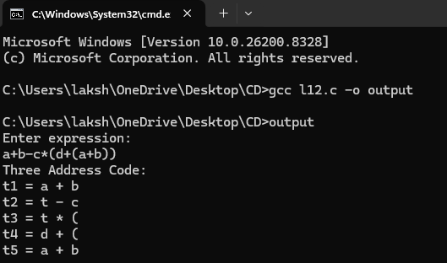

Result Analysis: The program successfully generated Three Address Code for arithmetic expressions using temporary variables.
Advantages:
- Simplifies code optimization
- Machine independent representation
- Easy intermediate code generation
- Useful in compiler construction
References:
- Compilers: Principles, Techniques, and Tools
- Compiler Design
- Compiler Design Notes
Quiz Questions:
- Three Address Code is used in:
- Lexical Analysis
- Intermediate Code Generation
- Linking
- Loading

- TAC contains maximum how many addresses?
- 1
- 2
- 3
- 4

- Temporary variables are represented as:
- x
- t1, t2
- id
- op

- Which phase generates TAC?
- Syntax Analysis
- Intermediate Code Generation
- Linking
- Execution

- TAC is:
- Machine dependent
- Machine independent
- Hardware code
- Binary code
Viva Questions
- What is Three Address Code?
- Why is TAC used?
- What are temporary variables?
- What is intermediate code?
- Advantages of TAC?
Practical - 09

Title: Write a program to implement the computation of postfix notation.

Outcome: To understand the conversion of infix expression into postfix notation using stack operations.

Objectives:
- To study postfix notation.
- To understand stack implementation.
- To convert infix expressions into postfix expressions.

Nomenclature:
Term | Description
Infix Expression | Operator written between operands
Postfix Expression | Operator written after operands
Stack | Linear data structure using LIFO
Operand | Data item on which operation is performed
Operator | Symbol representing operation
Precedence | Priority of operators

Solution: A C program is implemented to convert infix expressions into postfix notation using stack operations and operator precedence.

Assumptions:
- Expression is valid.
- Expression contains operators +, -, *, /.
- Parentheses are balanced.

Dependencies:
- GCC Compiler
- C Programming Environment

Code/ Pseudo Code:
#include<stdio.h>
#include<ctype.h>
#include<string.h>

char stack[100];
int top = -1;

void push(char x)
{
stack[++top] = x;
}

char pop()
{
return stack[top--];
}

int priority(char x)
{
if(x == '(')
return 0;

if(x == '+' || x == '-')
return 1;

if(x == '*' || x == '/')
return 2;

return 0;
}

int main()
{
char exp[100];
char *e, x;

printf("Enter infix expression:\n");
scanf("%s", exp);

e = exp;

printf("Postfix Expression: ");

while(*e != '\0')
{
if(isalnum(*e))
{
printf("%c", *e);
}

else if(*e == '(')
{
push(*e);
}
else if(*e == ')')
{
while((x = pop()) != '(')
{
printf("%c", x);
}
}
else
{
while(priority(stack[top]) >= priority(*e))
{
printf("%c", pop());
}

push(*e);
}

e++;
}

while(top != -1)
{
printf("%c", pop());
}

return 0;
}

Output:
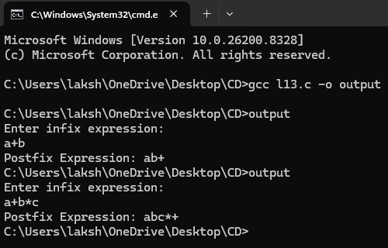

Result Analysis: The program successfully converted infix expressions into postfix notation using stack and operator precedence rules.
Advantages:
- Faster expression evaluation
- No need for parentheses in postfix
- Easy stack implementation
- Useful in compiler design

References:
- Data Structures Using C
- Compilers: Principles, Techniques, and Tools
- Compiler Design Notes

Quiz Questions:
- In postfix notation, operator is written:
- Before operands
- Between operands
- After operands
- None
- Which data structure is used for postfix conversion?
- Queue
- Stack
- Tree
- Graph
- Which notation does not require parentheses?
- Infix
- Prefix
- Postfix
- Binary
- Which operator has higher precedence?
- +
- –
- *
- =
- Stack follows:
- FIFO
- LIFO
- FILO
- None
Viva Questions
- What is postfix notation?
- Difference between infix and postfix?
- What is operator precedence?
- Why is stack used in postfix conversion?
- Advantages of postfix notation?

Practical - 10

Title: Write a case study of Peephole Optimization
Outcome:
Objectives:
Nomenclature:
Solution:
Assumptions:
Dependencies:
Code/ Pseudo Code:
Result Analysis:
Advantages:
References:
Quiz & Viva Questions:

