Input :

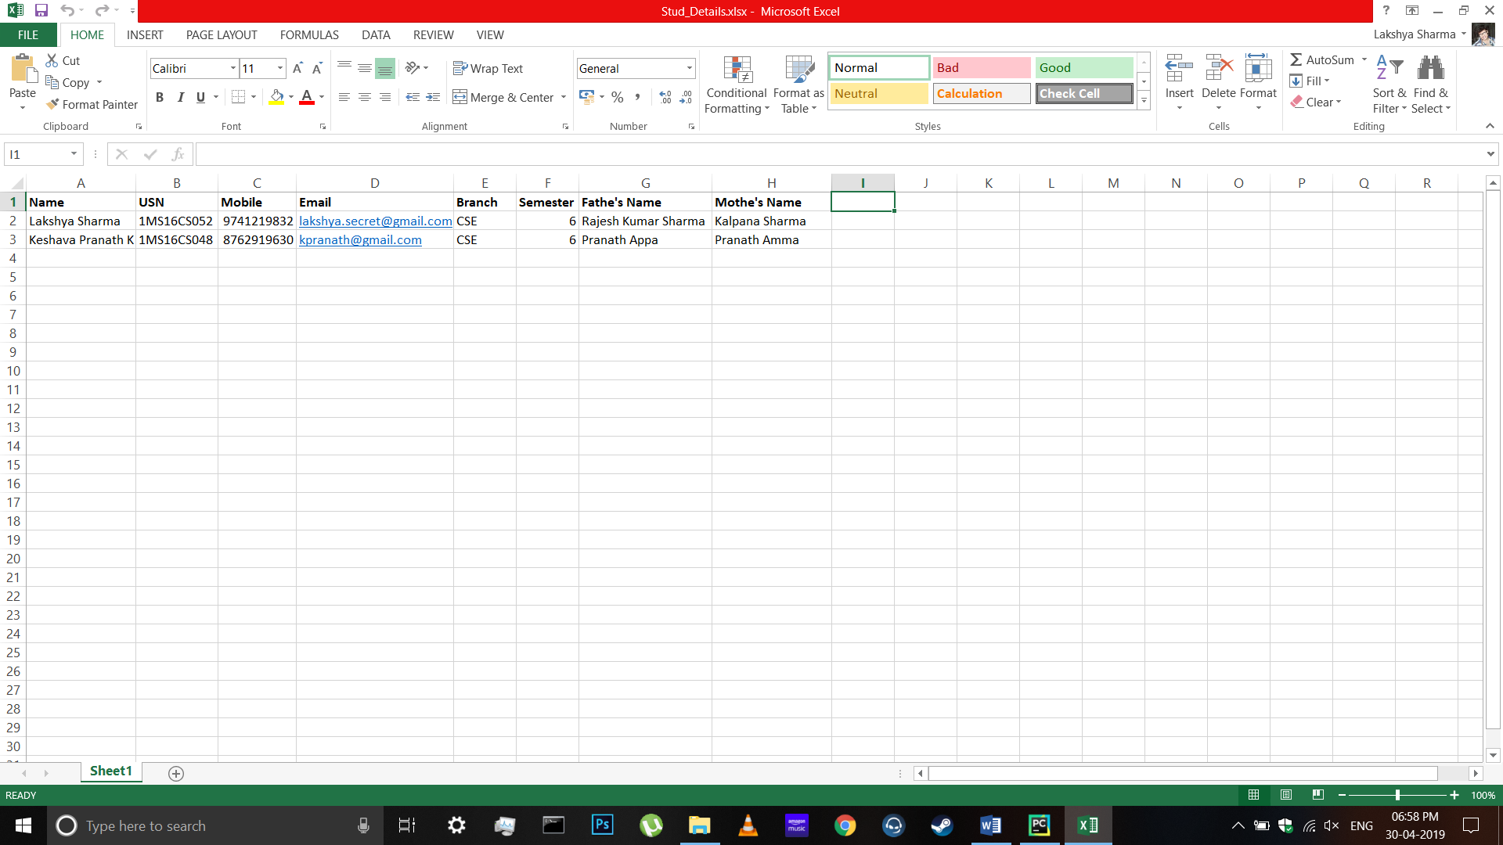

Sample Shape Images :

 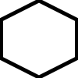 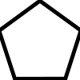

  

Code Output :

Reading Data from Excel Sheet

Data has been read from the Excel Sheet

Enter Choice of Shape :

1. Circle

2. Triangle

3. Square

4. Rectangle

5. Pentagon

6. Hexagon

Your Choice : 1

Image is being created

Image Created

Object Identification is starting

841 Objects in the image have been identified

Student Details are being Encoded

Student Data has been Encoded

Images are being created for each student

Image has been created for student 1

Image has been created for student 2

All the Images have been saved

Total Time Taken : 91 seconds

Generated input & output images on the basis of user’s choice of shape:



