## Results A: Simulating a repressilator for oscillating and non-oscillating conditions.

14.20 vs 14.90

NaN vs 12.5

## Results B: Issues with FFT in recognizing periodicity of non-sinusoidal waves, and the way utilized.

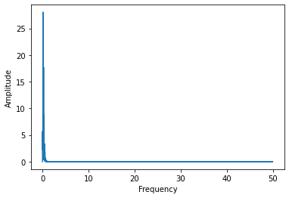

## Results C: Evolving networks (images showing increase/decrease in frequency for a particular network)