

AutoGrade

A Project Report submitted in partial fulfilment of the requirements for
the award of the degree of
Bachelor of Technology
d

in
Computer Science and Engineering
By
Name & Roll No. of Students:

Ansh Gaur (2215000282)
Lakshya Varshney (2215000985)
Priyank Singh (2215001329)
Krishna Singh (2215000941)

Under the Guidance of
Mr. Shubham Chaudhary
Department of Computer Engineering & Applications
Institute of Engineering & Technology

GLA University
Mathura- 281406, INDIA
May, 2024


Department of Computer Engineering and Applications

GLA University, 17 km. Stone NH#2, Mathura-Delhi Road, Chaumuha, Mathura – 281406 U.P (India)

Declaration

I hereby declare that the work which is being presented in the B.Tech. Mini Project “AutoGrade”, in partial fulfillment of the requirements for the award of the Bachelor of Technology in Computer Science and Engineering and submitted to the Department of Computer Engineering and Applications of GLA University, Mathura, is an authentic record of my own work carried under the supervision of Mr. Shubham Chaudhary.
The contents of this project report, in full or in parts, have not been submitted to any other Institute or University for the award of any degree.

Sign ______________________ Sign ______________________
Name of Candidate:Ansh Gaur Name of Candidate: Lakshya Varshney
University Roll No.: 2215000282 University Roll No.: 2215000985

Sign ______________________ Sign ______________________
Name of Candidate:Priyank Singh Name of Candidate: Krishna Singh
University Roll No.:2215001329 University Roll No.: 2215000941

Certificate

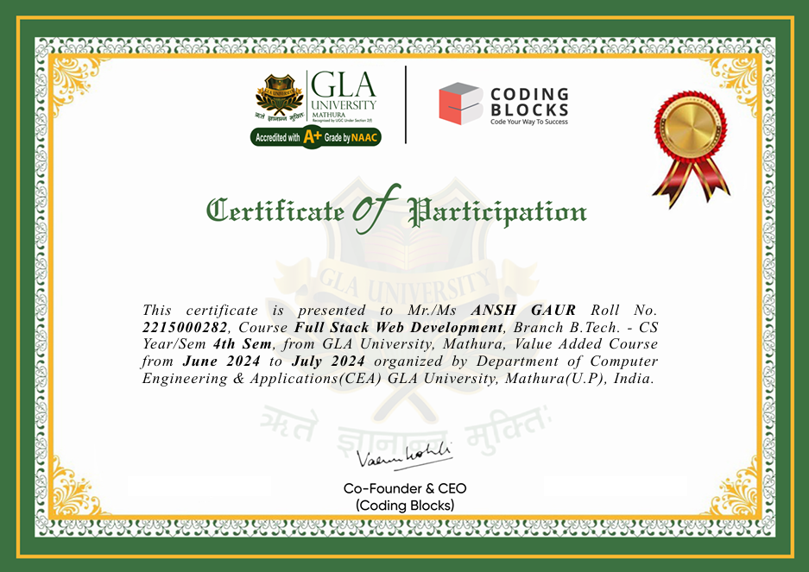

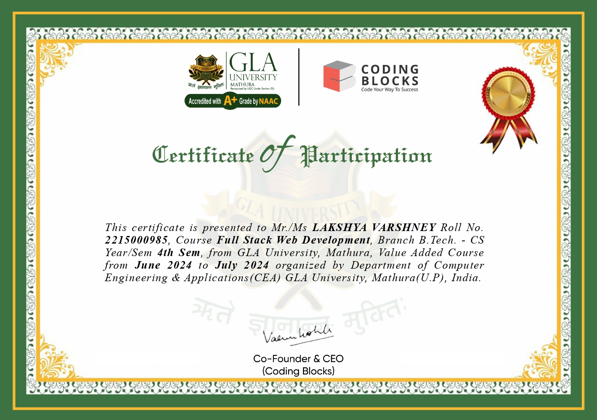

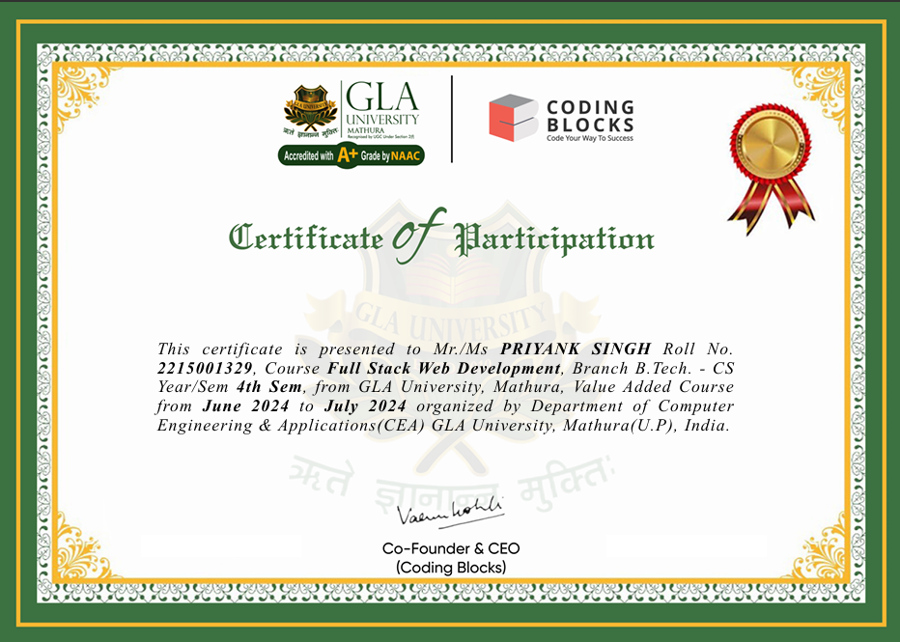

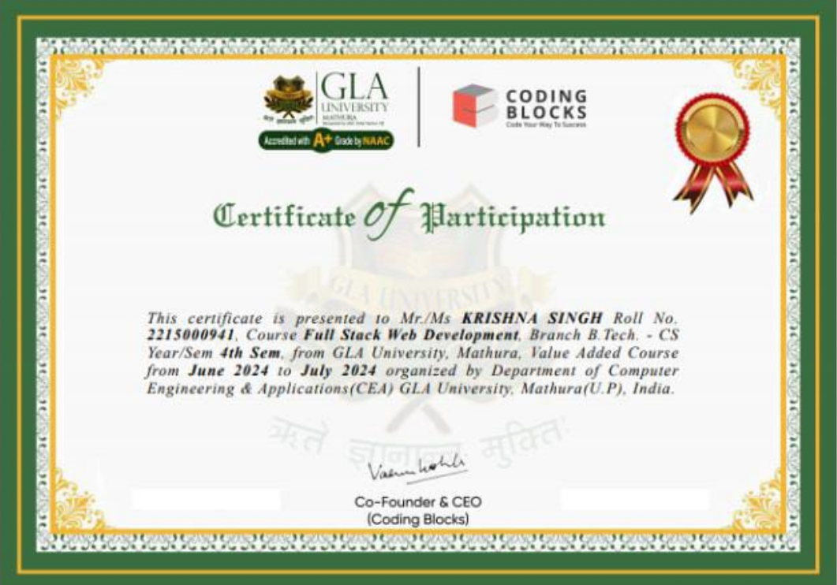

ACKNOWLEDGEMENT

I would like to express my deepest gratitude to everyone who contributed to the successful completion of this project, AutoGrade, as part of my summer internship training program.
First and foremost, I am sincerely thankful to GLA University, Mathura & Coding Blocks for providing me with this incredible opportunity to work on such a challenging and rewarding project. This experience has been invaluable in enhancing my technical knowledge and professional skills.
I extend my heartfelt thanks to my project mentor, Mr. Shubham Chaudhary, for their constant guidance, insightful feedback, and unwavering support throughout the project. Their expertise and encouragement have been instrumental in shaping the direction and outcomes of this project.
I also wish to thank my colleagues and team members for their cooperation, brainstorming sessions, and constructive collaboration. Working together has made the learning process enjoyable and productive.
Lastly, I am grateful to my family and friends for their continued encouragement and belief in my abilities, which motivated me throughout this journey.
This internship experience has not only broadened my technical horizons but has also instilled in me a deeper understanding of teamwork, time management, and problem-solving.

Sign ______________________ Sign ______________________
Name of Candidate:Ansh Gaur Name of Candidate: Lakshya Varshney
University Roll No.: 2215000282 University Roll No.: 2215000985

Sign ______________________ Sign ______________________
Name of Candidate:Priyank Singh Name of Candidate: Krishna Singh
University Roll No.:2215001329 University Roll No.: 2215000941

ABSTRACT

AutoGrade is a web-based application designed to automate and simplify the process of managing and retrieving student marks. Developed using the MERN stack (MongoDB, Express, React, Node.js), AutoGrade enables administrators to upload student grades and add student records, while providing a seamless experience for students to access their results. The platform is designed to be efficient and user-friendly, making it an ideal solution for academic institutions looking to streamline grade management.
The application features a login page where administrators can securely upload marks and manage student information. Students, however, do not need to log in to access their grades. Instead, they can use their unique roll number to retrieve the marks uploaded by the administrator, ensuring both simplicity and security. This approach eliminates the need for students to remember additional login credentials while still maintaining a secure and efficient system for mark retrieval.
The frontend of AutoGrade is built using HTML, CSS, JavaScript, and React, providing an intuitive and responsive user interface.
The backend, powered by Node.js and Express, handles requests efficiently and ensures smooth communication between the frontend and the database. MongoDB serves as the database for storing student details and marks, while Axios is used for seamless API communication.
The outcome of this project is a functional, scalable system that simplifies the grade management process. By providing an easy-to-use platform for administrators and a straightforward way for students to access their results, AutoGrade enhances the grading experience and reduces administrative workload.

About the Project:

AutoGrade is a web-based application developed using the MERN stack, which includes MongoDB, Express, React, and Node.js.
The system is designed to simplify the process of managing and retrieving student marks. It allows administrators to upload student data and grades securely, while students can easily view their marks by entering a unique roll number.
The platform eliminates the need for students to log in, making it more convenient and user-friendly. Unlike traditional grade management systems that often rely on paper records or complex student logins, AutoGrade streamlines this process by automating grade entry and retrieval.
The application is intended to address common challenges in academic institutions such as manual entry errors, paper-based systems, and time-consuming login processes. By providing a seamless interface for both administrators and students, AutoGrade helps reduce administrative overhead, enhance data security, and ensure that students have instant access to their results.
With AutoGrade, administrators can manage and upload grades for multiple students without having to worry about the complexity of creating individual logins for each one. For students, the process is equally simple—just enter a roll number to retrieve the associated grades.
This system makes it easier for educational institutions to manage grades efficiently while also providing a modern solution to traditional methods of academic record-keeping.

Primary Reason to Choose This Project:

The primary reason for selecting the AutoGrade project was to address the various inefficiencies and limitations present in traditional grade management systems used by many academic institutions.
Historically, institutions have relied on paper-based records and manual data entry processes, which are time-consuming, prone to human error, and challenging to scale.
Furthermore, many grade management systems require students to log in, which adds complexity and can be inconvenient for users. AutoGrade was created to offer a more efficient, secure, and user-friendly alternative. The platform eliminates the need for students to have accounts or passwords, simplifying the process of accessing academic results.
The goal of AutoGrade is to automate administrative tasks like grade uploads and student data management, freeing up staff time for more critical activities. Moreover, AutoGrade addresses data security concerns by providing a centralized database (MongoDB) for storing sensitive information, ensuring that only authorized users can access or modify records.
By using a modern web application stack (MERN), AutoGrade provides scalability, flexibility, and easy integration with other systems. It’s a solution designed to reduce administrative overhead and provide an instant, secure, and convenient way for students to access their marks.
This project is especially relevant in today’s educational landscape, where schools and universities are increasingly looking for digital solutions to improve operational efficiency, reduce paper usage, and enhance the student experience.

The Main Objective of the Project:

The main objective of the AutoGrade project is to modernize and simplify the process of managing and retrieving student grades by providing a streamlined, user-friendly system.
The application enables administrators to securely upload student marks and other related information, while providing students with an easy, hassle-free way to check their grades by entering a unique roll number.
The primary goal is to eliminate the need for manual grade entry and paper-based records, which are time-consuming and error-prone. By leveraging the power of a web-based platform, AutoGrade aims to automate grade management, improving efficiency and accuracy in academic institutions.
The system is designed to be both scalable and secure, ensuring that it can accommodate a growing number of users and handle sensitive student data with the highest level of protection.
For administrators, AutoGrade offers a straightforward interface for managing student data and uploading grades, with minimal complexity.
For students, the process is equally simple—by inputting their roll number, they can instantly view their marks without the need for login credentials. This approach not only saves time but also enhances user experience by providing quick access to academic results.4
Ultimately, the objective of AutoGrade is to provide a robust and practical solution that simplifies the grade management process for educational institutions while offering a modern and secure platform for students to access their results.

Scope of the Project:

The scope of the AutoGrade project is centered around creating a simple yet effective solution for managing and retrieving student marks in an academic setting.
Key features of the system include an admin panel for uploading student data and grades, a student interface for easily accessing their grades using a unique roll number, and a secure database system for storing student records.
The admin panel allows authorized users to manage and update student records and grades, ensuring that all data is accurate and up-to-date. The student interface provides a clean, user-friendly experience where students can enter their roll number and instantly retrieve their marks, without the need for complex logins.
The system is built with scalability in mind, capable of handling increasing amounts of data and users as needed. By using the MERN stack, AutoGrade is designed to be flexible and efficient, with each component (MongoDB, Express, React, and Node.js) working together to provide a seamless experience.
In terms of security, the application ensures that sensitive data, such as student grades, is stored securely and can only be accessed by authorized users. The project also aims to be easily extensible, so additional features such as report generation or integration with other academic systems can be added in the future.
Overall, the scope of the project is to provide a fully functional, secure, and user-friendly platform that simplifies grade management for educational institutions.

Working Methodology of the Project:

The AutoGrade project follows the Agile methodology, which is well-suited for iterative development and continuous feedback. This approach ensures that the project can evolve based on user input and testing, allowing for regular adjustments and improvements.
The development process began with an initial planning phase where the requirements for both the admin and student modules were defined. The next step involved the design and development of the user interface (UI) for both administrators and students.
Frontend components were built using React.js, ensuring a dynamic and responsive interface.
The backend, developed using Node.js and Express.js, was responsible for handling API requests, including grade uploads and grade retrieval based on student roll numbers. MongoDB, as a NoSQL database, was chosen for its scalability and ease of storing and retrieving data in a flexible format.
The system was built incrementally, with features like grade upload, roll number-based grade retrieval, and admin data management being developed and integrated over multiple iterations.
Testing played a key role throughout the development process. Unit tests were created for both frontend (using Jest and React Testing Library) and backend components (using Mocha and Chai). Postman was used for testing API endpoints.
As the system was continuously refined, user feedback was incorporated to ensure that both administrators and students had an intuitive experience. The project’s agile approach allowed the team to adapt to challenges and deliver a robust, high-quality final product.

Details About the Hardware and Software:

The hardware and software requirements for the AutoGrade project are designed to ensure smooth development, testing, and deployment.
Software Requirements include Node.js for backend development, MongoDB for the database, React.js for the frontend, and Express.js for building the API. Additionally, Axios is used for handling HTTP requests between the frontend and backend. For styling and structure, HTML, CSS, and JavaScript are used. These technologies ensure the application is both efficient and scalable, supporting a smooth user experience.
On the hardware side, the application can run on a computer with a minimum of 4GB of RAM and a modern web browser like Chrome or Firefox for testing and usage. The system supports a variety of operating systems, including Windows 10 or higher, macOS 10.14+, or Linux (Ubuntu 18.04 or higher). Developers will also need a code editor, such as VS Code or Sublime Text, to write and edit the code. The minimum storage requirement for development and testing is 10 GB of free space, which should be sufficient to store all the necessary tools and the project itself. Additionally, an internet connection is required for hosting and testing the application, particularly if a cloud-based database like MongoDB Atlas is used for data storage.
These requirements ensure that AutoGrade can be developed, tested, and deployed efficiently, providing a robust platform for grade management.

Listing Out Testing Technology:

AutoGrade uses various testing technologies to ensure the application works seamlessly across both the frontend and backend.
For frontend testing, Jest is used for unit testing of React components. Jest ensures that each component behaves as expected and that any changes in the code do not break existing functionality. The React Testing Library is also utilized for testing the integration of components and ensuring the overall user interface works correctly.
On the backend, Mocha and Chai are used for API testing, providing a framework for writing and executing tests to validate the behavior of the backend logic and endpoints. These tools help ensure that data is handled securely and efficiently, especially when grades are uploaded or retrieved. Postman is used for testing API endpoints and simulating real-world interactions between the frontend and backend. This tool helps ensure that the API performs as expected under different scenarios.
Additionally, MongoDB Atlas is used for cloud-based database testing, allowing for a reliable and scalable environment to test data storage and retrieval operations. MongoDB Atlas ensures that the backend can handle large amounts of student data securely.
Collectively, these testing technologies provide comprehensive coverage for both frontend and backend, ensuring the functionality, security, and performance of the application.

Frontend:

The frontend of AutoGrade is built using React.js, a powerful JavaScript library that facilitates the development of dynamic and responsive user interfaces. React’s component-based architecture is one of its core strengths, enabling the development of modular and reusable components. This modularity not only helps maintain cleaner and more maintainable code but also makes it easier to update individual parts of the application without affecting others. The user interface (UI) is designed to be simple and intuitive for both students and administrators. Students can easily input their roll number and instantly view their grades, while administrators have access to an admin panel where they can upload grades and manage student data.
React’s state management features allow for smooth, real-time updates to the UI, ensuring that students receive their grades promptly after entering their roll number. The frontend also ensures an optimal user experience by being mobile-responsive, meaning that the application works seamlessly across various devices and screen sizes. To communicate with the backend, the frontend uses Axios, a promise-based HTTP client. Axios makes it easy to handle GET requests to retrieve student data and grades, as well as POST requests to upload grades to the server.
React also provides efficient handling of user events and form submissions, making the application interactive and responsive. The forms for roll number input are designed to be simple and minimalistic, providing a clean, user-friendly interface. Overall, the frontend of AutoGrade is designed to ensure that both students and administrators have an easy and efficient experience, with clear navigation and smooth interactions.

Backend:

The backend of AutoGrade is developed using Node.js and Express.js, two technologies that together form a powerful platform for building scalable and efficient web applications. Node.js, a JavaScript runtime built on Chrome’s V8 engine, is used to handle the backend operations, while Express.js, a minimal and flexible Node.js web application framework, is employed to simplify the process of building API endpoints. The backend is responsible for processing the requests received from the frontend, interacting with the database, and ensuring the security of the application.
When a student enters their roll number to view their grades, the backend processes this request by querying the MongoDB database for the relevant information. The backend ensures that students can only access their grades using their unique roll number, safeguarding against unauthorized access. For administrators, the backend handles the logic of uploading grades and managing student records. The backend verifies that only authorized users, such as the administrators, can make changes to the grades, ensuring a secure and controlled environment.
The backend also implements important security measures such as input validation and authentication checks to prevent unauthorized users from accessing or modifying sensitive data. All interactions with the MongoDB database are secured, ensuring that student data is handled properly. MongoDB, a NoSQL database, is chosen for its scalability and flexibility, which allows the system to handle an increasing number of users and student records as the application grows. The backend architecture is designed to be both efficient and scalable, allowing AutoGrade to process data requests quickly while maintaining high performance even as the number of users increases.

Module Description:

AutoGrade consists of several key modules, each responsible for different aspects of the system’s functionality.
The Admin Module allows administrators to log in and upload student marks and other relevant data. The admin panel provides an interface for managing student records and updating grades, ensuring that the system remains accurate and up-to-date.
The Student Module allows students to view their grades by entering a unique roll number. This module is designed to be simple and user-friendly, providing instant access to grades without the need for complex login processes.
The API Module is responsible for handling communication between the frontend and backend. It processes requests for retrieving and uploading grades, ensuring that the data exchange is secure and efficient.
The Database Module is built using MongoDB, which stores all student information and grades. It supports CRUD (Create, Read, Update, Delete) operations, allowing administrators to update records and students to retrieve their grades. The system ensures that the database is secure, with sensitive student data stored and retrieved in an encrypted manner. Each module plays an integral role in ensuring the system functions seamlessly, with a focus on security, efficiency, and ease of use for both administrators and students.

Data Flow Diagrams:

0 Level DFD: The 0 Level Data Flow Diagram (DFD) provides an overview of the system, showing the high-level flow of data. The system starts with the Admin uploading student marks and data into the system. The Student can then retrieve their grades by entering a unique roll number. The system processes this data and provides the requested marks back to the student.

1 Level DFD: At the 1 Level, the DFD breaks down the system into its core modules. The Admin Module handles uploading grades, while the Student Module manages grade retrieval by roll number. The Database Module interacts with the system to store and retrieve student data, ensuring that the grades are available when requested by students. Each module interacts with others through the API Module, which ensures secure and seamless data flow.

2 Level DFD: The 2 Level DFD provides a detailed breakdown of each module’s internal processes. For example, the Admin Module includes steps like logging in, validating credentials, and uploading grades. The Student Module outlines the process of entering a roll number, querying the database, and displaying the grades. This level of detail ensures that each process within the system is well-defined and transparent.

References:

- MongoDB Documentation: MongoDB Docs
- Express.js Documentation: Express.js Docs
- React.js Documentation: React.js Docs
- Node.js Documentation: Node.js Docs
- Axios Documentation: Axios Docs
- Jest Testing Framework: Jest Docs

