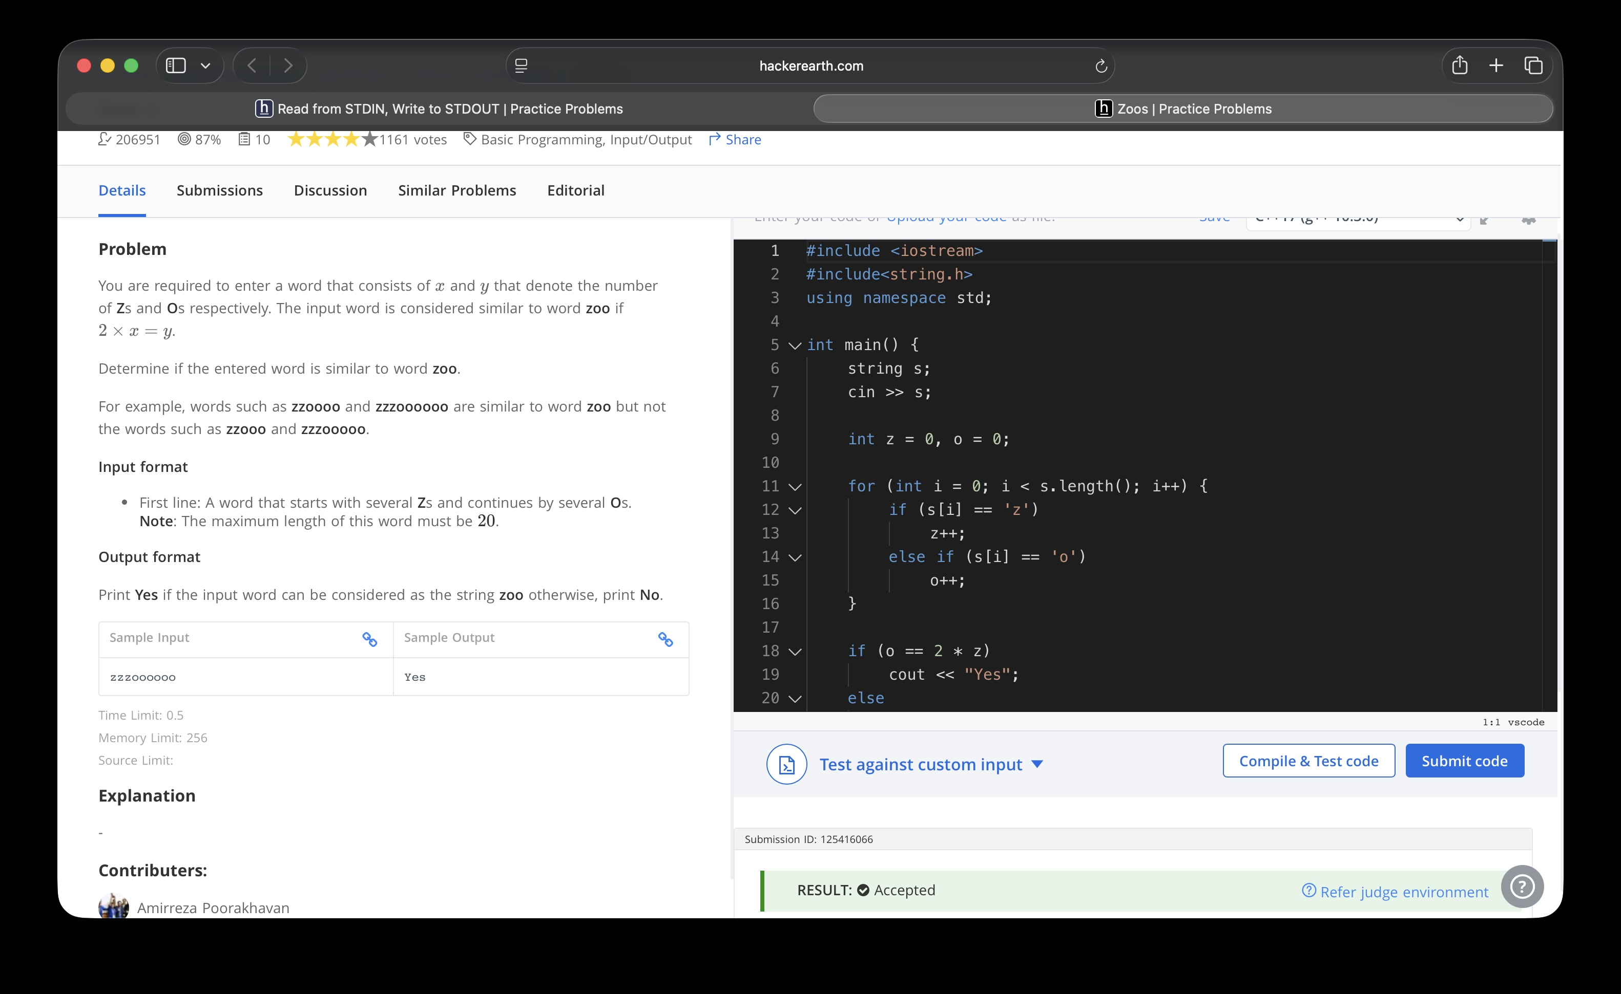

#include <iostream>
#include<string.h>
using namespace std;

int main() {
string s;
cin >> s;

int z = 0, o = 0;

for (int i = 0; i < s.length(); i++) {
if (s[i] == 'z')
z++;
else if (s[i] == 'o')
o++;
}

if (o == 2 * z)
cout << "Yes";
else
cout << "No";
return 0;
}

