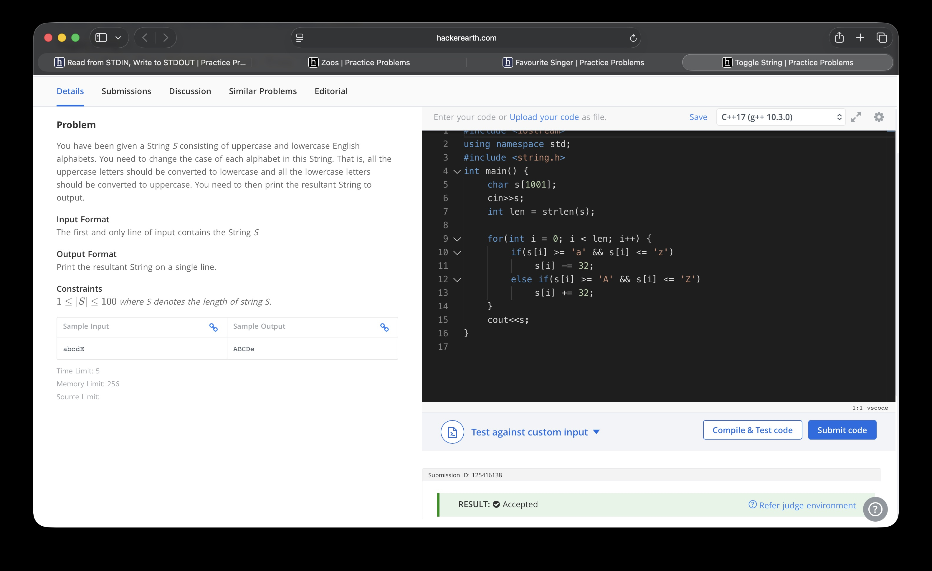
#include <iostream>
using namespace std;
#include <string.h>
int main() {
char s[1001];
cin>>s;
int len = strlen(s);

for(int i = 0; i < len; i++) {
if(s[i] >= 'a' && s[i] <= 'z')
s[i] -= 32;
else if(s[i] >= 'A' && s[i] <= 'Z')
s[i] += 32;
}
cout<<s;
return 0;
}

