import pandas as pd
import numpy as np
import matplotlib.pyplot as plt
import matplotlib as matplot
import seaborn as sns
import warnings
from sklearn.model_selection import train_test_split
from sklearn.metrics import accuracy_score, classification_report, precision_score, recall_score, confusion_matrix, precision_recall_curve,f1_score
from imblearn.over_sampling import SMOTE
from sklearn.metrics import roc_auc_score
from sklearn.metrics import accuracy_score
from sklearn.linear_model import LogisticRegression
from sklearn.ensemble import RandomForestClassifier
from sklearn.ensemble import GradientBoostingClassifier
from sklearn.tree import DecisionTreeClassifier
from sklearn.naive_bayes import GaussianNB
from sklearn.neighbors import KNeighborsClassifier
import xgboost as xgb
from sklearn.metrics import classification_report
from sklearn.metrics import roc_curve
from sklearn.metrics import confusion_matrix
import matplotlib.pyplot as plt
from sklearn.metrics import roc_curve
warnings.filterwarnings("ignore")
%matplotlib inline
df = pd.read_csv('HR_comma_sep.csv.txt')
df.head()
{"summary":"{\n \"name\": \"df\",\n \"rows\": 14999,\n \"fields\": [\n {\n \"column\": \"satisfaction_level\",\n \"properties\": {\n \"dtype\": \"number\",\n \"std\": 0.24863065106114257,\n \"min\": 0.09,\n \"max\": 1.0,\n \"num_unique_values\": 92,\n \"samples\": [\n 0.83,\n 0.13,\n 0.55\n ],\n \"semantic_type\": \"\",\n \"description\": \"\"\n }\n },\n {\n \"column\": \"last_evaluation\",\n \"properties\": {\n \"dtype\": \"number\",\n \"std\": 0.17116911062327533,\n \"min\": 0.36,\n \"max\": 1.0,\n \"num_unique_values\": 65,\n \"samples\": [\n 0.66,\n 0.44,\n 0.53\n ],\n \"semantic_type\": \"\",\n \"description\": \"\"\n }\n },\n {\n \"column\": \"number_project\",\n \"properties\": {\n \"dtype\": \"number\",\n \"std\": 1,\n \"min\": 2,\n \"max\": 7,\n \"num_unique_values\": 6,\n \"samples\": [\n 2,\n 5,\n 3\n ],\n \"semantic_type\": \"\",\n \"description\": \"\"\n }\n },\n {\n \"column\": \"average_montly_hours\",\n \"properties\": {\n \"dtype\": \"number\",\n \"std\": 49,\n \"min\": 96,\n \"max\": 310,\n \"num_unique_values\": 215,\n \"samples\": [\n 118,\n 112,\n 222\n ],\n \"semantic_type\": \"\",\n \"description\": \"\"\n }\n },\n {\n \"column\": \"time_spend_company\",\n \"properties\": {\n \"dtype\": \"number\",\n \"std\": 1,\n \"min\": 2,\n \"max\": 10,\n \"num_unique_values\": 8,\n \"samples\": [\n 6,\n 8,\n 3\n ],\n \"semantic_type\": \"\",\n \"description\": \"\"\n }\n },\n {\n \"column\": \"Work_accident\",\n \"properties\": {\n \"dtype\": \"number\",\n \"std\": 0,\n \"min\": 0,\n \"max\": 1,\n \"num_unique_values\": 2,\n \"samples\": [\n 1,\n 0\n ],\n \"semantic_type\": \"\",\n \"description\": \"\"\n }\n },\n {\n \"column\": \"left\",\n \"properties\": {\n \"dtype\": \"number\",\n \"std\": 0,\n \"min\": 0,\n \"max\": 1,\n \"num_unique_values\": 2,\n \"samples\": [\n 0,\n 1\n ],\n \"semantic_type\": \"\",\n \"description\": \"\"\n }\n },\n {\n \"column\": \"promotion_last_5years\",\n \"properties\": {\n \"dtype\": \"number\",\n \"std\": 0,\n \"min\": 0,\n \"max\": 1,\n \"num_unique_values\": 2,\n \"samples\": [\n 1,\n 0\n ],\n \"semantic_type\": \"\",\n \"description\": \"\"\n }\n },\n {\n \"column\": \"sales\",\n \"properties\": {\n \"dtype\": \"category\",\n \"num_unique_values\": 10,\n \"samples\": [\n \"marketing\",\n \"accounting\"\n ],\n \"semantic_type\": \"\",\n \"description\": \"\"\n }\n },\n {\n \"column\": \"salary\",\n \"properties\": {\n \"dtype\": \"category\",\n \"num_unique_values\": 3,\n \"samples\": [\n \"low\",\n \"medium\"\n ],\n \"semantic_type\": \"\",\n \"description\": \"\"\n }\n }\n ]\n}","type":"dataframe","variable_name":"df"}
df = df.rename(columns={'satisfaction_level': 'satisfaction',
'last_evaluation': 'evaluation',
'number_project': 'projectCount',
'average_montly_hours': 'averageMonthlyHours',
'time_spend_company': 'yearsAtCompany',
'Work_accident': 'workAccident',
'promotion_last_5years': 'promotion',
'sales' : 'department',
'left' : 'turnover'
})
df.columns
Index(['satisfaction', 'evaluation', 'projectCount', 'averageMonthlyHours',
'yearsAtCompany', 'workAccident', 'turnover', 'promotion', 'department',
'salary'],
dtype='object')
round(df.turnover.value_counts(1), 2)
turnover
0 0.76
1 0.24
Name: proportion, dtype: float64
plt.figure(figsize=(12,8))
turnover = df.turnover.value_counts()
sns.barplot(y=turnover.values, x=turnover.index, alpha=0.6)
plt.title('Distribution of Employee Turnover')
plt.xlabel('Employee Turnover', fontsize=16)
plt.ylabel('Count', fontsize=16)
Text(0, 0.5, 'Count')
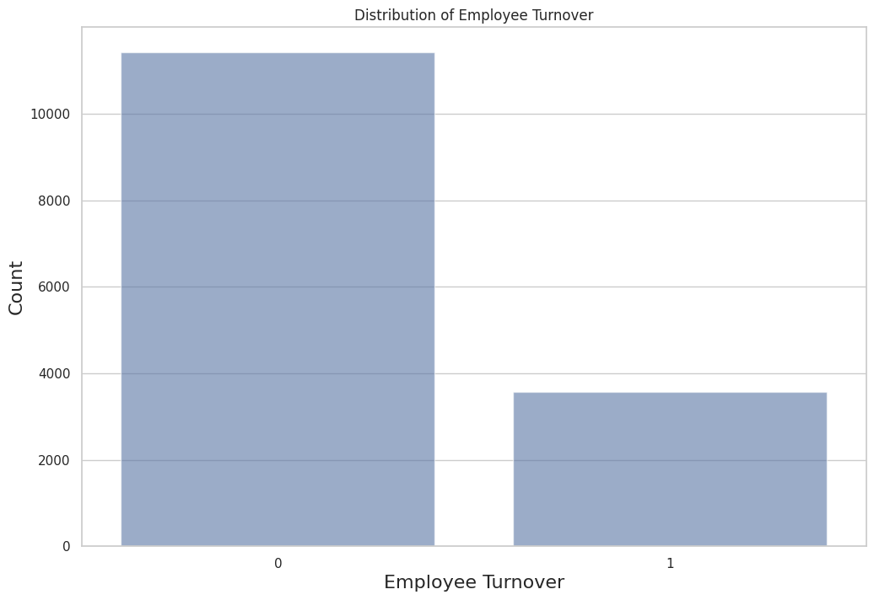
df.isnull().any()
satisfaction False
evaluation False
projectCount False
averageMonthlyHours False
yearsAtCompany False
workAccident False
turnover False
promotion False
department False
salary False
dtype: bool
df.dtypes
satisfaction float64
evaluation float64
projectCount int64
averageMonthlyHours int64
yearsAtCompany int64
workAccident int64
turnover int64
promotion int64
department object
salary object
dtype: object
round(df.describe(), 2)
{"summary":"{\n \"name\": \"round(df\",\n \"rows\": 8,\n \"fields\": [\n {\n \"column\": \"satisfaction\",\n \"properties\": {\n \"dtype\": \"number\",\n \"std\": 5302.752859236518,\n \"min\": 0.09,\n \"max\": 14999.0,\n \"num_unique_values\": 8,\n \"samples\": [\n 0.61,\n 0.64,\n 14999.0\n ],\n \"semantic_type\": \"\",\n \"description\": \"\"\n }\n },\n {\n \"column\": \"evaluation\",\n \"properties\": {\n \"dtype\": \"number\",\n \"std\": 5302.725078684948,\n \"min\": 0.17,\n \"max\": 14999.0,\n \"num_unique_values\": 7,\n \"samples\": [\n 14999.0,\n 0.72,\n 0.87\n ],\n \"semantic_type\": \"\",\n \"description\": \"\"\n }\n },\n {\n \"column\": \"projectCount\",\n \"properties\": {\n \"dtype\": \"number\",\n \"std\": 5301.632890511692,\n \"min\": 1.23,\n \"max\": 14999.0,\n \"num_unique_values\": 8,\n \"samples\": [\n 3.8,\n 4.0,\n 14999.0\n ],\n \"semantic_type\": \"\",\n \"description\": \"\"\n }\n },\n {\n \"column\": \"averageMonthlyHours\",\n \"properties\": {\n \"dtype\": \"number\",\n \"std\": 5240.043315300626,\n \"min\": 49.94,\n \"max\": 14999.0,\n \"num_unique_values\": 8,\n \"samples\": [\n 201.05,\n 200.0,\n 14999.0\n ],\n \"semantic_type\": \"\",\n \"description\": \"\"\n }\n },\n {\n \"column\": \"yearsAtCompany\",\n \"properties\": {\n \"dtype\": \"number\",\n \"std\": 5301.586273956127,\n \"min\": 1.46,\n \"max\": 14999.0,\n \"num_unique_values\": 7,\n \"samples\": [\n 14999.0,\n 3.5,\n 4.0\n ],\n \"semantic_type\": \"\",\n \"description\": \"\"\n }\n },\n {\n \"column\": \"workAccident\",\n \"properties\": {\n \"dtype\": \"number\",\n \"std\": 5302.8720602557505,\n \"min\": 0.0,\n \"max\": 14999.0,\n \"num_unique_values\": 5,\n \"samples\": [\n 0.14,\n 1.0,\n 0.35\n ],\n \"semantic_type\": \"\",\n \"description\": \"\"\n }\n },\n {\n \"column\": \"turnover\",\n \"properties\": {\n \"dtype\": \"number\",\n \"std\": 5302.8629691407195,\n \"min\": 0.0,\n \"max\": 14999.0,\n \"num_unique_values\": 5,\n \"samples\": [\n 0.24,\n 1.0,\n 0.43\n ],\n \"semantic_type\": \"\",\n \"description\": \"\"\n }\n },\n {\n \"column\": \"promotion\",\n \"properties\": {\n \"dtype\": \"number\",\n \"std\": 5302.888727810801,\n \"min\": 0.0,\n \"max\": 14999.0,\n \"num_unique_values\": 5,\n \"samples\": [\n 0.02,\n 1.0,\n 0.14\n ],\n \"semantic_type\": \"\",\n \"description\": \"\"\n }\n }\n ]\n}","type":"dataframe"}
df1 = df.copy()
df1 = df1.drop(["department","salary"],axis=1)
corr = df1.corr()
corr
{"summary":"{\n \"name\": \"corr\",\n \"rows\": 8,\n \"fields\": [\n {\n \"column\": \"satisfaction\",\n \"properties\": {\n \"dtype\": \"number\",\n \"std\": 0.40724280794270395,\n \"min\": -0.3883749834241161,\n \"max\": 1.0,\n \"num_unique_values\": 8,\n \"samples\": [\n 0.10502121397148648,\n 0.05869724105197295,\n 1.0\n ],\n \"semantic_type\": \"\",\n \"description\": \"\"\n }\n },\n {\n \"column\": \"evaluation\",\n \"properties\": {\n \"dtype\": \"number\",\n \"std\": 0.33950959992308527,\n \"min\": -0.008683767904798018,\n \"max\": 1.0,\n \"num_unique_values\": 8,\n \"samples\": [\n 1.0,\n -0.0071042885196038325,\n 0.10502121397148648\n ],\n \"semantic_type\": \"\",\n \"description\": \"\"\n }\n },\n {\n \"column\": \"projectCount\",\n \"properties\": {\n \"dtype\": \"number\",\n \"std\": 0.365619841342496,\n \"min\": -0.14296958603690096,\n \"max\": 1.0,\n \"num_unique_values\": 8,\n \"samples\": [\n 0.34933258851626237,\n -0.004740547719769696,\n -0.14296958603690096\n ],\n \"semantic_type\": \"\",\n \"description\": \"\"\n }\n },\n {\n \"column\": \"averageMonthlyHours\",\n \"properties\": {\n \"dtype\": \"number\",\n \"std\": 0.3483685940529834,\n \"min\": -0.020048113219472644,\n \"max\": 1.0,\n \"num_unique_values\": 8,\n \"samples\": [\n 0.3397417998383594,\n -0.01014288818580297,\n -0.020048113219472644\n ],\n \"semantic_type\": \"\",\n \"description\": \"\"\n }\n },\n {\n \"column\": \"yearsAtCompany\",\n \"properties\": {\n \"dtype\": \"number\",\n \"std\": 0.3380806429795136,\n \"min\": -0.10086607257796669,\n \"max\": 1.0,\n \"num_unique_values\": 8,\n \"samples\": [\n 0.13159072244765863,\n 0.0021204180967097077,\n -0.10086607257796669\n ],\n \"semantic_type\": \"\",\n \"description\": \"\"\n }\n },\n {\n \"column\": \"workAccident\",\n \"properties\": {\n \"dtype\": \"number\",\n \"std\": 0.3630186708479478,\n \"min\": -0.15462163370513443,\n \"max\": 1.0,\n \"num_unique_values\": 8,\n \"samples\": [\n -0.0071042885196038325,\n 1.0,\n 0.05869724105197295\n ],\n \"semantic_type\": \"\",\n \"description\": \"\"\n }\n },\n {\n \"column\": \"turnover\",\n \"properties\": {\n \"dtype\": \"number\",\n \"std\": 0.4059831183846381,\n \"min\": -0.3883749834241161,\n \"max\": 1.0,\n \"num_unique_values\": 8,\n \"samples\": [\n 0.006567120447529851,\n -0.15462163370513443,\n -0.3883749834241161\n ],\n \"semantic_type\": \"\",\n \"description\": \"\"\n }\n },\n {\n \"column\": \"promotion\",\n \"properties\": {\n \"dtype\": \"number\",\n \"std\": 0.35300628660894845,\n \"min\": -0.06178810657920049,\n \"max\": 1.0,\n \"num_unique_values\": 8,\n \"samples\": [\n -0.008683767904798018,\n 0.039245434583548434,\n 0.025605185709040485\n ],\n \"semantic_type\": \"\",\n \"description\": \"\"\n }\n }\n ]\n}","type":"dataframe","variable_name":"corr"}
plt.figure(figsize=(15,10))
sns.heatmap(corr, xticklabels=corr.columns.values, yticklabels=corr.columns.values, annot=True)
plt.title('Heatmap of Correlation Matrix')
Text(0.5, 1.0, 'Heatmap of Correlation Matrix')
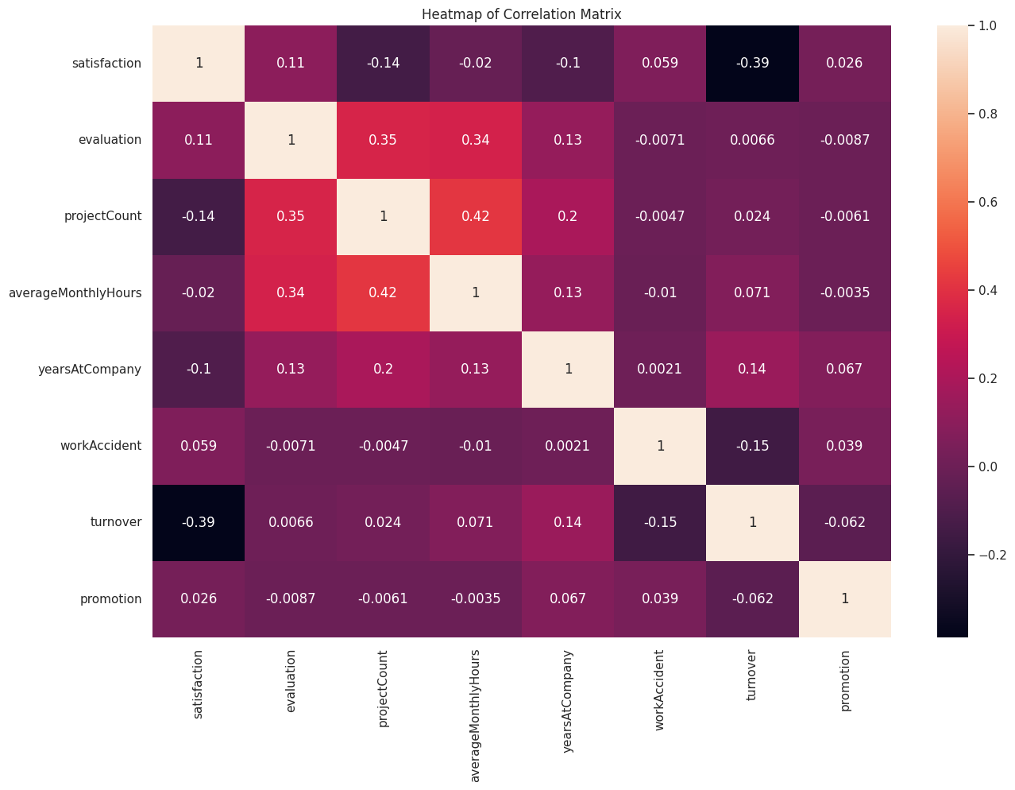
f, axes = plt.subplots(ncols=3, figsize=(16, 8))
sns.distplot(df.satisfaction, kde=False, color="g", ax=axes[0]).set_title('Employee Satisfaction Distribution')
axes[0].set_ylabel('Employee Count');
sns.distplot(df.evaluation, kde=False, color="r", ax=axes[1]).set_title('Employee Evaluation Distribution')
axes[1].set_ylabel('Employee Count');
sns.distplot(df.averageMonthlyHours, kde=False, color="b", ax=axes[2]).set_title('Employee Average Monthly Hours Distribution')
axes[2].set_ylabel('Employee Count');
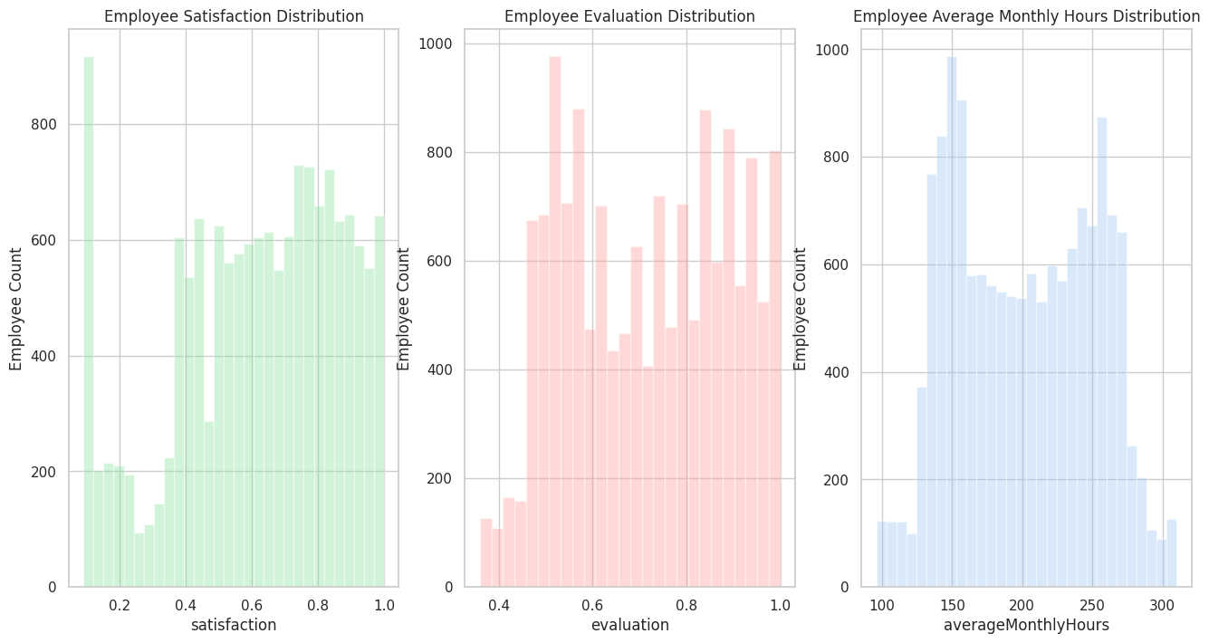
plt.figure(figsize=(20,8))
ax = sns.barplot(x="projectCount", y="projectCount", hue="turnover", data=df, estimator=lambda x: len(x) / len(df) * 100)
ax.set(ylabel="Percent");
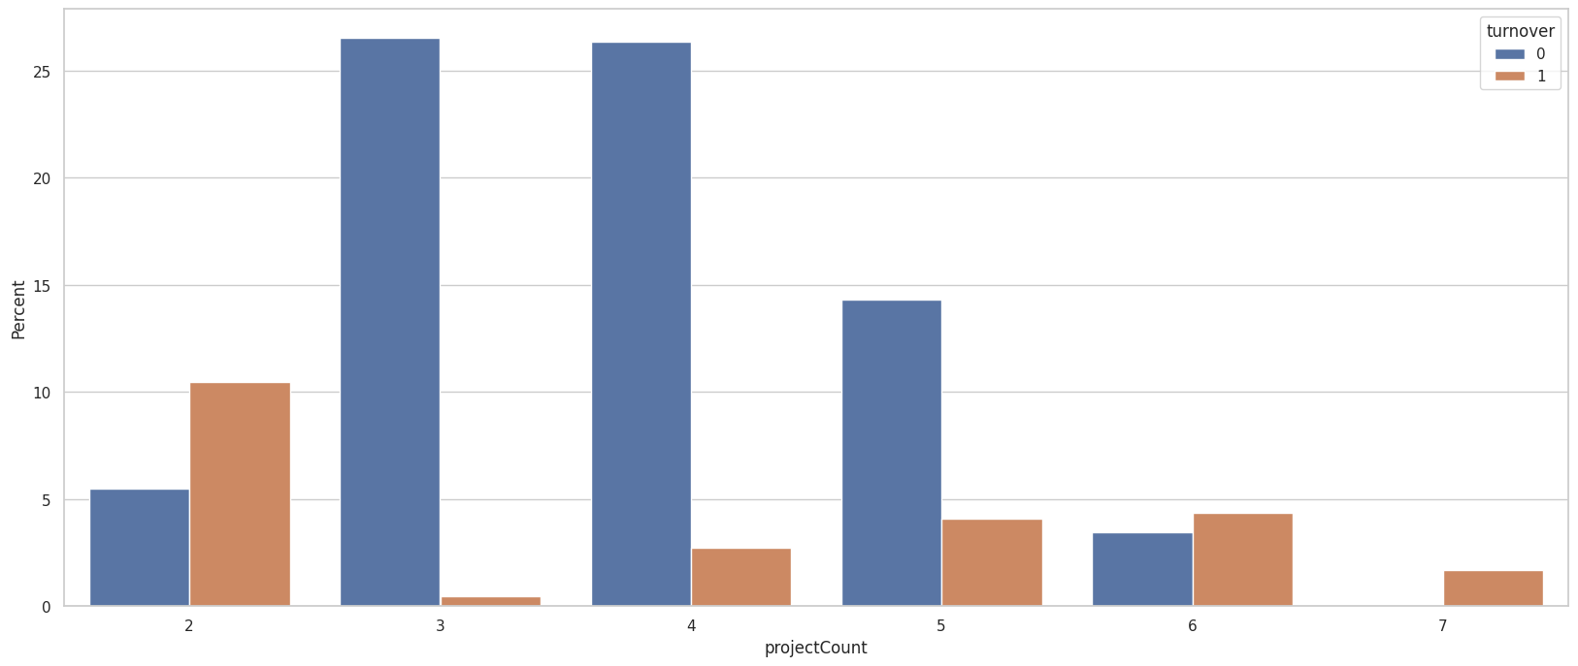

Pre-processing

cat_var = ['department','salary','turnover','promotion']
num_var = ['satisfaction','evaluation','projectCount','averageMonthlyHours','yearsAtCompany', 'workAccident']
categorical_df = pd.get_dummies(df[cat_var], drop_first=True, dummy_na=True)
numerical_df = df[num_var]
new_df = pd.concat([categorical_df,numerical_df], axis=1)
new_df.head()
{"type":"dataframe","variable_name":"new_df"}

Split Train/Test Set

Let's split our data into a train and test set. We'll fit our model with the train set and leave our test set for our last evaluation.
X = new_df.iloc[:,1:]
y = new_df.iloc[:,0]
X_train, X_test, y_train, y_test = train_test_split(X, y, test_size=0.20, random_state=123, stratify=y)
print(X_train.shape)
print(X_test.shape)
(11999, 20)
(3000, 20)

Class Imbalance
round(df.turnover.value_counts(1), 2)
turnover
0 0.76
1 0.24
Name: proportion, dtype: float64

Employee Turnover Rate: 24%
#Treat Imbalanced Datasets
sm = SMOTE(random_state=12, sampling_strategy = 1.0)
x_train_sm, y_train_sm = sm.fit_resample(X_train, y_train)

Model Training and Performance

Logistic Regression Classifier
lr = LogisticRegression()
lr = lr.fit(x_train_sm, y_train_sm)
lr
y_pred_lr = lr.predict(X_test)
print ("\n\n ---Logistic Regression Model---")
print(classification_report(y_test, lr.predict(X_test)))
---Logistic Regression Model---
precision recall f1-score support
0 0.91 0.76 0.83 2286
1 0.50 0.75 0.60 714
accuracy 0.76 3000
macro avg 0.70 0.76 0.72 3000
weighted avg 0.81 0.76 0.78 3000
cm = confusion_matrix(y_test, y_pred_lr)
print("Confusion Matrix:")
print(cm)
Confusion Matrix:
[[1747 539]
[ 175 539]]
class_labels = ['Not Turnover', 'Turnover']
# Plot confusion matrix
plt.figure(figsize=(8, 6))
sns.heatmap(cm, annot=True, fmt="d", cmap="Blues", xticklabels=class_labels, yticklabels=class_labels)
plt.xlabel('Predicted')
plt.ylabel('True')
plt.title('Employee Turnover Confusion Matrix')
plt.show()
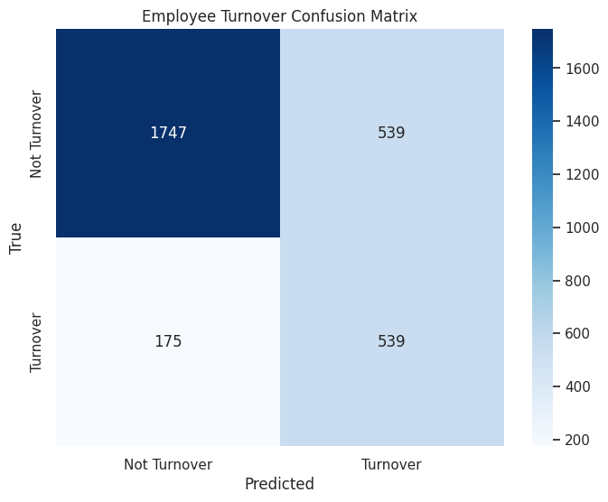

Random Forest Classifier
rf = RandomForestClassifier()
rf = rf.fit(x_train_sm, y_train_sm)
rf
y_pred_rf= rf.predict(X_test)
print ("\n\n ---Random Forest Model---")
print(classification_report(y_test, rf.predict(X_test)))
---Random Forest Model---
precision recall f1-score support
0 0.99 0.99 0.99 2286
1 0.97 0.98 0.97 714
accuracy 0.99 3000
macro avg 0.98 0.98 0.98 3000
weighted avg 0.99 0.99 0.99 3000
cm = confusion_matrix(y_test, y_pred_rf)
print("Confusion Matrix:")
print(cm)
Confusion Matrix:
[[2264 22]
[ 16 698]]
class_labels = ['Not Turnover', 'Turnover']
plt.figure(figsize=(8, 6))
sns.heatmap(cm, annot=True, fmt="d", cmap="Blues", xticklabels=class_labels, yticklabels=class_labels)
plt.xlabel('Predicted')
plt.ylabel('True')
plt.title('Employee Turnover Confusion Matrix')
plt.show()
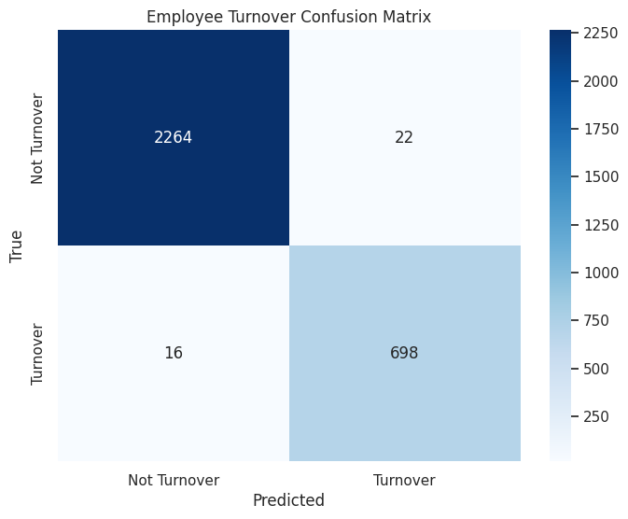

Gradient Boosting Classifier
gbc = GradientBoostingClassifier()
gbc = gbc.fit(x_train_sm,y_train_sm)
gbc
y_pred_gbc = gbc.predict(X_test)
print ("\n\n ---Gradient Boosting Model---")
print(classification_report(y_test, gbc.predict(X_test)))
---Gradient Boosting Model---
precision recall f1-score support
0 0.98 0.98 0.98 2286
1 0.92 0.93 0.93 714
accuracy 0.96 3000
macro avg 0.95 0.95 0.95 3000
weighted avg 0.97 0.96 0.97 3000
cm = confusion_matrix(y_test, y_pred_gbc)
print("Confusion Matrix:")
print(cm)
Confusion Matrix:
[[2230 56]
[ 49 665]]
class_labels = ['Not Turnover', 'Turnover']
plt.figure(figsize=(8, 6))
sns.heatmap(cm, annot=True, fmt="d", cmap="Blues", xticklabels=class_labels, yticklabels=class_labels)
plt.xlabel('Predicted')
plt.ylabel('True')
plt.title('Employee Turnover Confusion Matrix')
plt.show()
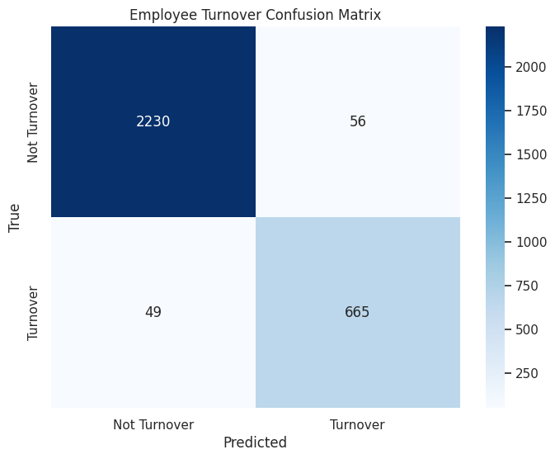

Decision Tree Classifier
Dt = DecisionTreeClassifier()
Dt = Dt.fit(x_train_sm,y_train_sm)
Dt
y_pred_Dt = Dt.predict(X_test)
print ("\n\n ---Decision Tree Model---")
print(classification_report(y_test, Dt.predict(X_test)))
---Decision Tree Model---
precision recall f1-score support
0 1.00 0.98 0.98 2286
1 0.93 0.98 0.95 714
accuracy 0.98 3000
macro avg 0.96 0.98 0.97 3000
weighted avg 0.98 0.98 0.98 3000
cm = confusion_matrix(y_test, y_pred_Dt)
print("Confusion Matrix:")
print(cm)
Confusion Matrix:
[[2229 57]
[ 11 703]]
class_labels = ['Not Turnover', 'Turnover']
plt.figure(figsize=(8, 6))
sns.heatmap(cm, annot=True, fmt="d", cmap="Blues", xticklabels=class_labels, yticklabels=class_labels)
plt.xlabel('Predicted')
plt.ylabel('True')
plt.title('Employee Turnover Confusion Matrix')
plt.show()
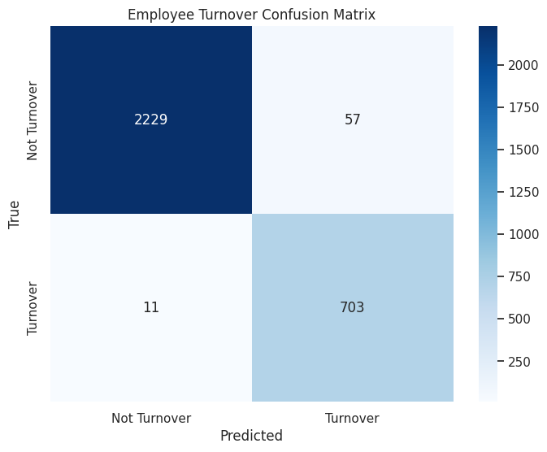

Gaussian Naive Bayes
gnb = GaussianNB()
gnb.fit(x_train_sm, y_train_sm)
gnb
y_pred_gnb = gnb.predict(X_test)
print ("\n\n ---Gaussian Naive Bayes Model---")
print(classification_report(y_test, gnb.predict(X_test)))
---Gaussian Naive Bayes Model---
precision recall f1-score support
0 0.92 0.45 0.61 2286
1 0.33 0.88 0.48 714
accuracy 0.55 3000
macro avg 0.63 0.67 0.55 3000
weighted avg 0.78 0.55 0.58 3000
cm = confusion_matrix(y_test, y_pred_gnb)
print("Confusion Matrix:")
print(cm)
Confusion Matrix:
[[1036 1250]
[ 86 628]]
class_labels = ['Not Turnover', 'Turnover']
plt.figure(figsize=(8, 6))
sns.heatmap(cm, annot=True, fmt="d", cmap="Blues", xticklabels=class_labels, yticklabels=class_labels)
plt.xlabel('Predicted')
plt.ylabel('True')
plt.title('Employee Turnover Confusion Matrix')
plt.show()
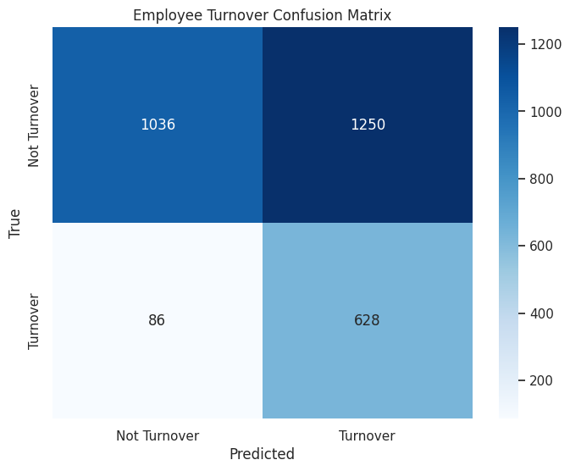

K-Nearest Neighbors Classifier
knn = KNeighborsClassifier(n_neighbors=5)
knn.fit(x_train_sm, y_train_sm)
knn
y_pred_knn = knn.predict(X_test)
print ("\n\n ---KNeighborsClassifier Model---")
print(classification_report(y_test, knn.predict(X_test)))
---KNeighborsClassifier Model---
precision recall f1-score support
0 0.99 0.91 0.95 2286
1 0.78 0.97 0.86 714
accuracy 0.93 3000
macro avg 0.88 0.94 0.91 3000
weighted avg 0.94 0.93 0.93 3000
cm = confusion_matrix(y_test, y_pred_knn)
print("Confusion Matrix:")
print(cm)
Confusion Matrix:
[[2091 195]
[ 22 692]]
class_labels = ['Not Turnover', 'Turnover']
plt.figure(figsize=(8, 6))
sns.heatmap(cm, annot=True, fmt="d", cmap="Blues", xticklabels=class_labels, yticklabels=class_labels)
plt.xlabel('Predicted')
plt.ylabel('True')
plt.title('Employee Turnover Confusion Matrix')
plt.show()
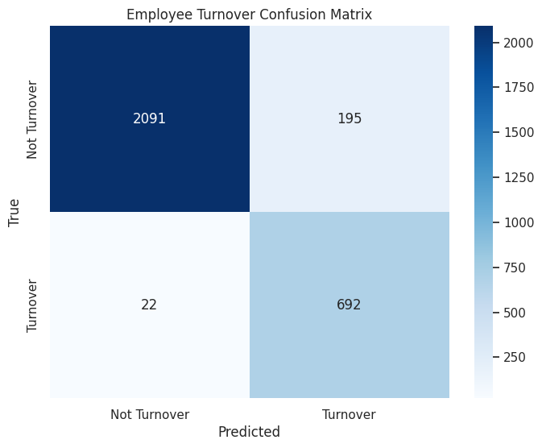

XGBoost Classifier
xgb = xgb.XGBClassifier(objective='binary:logistic', n_estimators=100)
xgb.fit(x_train_sm, y_train_sm)
y_pred_xgb = xgb.predict(X_test)
print("\n\n---XGBoost Model---")
print(classification_report(y_test, y_pred_xgb))
---XGBoost Model---
precision recall f1-score support
0 0.99 0.99 0.99 2286
1 0.96 0.98 0.97 714
accuracy 0.98 3000
macro avg 0.97 0.98 0.98 3000
weighted avg 0.98 0.98 0.98 3000
cm = confusion_matrix(y_test, y_pred_xgb)
print("Confusion Matrix:")
print(cm)
Confusion Matrix:
[[2255 31]
[ 17 697]]
class_labels = ['Not Turnover', 'Turnover']
plt.figure(figsize=(8, 6))
sns.heatmap(cm, annot=True, fmt="d", cmap="Blues", xticklabels=class_labels, yticklabels=class_labels)
plt.xlabel('Predicted')
plt.ylabel('True')
plt.title('Employee Turnover Confusion Matrix')
plt.show()
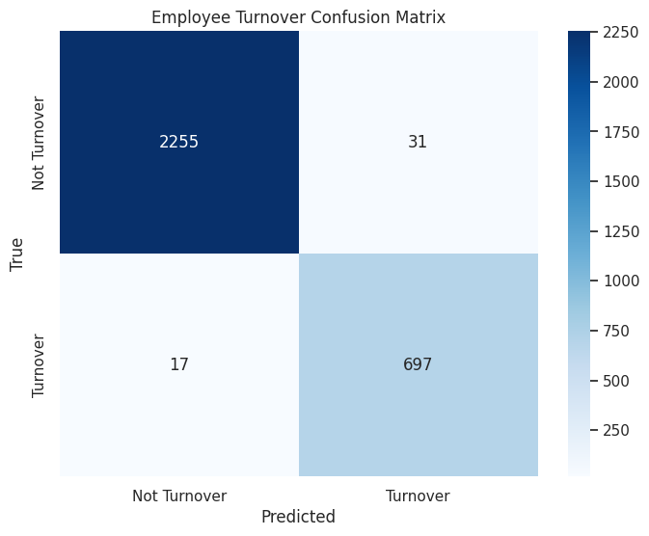

ROC Graph
lr_auc = roc_auc_score(y_test, lr.predict(X_test))
xgb_auc = roc_auc_score(y_test, xgb.predict(X_test))
rf_auc = roc_auc_score(y_test, rf.predict(X_test))
gbc_auc = roc_auc_score(y_test, gbc.predict(X_test))
gnb_auc = roc_auc_score(y_test, gnb.predict(X_test))
dtree_auc = roc_auc_score(y_test, Dt.predict(X_test))
knn_auc = roc_auc_score(y_test, knn.predict(X_test))
fpr, tpr, thresholds = roc_curve(y_test, lr.predict_proba(X_test)[:,1])
rf_fpr, rf_tpr, rf_thresholds = roc_curve(y_test, rf.predict_proba(X_test)[:,1])
gbc_fpr, gbc_tpr, gbc_thresholds = roc_curve(y_test, gbc.predict_proba(X_test)[:,1])
xgb_fpr,xgb_tpr,xgb_thresholds = roc_curve(y_test, xgb.predict_proba(X_test)[:,1])
gnb_fpr,gnb_tpr,gnb_thresholds = roc_curve(y_test, gnb.predict_proba(X_test)[:,1])
dt_fpr,dt_tpr,dt_thresholds = roc_curve(y_test, Dt.predict_proba(X_test)[:,1])
knn_fpr,knn_tpr,knn_thresholds = roc_curve(y_test, knn.predict_proba(X_test)[:,1])
colors = ['blue', 'green', 'red', 'purple', 'orange', 'magenta', 'Brown']

ROC Graph - Logistic Regression
plt.figure(figsize=(8,6))
plt.plot(fpr, tpr,color=colors[0], label='Logistic Regression (area = %0.2f)' % lr_auc)
plt.xlim([0.0, 1.0])
plt.ylim([0.0, 1.05])
plt.xlabel('False Positive Rate')
plt.ylabel('True Positive Rate')
plt.title('Logistic Regression ROC Curve')
plt.legend(loc="lower right")
plt.show()
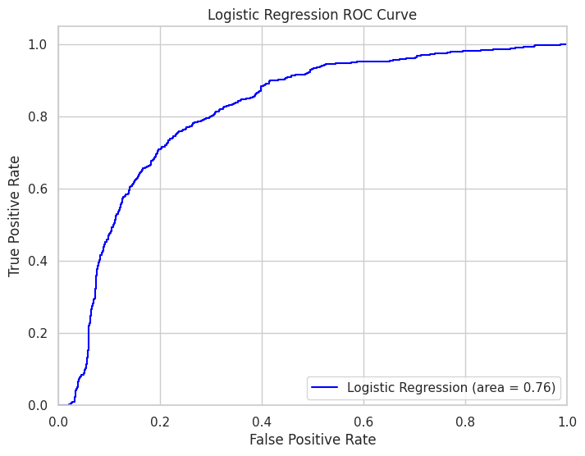

ROC Graph - Random Forest
rf_fpr, rf_tpr, rf_thresholds = roc_curve(y_test, rf.predict_proba(X_test)[:,1])
plt.figure(figsize=(8,6))
plt.plot(rf_fpr, rf_tpr,color=colors[1], label='Random Forest Classifier (area = %0.2f)' % rf_auc)
plt.xlim([0.0, 1.0])
plt.ylim([0.0, 1.05])
plt.xlabel('False Positive Rate')
plt.ylabel('True Positive Rate')
plt.title('Random Forest ROC Curve')
plt.legend(loc="lower right")
plt.show()
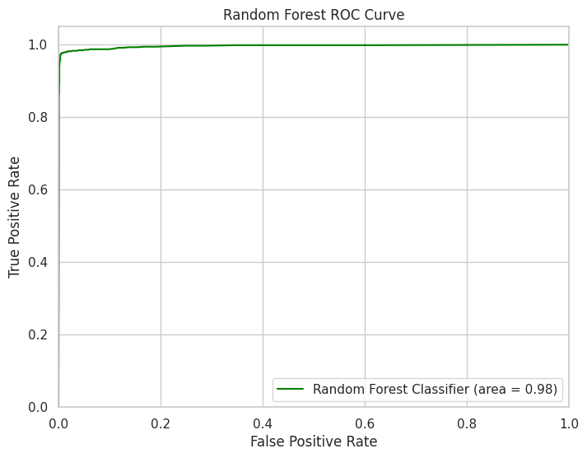

ROC Graph - Gradient Boosting Classifier
plt.figure(figsize=(8,6))
plt.plot(gbc_fpr, gbc_tpr,color=colors[2], label='Gradient Boosting Classifier (area = %0.2f)' % gbc_auc)
plt.xlim([0.0, 1.0])
plt.ylim([0.0, 1.05])
plt.xlabel('False Positive Rate')
plt.ylabel('True Positive Rate')
plt.title('Gradient Boosting Classifier ROC Curve')
plt.legend(loc="lower right")
plt.show()
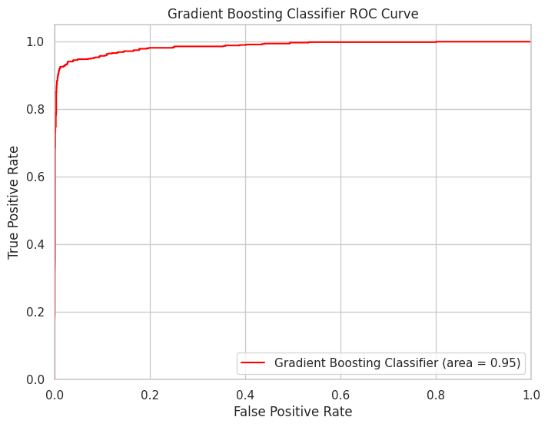

ROC Graph - XGBoost Classifier
plt.figure(figsize=(8,6))
plt.plot(xgb_fpr,xgb_tpr,color=colors[3], label='XGBoost Classifier (area = %0.2f)' % xgb_auc)
plt.xlim([0.0, 1.0])
plt.ylim([0.0, 1.05])
plt.xlabel('False Positive Rate')
plt.ylabel('True Positive Rate')
plt.title('XGBoost Classifier ROC Curve')
plt.legend(loc="lower right")
plt.show()
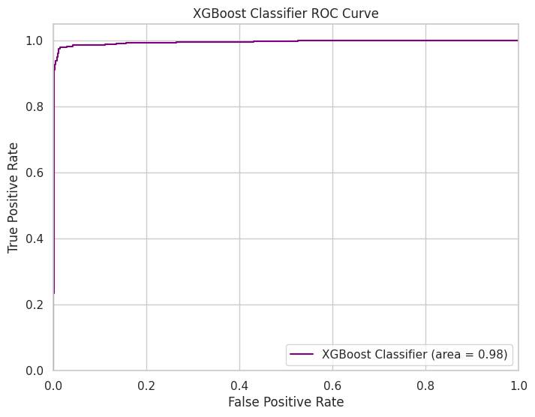

ROC Graph - k-Nearest Neighbors
plt.figure(figsize=(8,6))
plt.plot(knn_fpr,knn_tpr,color=colors[4], label='k-Nearest Neighbors (area = %0.2f)' % knn_auc)
plt.xlim([0.0, 1.0])
plt.ylim([0.0, 1.05])
plt.xlabel('False Positive Rate')
plt.ylabel('True Positive Rate')
plt.title('k-Nearest Neighbors ROC Curve')
plt.legend(loc="lower right")
plt.show()
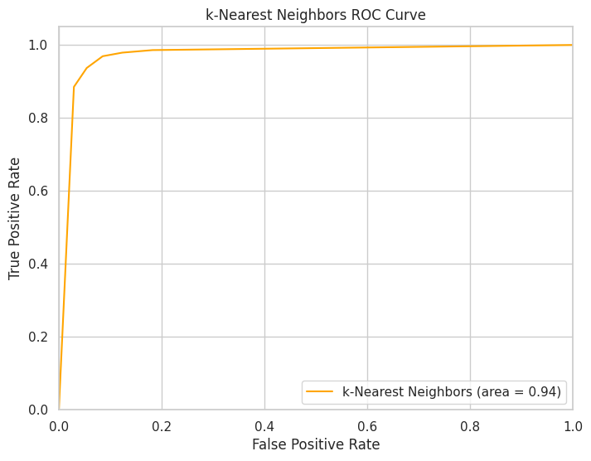

ROC Graph - Gaussian Naive Bayes
plt.figure(figsize=(8,6))
plt.plot(gnb_fpr,gnb_tpr,color=colors[5], label='Gaussian Naive Bayes (area = %0.2f)' % gnb_auc)
plt.xlim([0.0, 1.0])
plt.ylim([0.0, 1.05])
plt.xlabel('False Positive Rate')
plt.ylabel('True Positive Rate')
plt.title('Gaussian Naive Bayes ROC Curve')
plt.legend(loc="lower right")
plt.show()
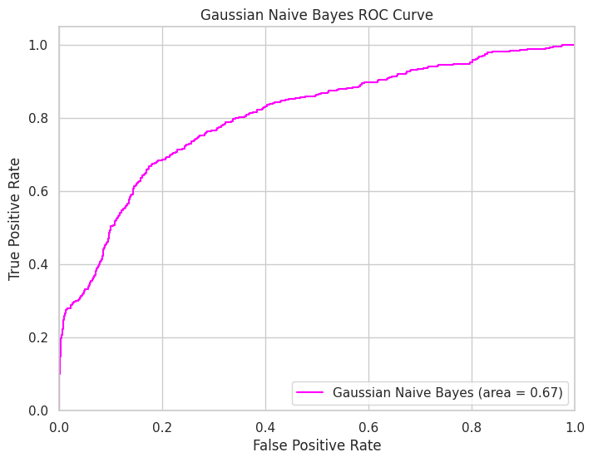

ROC Graph - Decision Tree
plt.figure(figsize=(8,6))
plt.plot(dt_fpr,dt_tpr,color=colors[6],label='Decision Tree (area = %0.2f)' % dtree_auc)
plt.xlim([0.0, 1.0])
plt.ylim([0.0, 1.05])
plt.xlabel('False Positive Rate')
plt.ylabel('True Positive Rate')
plt.title('Decision Tree ROC Curve')
plt.legend(loc="lower right")
plt.show()
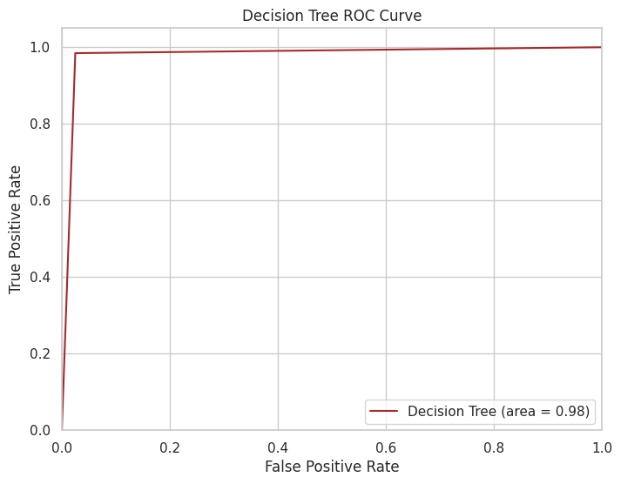

Feature Importance
feature_importances = pd.DataFrame(rf.feature_importances_,
index = x_train_sm.columns,
columns=['importance']).sort_values('importance', ascending=False)
feature_importances = feature_importances.reset_index()
feature_importances = feature_importances[:-2]
feature_importances
{"summary":"{\n \"name\": \"feature_importances\",\n \"rows\": 18,\n \"fields\": [\n {\n \"column\": \"index\",\n \"properties\": {\n \"dtype\": \"string\",\n \"num_unique_values\": 18,\n \"samples\": [\n \"satisfaction\",\n \"yearsAtCompany\",\n \"department_technical\"\n ],\n \"semantic_type\": \"\",\n \"description\": \"\"\n }\n },\n {\n \"column\": \"importance\",\n \"properties\": {\n \"dtype\": \"number\",\n \"std\": 0.08557167881686224,\n \"min\": 0.0012091589167234692,\n \"max\": 0.24866881848403025,\n \"num_unique_values\": 18,\n \"samples\": [\n 0.24866881848403025,\n 0.2206597012324442,\n 0.00640943828788299\n ],\n \"semantic_type\": \"\",\n \"description\": \"\"\n }\n }\n ]\n}","type":"dataframe","variable_name":"feature_importances"}
colors = [
"red",
"green",
"blue",
"purple",
"orange",
"#F7CAC9", # Light salmon pink
"#A9A9A9", # Dark gray
"#32CD32", # Lime green
"#FFD700", # Gold
"#C0C0C0", # Silver
"teal",
"#EE82EE", # Violet
"#FFA500", # Orange red
"#00CED1", # Dark turquoise
"#DC143C", # Crimson
"#00FFFF", # Cyan
"#000000" # Black
]
sns.set(style="whitegrid")
f, ax = plt.subplots(figsize=(18, 15))
sns.set_color_codes("pastel")
sns.barplot(x="importance", y='index', data=feature_importances,
label="Total", palette = colors);
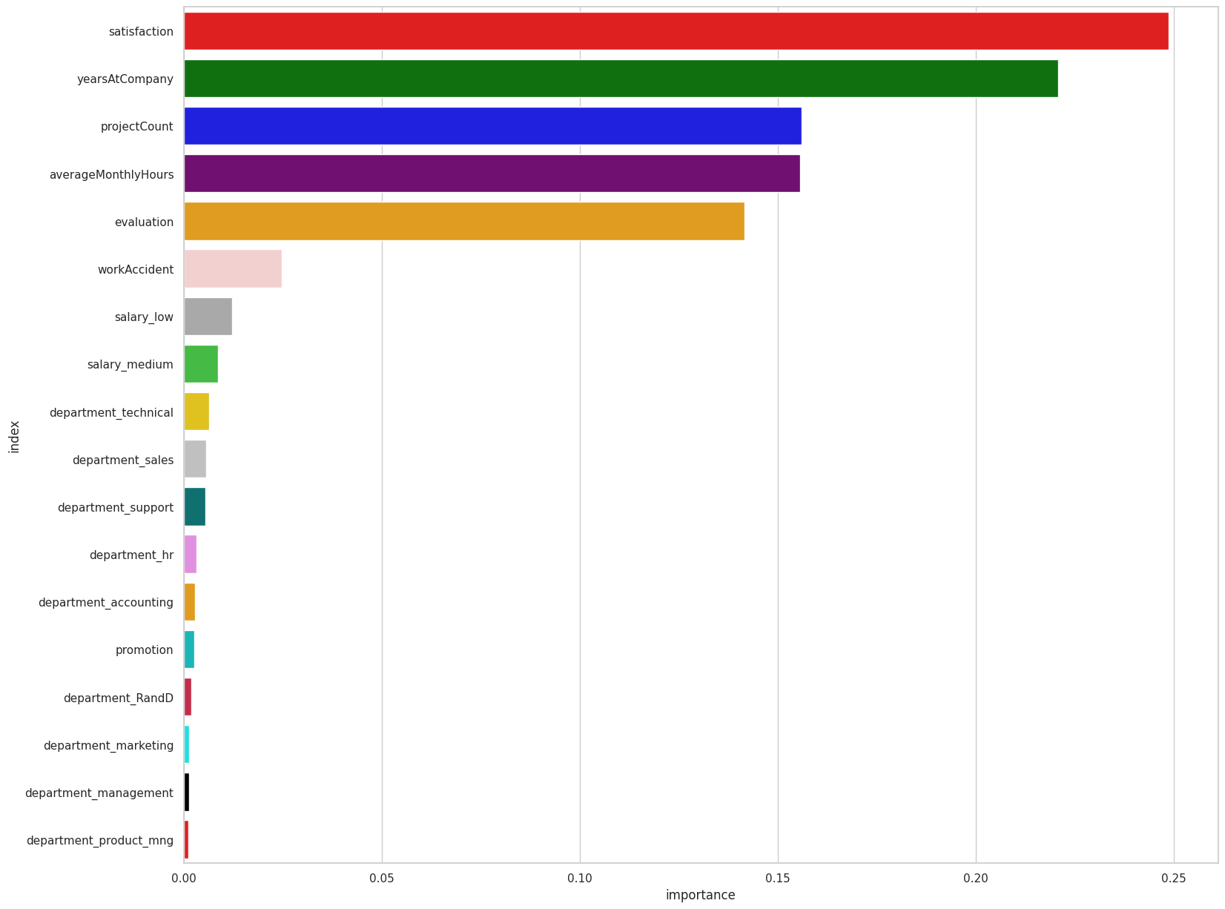
model_results = {}
models = [lr, rf, gbc, xgb, knn, gnb, Dt]
metrics = ["accuracy", "precision", "recall", "f1-score", "roc_auc"]
for model, name in zip(models, ["Logistic Regression", "Random Forest", "Gradient Boosting", "XGBoost", "KNN", "Naive Bayes", "Decision Tree"]):
y_pred = model.predict(X_test)
model_results[name] = {
"accuracy": accuracy_score(y_test, y_pred),
"precision": precision_score(y_test, y_pred),
"recall": recall_score(y_test, y_pred),
"f1-score": f1_score(y_test, y_pred),
"roc_auc": roc_auc_score(y_test, y_pred)
}
print("Model Comparison Table:")
print("{:<25} | {:<10} | {:<10} | {:<10} | {:<10} | {:<10} |".format(*("Algorithm", *metrics)))
print("-" * 100)
for name, results in model_results.items():
print("{:<25} | {:<10.2f} | {:<10.2f} | {:<10.2f} | {:<10.2f} | {:<10.2f} |".format(name, *results.values()))
Model Comparison Table:
Algorithm | accuracy | precision | recall | f1-score | roc_auc |
----------------------------------------------------------------------------------------------------
Logistic Regression | 0.76 | 0.50 | 0.75 | 0.60 | 0.76 |
Random Forest | 0.99 | 0.97 | 0.98 | 0.97 | 0.98 |
Gradient Boosting | 0.96 | 0.92 | 0.93 | 0.93 | 0.95 |
XGBoost | 0.98 | 0.96 | 0.98 | 0.97 | 0.98 |
KNN | 0.93 | 0.78 | 0.97 | 0.86 | 0.94 |
Naive Bayes | 0.55 | 0.33 | 0.88 | 0.48 | 0.67 |
Decision Tree | 0.98 | 0.93 | 0.98 | 0.95 | 0.98 |

