PHASE-5 CAPSTONE PROJECT- MEDICARE (DOMAIN: HEALTHCARE)

# Project Objective & Background:

To develop a dynamic and responsive web application for online ordering of medicines through Medicare Application. Medicare is a company that supplies medicines and a couple of other healthcare essentials at an affordable price. It was established in 2012 in Delhi, India.

# Developer Details:

**Name:** Lakshya Chaudhary

**Simplilearn UserId:** [lakshyachaudhary0098@gmail.com](mailto:lakshyachaudhary0098@gmail.com).

## Github link:<https://github.com/Lakshya99ch/CapstoneProject-Medicare.git>

# Product Features:

1. Medicare application is made specifically to the required business needs. It is completely flexible and scalable to the business demands and growth.
2. The whole application is a Single Page Application that is more efficient in terms of processing and provides a seamless user experience.
3. The application web pages are responsive and secure.
4. The application has one Administrator. The Admin Portal features are:
   * The admin can login with username and password in admin portal.
   * The admin can add or remove medicine details.
   * Edit medicine details like name, price etc., to keep the product information updated with current prices.
   * Enable or disable the medicines.
5. The application has a User portal. The User Portal features are:
   * Sign up and login with username and password.
   * The User can maintain the record of activities.
   * Search for products based on the search keyword.
   * Apply filters and sort result based on different categories.
   * Add the product to cart and customize the purchase at the end.
   * Experience a seamless payment experience.
   * Receive an order summary once the payment is successful.

# Core Concepts Used and Project Architecture:

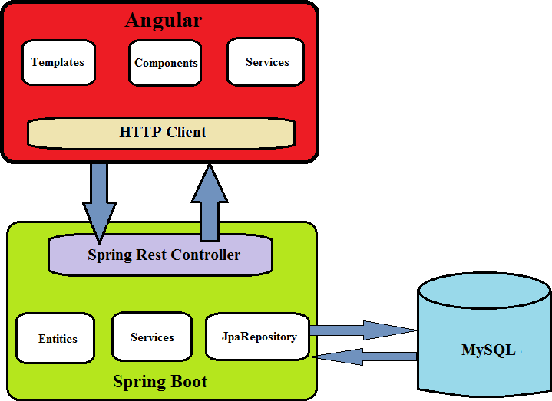

* Angular framework for frontend UI’s.
* Spring boot framework for backend .
* MySQL Database for storing all the data.
* HTML, Bootstrap 4.
* Typescript.
* Spring Security and JWT Authentication.
* Spring Data Jpa, Spring Web.

# Sprint Planning and Task Achieved:

Number of sprint planned = 4.

## Sprint 1:

1. Planned to develop backend code for project. Generated Spring boot project from [http://start.spring.io](http://start.spring.io/).
2. Planned to develop the rest api’s to create Admin and User. Used spring security and Jwt authentication to achieve this task.
3. Planned to develop api’s for admin portal to add, update, delete, enable or disable products.
4. Successfully developed and tested the admin portal rest api’s using Postman software.
5. Planned to develop frontend code for project. Generated Angular project using angular cli.
6. Planned to develop login ui for admin and user portal. Successfully developed the ui’s for admin and user.
7. Planned to develop admin dashboard that enables admin to perform the required functionalities. Successfully developed the admin dashboard.

## Sprint 2:

1. Planned to develop home page of the application. Successfully developed the home ui of the application.
2. Planned to develop Sign up ui for users. Developed successfully.
3. Planned to develop ui for search product based on keyword, show product based on category. Successfully developed the ui’s for user portal feature.
4. Planned to develop user home ui. Developed successfully.

## Sprint 3:

1. Planned to develop add to cart feature ui in user portal. Developed successfully.
2. Planned to develop rest api’s to create an order and to view orders by user. Successfully developed and tested the user order api’s using postman software.
3. Planned to develop create a new order ui in user portal. Developed successfully.
4. Planned to develop ui’s for order summary, show all orders in user and admin portal. Developed successfully.

## Sprint 4:

1. Planned to test the complete web application by giving the required inputs in respective fields.
2. Successfully tested all the admin portal features and user portal features.
3. The Web application is responsive, secure and all features are working as per the given requirements.