Phase-6 Capstone Project- Complaint Redressal System

# Project Objective & Background:

To develop an online complaint management application for ABC Telecom Ltd. which is one of India’s major telecommunication service providers where the customers can raise complaints regarding their landlines and broadband services.

# Developer Details:

**Name:** Twarit Soni. **Simplilearn UserId:** [twarit.s88@gmail.com](mailto:twarit.s88@gmail.com).

**Github link:** <https://github.com/twarit08/CapstoneProject-CRS.git> **Product Features:**

1. Complaint Redressal System is made specifically to the required business

needs, it’s completely flexible and scalable to the business demands and growth.

1. The whole application is a Single Page Application that is more efficient in terms of processing and provides a seamless user experience.
2. The application web pages are responsive and secure.
3. The application has one Administrator. The Admin after login with username and password and can create and manage the lifecycle of different types of user’s like Customer’s, Manager’s, Engineer’s.
4. The User Customer can login with username and password and can register a new complaint regarding the services. The customer can also track the status of the complaint raised and after successful redressal he/she can provide valuable feedback.
5. The User Manager can login with username and password and can assign engineer to the complaints raised by customers based on pincode. The

manager can also view all the complaints raised in all the area’s pincode and all the feedback’s given by customers.

1. The User Engineer can login with username and password and can see the complaints assigned to him/her from manager of related pincode. The engineer can assign the appropriate status and can view all the customer feedback.

# Core Concepts Used and Project Architecture:

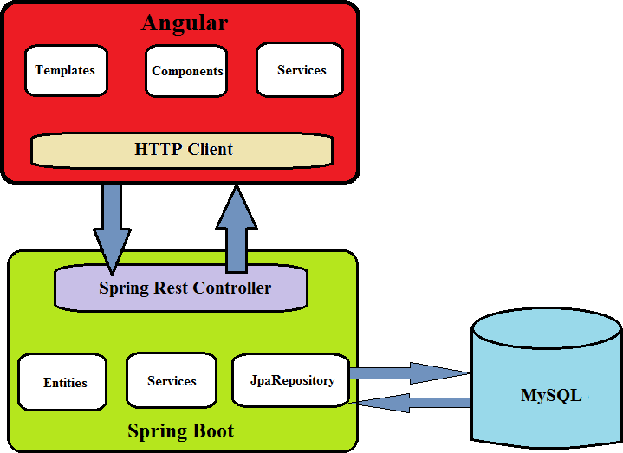

1. Angular framework for frontend UI’s.
2. Spring boot framework for backend .
3. MySQL Database for storing all the data.
4. Junit to perform unit testing of services.
5. HTML, Bootstrap 4.
6. Typescript.
7. Spring Security and JWT Authentication.
8. Spring Data Jpa, Spring Web.

# Sprint Planning and Task Achieved:

Number of sprint planned = 3.

## Sprint 1:

1. Planned to develop backend code for project. Generated Spring boot project from [http://start.spring.io](http://start.spring.io/).
2. Planned to develop the rest api’s for admin user. Used spring security and Jwt authentication to achieve this task.
3. Successfully developed and tested the admin user rest api’s using Postman software.
4. Planned to develop frontend code for project. Generated Angular project using angular cli.
5. Planned to develop home page and login feature. Successfully developed the home page and login page.
6. Planned to develop admin dashboard. Successfully developed the admin dashboard.

## Sprint 2:

1. Planned to develop the rest api’s for features regarding customer user. Successfully developed and tested the customer user rest api’s using Postman software.
2. Planned to develop the rest api’s for features regarding manager user. Successfully developed and tested the manager user rest api’s using Postman software.
3. Planned to develop the rest api’s for features regarding engineer user. Successfully developed and tested the engineer user rest api’s using Postman software.
4. Planned to develop the frontend view for customer, manager and engineer user. Successfully developed the dashboards and other features for customer, manager and engineer user.

## Sprint 3:

1. Planned to test the complete web application by giving the required inputs in respective fields.
2. Successfully tested the login logout, complaint registration, view complaints, user creation and lifecycle and complaint assigning features.
3. The Web application is responsive, secure and all features are working as per the given requirements.