Fail-Closed or Fail-Degraded? A Simulation Study
of Forced Assurance Loss in Contested Multi-Hop QKD Networks
Lakshya Jain
Maharaja Agrasen Institute of Technology
Delhi, India
10jainlakshya@gmail.com
Siddhi Arora
Noida Institute of Engineering and Technology
Greater Noida, India
Sid.arora1701@gmail.com
Abstract—In multi-hop trusted-relay quantum key distribution (QKD), every hop of a relayed path consumes secret key, so key is a per-link resource that can run out. What a network should then do is still open: ITU-T Y.3803 allows falling back to a symmetric cipher, while a recent layered design fails closed and treats the switch as a downgrade attack. We measure the trade-off on an eight-node tactical relay formation and four other graphs with minimum cuts of two to four links, against an adversary that raises the quantum bit error rate until targeted links stop generating key. We define forced assurance loss, the fraction of requests entitled to an information-theoretically secure (ITS) key that are served without one, and the downgrade-forcing cost, the attack effort needed to cause it. Holding the formation’s two-link cut for 24 hours, with stores at 2% of usable capacity, drops fail-closed service from 97.5% to 6.7%. Fail-degraded operation still serves 97.5% of requests, but only 6.6% at their authorised grade, and pushes 90.1% of entitled requests below an ITS key. Forcing needs a per-link capability, a cost-weighted cut and endurance: with full stores the same attack forces nothing within 24 hours. A learned grade controller tested on held-out seeds gains little utility and raises below-ITS payload exposure. QKD resilience reports should therefore state the assurance grade of the traffic served.
Index Terms—Quantum key distribution, trusted-relay networks, key management, post-quantum cryptography, graceful degradation, military communications.

Introduction
Consider a brigade in mountainous terrain whose link to the rear area is a chain of relay sites carrying command circuits rekeyed every few minutes, imagery encrypted at one-time-pad rates and bulk, delay-tolerant logistics. Suppose the network can no longer supply quantum key for all of it. Refusing service gives the commander an outage to act on. Keeping the circuit up and rekeying the imagery link with a computationally secure algorithm shows nothing, and the loss surfaces only at audit. Which failure is worse is unclear.
Trusted relays make the question pressing. Beyond one quantum channel’s reach, keys are forwarded hop by hop: each node re-encrypts the end-to-end key under its neighbour key with a one-time pad and an ITS authenticator [1]. An $n$-hop path thus consumes key on every one of its $n$ links, and at free-space rates of order ${10}^{2}$ bit/s per hop the binding constraint is the key supply.
Standards, key managers and layered designs treat exhaustion in opposite ways. Some permit degradation: a symmetric cipher may replace missing one-time-pad key if the method is recorded [2], deployments do so [3], and key managers can put both branches under policy control [4]. Others fail closed, tearing down the tunnel to prevent a downgrade attack [5]. The worry is older than either mechanism: an adversary who cannot steal quantum keys may deny them instead, precisely to force classical cryptography into use [6].
To our knowledge neither option has been measured on a multi-hop network, and no study has asked what each costs or what an adversary must spend to force the choice. Refusal turns attack effort into a visible outage and degradation into a silent loss of assurance, so operators choose without data.
Our contributions are: (i) a threat-aware model in which stored key outlives generation and three failure surfaces stay separate (§III-A); (ii) forced assurance loss on traffic entitled to ITS key, reported beside floor-compliant service, the downgrade-forcing cost with per-link attack costs, and a cut condition predicting service under a held cut (§III-C); (iii) evidence on five graphs that forcing needs capability, a cut and endurance, with routing and retargeting analyses (§V-A–§V-D); (iv) an audit of a learned grade controller on disjoint seeds (§V-E); and (v) a check of the key accounting against published measurements (§IV-A).

Related Work
Trusted-relay QKD research follows four largely separate lines. Routing work asks which path a request should take when key is scarce [7]–[9], [17], and quality-of-service work adds priority classes and admission control [10] or couples key supply to an optical control plane [11]. Both share one outcome model: a request gets a path with key on every hop or is blocked. Priority therefore decides which requests receive quantum key, never what kind.
The third line deals with exhaustion. Standards and key managers allow recorded substitution [2], [4], deployments implement it [3], graded delivery has been specified [12] and costed [13], and a layered design fails closed [5]. Single-link studies fall back to a KEM on attack or failure [18], [19] but score it by availability, which counts a post-quantum-only session as served. The fourth line adds an adversary (key-store depletion by denial of service [20], attack-radius minimisation [14], zero-trust relays [15], swept degradation for 6G [16]) but keeps the served-or-blocked outcome, so the threat of forced classical cryptography [6] is missing.
Table I covers studies that model key supply over more than one relay hop. Its assurance column has no full mark: none of the studies we found reports the fraction of entitled traffic served below ITS, and the nearest, [13], is neither restricted to entitled traffic nor swept. We know of no prior work that compares the two fail modes on a multi-hop network or prices what forcing the choice costs an adversary.

System Model
Because hybrid denotes a key combiner that is secure if one component survives [21], a QKD$→$post-quantum substitution is not hybrid; we call it a labelled grade downgrade.
- Dimensions addressed by representative trusted-relay QKD studies, in the order the text discusses them.
Work | MH | KS | TC | AD | SW | FB | FA
Routing [7]–[9] | ✓ | ✓
Mehic et al. [10] | ✓ | ✓ | ✓ | $∘$
Cao et al. [11] | ✓ | ✓ | $∘$
Tysowski et al. [4] | ✓ | ✓ | ✓ |  |  | ✓
Sanz et al. [12] | ✓ |  | ✓ |  |  | ✓
Zhu [13] | $∘$ | ✓ | ✓ |  |  | ✓ | $∘$
Makris et al. [3] | ✓ | $∘$ |  | $∘$ |  | ✓
Spooren et al. [5] | ✓ |  |  | $∘$ |  | $†$
Li et al. [14] | ✓ | ✓ |  | ✓
Ghourab et al. [15] | ✓ | ✓ |  | ✓ | ✓
Hafeez et al. [16] | ✓ | ✓ |  | ✓ | ✓ | ✓
MH multi-hop; KS scarcity binds; TC traffic classes; AD adversary; SW pressure swept; FB computational fallback; FA assurance loss on entitled traffic. ✓ addressed; $∘$ partial; $†$ specified, fails closed.
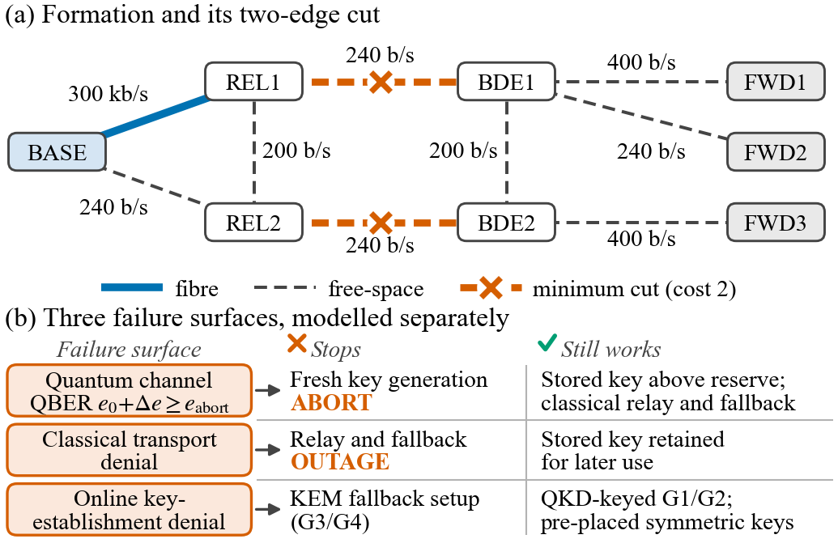
- (a) The eight-node formation, per-link secret key rates and the minimum cut isolating its forward posts. (b) The three failure surfaces, which the model keeps separate (§III-A).
We model (T1) an eight-node formation (rear node, two relays, two brigade nodes, three forward posts; one 300 kbit/s fibre and eight 200–400 bit/s free-space links, Fig. 1a) and (T2) a depth-$d$ chain with one longer alternate for $d≥2$. An eight-node ring, a $3×3$ grid and 3- and 4-path parallel graphs, each with one source, one sink and 240 bit/s links, add minimum cuts of two, two, three and four. Sessions run from the rear node to the forward posts and debit the reservoir of every hop. Every formation session crosses one of two 240 bit/s links, so the fibre’s surplus is stranded one hop from the bottleneck.
Reservoirs follow QKDNetSim’s key-buffer semantics with its SECOQC example values [22]: capacity $52 428 800$, threshold $11 324 620$ and a protected reserve of $1 048 576$ bits, the role SECOQC gave to key held for authentication [23]. Overflow is discarded; we found no published capacity from vendors or ETSI [24]. Distilled key remains spendable after generation stops, so an attack on the quantum channel cuts off replenishment but leaves the stock. Stores start at a declared usable fill, 2% (1.03 Mbit per link) in the main runs.
Sessions are served at four grades: G₁ one-time pad (key $=$ payload bits); G₂ QKD-keyed symmetric (256 bit, ITS-delivered key under a computational cipher); G₃ hybrid QKD $⊕$ ML-KEM-768 (128 bit plus KEM); G₄ ML-KEM-768 only. Each class has an authorised floor. If the floor cannot be met, the controller either blocks at the deadline (fail_closed) or serves below the floor at once and records an auditable violation (fail_degraded).

Link model and adversary
An adversary who raises the noise past the security threshold halts key generation [25], so a fixed degraded rate is indefensible. A link is nominal ($R_{0}$), degraded ($R_{0}ρ(e)$), in abort (no fresh key, $e≥e_{abort}$) or in outage (no classical transport), with
$$\begin{aligned}ρ(e)={\left[\frac{max​\left(0, 1−(1+f)H_{2}(e)\right)}{1−(1+f)H_{2}(e_{0})}\right]}^{γ},\#\left(1\right)\end{aligned}$$
$f=1.16$ and $e_{0}=0.03$ [26]. We report $γ=1$ (asymptotic BB84) and $γ=3.4$, a steeper shape matched to one datapoint from another modality [26] for illustration only. The threshold $e_{abort}=0.075$ is an engineering value (the NEC–NICT engine of [26] codes only below 7.5%), with 0.11 as a sensitivity.
QBER pressure stops generation but leaves the classical channel intact, so stored key can still be relayed and any fallback still works. Classical-channel denial halts post-processing and transport [10], and denial of the online key-establishment service blocks a KEM fallback but not QKD-keyed grades or pre-placed keys (Fig. 1b). Detector blinding [27] raises no QBER and is invisible here. The adversary injects excess QBER $Δe$ on the links it buys [6], at relative cost 1 per free-space link and 10 for the fibre (1 and 100 as sensitivities); these are scenario weights, not measured expenditure. It chooses targets by static betweenness per unit cost, by residual betweenness recomputed after each removal, by the cost-weighted minimum cut, or online from committed routes.

Key accounting and traffic
Relaying $K$ bits of key across one hop costs
$$\begin{aligned}q=K+M_{meta}+n_{auth} t,\#\left(2\right)\end{aligned}$$
with metadata $M_{meta}=240$ bit (Y.3803 relays a key file) and a tag $t=127$ bit [28] charged per authenticated message [29]. No specification fixes the count $n_{auth}$ per delivery. Two is a lower bound and field data imply about 7 (§IV-A), so we use 7 unless stated (a G₂ debit of 1385 bit per hop), with 2 and 40 as sensitivities.
Demands follow measured deployments. C2: 2048 bit, floor G₂, 5 s deadline, $λ=0.05$ s$​^{−1}$ (256 bit/min per encryptor [30]). ISR: 144 000 bit, floor G₁, 30 s, i.e. a 60 s session of 2.4 kbps one-time-pad voice [31]. LOG: 320 000 bit [31], floor G₃, 120 s, $λ=0.03$ s$​^{−1}$. Priority follows this order. At 0.02 s$​^{−1}$ (ISR factor 1) the mean debit across the formation’s cut would exceed six times its 480 bit/s supply, which no store could fund, so ISR runs at factor 0.1, or 0.002 s$​^{−1}$ (397 bit/s in total across the cut, 83% of supply). Factors 1 (overload) and 0.03 (light) are sensitivities.

Metrics and a cut condition
Of $N$ arriving requests, let $S$ be those served within their deadlines and $D⊆S$ those below their authorised floor:
$$\begin{aligned}A=|S|/N, Q=|S\backslash D|/N, L=|D|/N,\#\left(3\right)\end{aligned}$$
so $A=Q+L$, splitting availability into compliant service $Q$ and below-floor service $L$, which includes post-quantum-only fallback. Forced assurance loss $F=|D_{ITS}|/|E|$ is the number of requests entitled to ITS key (floors G₁, G₂) served at G₃ or G₄, divided by all entitled arrivals including blocked ones, so both modes share one denominator. An ISR request served at G₂ misses its floor (counted in $L$) but keeps an ITS-delivered key (not in $F$). Payload weighting gives $F_{B}$, and class weights $(5,2,1)$ and $(10,3,1)$ for (C2, ISR, LOG) give a second reweighting; both are exposure proxies.
For a cut $δ(W)$ separating the rear node from the forward posts, with usable stock $U_{e}(0)$ and generation $G_{e}(T)$ on cut link $e$, every compliant session completed by $T$ debits at least its floor debit $q_{s}$ from some cut link:
s∈CT​qs ≤ e∈δ(W)​Ue(0)+Ge(T).#4
Holding every cut link past abort sets $G_{e}=0$, so at demand D=c​λcqc compliant service lasts at most T*=e​Ue(0)/D, or 1.44 h for the formation at 2% fill. The condition is necessary but not sufficient: a test graph of three two-hop branches strands 400 bits per branch and serves six requests where the bound allows seven.

Experimental Setup
We use discrete-event simulation at 1 s resolution. Admission checks every hop before any debit, and a pending request retries until its deadline, within which G₃/G₄ must also finish a 0.35 s online setup. Arrivals and the attack last 24 h, and pending requests are followed to their deadlines. A declared initial fill replaces a warm-up, since full stores drain only under an overloaded ISR class. Free-space generation and each link’s transport fail independently (mean up 3600 s, down 120 s); a severe-weather variant (900/600 s) runs independently or switches all free-space generation together. Under common random numbers every policy and attack sees identical arrivals and environmental draws per seed, so attack effects are paired differences against the unattacked run. We report means of per-seed fractions with 95% percentile bootstrap intervals (20 000 resamples) over twelve seeds (main grid, routing, floors, code comparison), eight (sensitivities) or six (online adversary, abort sweep).

Validation
No established simulator models a trusted-relay key economy (SeQUeNCe, QuISP and NetSquid have no key pool; QKDNetSim, whose buffers we adopt, has no admission control), and no deployment publishes the assurance composition of its traffic. A 43-check gate and 127 regression tests with exact resource fixtures precede every result, and four published measurements test the accounting. V1 (SECOQC rerouting [23]) matches to the second, which only checks the arithmetic; V4 bounds the one-time-pad demand law to an order of magnitude (1.2–12.6 voice pairs against eleven [31]). V2 and V3 fail, in the same direction. Relaying cost Cambridge $3.69×$ the delivered key [32] against our $2.23×$ at $n_{auth}=2$, and SECOQC’s tunnel spent 91.2% of its rekey budget on authentication overhead against our 65.9% (metadata and tags). Solved for $n_{auth}$, they give about 7 per relay hop and 40 per tunnel. Neither pins the count down, but both show the direction of the bias, hence our default of 7.
- Formation under a 24 h generation attack ($Δe=0.05$) from 2% usable fill, twelve seeds. $b$: budget in relative cost; cut: cut links first ($b=2$ is the cut); betw.: static-betweenness adversary. $A$, $Q$, class $Q$: % of arrivals; $F$: % of entitled arrivals; G₄: % of served sessions. 95% bootstrap half-widths $≤1.0$ point and seed SDs $≤1.8$, except $Q_{ISR}$ (3.1 and 5.6; $≈175$ ISR arrivals per seed).
Mode | Target | $b$ | $A$ | $Q$ | $Q_{C2}$ | $Q_{ISR}$ | $Q_{LOG}$ | $F$ | G₄
closed | – | 0 | 97.5 | 97.5 | 96.7 | 97.0 | 98.9 | 0 | 0
closed | cut | 1 | 92.9 | 92.9 | 92.2 | 50.9 | 97.1 | 0 | 0
closed | cut | 2 | 6.7 | 6.7 | 6.7 | 5.7 | 6.8 | 0 | 0
closed | betw. | 1 | 96.8 | 96.8 | 96.1 | 90.7 | 98.5 | 0 | 0
closed | betw. | 2 | 38.2 | 38.2 | 37.7 | 37.3 | 39.1 | 0 | 0
degr. | – | 0 | 97.5 | 97.5 | 96.7 | 97.0 | 98.9 | $<$0.1 | 0
degr. | cut | 1 | 97.5 | 91.7 | 91.9 | 50.9 | 94.1 | 4.8 | 4.9
degr. | cut | 2 | 97.5 | 6.6 | 6.6 | 5.7 | 6.6 | 90.1 | 93.2
degr. | betw. | 1 | 97.5 | 96.6 | 96.0 | 90.5 | 98.1 | 0.7 | 0.8
degr. | betw. | 2 | 97.5 | 38.0 | 37.7 | 37.2 | 38.6 | 59.0 | 61.0

Results

The fail-mode exchange rate
Table II shows an abrupt transition. Holding the formation’s two-link cut for 24 h drops fail-closed service from 97.5% to 6.7%. Fail-degraded operation still serves 97.5%, but only 6.6% at the authorised grade, against 6.7% under fail-closed (paired $ΔQ=−0.09$ points, CI $[−0.11,−0.07]$). The fallback turns 90.8 points of refused service into below-floor service and forces 90.1% of entitled requests below an ITS key (CI $[89.2,91.0]$; 90.3% payload-weighted), almost all at G₄, since the G₃ hybrid still needs 1257 bit of quantum key per hop.
A single cut link shows a second mechanism. Fail-closed service falls 4.6 points, and ISR loses half its service because its 145 kbit debits no longer fit one 240 bit/s link. Fail-degraded operation forces 4.8% below ITS, and its compliant service ends 1.2 points below fail-closed’s (CI $[−1.4,−1.1]$), because it downgrades at once requests that waiting would have served. A static-betweenness adversary buys BDE1–BDE2 and BDE1–REL1, isolating FWD1 and FWD2 but not FWD3, and forces 59.0%; its first link alone costs fail-closed service 0.7 points.
Without an attack both losses are near zero. $F$ is zero under fail-closed and 0.002% under fail-degraded operation (one request in twelve runs), and ISR reaches its one-time-pad floor in 97.0% of arrivals, against 12.6% at factor 1, so a G₁ floor fails through overload and is not infeasible by design.
The headline numbers are specific to this graph, but their scaling carries over (Fig. 2). With the budget equal to the cut, $F$ is 87.6–92.9% on all five graphs, and fail-closed service is roughly the stock behind the cut divided by the demand: $kU/(\overset{‾}{D}T)$ predicts 6.0, 9.0 and 12.0% for two-, three- and four-link cuts, against 6.5–6.7, 9.6 and 12.3% observed. The observed values are slightly higher because the stock serves cheaper requests once ISR’s large debits stop fitting. With one cut link suppressed, loss appears only where the remaining links cannot carry the 397 bit/s demand: 4.8–11.5% on two-link cuts, 0.71 and 0.05% elsewhere.

Key-aware routing under a fallback
(1) Availability. A post-quantum fallback succeeds wherever a classical path exists, so unattacked key-aware and shortest-path routing give identical fail-degraded availability in every seed and condition; the zero-width interval is an identity of the model, not a measured precision. $Q$ still separates them: key-aware routing raises it by 0.12 points (CI $[0.05,0.19]$) for 5.0 Mbit (CI $[2.3,7.7]$) more key per day.
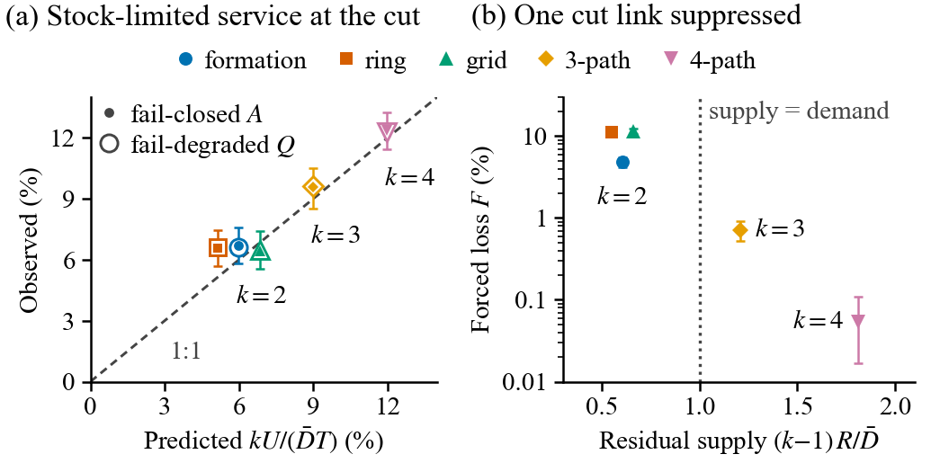
- Scaling with cut size $k$ on five graphs (twelve seeds, 95% intervals). Ring and grid are offset sideways for legibility. (a) Under a held cut, fail-closed $A$ and fail-degraded $Q$ follow the stock-limited prediction $kU/(\overset{‾}{D}T)$ of (4), $U=1.03$ Mbit per link. (b) With one cut link suppressed, forced loss stays small unless the $k−1$ remaining links ($R=240$ bit/s) cannot carry the demand $\overset{‾}{D}$.
(2) Hop penalty. At ISR factor 1, key-aware routing loses 2.6 points of fail-closed service to shortest path (CI $[−2.9,−2.3]$), but only when measured after a 12 h warm-up from full stores, by which time it has left less stock for ISR. Measured from $t=0$ it gains 0.08 points, from 2% fill 0.11–0.13, and at the rescaled load 0.13 (CI $[0.07,0.20]$), so the penalty is a warm-up transient. The hop multiplier costs key but little service; the 25–40% gains reported in [17] measure blocking without a fallback.
(3) Reservation floors. Class-aware floors [10] reserving 20 and 40% of each store against ISR and LOG work as an admission decision rather than a graded control. At 2% fill they deny logistics its quantum key (fail-closed service $−37.6$ points, logistics 98.9$→$0%), and fail-degraded operation then forces 2.1% below ITS with no adversary present; at full stock and the rescaled load they have no effect. Under the cut, the denial buys endurance: $+14.3$ points of fail-closed service (CI $[13.4,15.2]$) and $F$ down from 90.1 to 63.6%, because logistics’ hybrid debits stop draining the cut.
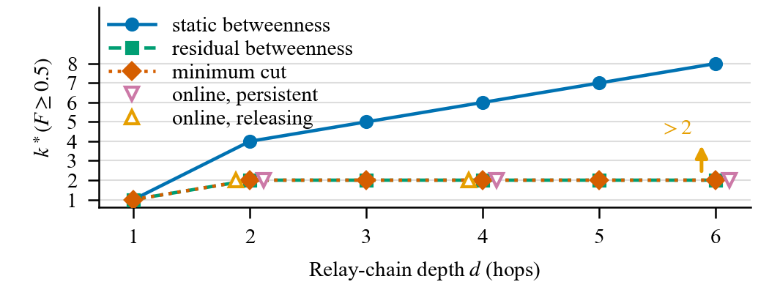
- Forcing cost $k^{*}$, the smallest budget whose mean forced loss reaches 50% in 24 h, against chain depth (fail-degraded, 2% fill, eight seeds; online adversaries: six seeds, at most two links; arrow: not reached).

Downgrade-forcing cost versus depth
For $d≥2$ every link of the depth-$d$ chain lies on one cycle with equal betweenness, so a static centrality ranking is decided by its tie order. Ours attacks the longer alternate first and needs $d+2$ links to force half the entitled traffic below ITS (another tie order needs $d+1$). Recomputing betweenness on the residual graph after each removal needs only the minimum cut, two links, at every depth $d≥2$ (Fig. 3). An online adversary that sees only committed routes and updates every 60 s holds a cut from its first choice if it keeps its slots (89.7–92.9% at depths 2, 4 and 6; 48 link-hours). If it releases slots while its path is briefly unreachable, forced loss falls with depth from 72.3 to 35.5%, as longer paths are unreachable more often and released links refill. The linear growth under a static ranking therefore overstates resilience; against residual betweenness or a cut-holding adversary, depth buys no protection. Per-link costs do matter on the formation: with the fibre 10 or 100 times dearer, residual betweenness avoids it and forces 10.1% at budget two instead of 89.8%, and the fibre-free cut is unaffected.
- Capability against budget: forced assurance loss $F$ (%) after a 24 h attack from 2% usable fill, outage-free, eight seeds; $±$ is the larger side of the 95% bootstrap interval. Complete suppression starts at $Δe=0.045$.
 |  | $γ=1$, $Δe=$ |  |  |  | $γ=3.4$, $Δe=$
Graph | $b$ | 0.03 | 0.04 | 0.045 | 0.05 | 0.03 | 0.04
Formation | 1 | 0 | $<$0.1 | 0 | 0 | 0.47$±$0.06 | 0.15$±$0.05
 | 2 | $<$0.1 | $<$0.1 | 93.1$±$0.9 | 93.1$±$0.9 | 63.0$±$1.0 | 88.8$±$0.9
 | 3 | $<$0.1 | $<$0.1 | 93.1$±$0.9 | 93.1$±$0.9 | 63.0$±$1.0 | 88.8$±$0.9
3-path | 2 | 0 | 0 | $<$0.1 | $<$0.1 | 0 | 0
 | 3 | 0 | 0 | 90.4$±$0.7 | 90.4$±$0.7 | 41.6$±$0.8 | 83.8$±$0.9
 | 4 | 0 | 0 | 90.4$±$0.7 | 90.4$±$0.7 | 41.6$±$0.8 | 83.8$±$0.9
4-path | 3 | 0 | 0 | $<$0.1 | $<$0.1 | 0 | $<$0.1
 | 4 | 0 | 0 | 87.7$±$1.1 | 87.7$±$1.1 | 17.3$±$0.9 | 78.2$±$1.7
 | 5 | 0 | 0 | 87.7$±$1.1 | 87.7$±$1.1 | 17.3$±$0.9 | 78.2$±$1.7

Sensitivity and operating envelope
Capability. A link at nominal $e_{0}$ aborts once $Δe≥e_{abort}−e_{0}=0.045$. Below that it keeps $ρ(e)$ of its rate, and loss is forced once the cut’s residual supply nears the entitled classes’ cheapest ITS demand, about 72 bit/s, plus the hybrid debits competing for it. The response shape therefore matters below the threshold but not above it (Table III). At $γ=1$, sub-threshold injection forces under 0.1% on the formation at any budget up to five links; without outages and one link short of the cut, even supra-threshold injection forces under 0.1% (4.8% with them, Table II); and every budget from the cut upward gives the same 93.1%. The larger cuts repeat the pattern. At $γ=3.4$ the attack bites earlier: $Δe=0.03$ leaves 9.8% of the rate and forces 63.0, 41.6 and 17.3% at the three cuts without aborting a link. Raising $e_{abort}$ to 0.11 moves the threshold to $Δe=0.068$ rather than the 0.08 that $e_{abort}−e_{0}$ suggests, because the ITS zero of (1), at 9.8%, is reached first; $Δe=0.06$ already forces 40.9% on the three-link cut.
Endurance. Sensitivity runs use eight seeds (headline cell $F=89.9\%$, fail-closed $A=7.0\%$). Initial fills of 2, 10 and 100% give $F=89.9$, 65.4 and 0%, and 1, 6 and 24 h attacks at 2% fill give 0.06, 17.6 and 89.9%, with first forcing after about 1.5 h, the $T^{*}$ of (4). The same bound predicts 7.2 and 72 h at 10 and 100% fill; we see a median first forcing of 6.6 h and none within 24 h. Stock matters from full stores as well. At ISR factor 1 and $n_{auth}=2$, after a 12 h warm-up and under the two-link betweenness attack, treating an aborted link’s stock as unusable leaves 30.4% fail-closed service and $F=65.1\%$; spending it gives 76.7% (paired $+46.4$ points, CI $[45.8,46.9]$) and 4.1%. Forcing thus needs a per-link capability, a cost-weighted cut and an attack that outlasts the stock behind it.
Load. Unattacked, the fail-mode gap vanishes at sustainable load (paired $ΔA=0.00$ and $+0.01$ points at ISR factors 0.03 and 0.1) and appears only under overload ($+17.2$ at factor 1). Under the cut it persists at every load ($ΔA=85.4$, 90.6 and 94.7 points), narrowing only because a lighter load drains the stock more slowly, and $ΔQ≤0$ holds throughout on the formation, so the ordering never reverses.
Authentication. With $n_{auth}$ of 2 or 40 instead of 7, fail-closed service under the cut is 8.5 or 3.3% (7.0%) and $F$ 87.9 or 93.5% (89.9%). At 40 the unattacked formation already forces 3.7%, so policy differences do not simply cancel.
Correlated weather. Weather alone can sever the cut. Up/down times of 900/600 s give an unattacked $F$ of 1.7% (independent links) and 3.0% (all free-space generation failing together) and lower unattacked fail-closed service to 95.4 and 94.2%, while the paired attack excess stays at 88.1 and 86.9 points. Since $F$ counts loss whatever its cause, attribution needs the weather-matched baseline; a held correlated outage looks like an attack of the same duration.
Classical channel. Fail-degraded availability survives QBER attack only because aborted links keep their classical channels; denying transport on the cut drops both modes to 0.06%. Pre-placed symmetric keys cannot change this, since ciphertext still needs a path, but they do remove the dependence on a live key-establishment service. With that service down under the held cut, an online KEM fallback serves 5.0% and pre-placed keys 97.5%, still forcing 89.9% below ITS. Pre-placed keys thus move the dependency without reducing the assurance loss. Their lifetime, refresh and distribution cost are not modelled, so their 97.5% is an upper bound.
- Learned grade controllers against the budget-greedy heuristic on the frozen test set (seven conditions, twelve held-out seeds): paired differences, 95% intervals; $J$ in ${10}^{−3}$, others in points. $​^{*}$Never below the floor; also the 24 h nominal result.
 | Strict floor$​^{*}$ | 6 h nominal | Multi-condition
$ΔJ$ (${10}^{−3}$) | $−3.6$ $[−4.0,−3.4]$ | $−4.7$ $[−5.8,−3.5]$ | $+1.1$ $[+0.2,+2.0]$
$ΔQ$ | $+0.04$ $[0.00,+0.06]$ | $−0.08$ $[−0.19,+0.04]$ | $+0.10$ $[+0.01,+0.20]$
$ΔQ_{ISR}$ | $+0.25$ $[+0.14,+0.36]$ | $−0.21$ $[−0.36,−0.05]$ | $−2.77$ $[−2.97,−2.59]$
$ΔF_{B}$ | $−1.99$ $[−2.03,−1.94]$ | $−1.99$ $[−2.03,−1.94]$ | $+1.71$ $[+1.55,+1.85]$

Policy-space audit with a learned controller
A better score in our own simulator would prove little, so we ask how much room a budget-greedy heuristic (the strongest affordable grade within the shield) leaves. The cross-entropy method [33] searches an 18-state, five-action grade table for $J=A−0.75L$ behind a per-class shield [34] that caps class-$c$ violations at $⌊ϵ_{c}N_{c}(t)⌋$, with $ϵ=(0,0.1,0.1)$ for (C2, ISR, LOG). Six training, four validation and twelve test seeds are disjoint, and tables were frozen before testing on seven conditions, two on unseen graphs (Table IV).
Trained on nominal, attacked and severe-weather runs, the learner gains $ΔJ=+1.1×{10}^{−3}$; that the heuristic reaches 99.8% of this reflects our search budget more than the room left. The gain spends ISR’s allowance where it costs the most one-time-pad payload (ISR $Q$ $−2.8$ points, $F_{B}$ $+1.7$), under every class weighting. As $ΔJ$ is linear in the weights, reversal prices follow by algebra once the search supplies a candidate: the heuristic beats the strict floor for $λ<0.98$ (CI $[0.96,1.00]$) in $J=A−λL$, while the learned gain is insensitive to $λ$ and reverses at a forced-loss price $μ^{*}=0.32$ (CI $[0.06,0.60]$; $ΔF=+0.33$ points). Tables trained on nominal traffic alone lose on all the stressed conditions, because nominal runs never reach depletion, a failure the training curves do not show. The per-class shield is also spent where scoring is cheapest, so floors must be specified and priced per class.

Discussion and Limitations
Choosing between refusal and degradation amounts to choosing whether the adversary takes availability or assurance. For operators, three rules follow: report $Q$ and $F$ beside $A$; provision stock behind the minimum cut for $T^{*}$ hours of the attacks of concern; and set fail modes and exception allowances per class, pricing each allowance. The study has limitations. Key rates are parameterised (no photonics is simulated), response shapes are illustrative, relays are trusted and detector blinding is invisible by construction. Weights are exposure proxies, and fill, outages and attack costs are declared scenarios, which we sweep. No cipher or KEM is executed, the policy search was modest and the five graphs are synthetic. Next steps are QKDNetSim cross-validation and a reimplemented published router. Y.3803 asks key managers to record the relay method and prefer OTP-relayed keys for QKD-level requests [2], but the ETSI interface [24] still exposes no grade a consumer could enforce.

Conclusion
Standards permit fallback to weaker key supply, while a layered post-quantum design forbids it as a downgrade attack. Holding the formation’s minimum cut for a day either collapses fail-closed service from 97.5% to 6.7% or keeps 97.5% served while only 6.6% meets its authorised grade and 90.1% of entitled traffic is forced below ITS protection; on all five graphs a held cut forces 87.6–92.9%. Forcing takes a per-link capability, a cost-weighted cut and an attack that outlasts the stock behind the cut. A fallback also needs the classical channel, and a learned controller pays for its small gain with one-time-pad payload. We argue that QKD resilience reporting should cover the assurance-grade composition of served traffic alongside key-supply continuity.

Reproducibility and Acknowledgements
A large language model assisted with coding and drafting; all modelling decisions, parameter provenance, experimental design and claims are the authors’, and every reported number comes from the released simulator, configurations, per-seed results, validation gate and figure and table scripts at https://github.com/LakshyaJ1/Quantum_ResearchPaper.

References
- L. Salvail et al., “Security of trusted repeater quantum key distribution networks,” J. Comput. Secur., vol. 18, no. 1, pp. 61–87, 2010.
- Quantum Key Distribution Networks—Key Management, ITU-T Rec. Y.3803, Dec. 2020, cl. 8.2.3–8.2.5.
- N. Makris et al., “Field demonstration of a fully managed, L1 encrypted 3-node network with hybrid relayed-QKD and centralized symmetric classical key management,” in Proc. ECOC, 2024.
- P. K. Tysowski, X. Ling, N. Lütkenhaus, and M. Mosca, “The engineering of a scalable multi-site communications system utilizing quantum key distribution (QKD),” Quantum Sci. Technol., vol. 3, no. 2, 024001, 2018.
- P. Spooren, A. Neuhold, S. Ramacher, and T. Hühn, “PQC-enhanced QKD networks: A layered approach,” in Proc. IEEE QCNC, Kobe, Japan, 2026, pp. 354–358, doi:10.1109/QCNC69040.2026.00060.
- P. Schartner and S. Rass, “Quantum key distribution and denial-of-service: Using strengthened classical cryptography as a fallback option,” in Proc. Int. Comput. Symp., 2010, pp. 131–136.
- T. van Duijn, S. R. Verschoor, S. Rommel, and I. Tafur Monroy, “Routing strategies for quantum key distribution networks based on trusted relay nodes,” in Proc. ONDM, 2024.
- T. Johann et al., “Comparison and optimization of different routing methods for meshed QKD networks using trusted nodes,” J. Opt. Commun. Netw., vol. 16, no. 3, pp. 382–391, 2024.
- Y. Hao, Y. Xie, W. Gao, and J. Tang, “Q-learning for resource-aware and adaptive routing in trusted-relay QKD network,” Photonics, vol. 12, no. 10, 969, 2025.
- M. Mehic et al., “A novel approach to quality-of-service provisioning in trusted relay quantum key distribution networks,” IEEE/ACM Trans. Netw., vol. 28, no. 1, pp. 168–181, 2020.
- Y. Cao, Y. Zhao, C. Colman-Meixner, X. Yu, and J. Zhang, “Key on demand (KoD) for software-defined optical networks secured by quantum key distribution (QKD),” Opt. Express, vol. 25, no. 22, pp. 26453–26467, 2017.
- A. Sanz et al., “QuLore: An adaptive security framework to extend quantum-safe communications to real-world networks,” arXiv:2511.22416v2, 2026.
- Z. Zhu, “Techno-economic feasibility analysis of quantum key distribution for power-system communications,” arXiv:2510.15248, 2025.
- M. Li et al., “Routing and wavelength assignment with minimal attack radius for QKD networks,” in Proc. IEEE GLOBECOM, 2025, pp. 4071–4076.
- E. M. Ghourab, M. Azab, and D. Gračanin, “A quantum key distribution routing scheme for a zero-trust QKD network system: A moving target defense approach,” Big Data Cogn. Comput., vol. 9, no. 4, 76, 2025.
- S. Hafeez et al., “Quantum-secured routing in drone communication for 6G-enabled smart mobility,” Sci. Rep., vol. 16, 8626, 2026.
- I. Cvitić, D. Peraković, and A. N. Pinto, “Overview of routing approaches in quantum key distribution networks,” in Proc. FABULOUS 2025, LNICST, vol. 700, Springer, 2026, pp. 50–67.
- A. Agalya and K. Priyadarsini, “Trust-aware hybrid QKD–PQC key management for quantum-safe communication networks,” Front. Commun. Netw., vol. 7, 1929455, 2026.
- J. C. Hernandez-Hernandez et al., “Sentinel-based failover for QKD-augmented IPsec tunnels,” to appear in Proc. NetQSA, IEEE ICNP, Oct. 2026, arXiv:2609.01121.
- M. Mehic, S. Rass, E. Dervisevic, and M. Voznak, “Tackling denial of service attacks on key management in software-defined quantum key distribution networks,” IEEE Access, vol. 10, pp. 110512–110520, 2022.
- D. Stebila, S. Fluhrer, and S. Gueron, “Hybrid key exchange in TLS 1.3,” IETF RFC 9954, Jul. 2026, §1.1.
- M. Mehic, O. Maurhart, S. Rass, and M. Voznak, “Implementation of quantum key distribution network simulation module in the network simulator NS-3,” Quantum Inf. Process., vol. 16, no. 10, 253, 2017.
- M. Peev et al., “The SECOQC quantum key distribution network in Vienna,” New J. Phys., vol. 11, 075001, 2009.
- Quantum Key Distribution (QKD); Protocol and Data Format of REST-Based Key Delivery API, ETSI GS QKD 014 V1.1.1, Feb. 2019.
- R. Alléaume et al., “Using quantum key distribution for cryptographic purposes: A survey,” Theor. Comput. Sci., vol. 560, pp. 62–81, 2014.
- M. Sasaki et al., “Field test of quantum key distribution in the Tokyo QKD Network,” Opt. Express, vol. 19, no. 11, pp. 10387–10409, 2011.
- L. Lydersen et al., “Hacking commercial quantum cryptography systems by tailored bright illumination,” Nat. Photonics, vol. 4, no. 10, pp. 686–689, 2010.
- N. Walenta et al., “A fast and versatile quantum key distribution system with hardware key distillation and wavelength multiplexing,” New J. Phys., vol. 16, 013047, 2014.
- C.-H. F. Fung, X. Ma, and H. F. Chau, “Practical issues in quantum-key-distribution postprocessing,” Phys. Rev. A, vol. 81, 012318, 2010.
- D. Stucki et al., “Long-term performance of the SwissQuantum quantum key distribution network in a field environment,” New J. Phys., vol. 13, 123001, 2011.
- T.-Y. Chen et al., “Implementation of a 46-node quantum metropolitan area network,” npj Quantum Inf., vol. 7, 134, 2021.
- J. F. Dynes et al., “Cambridge quantum network,” npj Quantum Inf., vol. 5, 101, 2019.
- R. Rubinstein, “The cross-entropy method for combinatorial and continuous optimization,” Methodol. Comput. Appl. Probab., vol. 1, no. 2, pp. 127–190, 1999.
- M. Alshiekh et al., “Safe reinforcement learning via shielding,” in Proc. AAAI, 2018, pp. 2669–2678.

